


Office of Executive Engineer (Electrical), Ground Floor, Nirman Building, New Kandla, Kutch,
Pin Code 370210.

No.: EL/AC/ EOI/Roads/ Date: 14/11/2025.

EXPRESSION OF INTEREST [EOI]

“Special repairs to roads in Gopalpuri (Cement Concrete Pavement) – Phase-I – Electrical Part”

(This EOI is issued to elicit Expression of Interest from the parties interested in the work and does not constitute any binding commitment from the Deendayal Port Authority to proceed with the work or invite any or all the parties in the subsequent bidding process. The Open Tenders will be issued subsequently.)

Executive Engineer (Electrical), DPA invites Expression of Interest for the work of “Special repairs to roads in Gopalpuri (Cement Concrete Pavement) – Phase-I – Electrical Part” from the reputed firms from those who have executed similar work in Government/public sectors and other leading private organizations. The Expression of Interest (EOI) documents containing Technical Specifications & Approved Make List are enclosed herewith.

The interested firms are requested to submit their expression of interest for the said work in BOQ format as enclosed at Annexure I. The completed EOI (Expression of Interest) shall be submitted to the office of the undersigned on or before 18/11/2025. A soft copy of EOI is also acceptable through e-mail Id xenedpa@gmail.com & deepak.hazra@deendayalport.gov.in

Sd/-
Executive Engineer (E)
Deendayal Port Authority

TECHNICAL SPECIFICATION

Technical Specification for Item No. 1 (a) (b) & (c)

This includes supply at site 1.1 KV grade, 4 core X 16 sq.mm, 4 Core X 25 sq.mm., 4 Core X 35 sq.mm. and 4 Core X 50 sq.mm. aluminum conductor, XLPE insulated armoured cable of given sizes confirming to IS: 7098 (Part-I) 1985 with up to date amendments and of approved make with ISI mark. The manufacturer shall produce TYPE TEST certificate with similar size of cable, which shall not be more than 3 years old. The cable shall have marking/embossing at the interval of every meter showing its progressive length. The manufacturer’s routine test certificate shall produce with supply of cable at site. The rate shall be inclusive of all taxes including loading, unloading and transportation.

Technical Specification for Item No. 2

This item includes supply at site single arm detachable type 7 meter height GI Octagonal Pole at site. The pole shaft shall be made from sheet steel confirming to BSEN 10025 S355. The pole shaft shall have octagonal cross section and shall be continuously tapered with single longitudinal welding. There shall not be any circumferential welding. The welding of pole shaft shall be done by Submerged Arc Welding (SAW) process. Octagonal pole shaft shall be provided with the rigid flange plate manufactured from MS FE410 confirming to IS: 2062 with provision for fixing 4 foundation bolts. This base plate shall be fillet welded to the pole shaft at two locations i.e. from inside and outside. The Octagonal Pole shall be in single section.

The Octagonal Pole shall have door of approximate 500 mm length at the elevation of 500 mm from the Base plate. The door shall be vandal resistance and shall be weather proof to ensure safety of inside connections. The door shall be flush with the exterior surface and shall have suitable locking arrangement. There shall also be welded a cleat of size 40 x 40 x 4mm for the purpose of Earthing. The pole shall be adequately strengthened at the location of the door to compensate for the loss in section.

The poles shall be hot dip galvanized as per BSEN ISO 1461 standard with minimum average coating thickness of 85 micron. The galvanizing shall be done in single dipping.

The Octagonal Poles shall be bolted on a pre-cast foundation with a set of four foundation bolts for greater rigidity.

The pole shall be provided on top with the detachable type canopy having galvanized single arm emerging from the canopy pipe at an angle of 105 degrees with respect to vertical top pipe. The side arm shall be of 1500 mm and made from approx. 75 mm OD and minimum 2 mm thickness. The octagonal canopy shall be of suitable size with respect to top of Pole. The arm pipe shall have suitable nipple for receiving 140/150 watt LED Street Light fitting.

The base compartment shall have provision to fix up the small Bakelite wooden board of suitable size to mount one of 6A SP MCB, terminal connector & service connections etc. The contractor shall supply the bakelite wooden board.

The dimensions of the Octagonal Pole shall be as below:

Total Height : 7000 mm
Top A/F : 70 mm
Bottom A/F : 130 mm
Sheet Thickness : 3 mm
Base Plate size : 220 mm × 220 mm × 12 mm
PCD : 210 mm
Size of Foundation Bolt : 4 Nos. M20 × 600 mm J Bolt

All MS parts including hardware shall be hot dip galvanized as per BSEN-ISO1461 or equivalent. The Pole manufacturer shall have ISO 9001, ISO 14001 and ISO 45001 certification for Pole manufacturing.

The rate shall be inclusive of all the taxes (excluding GST), insurance, packing, forwarding, transportation, unloading at site as directed by Engineer in Charge.

Technical Specification for Item No. 3

The contractor shall prepare foundation for octagonal pole as per drawing provided at Section-I

The foundation of Pole shall be prepared at the location as directed by Engineer In- Charge. The work includes necessary excavation of required size in hard/soft soil after removal of Paver as the case may be. After casting of foundation, proper curing shall be done. Also, after completion of foundation work, the pavers/soil shall be arranged/leveled to its original condition nearby the pole foundation.

The Octagonal Pole shall be erected on the constructed RCC foundation with a set of four foundation bolts for greater rigidity. For cable entry & exit, suitable size & length of two HDPE Pipe shall be kept in the center of Pole foundation during its casting as shown in the drawing. This item also includes passing of supplied 4 core, 10 Sq.mm XPLE aluminum conductor Cable through provided HDPE Pipe in the Pole foundation and end termination of 4 core, 10 Sq.mm XPLE aluminum conductor Cable with suitable size of cable glands & lugs in the Pole. This work includes all material, labour, tools & tackles as directed by Engineer in Charge.

Technical Specification for Item No. 4

The contractor shall supply at site 140/150 Watt energy efficient LED Street Light fitting. The Technical Specification of 140/150 Watt LED Street Light fitting is as below:

S/N. | DESCRIPTION | SPECIFICATION
1 | Input Power | 140/150 Watt
2 | Input voltage AC | 120-270 V AC
3 | Input Frequency | 50 Hz +/-1 Hz
4 | Life | 50,000 burning hours @ L70B50, Ta 35°C Outdoor
5 | Mounting type | Suitable for wall mounting with bracket
6 | Total Harmonic Distortion | <10% maximum
7 | Working Temperature | 0°C to +45°C
8 | Working Humidity | 10% to 90% RH
9 | Temperature | 5700K
10 | Colour rendering index | ˃70
11 | Efficacy | ≥ 110 Lumen/Watt
12 | Finishing | Corrosion resistant powder coating
13 | Power factor | Not less than 0.95
14 | Warranty | 5 Years from the date of successful commissioning.  It is clarified that during Warranty Period, if the material is found to be defective or has poor performance or has lumen depreciation beyond permissible limit as per LM80 report, the contractor shall promptly, Replace the material against manufacturing defects /Rectify the material, on receiving the instruction from Engineer in Charge at contractor's cost.  The contractor shall have final & total single point responsibility for performance of the LED light fitting supplied.
15 | Construction | The housing should be of non-corrosive powder coated pressure die-cast aluminum frame with heat resistant toughened clear glass fixed with SS screw.  The LED Street Light shall have its make embossed/engraved on the Fitting.
16 | Surge Protection | The Luminaire should have a 10kV SPD duly bolted inside the Luminaire. The SPD should be able to sustain a minimum 15 hits of 5kA rating i.e. Total
 |  | of 45 hits across all the three modes as per IEC 61000.
17 | Electrical Protection | The Luminaire should be capable of withstanding voltage stress of 440V phase to phase for 8 hrs at 50 degree Celsius and should have low voltage protection as 100V for 48 hours & high voltage cut- off above 325 VAC and should have an auto restart  feature.
18 | Impact Resistance | IK07
9 | Driver Construction | The Drivers should be a potted driver not a printed circuit board without casing, mounted inside the luminaire.  The Driver shall be of constant current type and shall have Over voltage, Over current, Over temperature & Short circuit Protection.  The driver efficiency shall be more than 85%.  List of make of Driver: PHILLIPS Xitanium/ MEANWELL/ OSRAM/ BAG/ SOSEN/ INVENTRONICS.  Manufacturers can use their own make LED driver and the LED Driver shall be BIS certified and shall meet the specifications and comply with Safety requirements (IEC 61347-1, IEC 61347-2-13), EMC  requirements (CISPR 15/ EN 55015, IEC/EN 61547, IEC/EN 61000-3-2, IEC/EN 61000-3-3).
20 | Driver shall safety compliance | As per IEC 61347-1/ IS 15885 (Part2/ SEC13)/BIS  certified
21 | Ingress Protection Level of LED Light Fitting | IP 65 or more
22 | Optics | Asymmetric Wide or Wide Beam Angle
23 | Material of optics | PC lens with toughened glass cover. The LEDs should be provided with UV resistant lens/glass cover for avoiding yellowing of the lense/glass cover.  Or Exposed lensed PC Lens plate, the LEDs should be provided with anti-dust, UV resistant exposed lens for avoiding any dust & dirt accumulation on  the fixtures and yellowing of the lenses.
24 | Makes of LEDs | Osram, Cree, Lumileds, Nichia, Seoul.
25 | Specification of LED | SMD type with wattage of each LED should be > 1  Watt and ≤ 3 Watt.
26 | Certificate/Report | - Type test reports for LED fitting & LED Driver.  - Should comply to IESNA LM-79 (Approved method for the Electrical and Photometric Measurements of Solid-State Lighting Products). LM79 report from any NABL accredited laboratory.
- The LEDs used should comply to LM-80 standards (IESNA: Approved Method for Measuring Lumen Maintenance of LED Light Sources and LED lumen depreciation time to L70 based on LM-80 data).
- BIS Certificate for LED Driver.
- BIS Certificate for LED Luminaire.
Contractor shall submit all the above certificate/report including BIS certificate for the
Luminaire at the time of supply of fittings.

The rate shall be inclusive of all taxes (excluding GST), insurance, transportation, unloading at site as directed by Engineer in charge.

Technical Specification for Item No. 5 :

This item includes fixing & commissioning of supplied 140/150 W LED Street Light fitting. The fitting shall be fixed on nipple of GI pipe bracket on the Octagonal Pole. This includes supply of one No. of 6 Amp SP MCB, terminal connector suitable for 4 core, 10 Sq.mm size cable and 3 Core 1.5 Sq. mm flexible copper Cable for connection between the Street Light fitting to the 6A SP MCB. This work also includes necessary wiring, connections & necessary earth linking connections with all material, labour, tools & tackles as directed by Engineer in Charge.

Technical Specification for Item No. 6 :

This includes Complete dismantling, removal & shifting of existing deteriorated poles including relevant accessories. Before dismantling & removal of Poles the conductor, street lights shall be removed from each pole in such a way that same shall not be get damaged. All the items dismantled have to be minutely recorded and handed over to the substation, Gopalpuri, DPA or as directed by EIC.

Technical Specification for Item No. 7

- Supply:

This includes supply at site, installation, testing & commissioning of outdoor pedestal type Feeder Pillar Panel, double shutter, handle with locking arrangement (Pad lock-5 lever with keys), dust, damp and vermin proof of size 1000 mm Height, 1000 mm Length & 400 mm depth. The main distribution panel shall be fabricated from MS Sheet of 2.00 mm thick, MS angle 25X25X6 mm and MS flat of suitable size.

The main panel shall be designed as per IS norms and shall be spacious for easy maintenance and frame structure shall be with MS angle of suitable size (min. 35 X 35 X 6mm) with inner sheet & inner angles & pedestal of pane made from 65 X 65 X 6mm MS angle with four legs of 1200 mm and shall be provided with following items. The panel shall be duly painted with Epoxy Paint light grey shed.

1 | 200A, 4 Pole, 415V, 35KA, Panel Mounted MCCB | 1 No.
2 | Panel mounted change over switch of 200 Amp. Capacity (manually operated), 415 V, 50 Hz. AC | 1 No.
3 | 100 A, 4 Pole, 415V, 50 Hz. AC of 35KA, Panel Mounted MCCB | 3 No.
4 | Indicating Lamps, 230/240V, AC with in-built resistance | 3 No.
5 | Indicating Lamp- Red, Green, blue & yellow 230V AC with in-built resistance. | 1 set
6 | Three phase, 4 wire electronic energy meter CT operated with 100/5 ratio | 1 No.
7 | Surface mounted light sensor time switch | 1 No.
8 | 50A, Three phase Air Breaker Contactor | 1 No.
9 | Analog Timer for control of street light | 1 No.
10 | Electrolytic copper bus-bar of suitable size for phase and neutral, PVC sleeved with colour code, Danger Board tie belt MS Wall  Mounted stand etc. | 1 No.

All these compartments shall be mounted in the Panel by means of suitable cadmium passivated hardware. The Panel shall be complete in all respects with cable glands, lugs for incoming and outgoing cables including interconnection with PVC insulated cable single core, 25 sq.mm. standard copper conductor of 650/1100V grade.

The Panel shall be tested as per IS and test certificate to be submitted along with panel at site. All the components shall be panel mounted type and hardware cadmium passivated. The Feeder Panel shall be provided with 2 Nos. GI Terminals for earthing.

The Panel shall be manufactured from type test certificate holder having Type Test Certificate of Feeder Panel of similar or above ratings. This includes all labour & material as directed by Engineer-In-Charge.

(b) Installation, testing & commissioning

The Panel shall be erected on cement concrete platform duly plastered with tapped collar of suitable size having height of 500 mm above ground level including grouting of legs in reinforced foundation of suitable design.

Technical Specification for Item No. 8

This item includes preparation of Pole earthing with GI earth rod of 20mm diameter and 1.5 meter length. The Earth rod shall be installed nearby the Lighting Pole into the ground as directed. The connection between the earthing stud inside pole and the earthing rod shall be done with two runs of 8 SWG GI wire with necessary clamps and nut bolts. The work includes all labour and material as directed by Engineer in charge.

Note :- All the materials shall be as per approved make list of DPA but before procurement approval from the Engineer Incharge shall be obtained. However, wherever the items are not available in the approved make list then the approval of the same shall be obtained from the Engineer-in-Charge.

 |  |  |  | Sd/-
 | Seal & Signature of Contractor |  | Executive Engineer (Elect.)
 |  |  |  | Deendayal Port Authority

Schedule-B
ELECTRICAL DIVISION
Name of Work: Special repairs to roads in Gopalpuri (Cement Concrete Pavement)-Phase-I - Electrical Part
S/N | Description | Qty | Unit | Rate | Amount
1 | Supply at site 4 Core, LT armoured aluminium conductor XLPE cable of 1.1 KV grade of following type and size as per the Technical Specification No. 1.
(a) | 4 Core X 16 Sq.mm | 1000 | Mtr.
(b) | 4 Core X 25 sq.mm. | 2000 | Mtr.
(c) | 4 Core X 35 sq.mm. | 1000 | Mtr.
(d) | 4 Core X 50 Sq.mm. | 2000 | Mtr.
2 | Supply at site 7 meter height single arm Octagonal type Pole as per the Technical Specification No. 2. | 100 | No.
3 | Erection of 7 meter height single arm Octagonal type Pole as per the Technical Specification No. 3. | 100 | No.
4 | Supply of Energy Efficient 140/150 W LED Street Light fitting as per the Technical  Specification No. 4 | 100 | No.
5 | Fixing of 140/150 W LED Street Light fitting with  with all accessories as per Technical Specification No. 5. | 100 | No.
6 | Removal of PSC pole with overhead conductor and street lights as per the technical specification no. 6 | 57 | No.
7 | Supply, Installation, Testing and Commissioning of Feeder Panel for distribution of underground power supply as per the Technical Specification No. 7.
(a) | Supply | 5 | No.
(b) | Installation, Testing and Commissioning | 5 | No.
8 | Preparation of Pole earthing with 20 MM diameter GI rod as per Technical Specification No. 8. | 100 | No.
Total Amount: Rs.
(In words ________________________________________________________________________)
(NOTE: The rates should be inclusive of all taxes, duties, fees, cess etc and all incidental charges; but exclusive of Goods & Service Tax).
 |  |  |  | Sd/-
 | Seal & Signature of Contractor |  | Executive Engineer (Elect.)

Approved Make List for Electrical Items

SN | Description | Recommended Makes
1 | HT VCB | SIEMENS / CROMPTON GREAVES/ABB/Schneider
1(a) | HV Gas Insulated Breakers | SIEMENS /Schneider/ABB
2 | POWER TRANSFORMERS | VOLTAMP/CROMPTON GREAVES /BHARAT BIJLEE/  BHEL/ SIEMENS/ ABB/ Schneider/T&R
3 | DISTRIBUTION TRANSFORMERS | EMCO/KIRLOSKAR/PATSON/VOLTAMP/ ABB /  Schneider / T&R
4 | RESIN CAST TRANSFORMERS
4 | A) RESIN CAST  IMPREGNATED | VOLTAMP / KIRLOSKAR / EMCO
4 | B) DRY CAST | VOLTAMP/KIRLOSKAR/EMCO
5 | HT XLPE CABLES | POLYCAB/TORRENT/RPG ASIAN/ /GLOSTER/  UNISTAR/ UNISTAR/KEI/FINOLEX/HAVELS
6 | LT XLPE CABLES | POLYCAB/TORRENT/RPG ASIAN/ / RALLISON/PRIMECAB/ HAVELLS/UNISTAR/AVOCAB / ADCAB
7 | LT ACB | SIEMENS/L&T/SCHNEIDER/C&S
8 | PROTECTION RELAYS | AREVA/L&T/SIEMENS/ABB/C&S
9 | LT PANEL | CPRI APPROVED
10 | CHANGE OVER SWITCH | SIEMENS/L&T/ABB/C&S/SCHNIDER/ LEGRAND /  INDOASIAN
11 | SFU FOR MAIN LT DISTRIBUTION  PANELS | SIEMENS/L&T/ABB/C&S
12 | SFU FOR DISTRIBUTION PANELS & FEEDER PILLERS | SIEMENS/L&T/ABB/C&S/ SCHNEIDER/ LEGRAND/ INDOASIAN/HAVELLS
13 | MCCB FOR MAIN LT DISTRIBUTION PANELS | SIEMENS/L&T/ABB
14 | MCCB FOR DISTRIBUTION PANELS AND FEEDER PILLERS | SIEMENS/L&T/ABB/C&S/ SCHNIDER/ LEGRAND/ INDOASIAN/HAVELLS
15 | MCB/ELCB/RCCB/RCCBO FOR MAIN LT DISTRIBUTION PANEL | SIEMENS/HAGER L&T/ABB

16 | MCB FOR DISTRIBUTION PANELS AND FEEDER PILLERS |  | SIEMENS/L&T/ABB/C&S/ SCHNEIDER/ LEGRAND/ INDOASIAN/ HAVELLS/ STANDARD
17 | MCB DISTRIBUTION BOARD |  | STANDARD / HENSEL/LEGRAND / INDOASIAN /  HAVELLS
18 | MULTI FUNCTION DIGITAL METER FOR MAIN LT DISTRIBUTION PANELS/DIGITAL  KWH METERS |  | L&T/ENERCON/SECURE/L&G/ RISHABH
19 | ANALOG VOLT/AMPARE METER FOR DISTRIBUTION PANELS AND  FEEDER PILLERS |  | RISHABH/AE/ENERCON/L&T
20 | SLECTOR SWITCH FOR VOLTMETER/AMPARE METER |  | L&T/SIEMENS/C&S
21 | POWER CONTACTOR &  OVER LOAD RELAYS |  | L&T/SIEMENS/ABB
22 | QUARTZ TIME CLOCK SWITCH |  | L&T/INDOASIAN/SIEMENS
23 | PVC WIRE WITH  COPPER CONDUCTOR |  | RR KABEL / KEI / POLYCAB/MILEX/GUJCAB/ STANDARD / FINOLEX / ANCHOR
24 | FLUSH TYPE SWITCHES, SOCKETS, HOLDERS AND CEILING ROSES & ELECTRONIC  REGULATORS |  | ANCHOR/MK/NORTHWEST/VINAY /PANAMA / HAVELLS
25 | DOOR BELLS/CALL BELLS |  | ANCHOR/LEGEND/MK/NORTHWEST
26 | MODULAR SWITCHES, SOCKETS, PLATES & BOXES |  | ANCHOR / MK / NORTHWEST / LEGRAND  /HAVELLs / INDOASIAN / SIMENS.
27 | PVC CONDUIT / OVAL CONDUIT & CASSING CAPPING  AND ACCESSORIES |  | PRECISION/VULCAN/FINOLEX/ GARWARE/  PRESTOPLAST/ SWASTIK / BPI
28 | GLS LAMPS & FLUORESCENT  LAMPS |  | PHILIPS / BAJAJ / WIPRO / CROMPTON GREAVES / OSRAM / SURYA ROSHNI / GE
29 | HPSV, HPMV & METAL HELIDE LAMPS |  | PHILIPS / BAJAJ / WIPRO / CROMPTON GREAVES / OSRAM / SURYA ROSHNI / GE
30 | IGNITORS FOR HPSV, METAL HELIDE LAMPS |  | PHILIPS / BAJAJ / WIPRO / CROMPTON GREAVES / OSRAM / SURYA ROSHNI / GE
31 | LUMINARIES |  | PHILIPS / BAJAJ / WIPRO / CROMPTON GREAVES /  OSRAM / SURYA ROSHNI / GE/C&S
31a | LED LUMINARIES |  | Philips/Bajaj/Wipro/CG/Surya/Pyrotech/Syska/Nessa/C&S having surge Protection ≥10KV for fittings & internal Surge Protection for Driver of≥4KV, LED Chip only OSRAM/CREE/Philips Lumileds/Citizen/with LM- 79,80 CERTIFICATION
32 | CEILING FANS |  | BAJAJ/ORIENT/USHA/CROMPTON GREAVES /  ALMONARD/GEC
33 | WALL MOUNTING FANS |  | BAJAJ/ORIENT/USHA/CROMPTON GREAVES /  ALMONARD/GEC
34 | EXHUAST FANS |  | BAJAJ/ORIENT/USHA/CROMPTON GREAVES /  ALMONARD/GEC
35 | HEAVY DUTY INDUSTRIAL WALL  MOUNTING FANS |  | BAJAJ/ORIENT/USHA/CROMPTON GREAVES /  ALMONARD/GEC or its equivalent
36 | WATER COOLER |  | VOLTAS/SHRIRAM USHA/BLUE STAR
37 | AIR CONDITIONERS |  | VOLTAS/CARRIER/BLUESTAR/USHA/  HITACHI/LG/ SAMSUNG/ONIDA
38 | REFRIGERATORS |  | VOLTAS / CARRIER / BLUESTAR / USHA /  HITACHI / LG / SAMSUNG / WHIRLPOOL
39 | VOLTAGE STABILIZER |  | VEELINE / CAPRI
40 | INVERTERS |  | SUKAM / MICROTEK
41 | D.G. SETS
41 | A) ENGINE |  | CUMMINS/GREAVES/KIRLOSKAR/ CATERPILLAR  /ASHOK LEYLAND /VOLVO
41 | B) ALTERNATOR |  | STAMFORD/CROMPTON GREAVES /JYOTI/  KIRLOSKAR ELECTRIC
42 | ELECTRIC MOTOR |  | ALSTOM/CROMPTON GREAVES /SIEMENS/  KIRLOSKAR/ABB
43 | WATER PUMPS |  | SWASTIK / KSB
44 | WATER GEYSER |  | BAJAJ/USHA / CROMPTON GREAVES / SPHEREHOT  / RACOLD
45 | LUGS & CABLE  GLANDS |  | DOWELLS / JAINSON / BRACO
Note: In case of supply of Make of material which is neither available in the DPA approved, the said material should be supplied as per the Make decided by EIC for which written intimation will be given to the contractor.
Before procurement of material, the Make of the material should be approved by EIC in writing.
 |  | Seal & Signature of Contractor |  |  |  | Sd/-  Executive Engineer (E)  Deendayal Port Authority

Civil Foundation for Octagonal Pole:

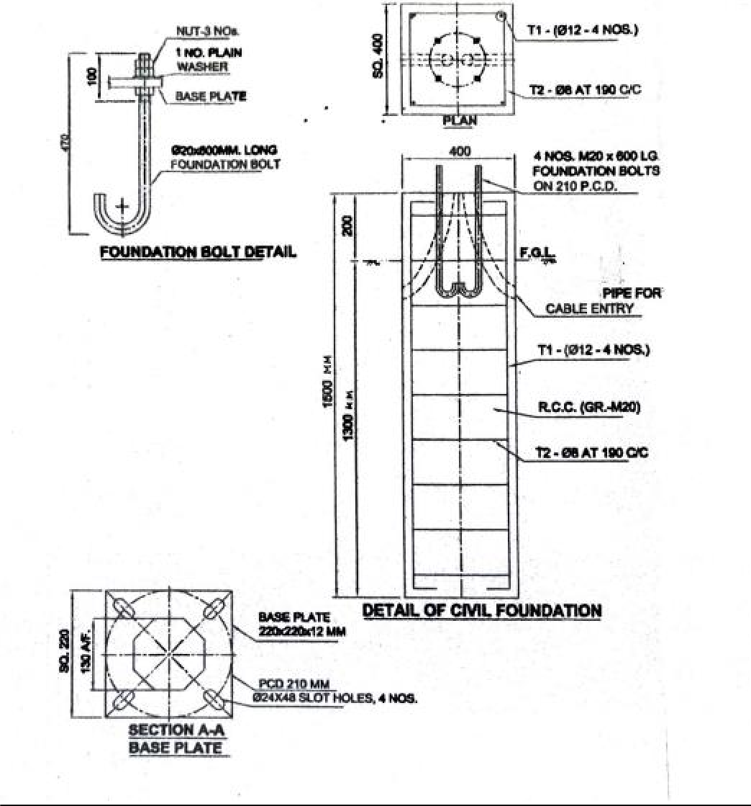

Sd/-

Signature & Seal Executive Engineer (E)
of Contractor Deendayal Port Authority

