SAP PS USER MANUAL
1) Login to SAP with your USER ID and Password
SAP Easy Access Screen will display :

Enter CJ20N (in TCode Box) – to go to Project Builder

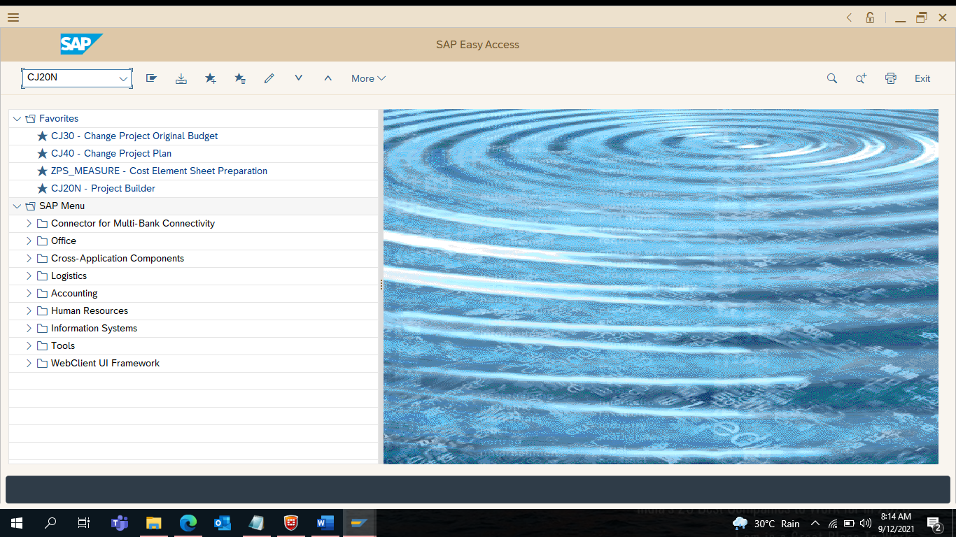

2) To Create New Project

Click on Icon Create

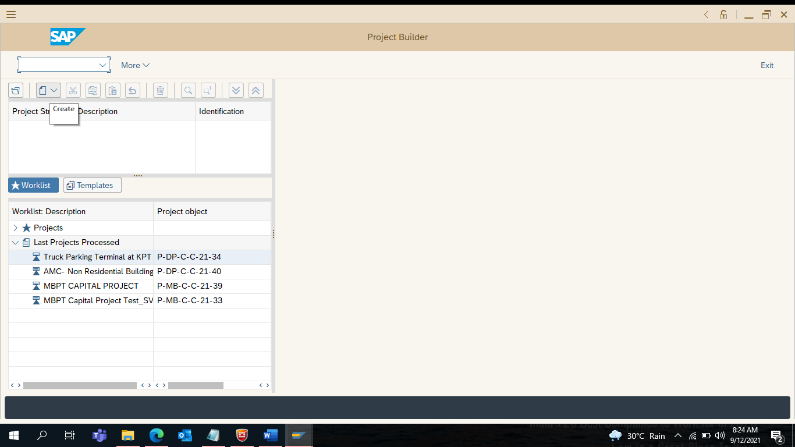

3) Select on Project

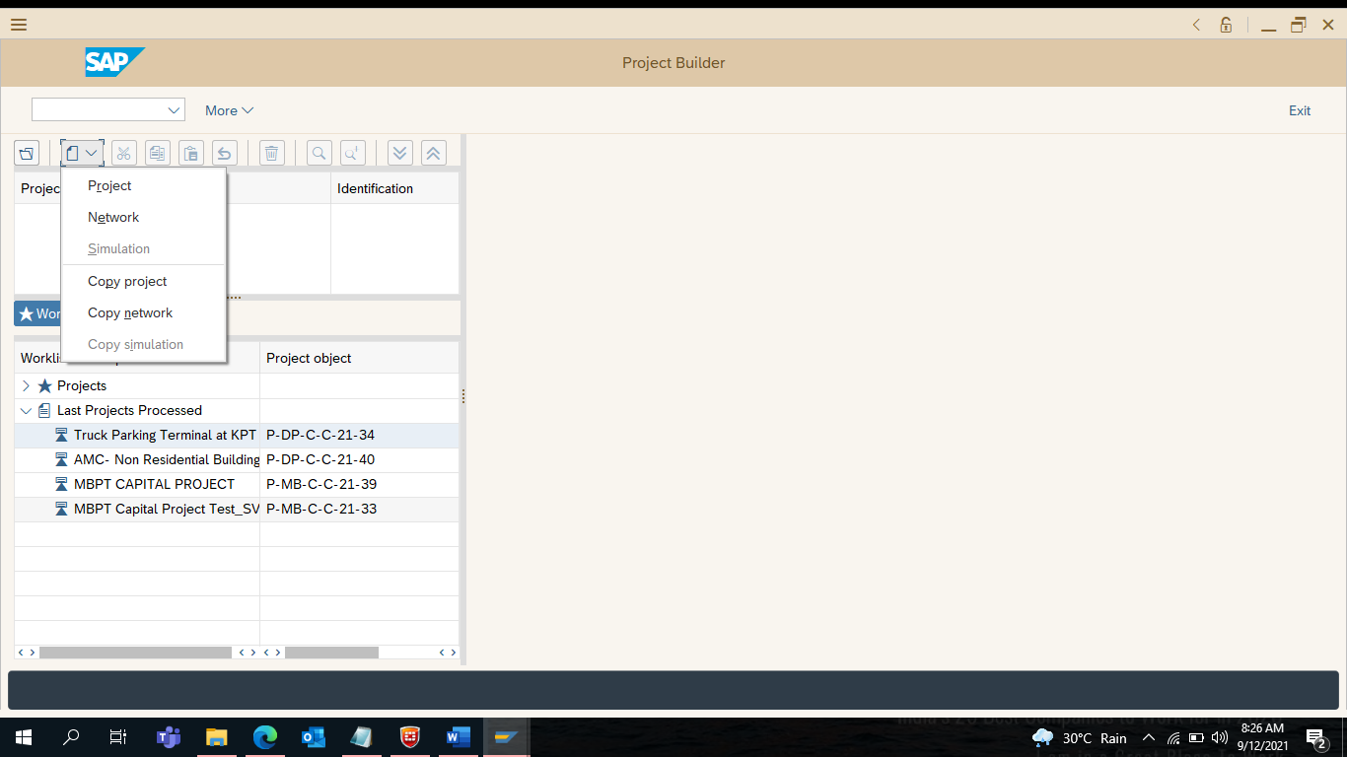

4) Enter Project Definition

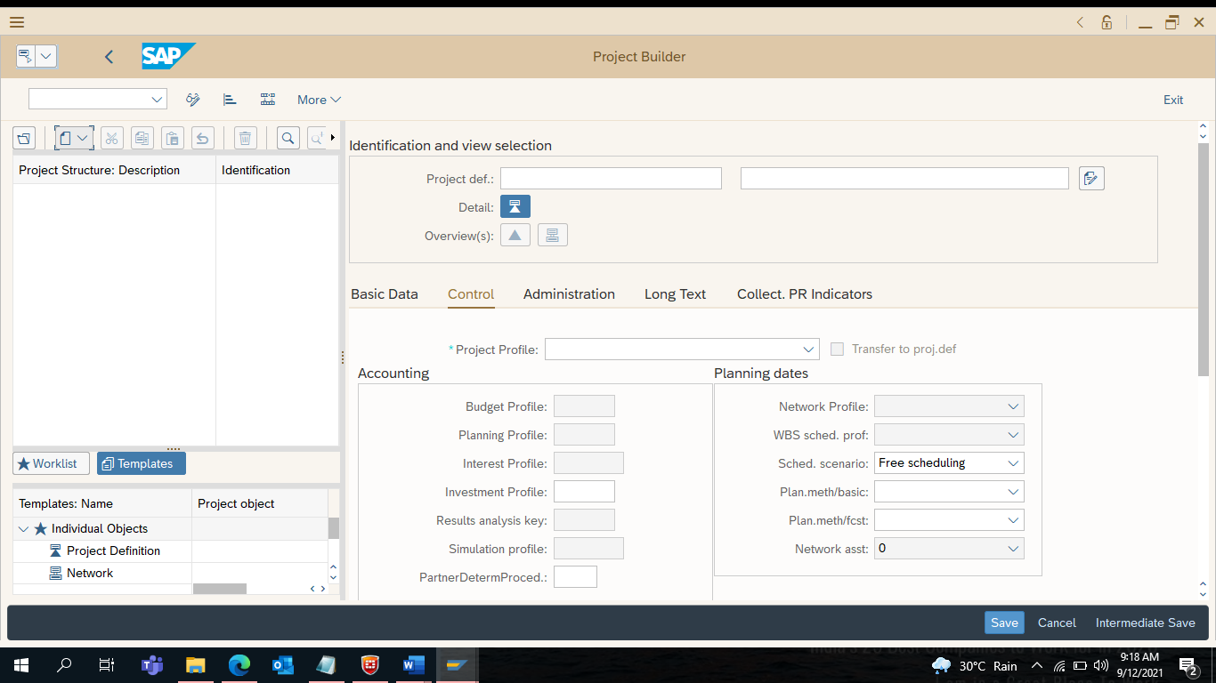

5) Enter Project Definition : P-DP-C-C-21-01

Click on Find Search for New Open Number of Project
System shows you the Open Number : P-DP-C-C-21-45….. Click on Continue [ _/ ]

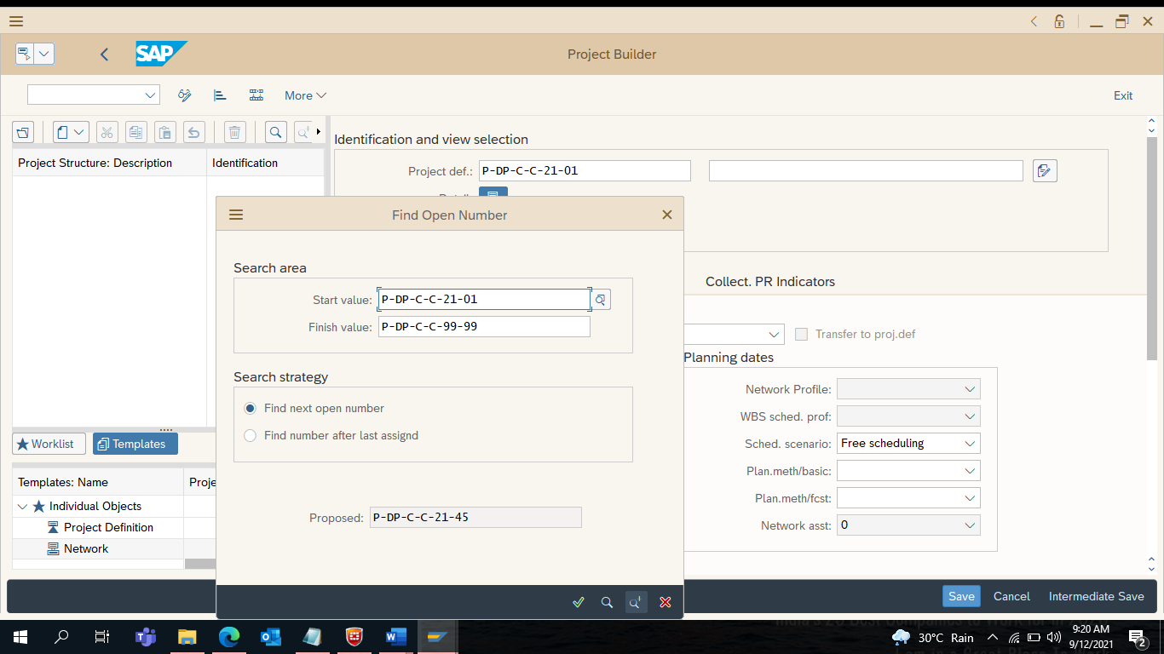

6) Enter Short Description (allows only 40 characteristics) : SIC 14 MW Wind Power Project

Click on Intermediate Save Tab
Note : Intermediate Save - will save instantly and active in Project Builder
Save – will save and comes out of the Project Builder

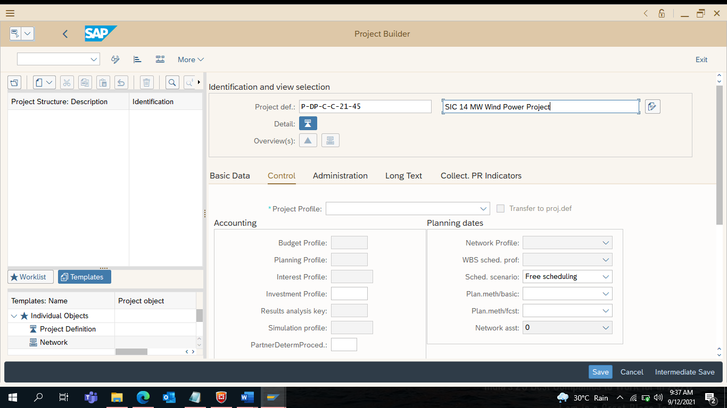

7) Select Project Profile from the drop down : New Capital Project Profile-DPT
Click on Intermediate Save Tab

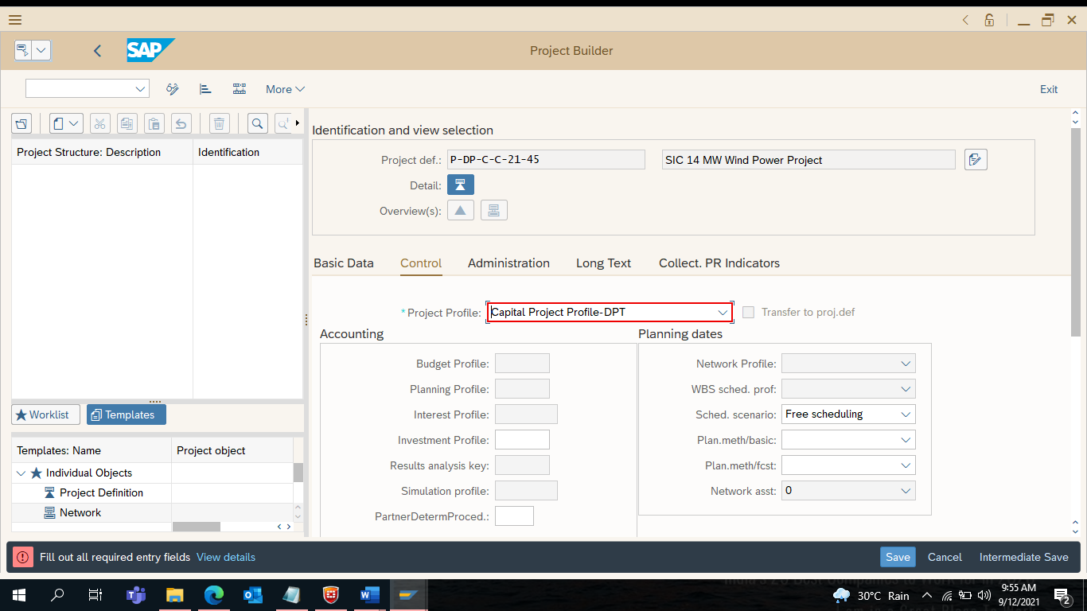

8) Enter Start Date and Finish Date

Enter Profit Center of DPT : 1201
Click on Save

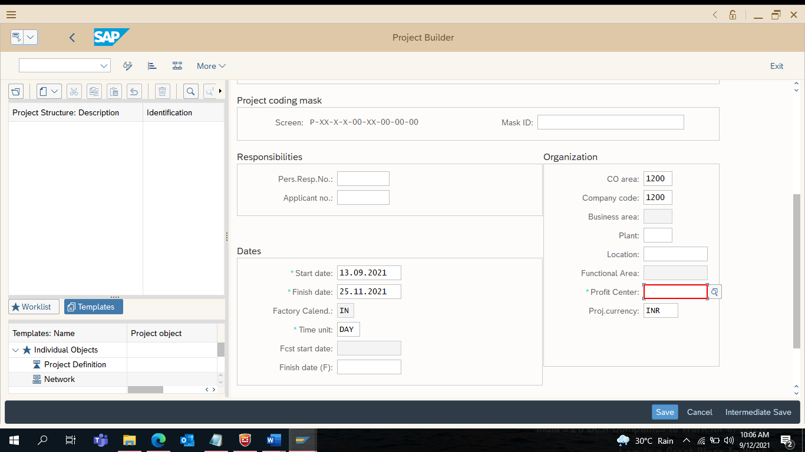

9) Project is being created : P-DP-C-C-21-45
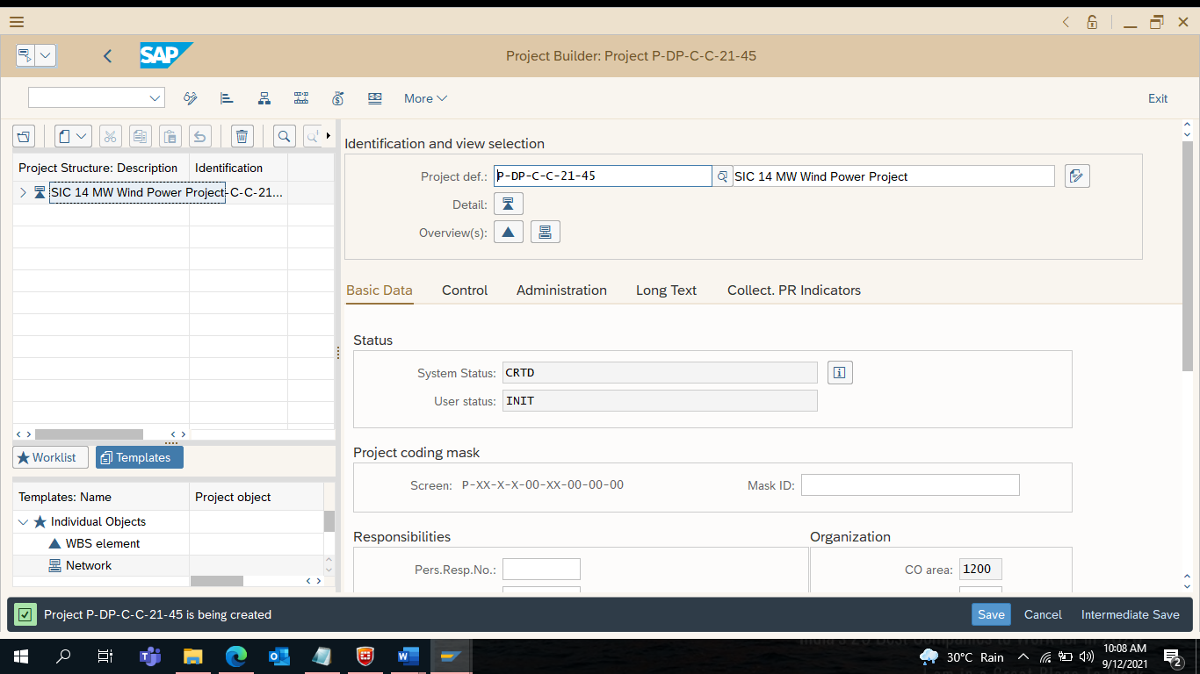

10) Create Level 1 WBS Element
Right Click on the Project Number
Select Create
Click on WBS Element

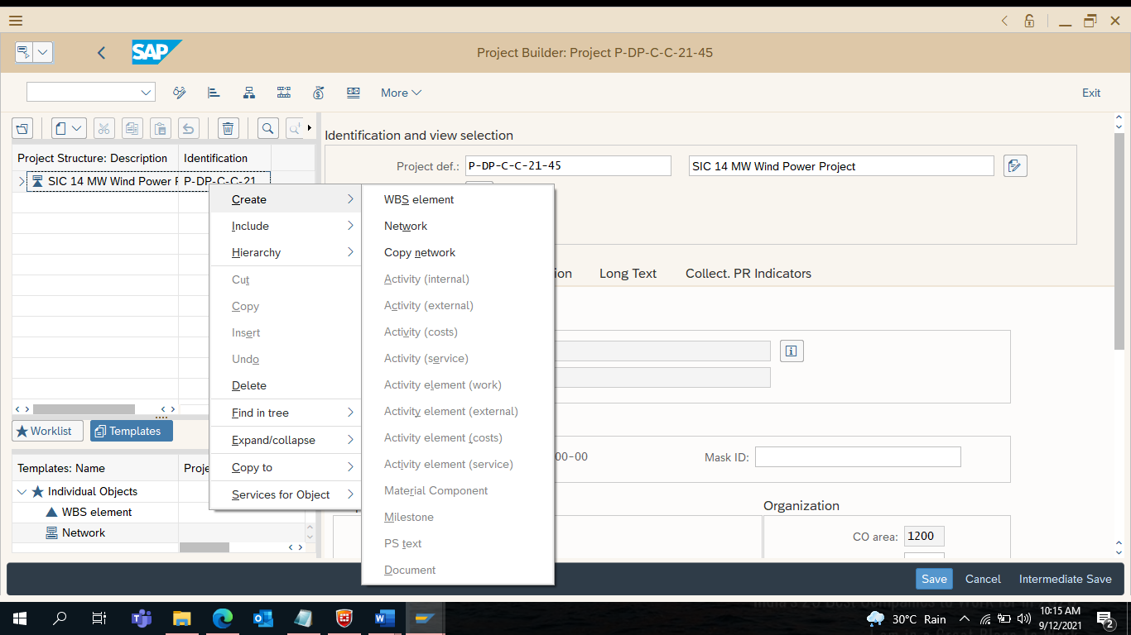
11) Enter WBS Element Code : P-DP-C-C-21-45
Note: Should be similar as Project Code (it’s a basic rule in SAP)
Enter Short Description : SIC 14 MW Wind Power Project Level 1 WBS
Under Operative Indicators - Check [_/] Planning Elements
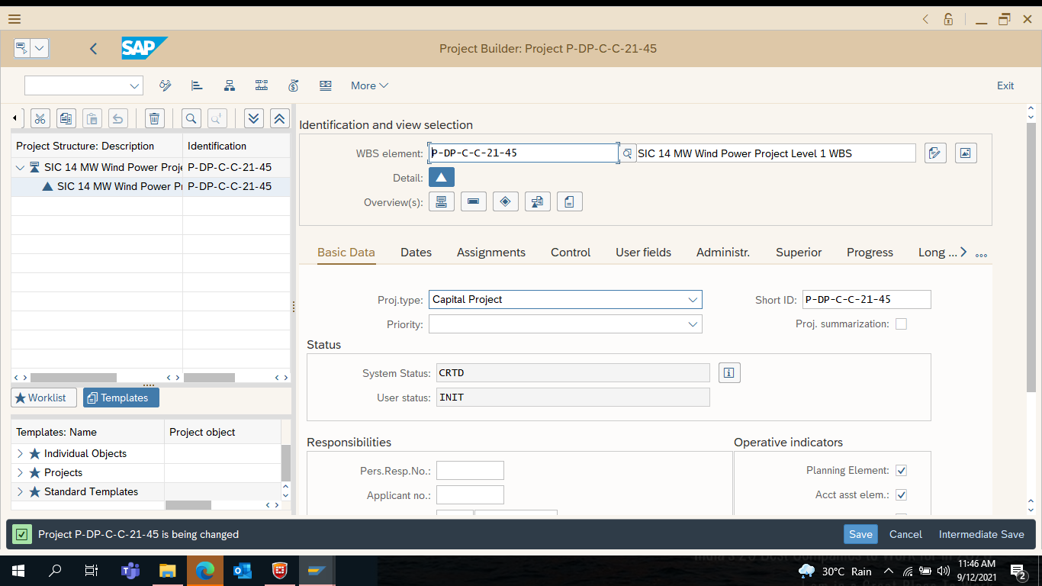

12) Create Level 2 WBS Element
Right Click on the Level 1 WBS Element
Select Create
Click on WBS Element

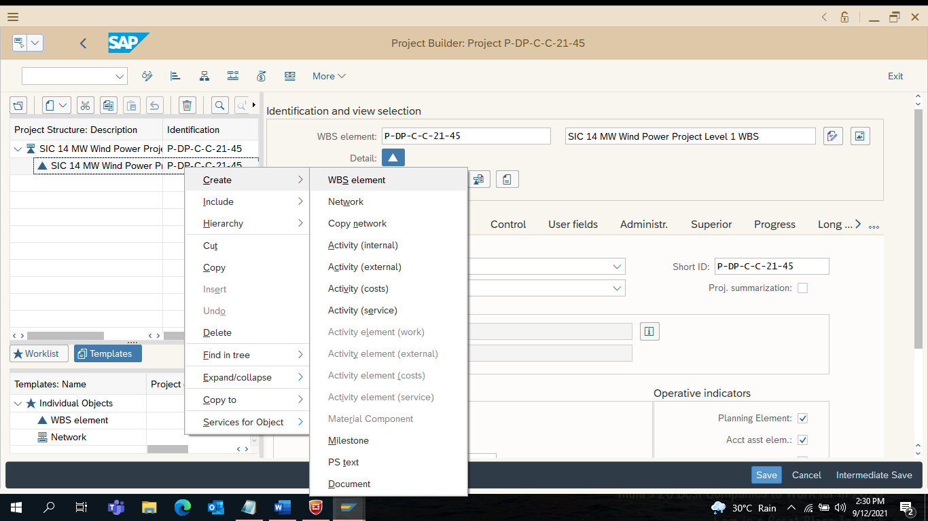
13) Level 2 WBS Element is assigned by System Automatically : P-DP-C-C-21-45-01

Enter Short Text : Construction, Erection & Commissioning

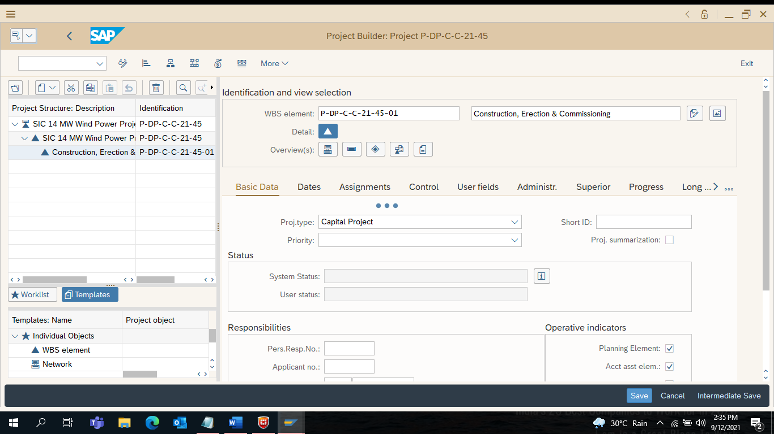

14) Create Network :
Right Click on Level 1 WBS Element
Select Create
Click on Network
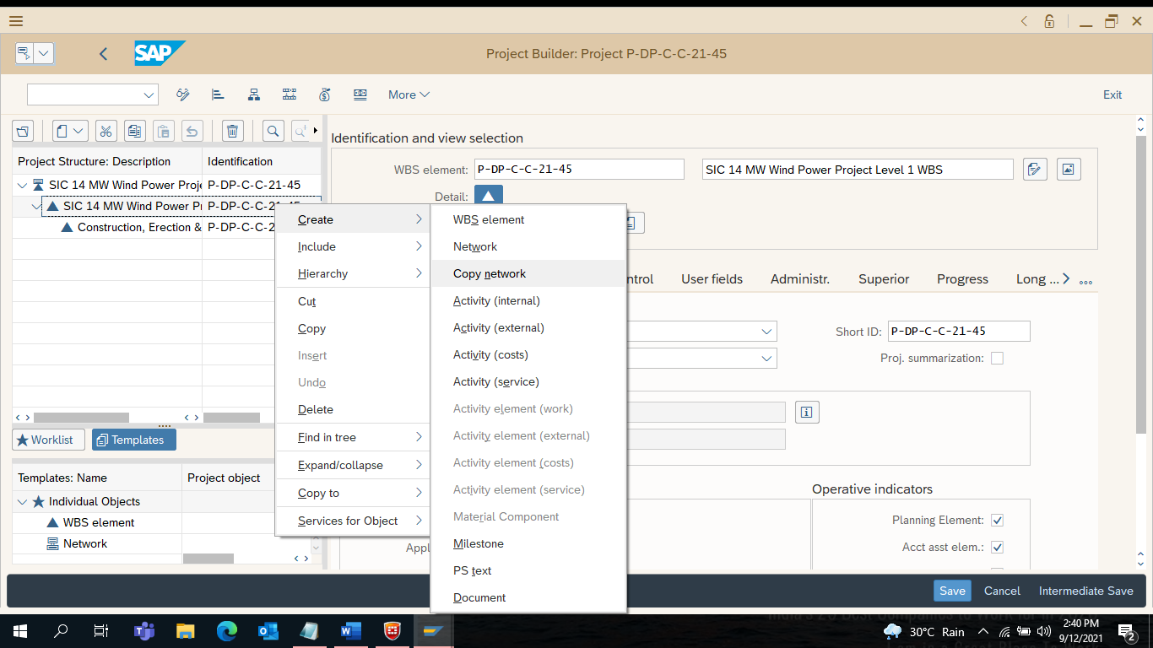
15) Enter Short Text : SIC 14 MW WP Network
Click on Intermediate Save
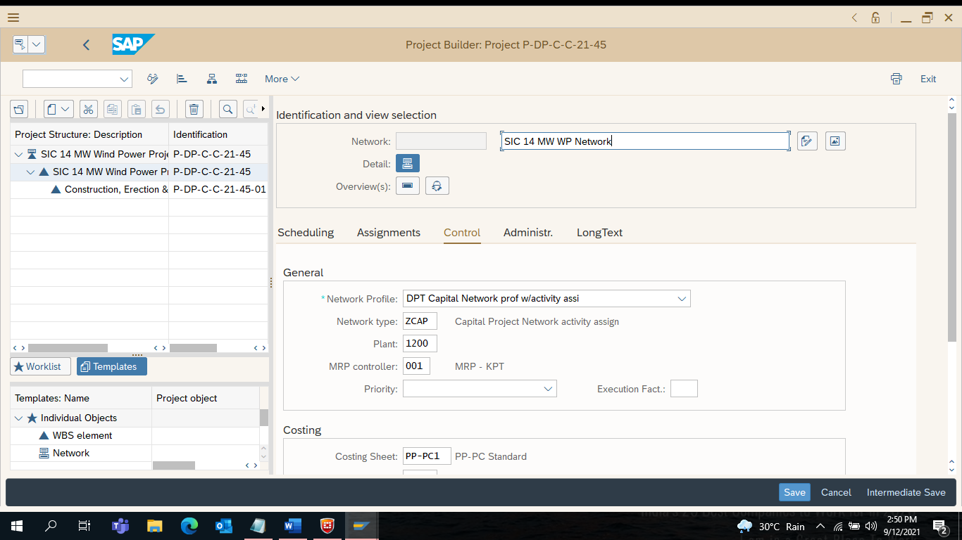

16) Enter Scheduling Type from the drop down Menu

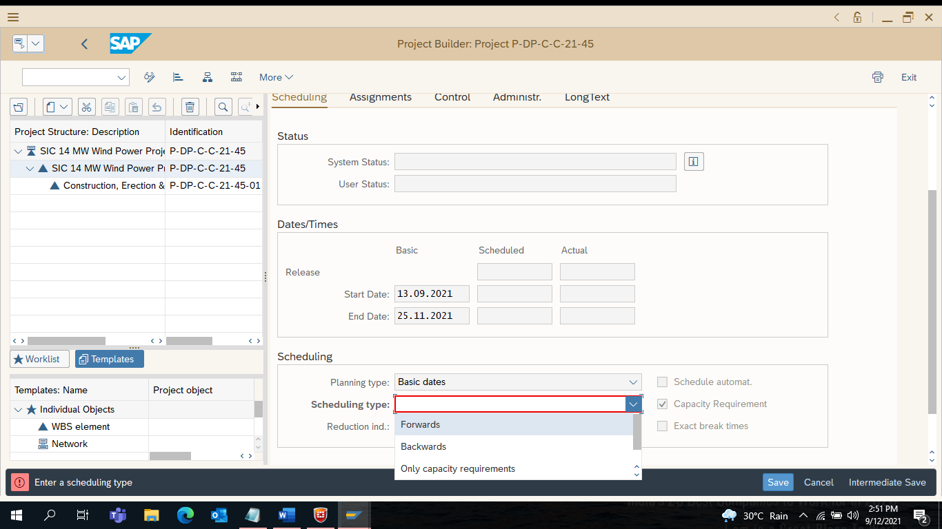
17) Click on Save
Network Created : 401000955
Click on Exit
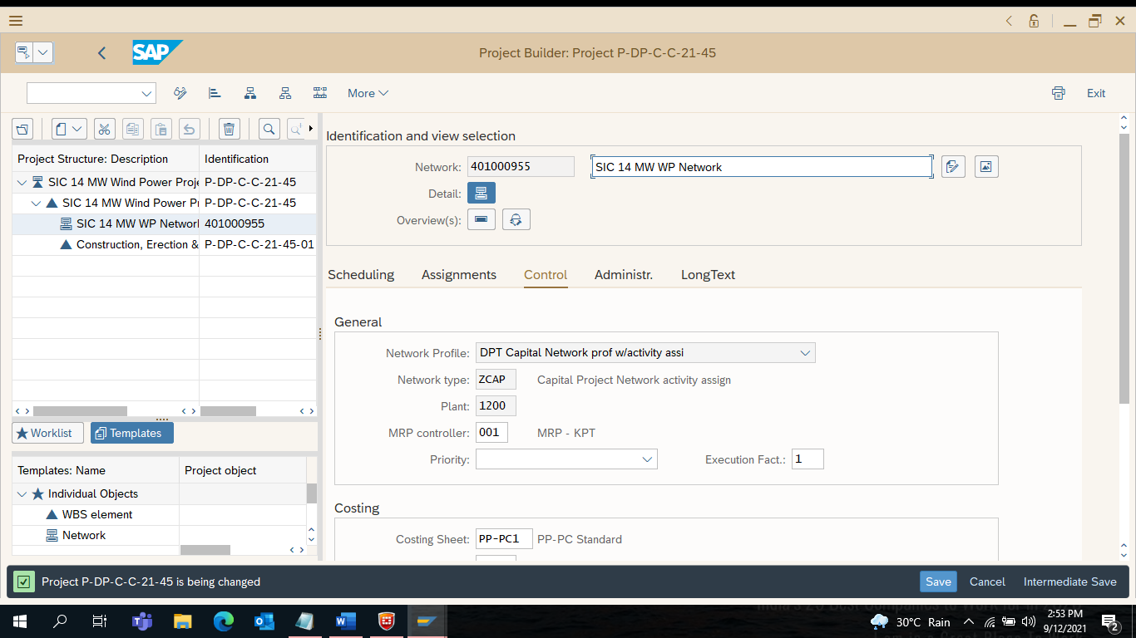

18) Enter ZPS_MEASURE (Screen with display)

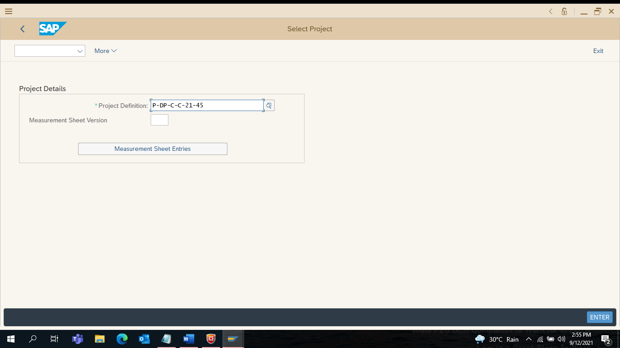
19) Select Version[ 1] under Measurement Sheet Version Box

Select Version [ 1 ] To Create Block Estimate in ZPS_MEASURE
Click on Measurement Sheet Entries

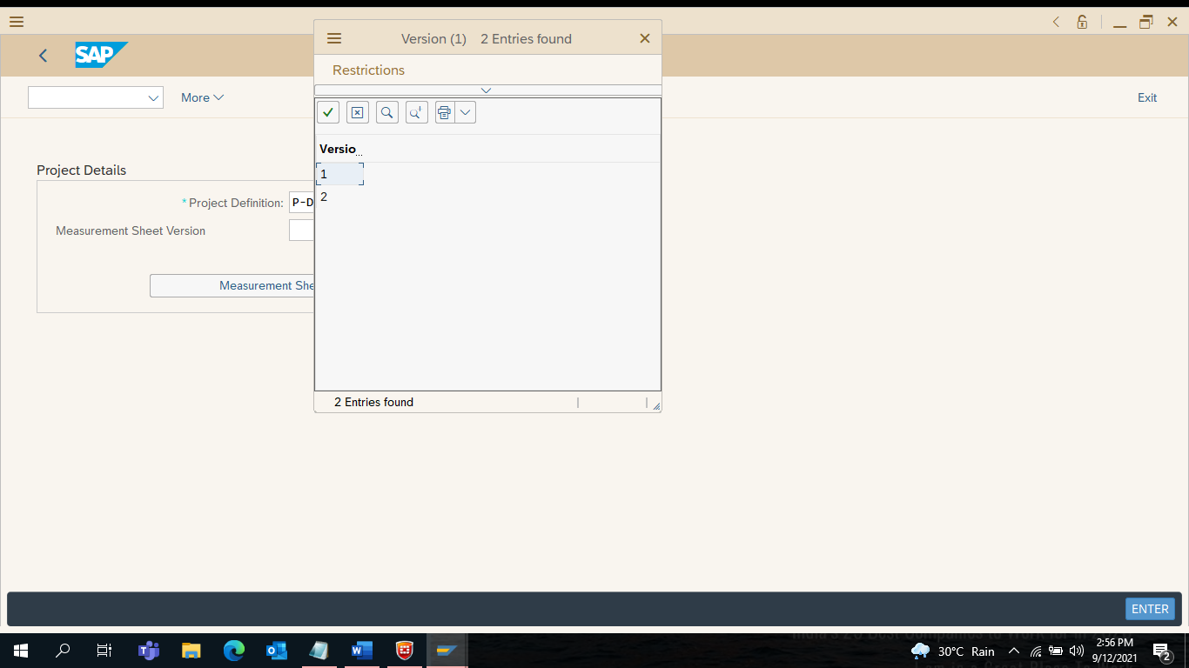

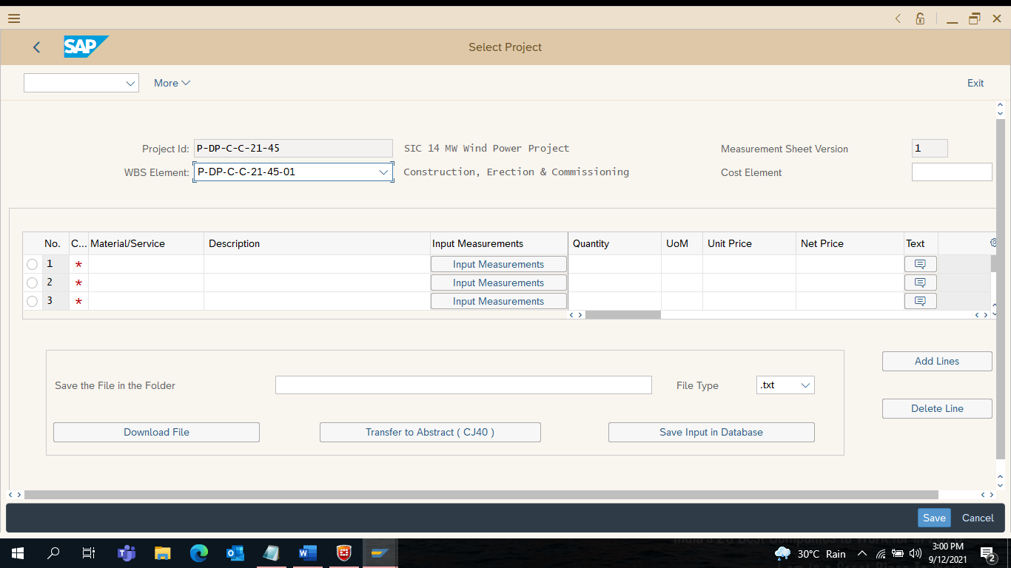

21) Select N (for Services) under item Category

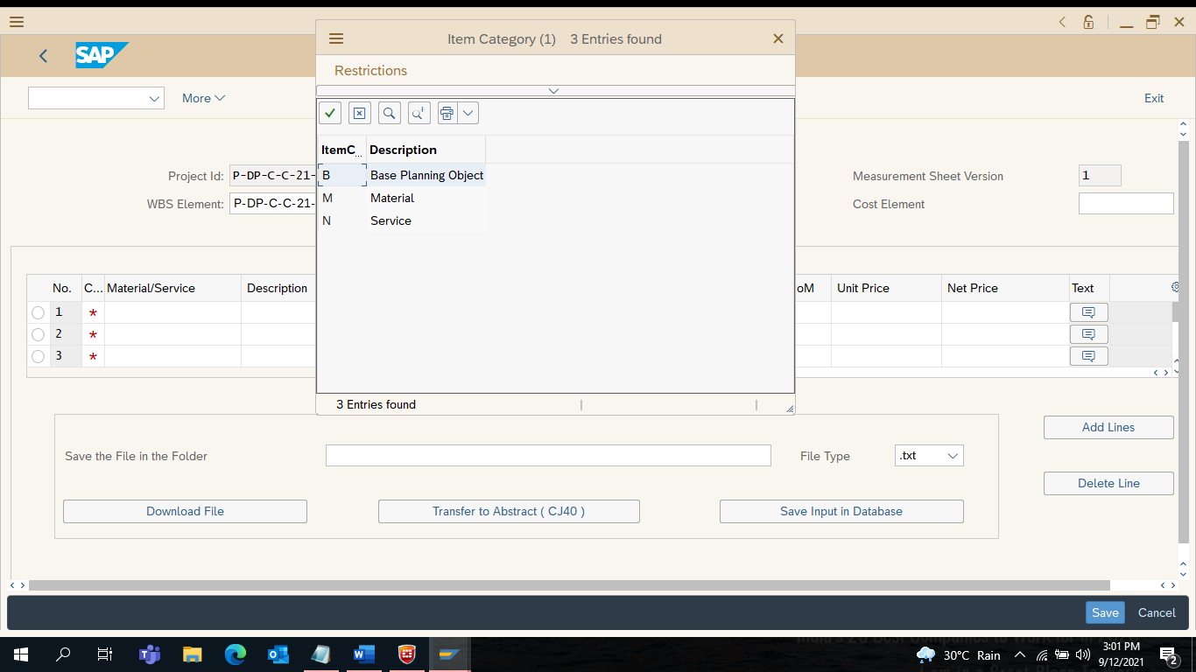

22) Enter Cost Element Number : 41400008
Enter Service Item No.
Ex. 8300001679 under Material/ Service Box
Click on Enter

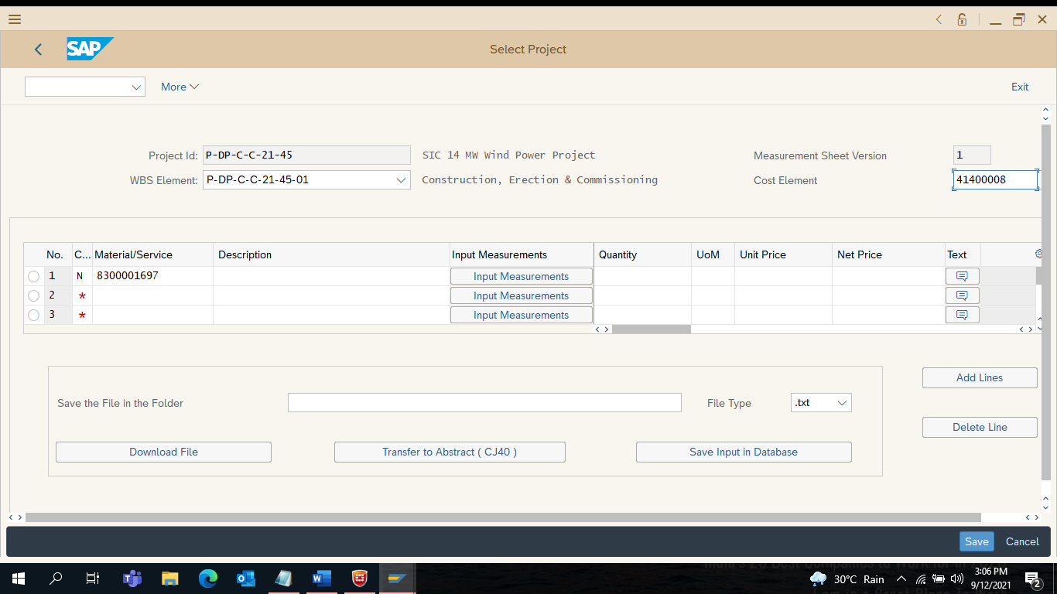

23) Click on Input Measurements Tab (in the Middle)

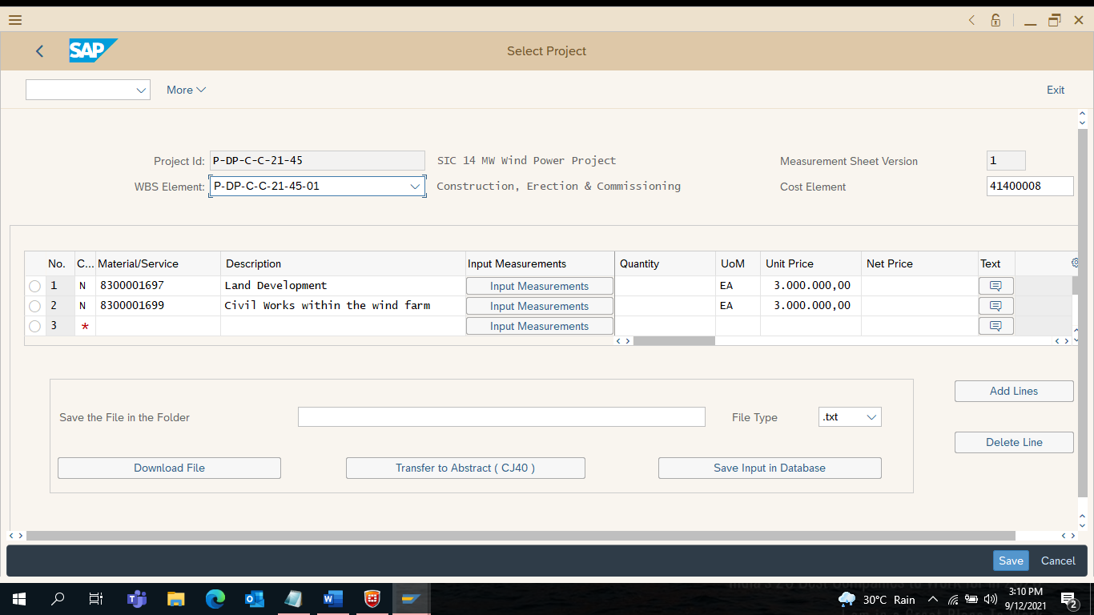

24) Enter Description and Number.. Number… Each…. Remarks in the last

Click on Save & Exit

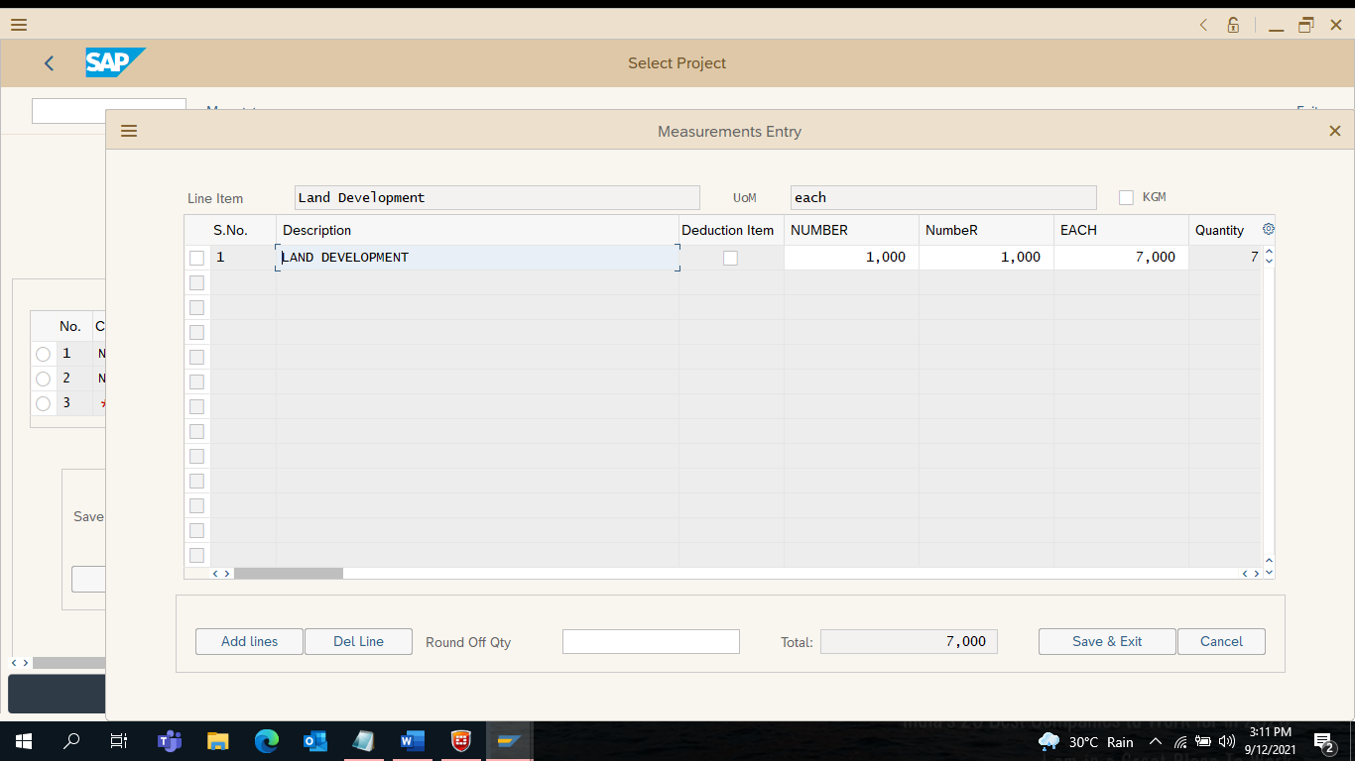

25) Click on Save Input Database

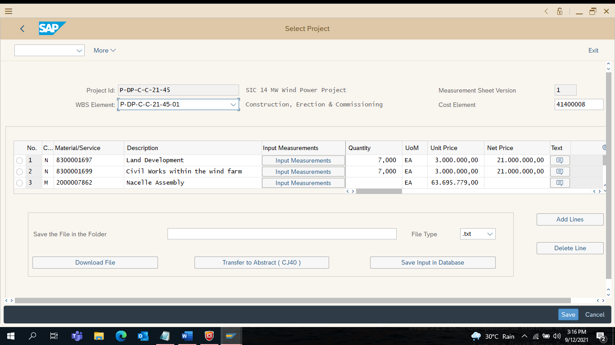

26) Click on YES to Save the Measurement Sheet Entries in the DB

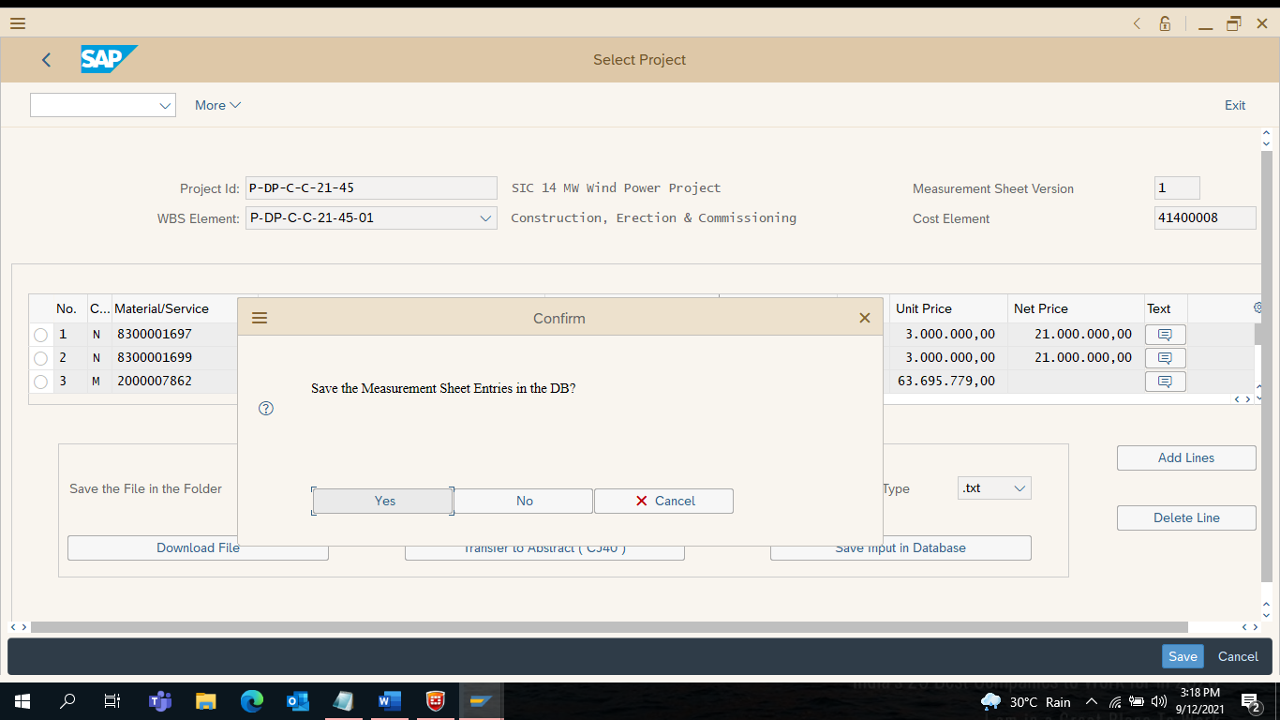

27) Click on Measurement Sheet Entries

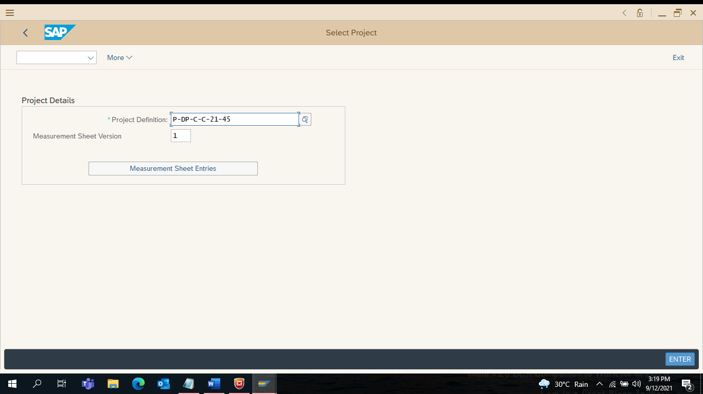

28) Click on Transfer to Abstract (CJ40)

29) Click on YES to Process with CJ40

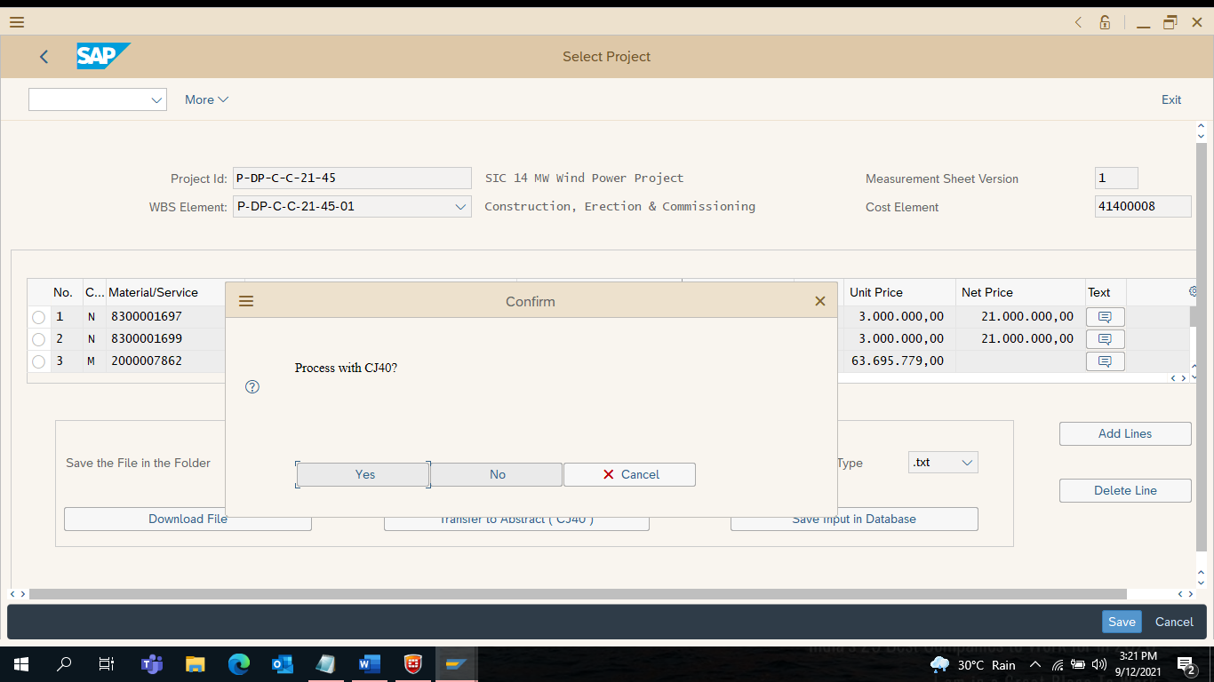

30) Workflow Released for Approval will trigger for Version [ 1 ]

Click on Exit

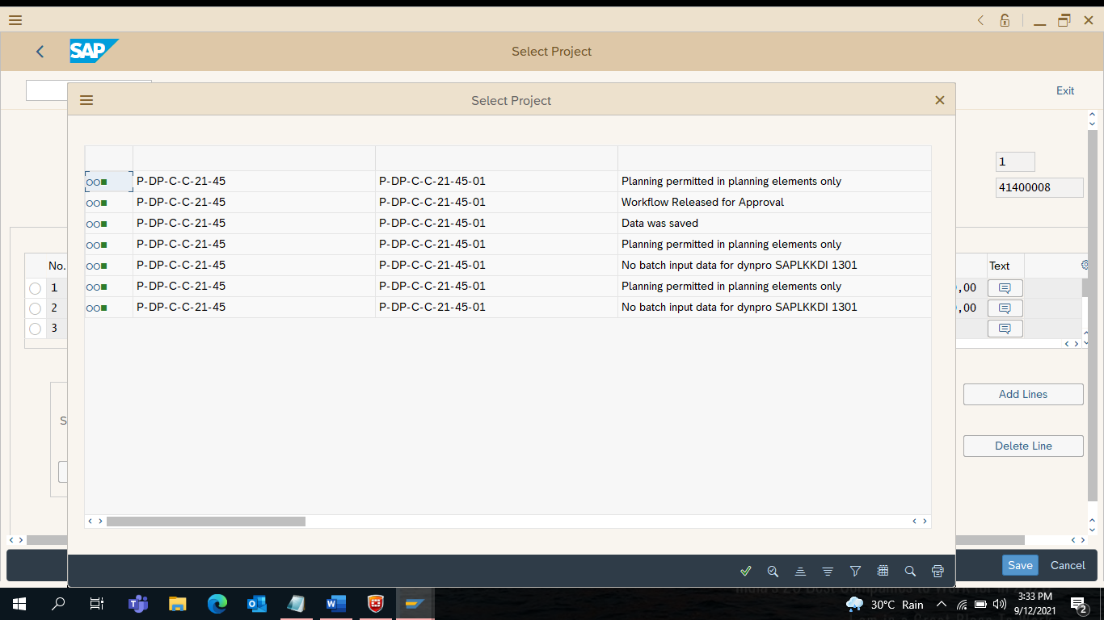

31) Enter CJ40

Click on Enter

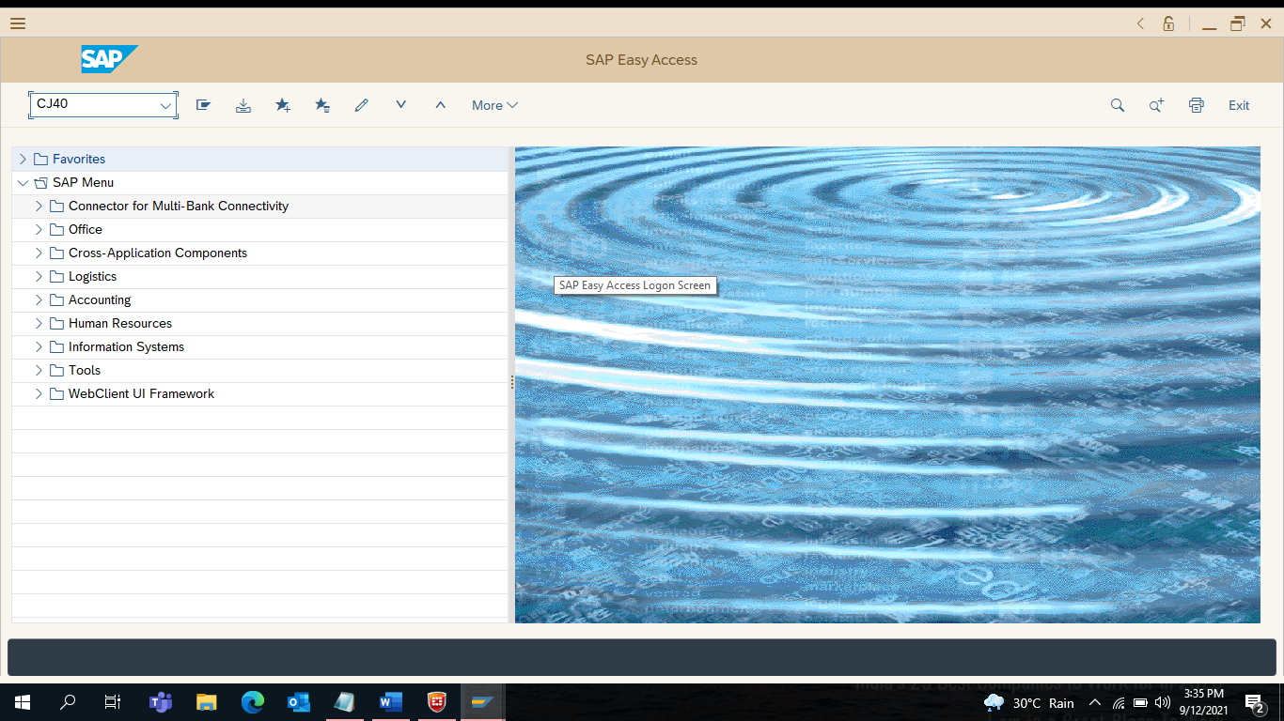

32) Change Cost Planning Initial Screen will display

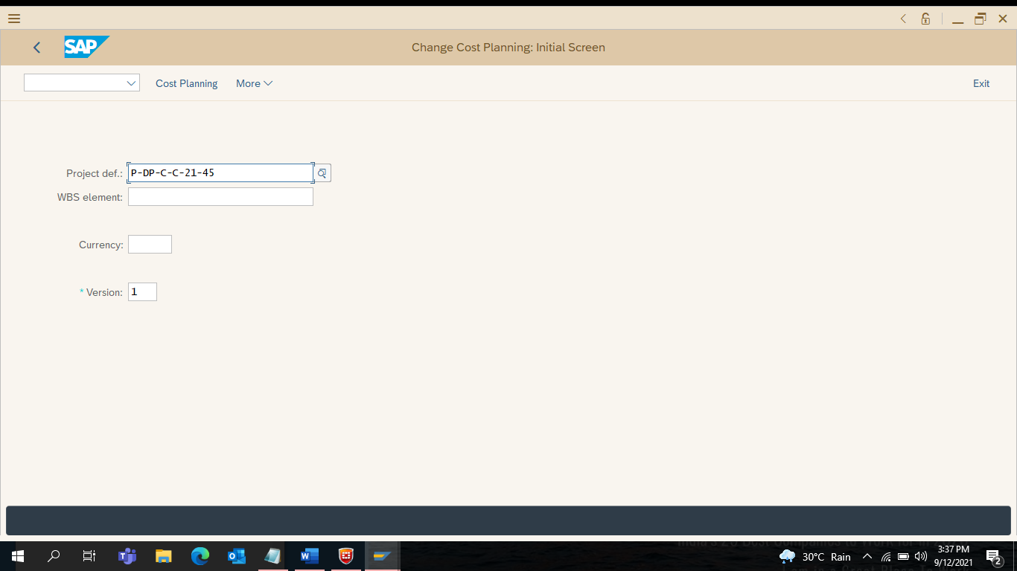

33) Select Planned Total Column

Right Click on Planned Total…. Select Total Up

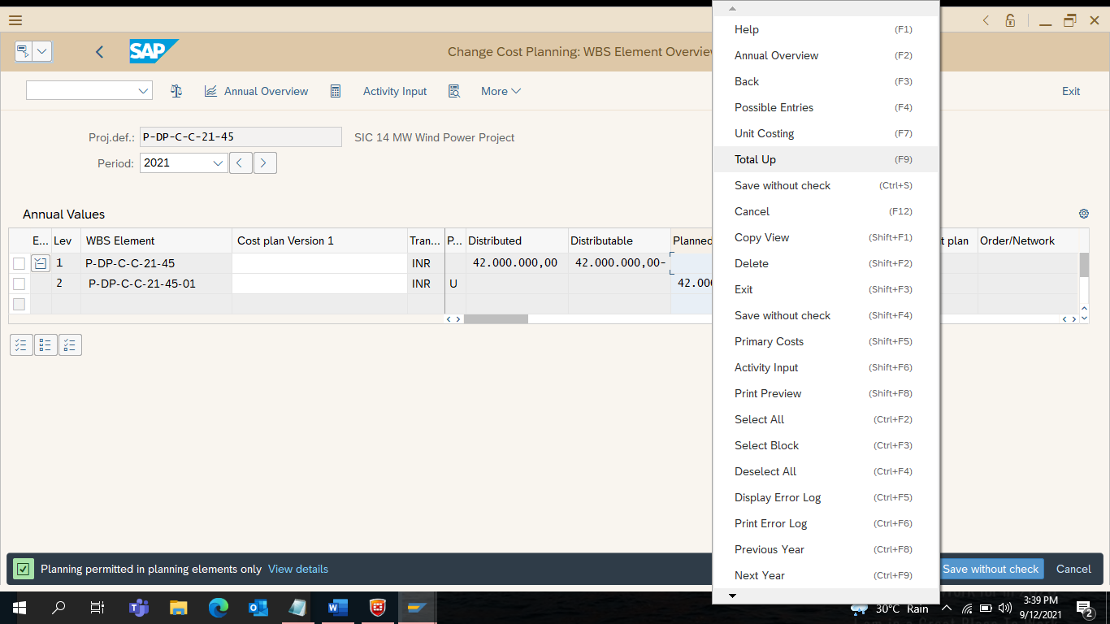

34) Click on [ _/ ]

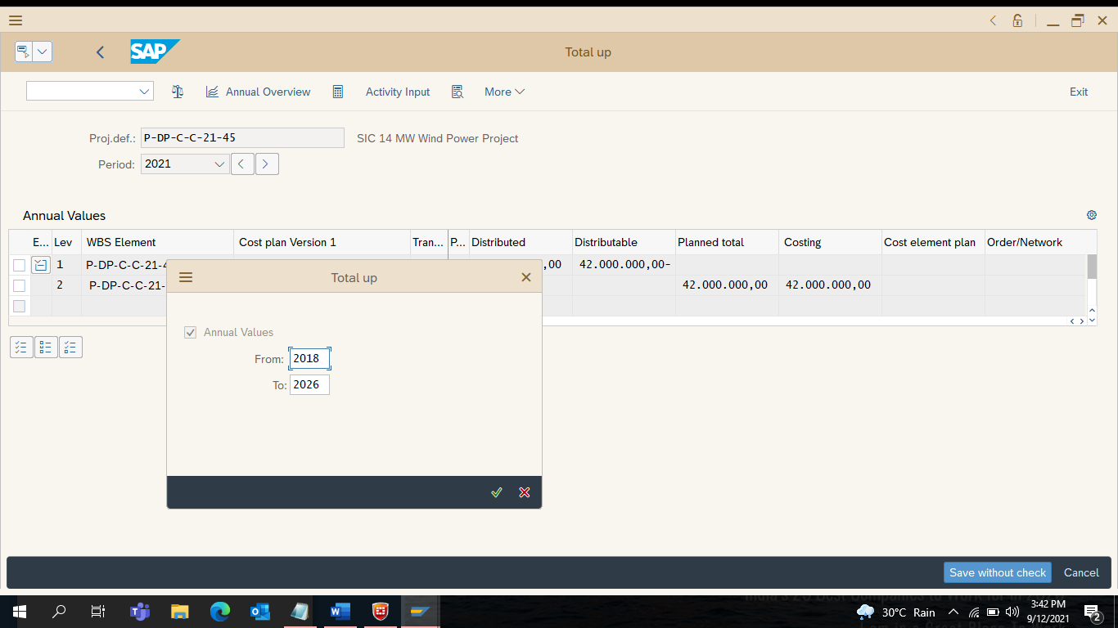

35) Cost Planning of Version [ 1 ] completed

Click on Save without Check

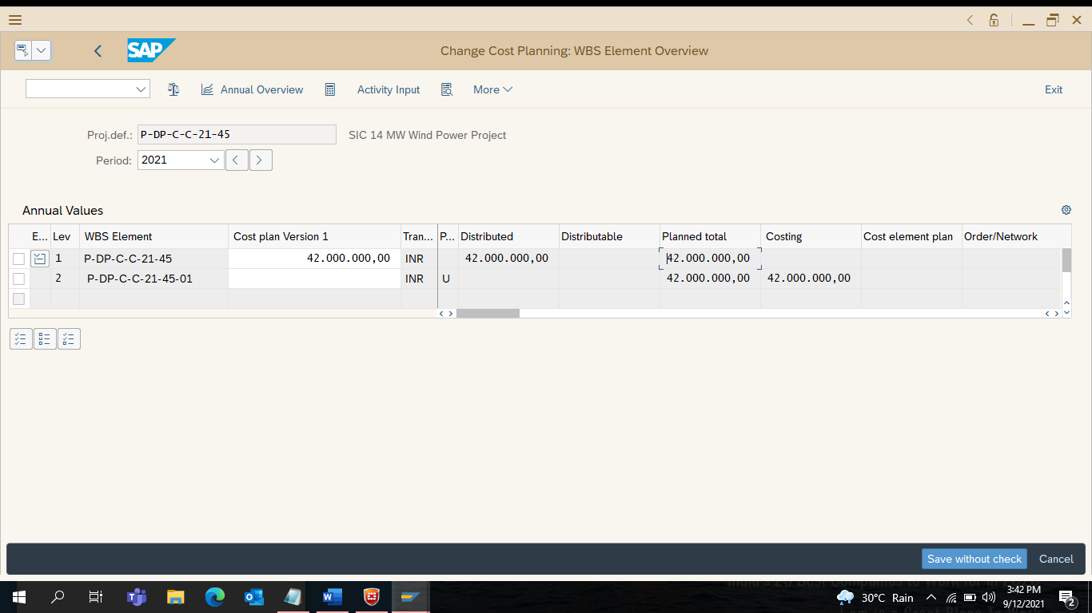

36) Check Notification.. Data was Saved in the bottom

Click on Exit

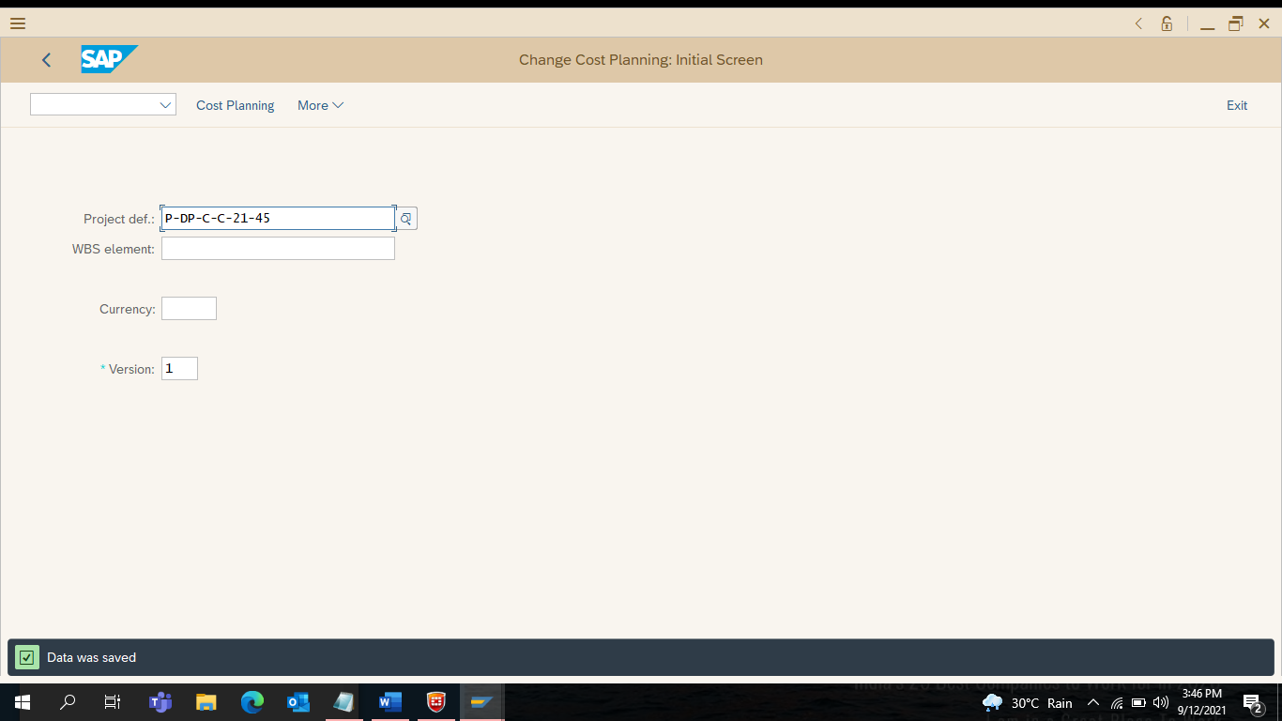

37) Enter CJ20N

Click on Enter

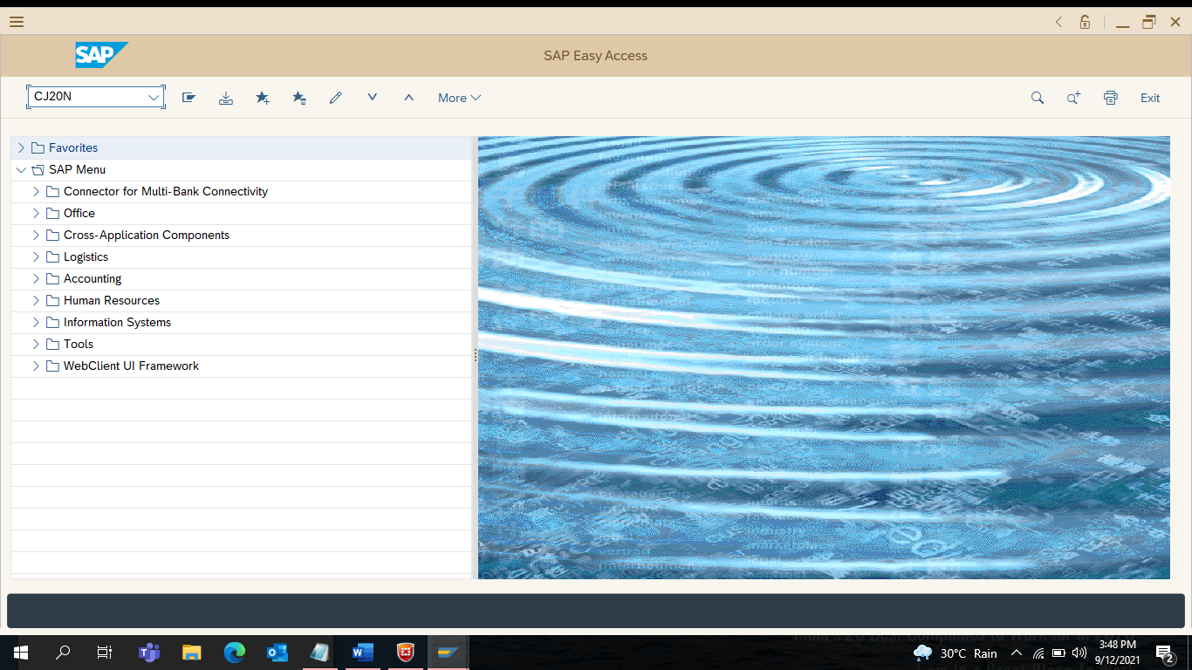

38) Select the Current Project
User Status showing BEPR – Block Estimate Prepared

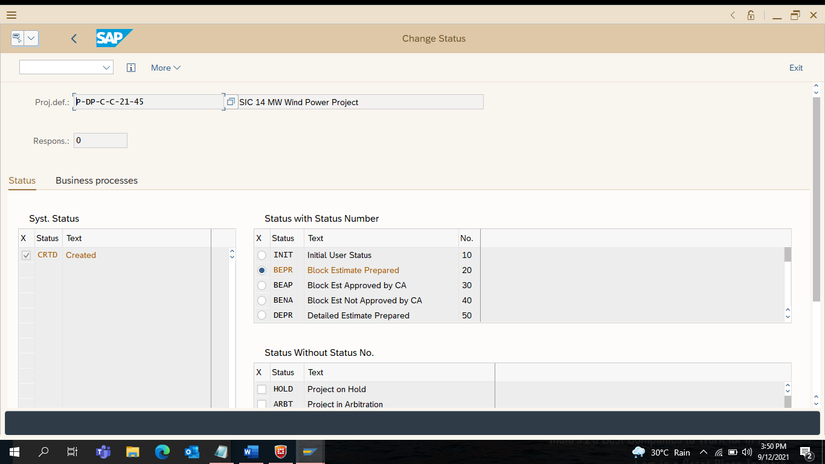
39) Change the User Status to BEAP
Double Click on BEAP – Block Estimate Approved by CA

Click on Exit

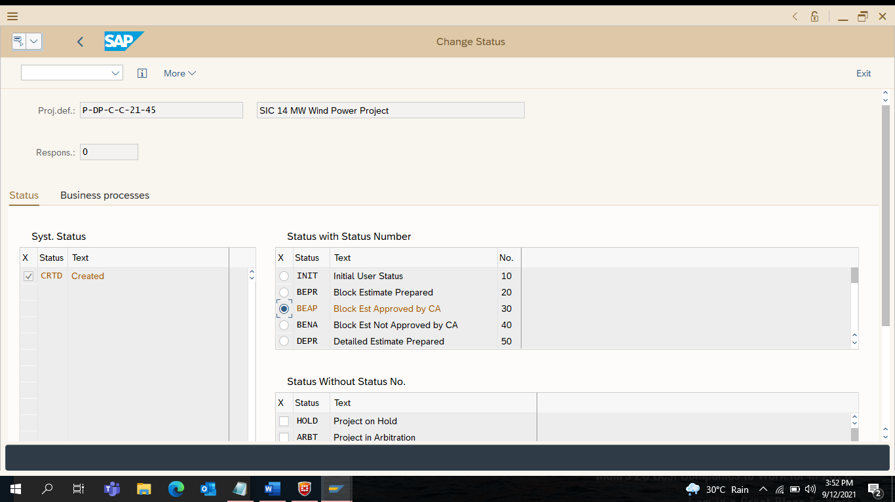

40) Click on Save

Click on Exit

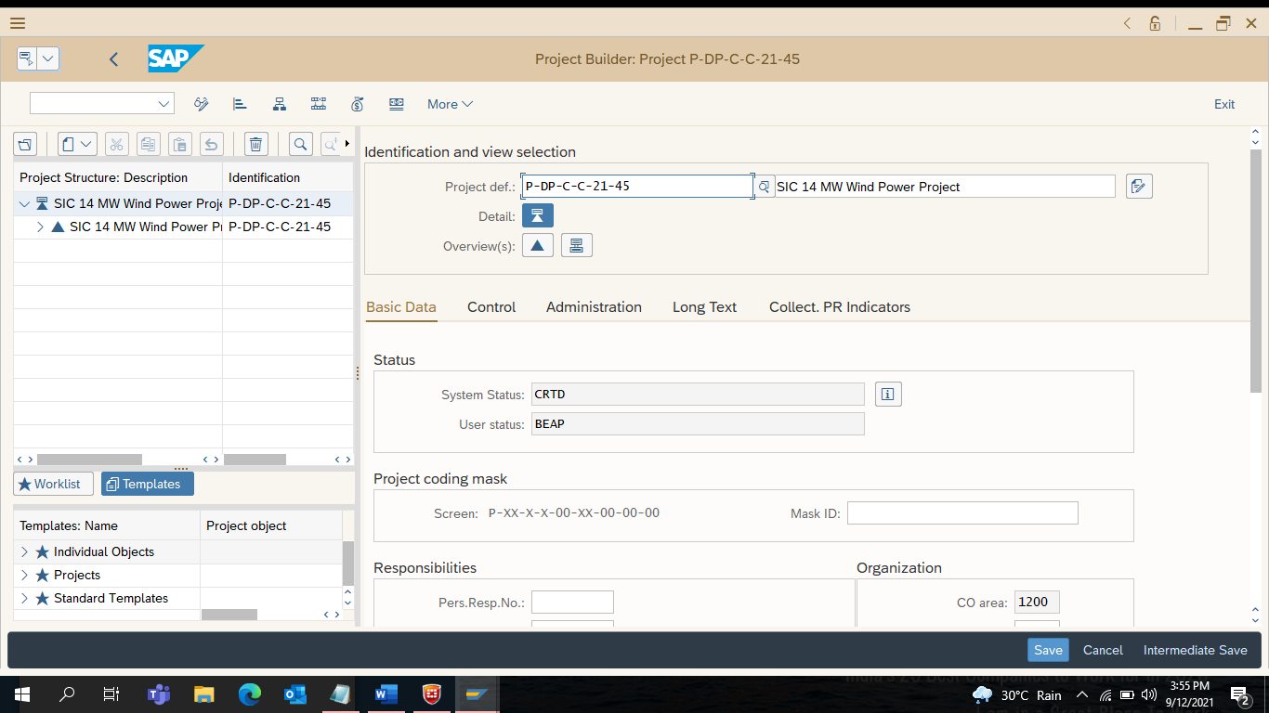
41) Enter ZPS_MEASURE
Click on Enter

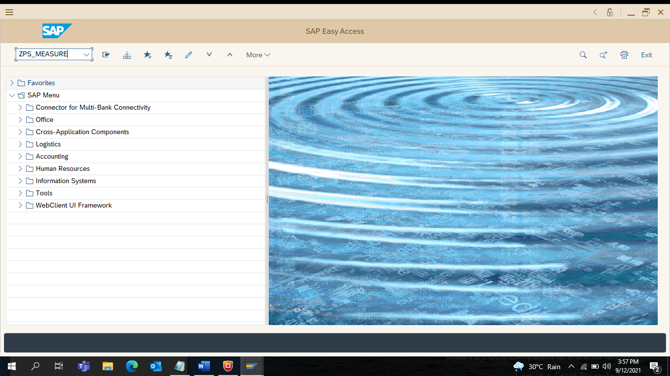

42) Select Version[ 2 ] under Measurement Sheet Version Box

Select Version [ 2 ] To Create Detailed Estimate in ZPS_MEASURE

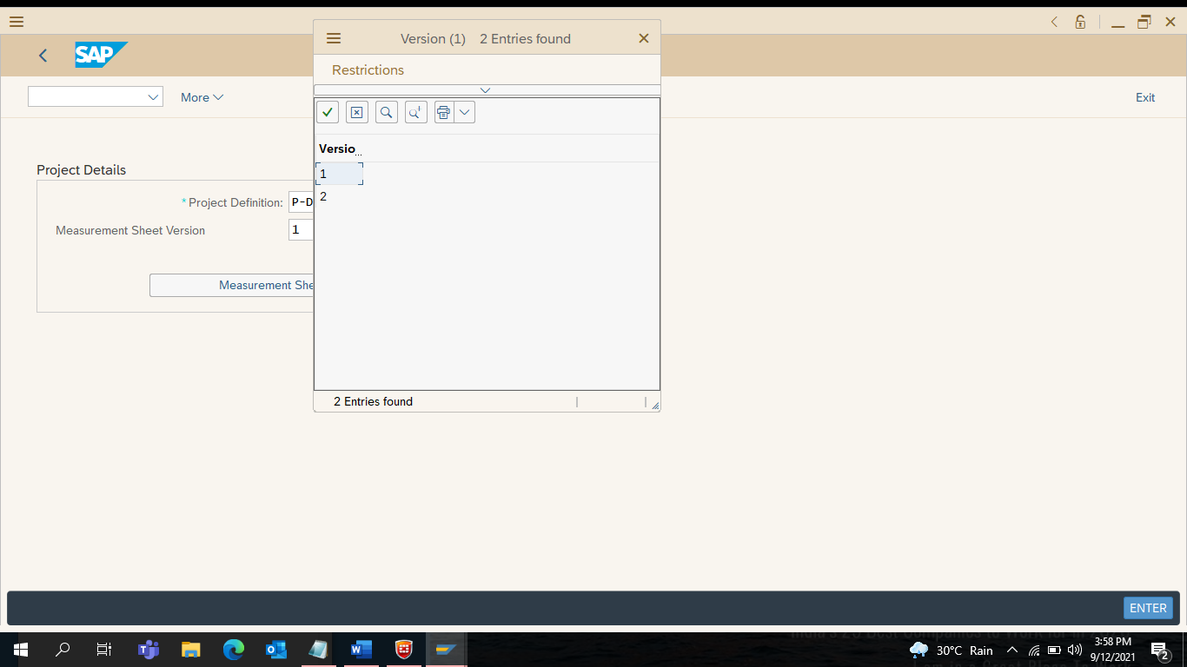

43) Select [ _/ ] Copy Measurement Sheet Elements from Version 1

Click on Measurement Sheet Entries
Click on Enter

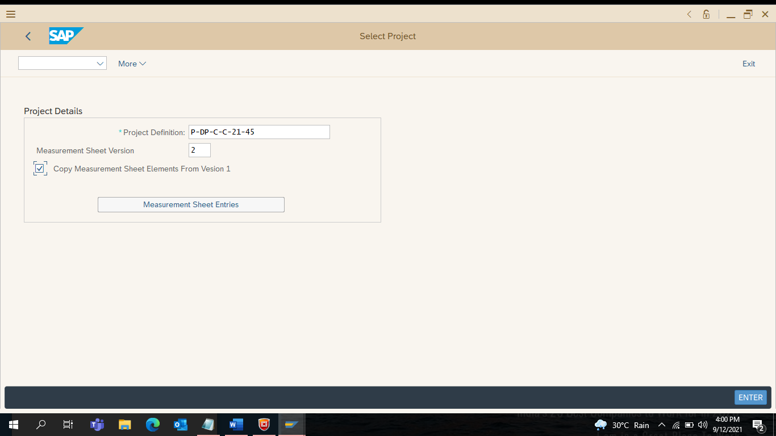

44) Click on Save Input Database Tab
Measurement Sheet Version [ 2 ]

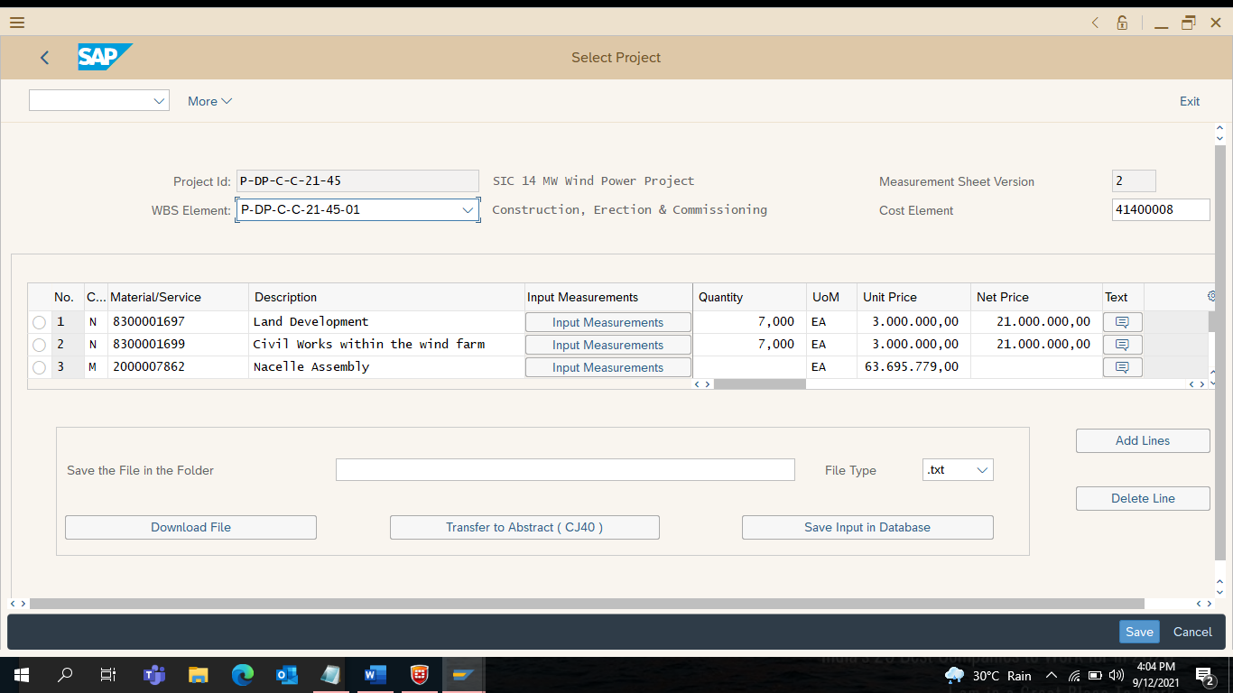

45) Click on Save
Confirm YES to Save the Measurement Sheet Entries in the DB

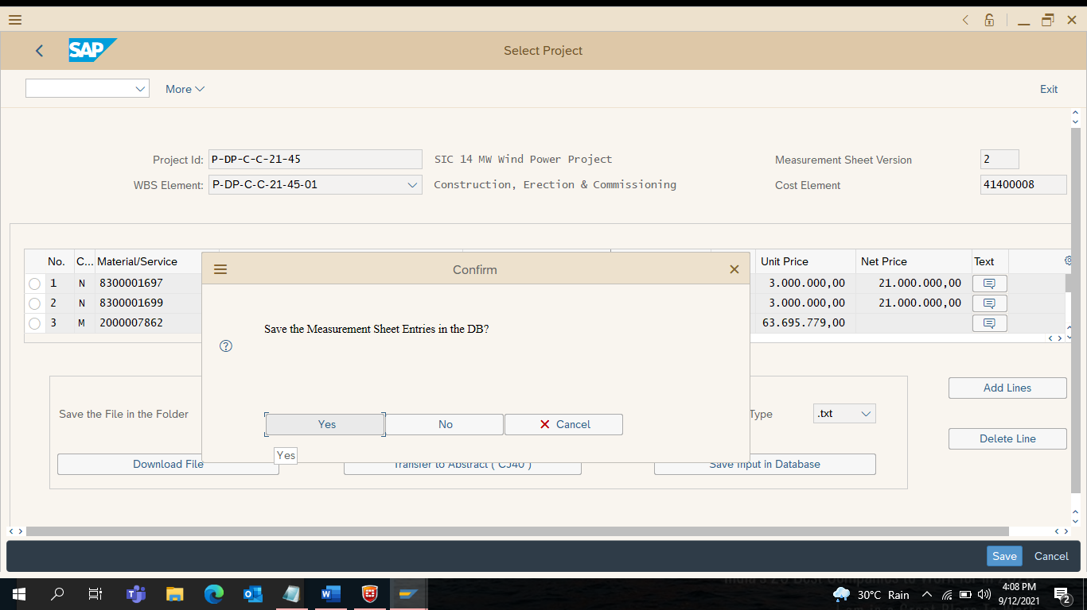

46) Click on Measurement Sheet Entries

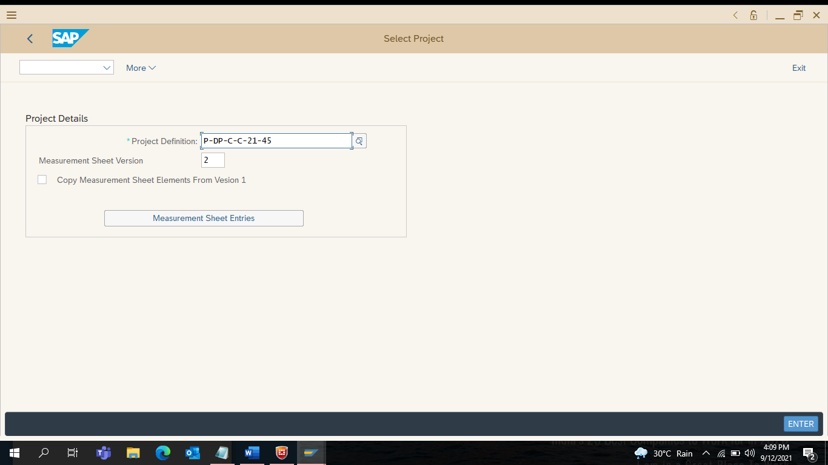

47) Click on Transfer to Abstract (CJ40)

48) Confirm YES to Process with CJ40

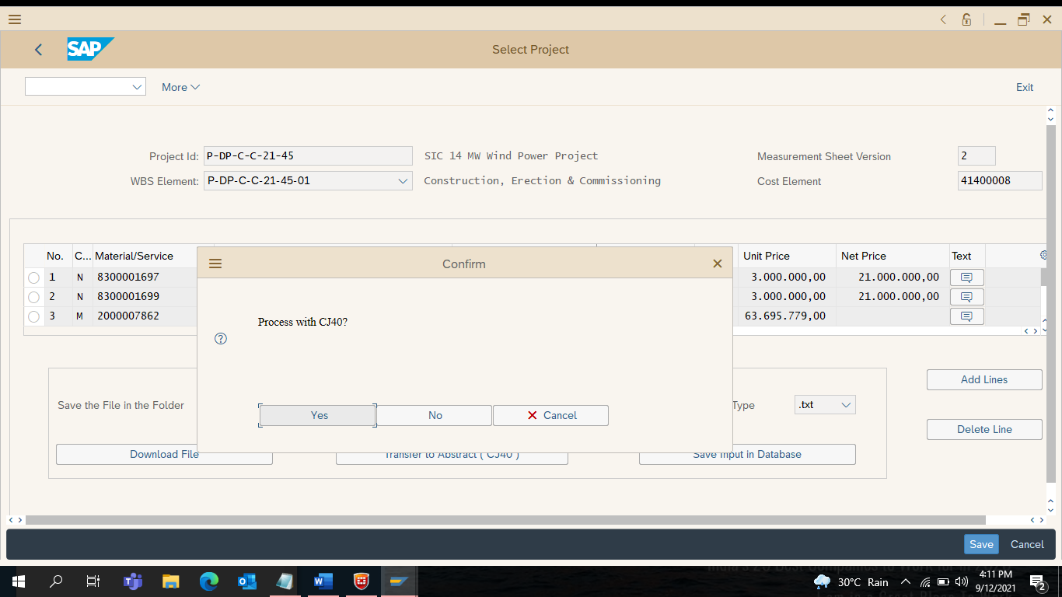

49) Workflow Released for Approval for Version [ 2 ]

Click on [ _/ ]
Click on Exit

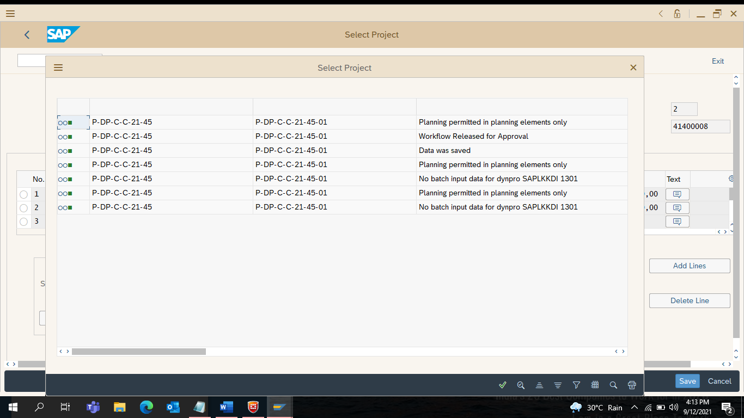

50) Enter CJ40
Click on Enter

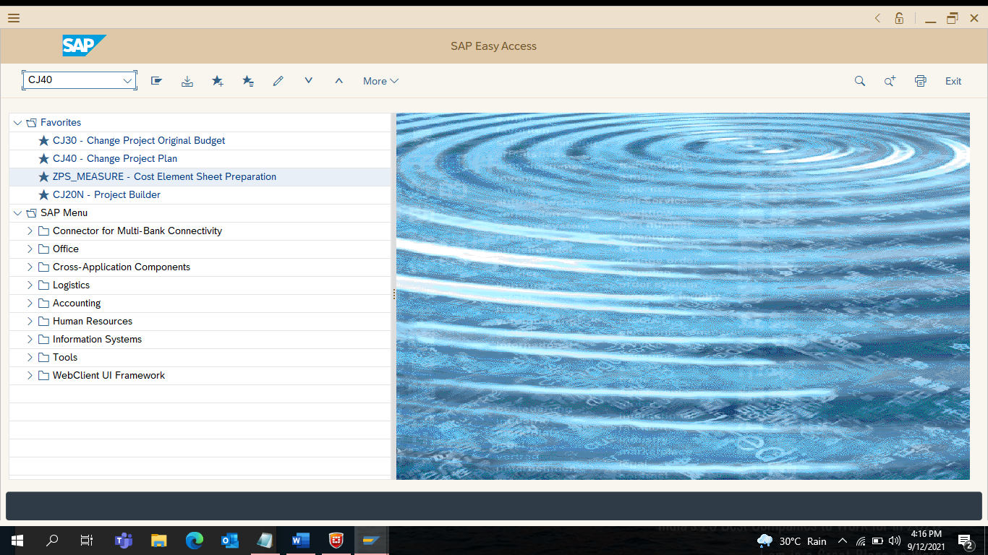

51) Select Planned Total Column

Right Click on Total Up

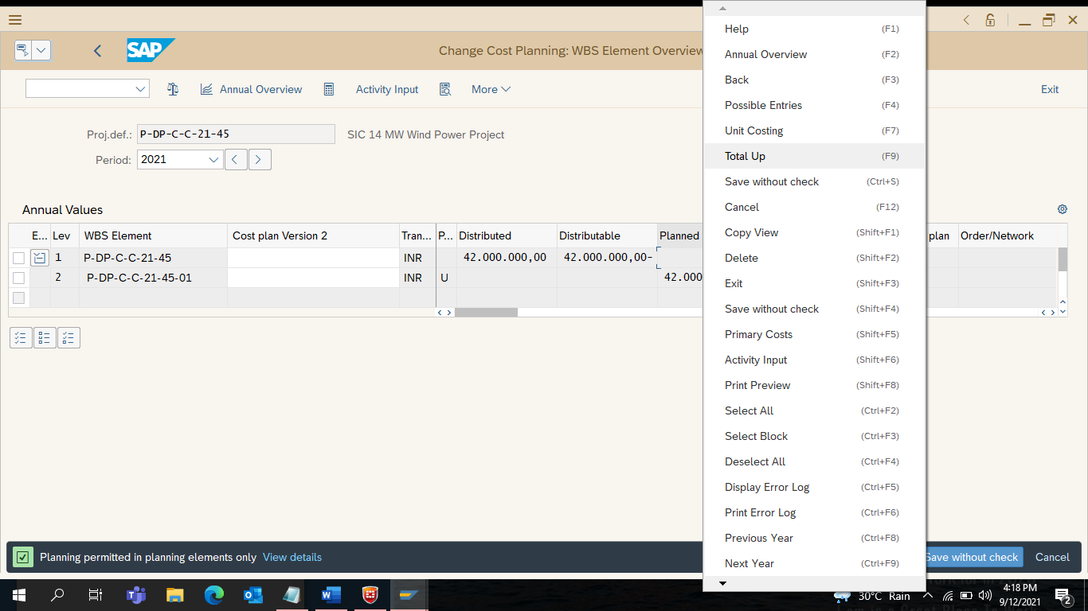

52) Click on [ _/ ] Continue
Click on Save
Click on Exit

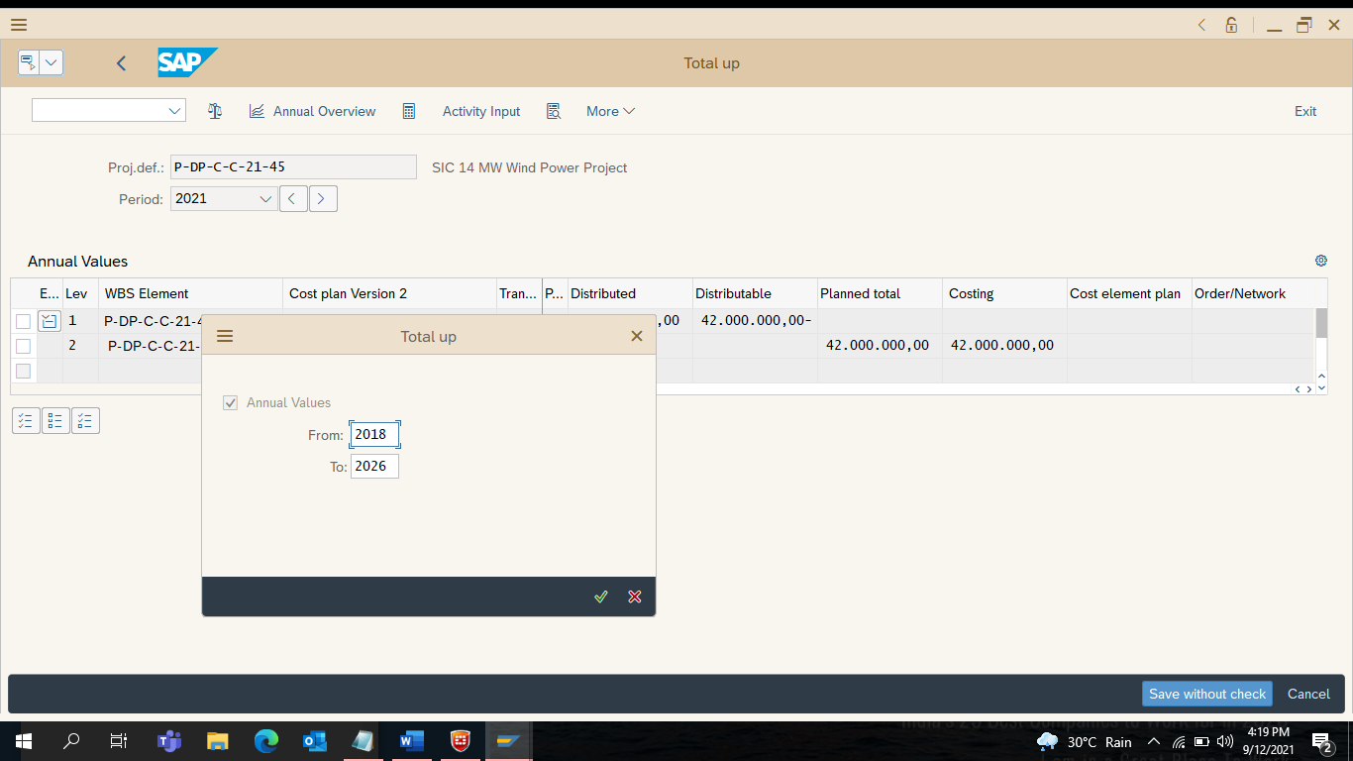

53) Enter CJ20N
Click on Enter

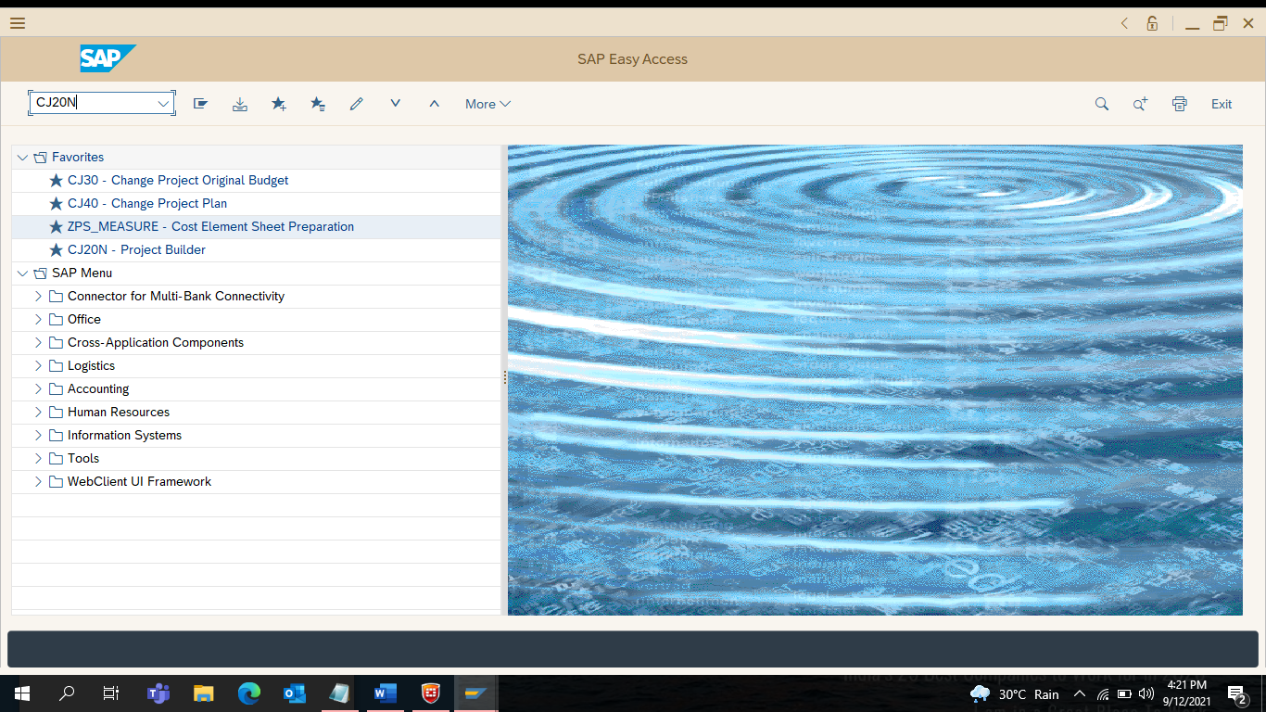

54) Select the Current Project
User Status showing DEPR – Detailed Estimate Prepared

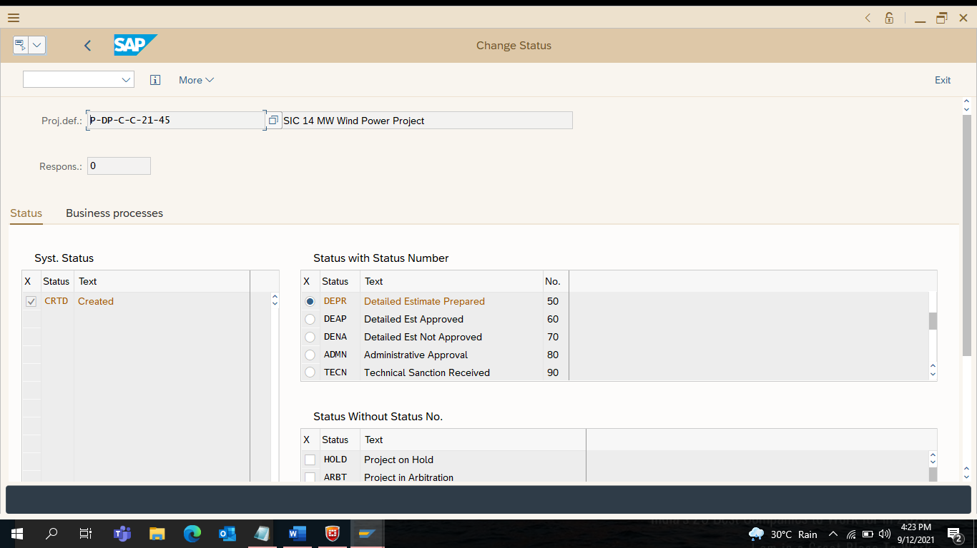

55) Double Click on DEAP – Detailed Estimate Approved
Click on Exit

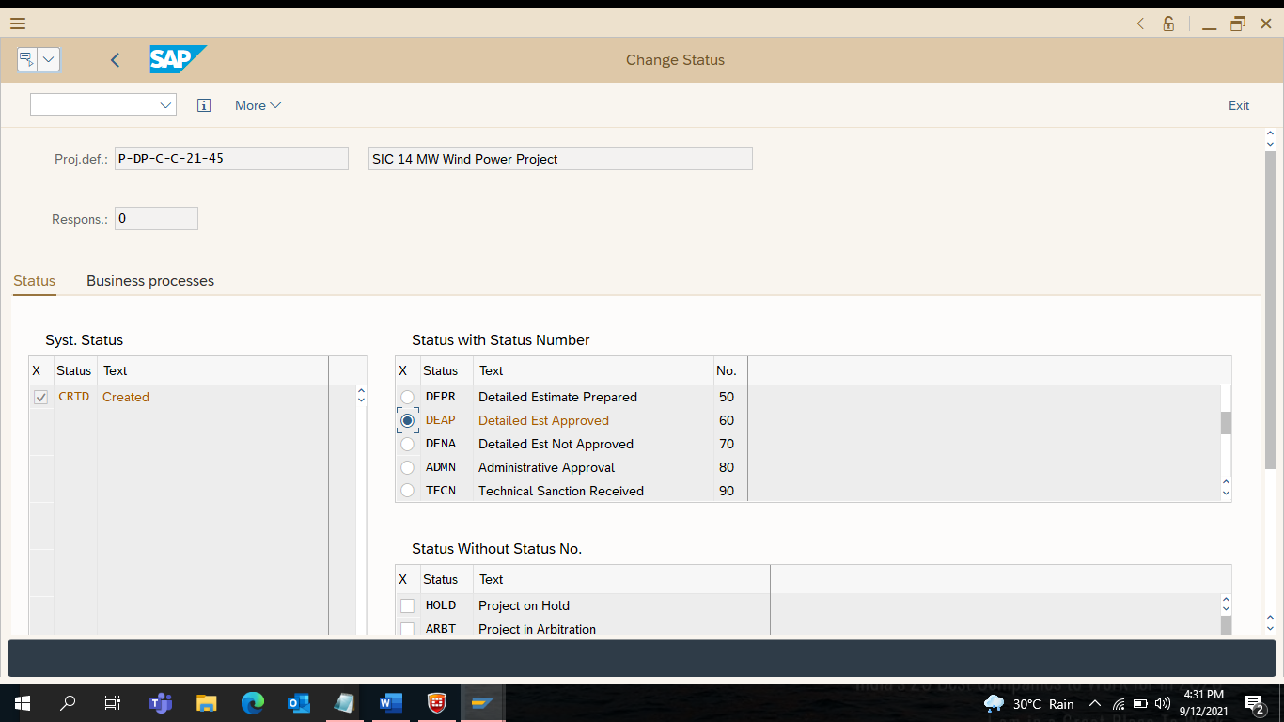

56) Enter ZPS_TRANSFER (To Transfer Services)
Click Enter

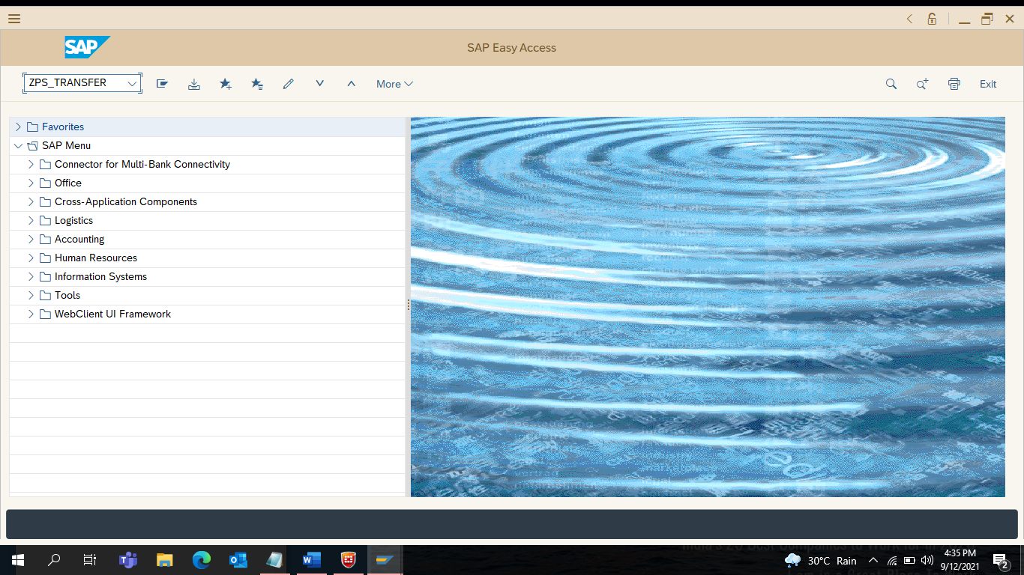

57) Enter Project Definition – P-DP-C-C-21-45
Select Service Activity Group
One Service Activity – One Service ID
Click on Execute
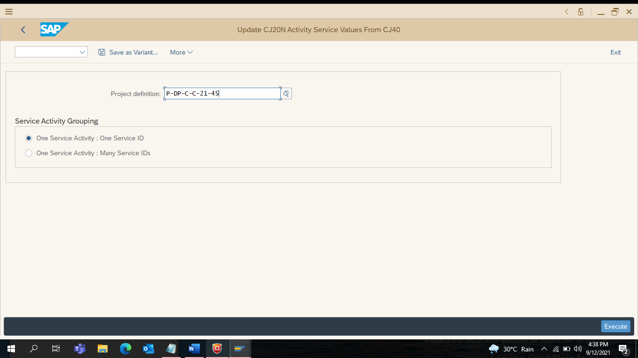

58) Network Changed – Update CJ20N Activity Services Values from CJ40

Click on Exit
Click on Exit
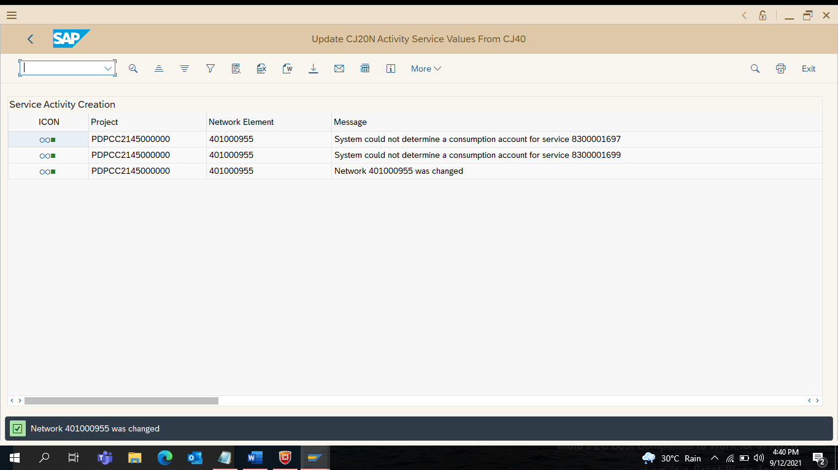

59) Enter ZPS_TRANSMAT (To Transfer Materials – If Applicable only Use)
Click Enter

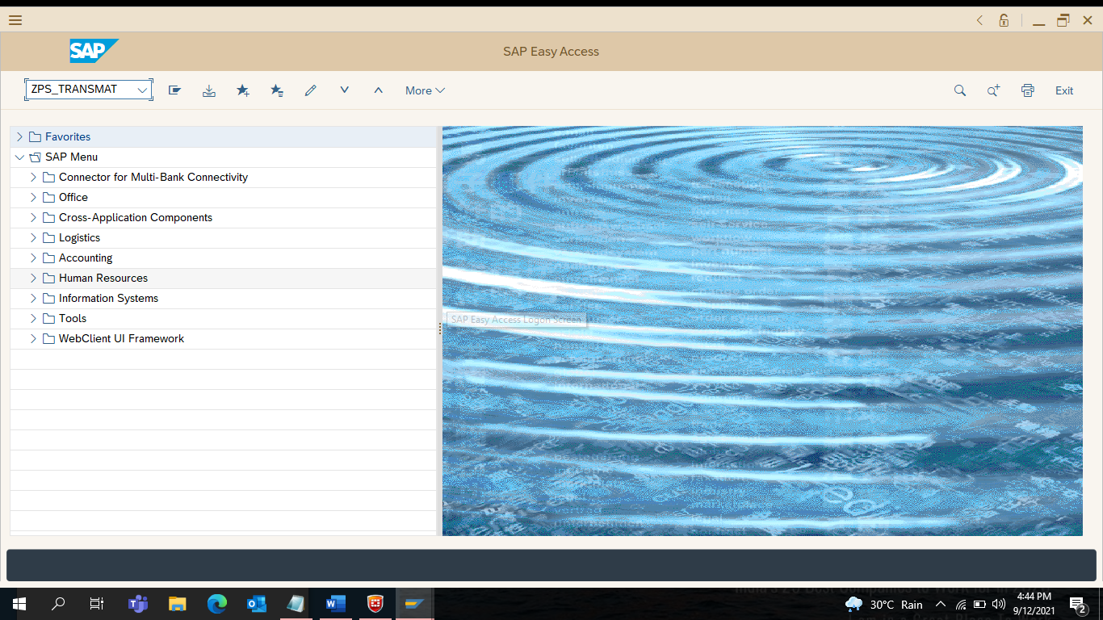

60) Enter Current Project Definition : P-DP-C-C-21-45

Click on Execute

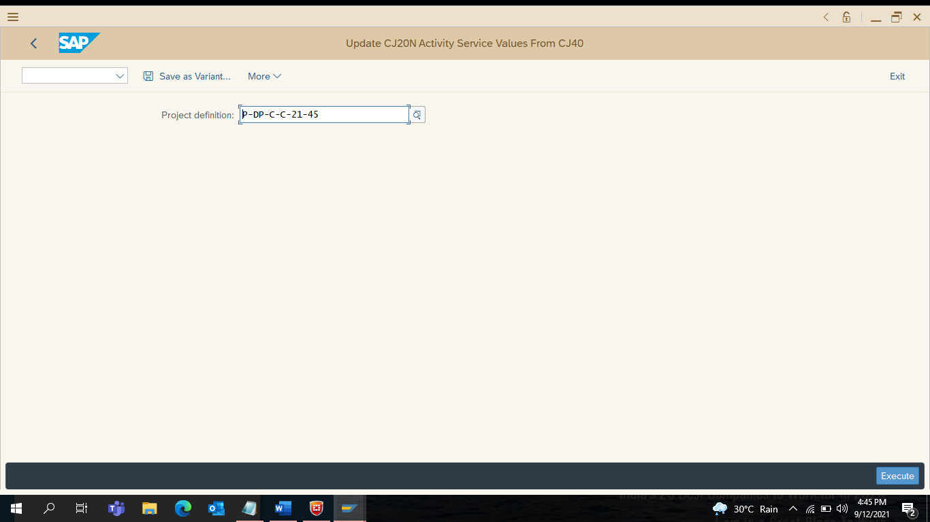

61) Network Changed – Update CJ20N Activity Services Values from CJ40

Click on Exit…… Click on Exit….

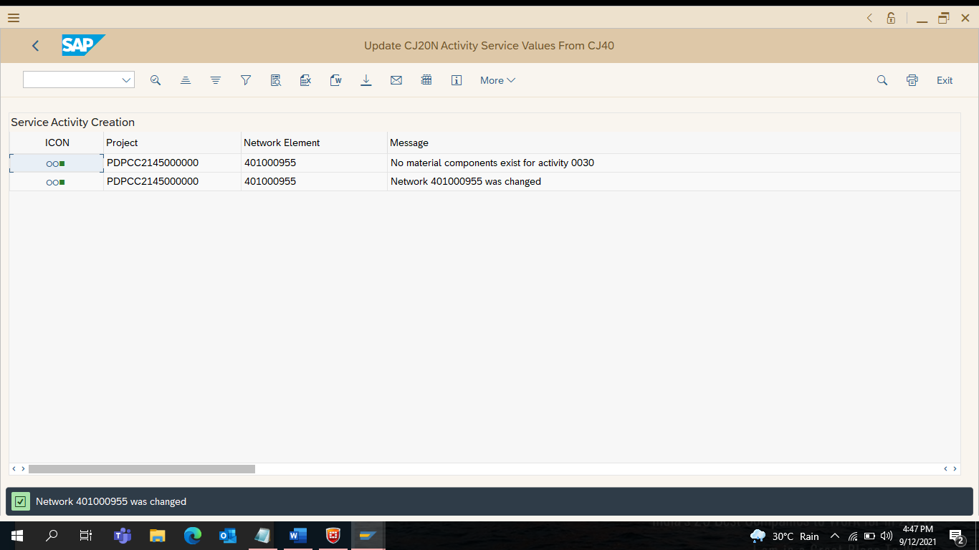

62) Enter CJ20N
Click on Enter
Select the Current Project

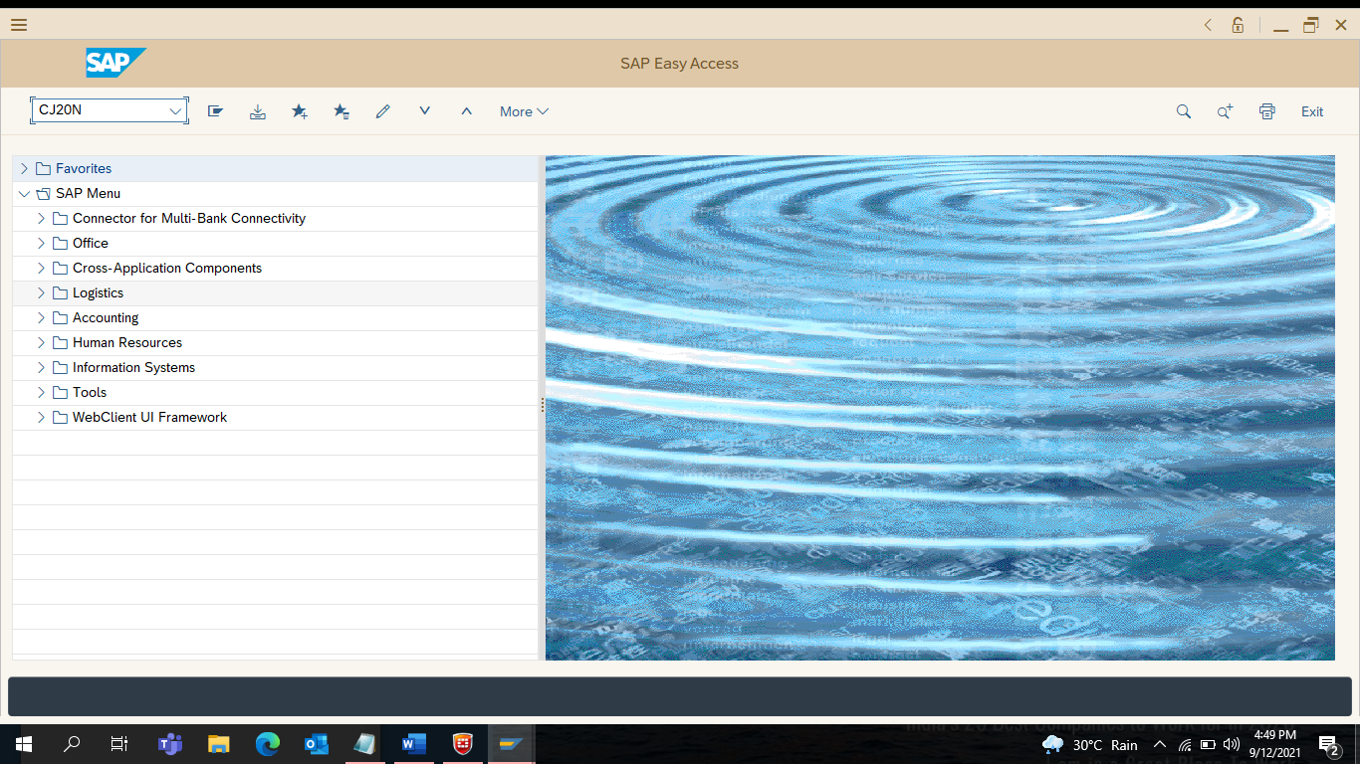

63) Expand the Project Structure

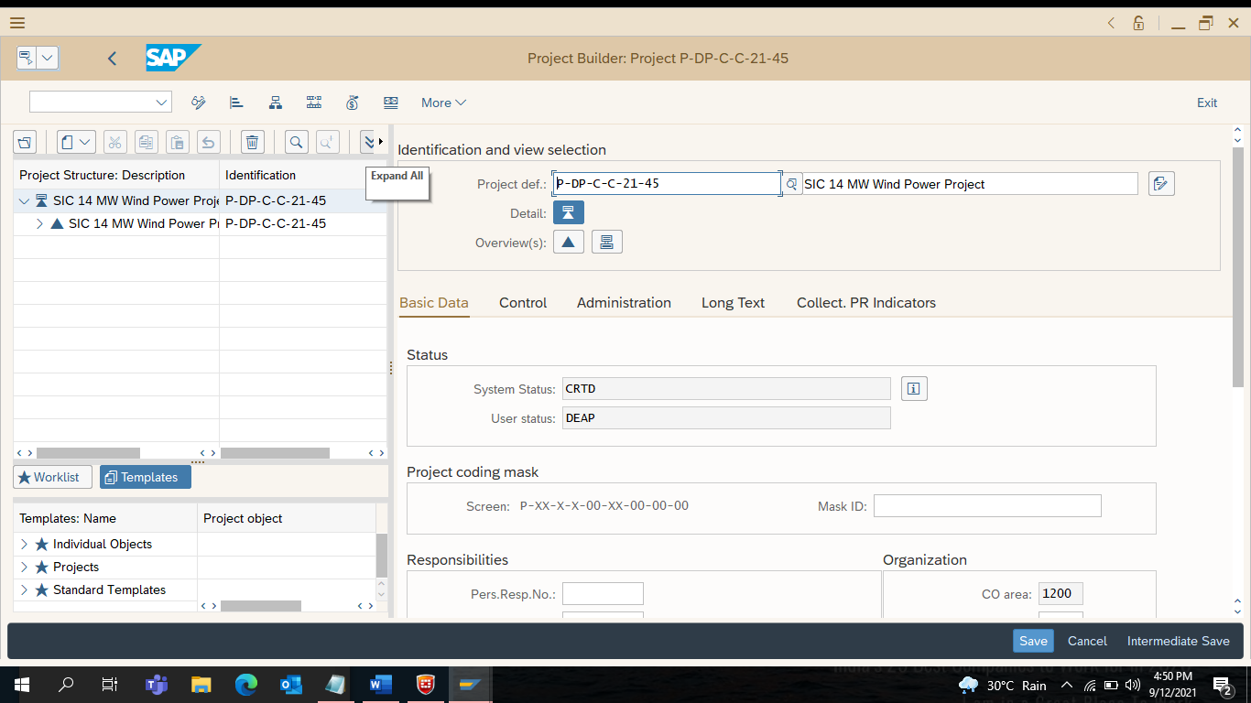

64) Click on the Service Network – Land Development ID : 401000955/10

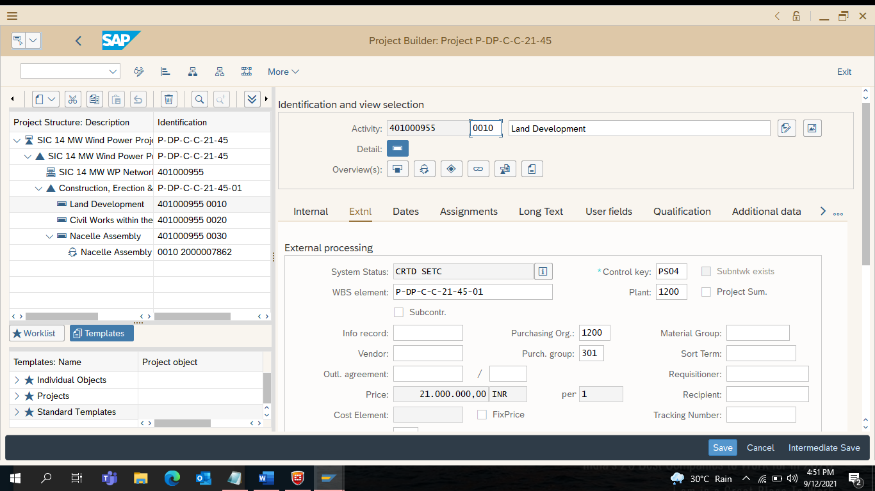

65) Enter Purchase Group – 302 MEED (Respective Division have to take) – Land Development
Similarly Click Civil Works and Enter Purchase Group – 302 MEED

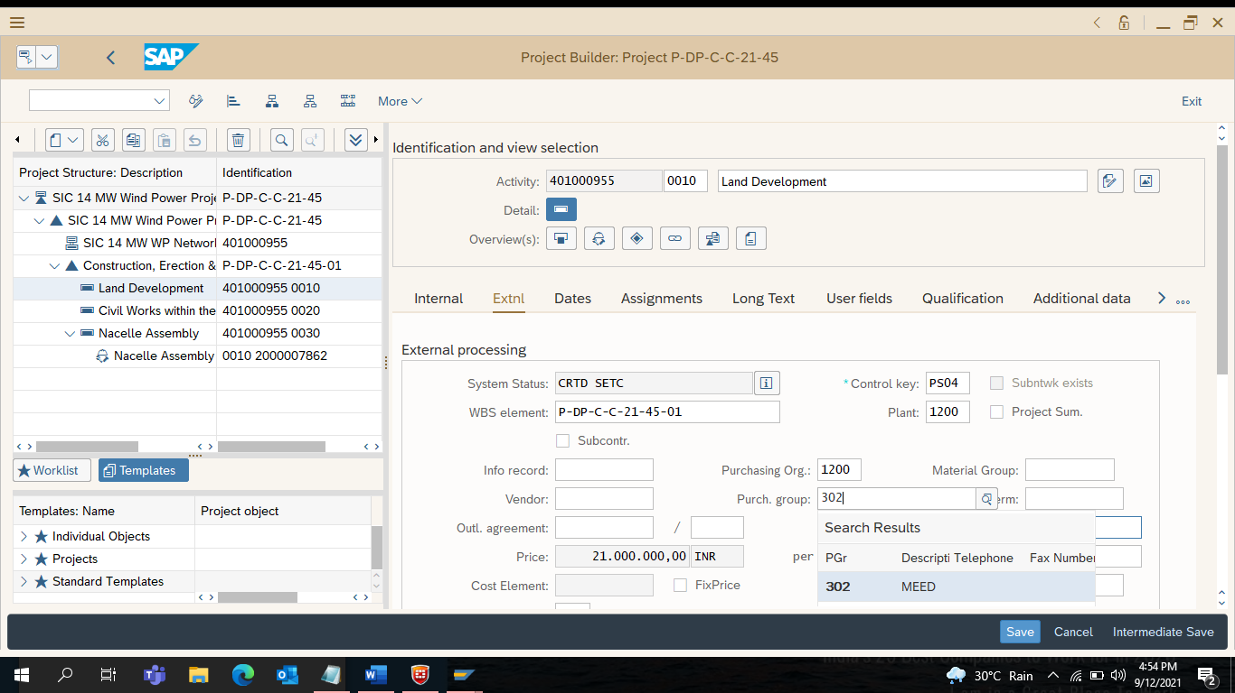

66) Enter Material Group : 81000000 – Land Development
Similarly Enter Material Group : 81000000 to Civil Works

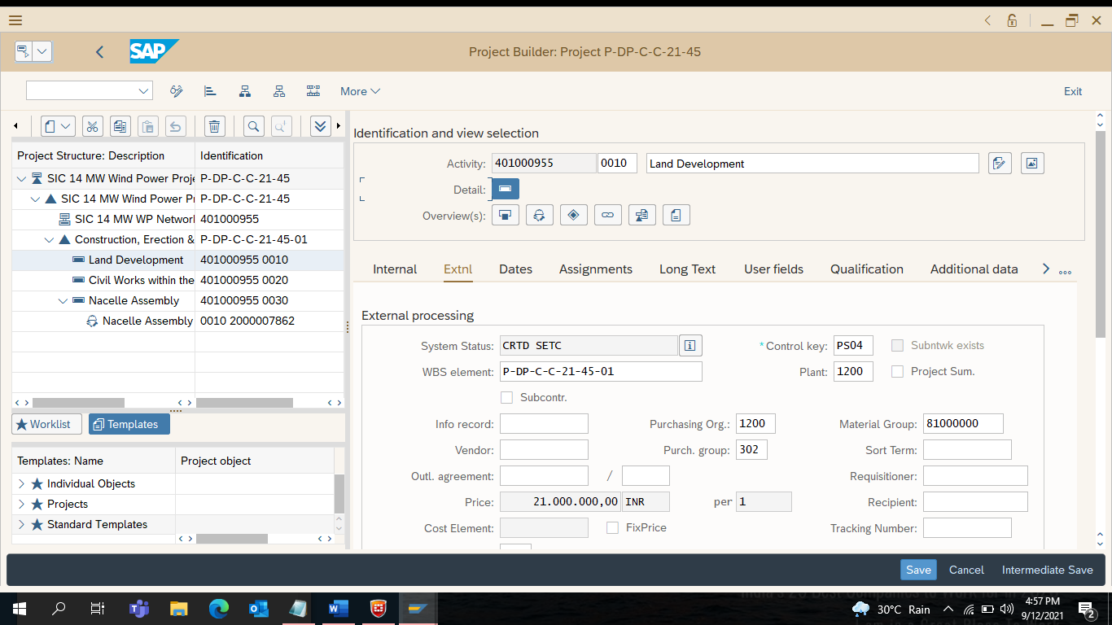

67) Double Click on Administrative Approval (for Purchase Requisition)

Change User Status to ADMN – Administrative Approval

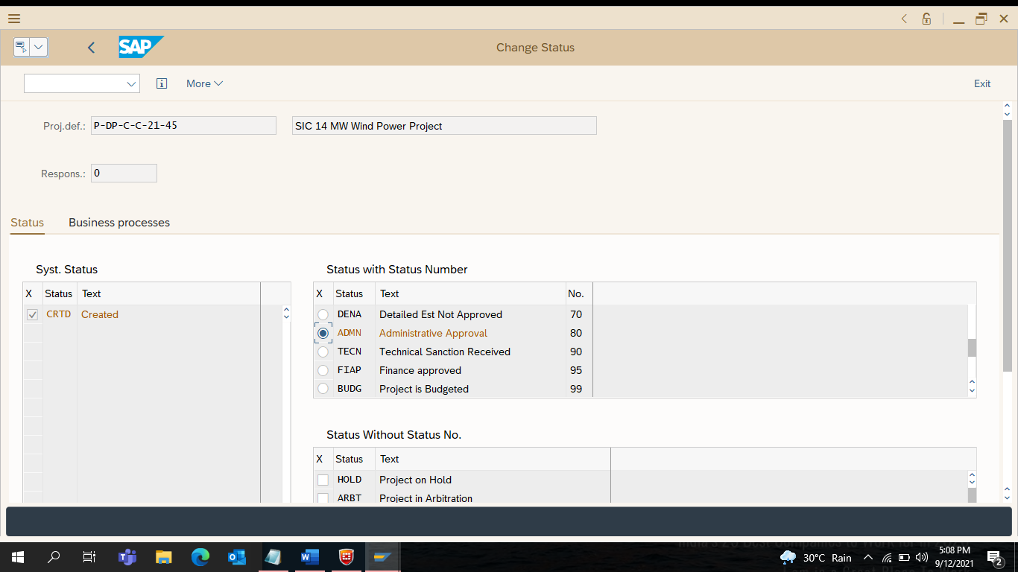

68) Double Click on Technical Sanctioned Received
Click on Exit

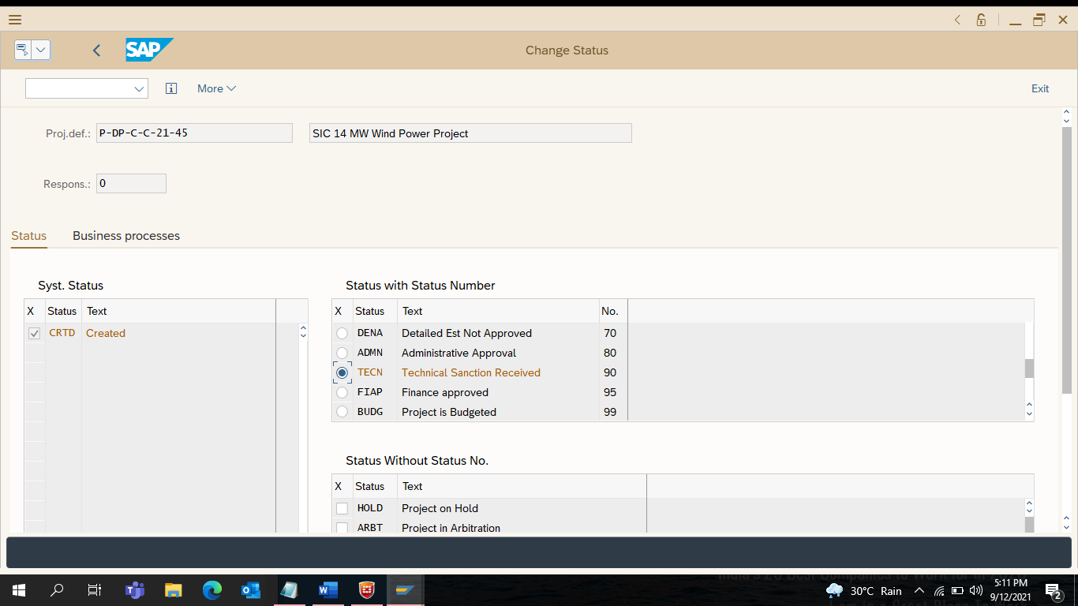

69) Enter CJ30 – for Budget Allocation
Click on Enter

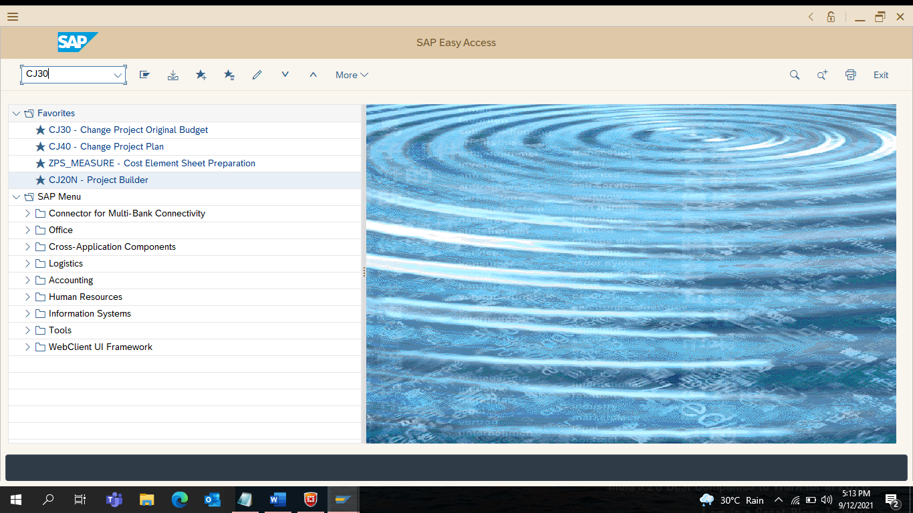

70) Click on Enter (on View of this Screen)

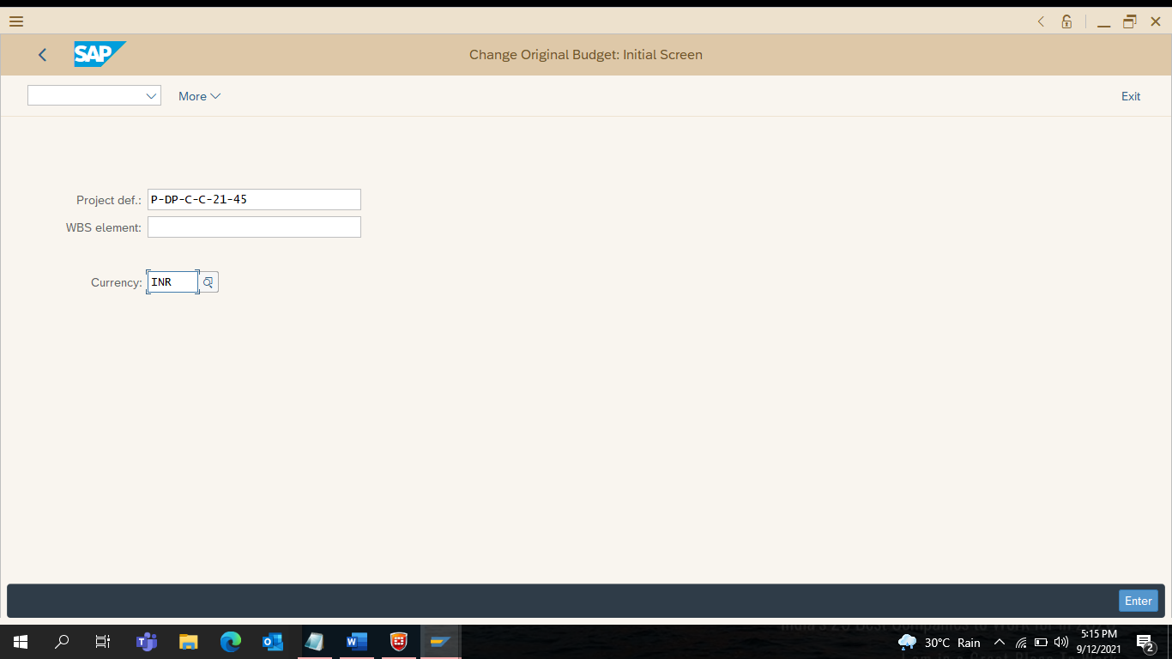

71) Select total Rows
Right on Budget Column
Select Copy View

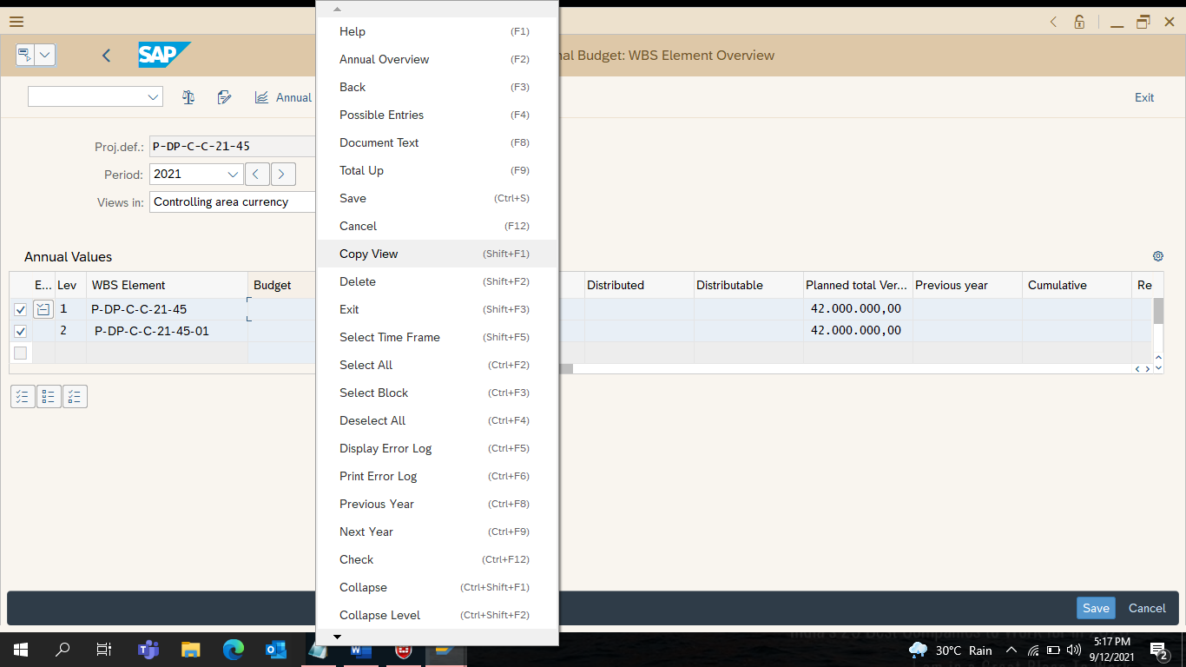

72) Select 05 – Planned Total from the Menu and double click
Click Enter

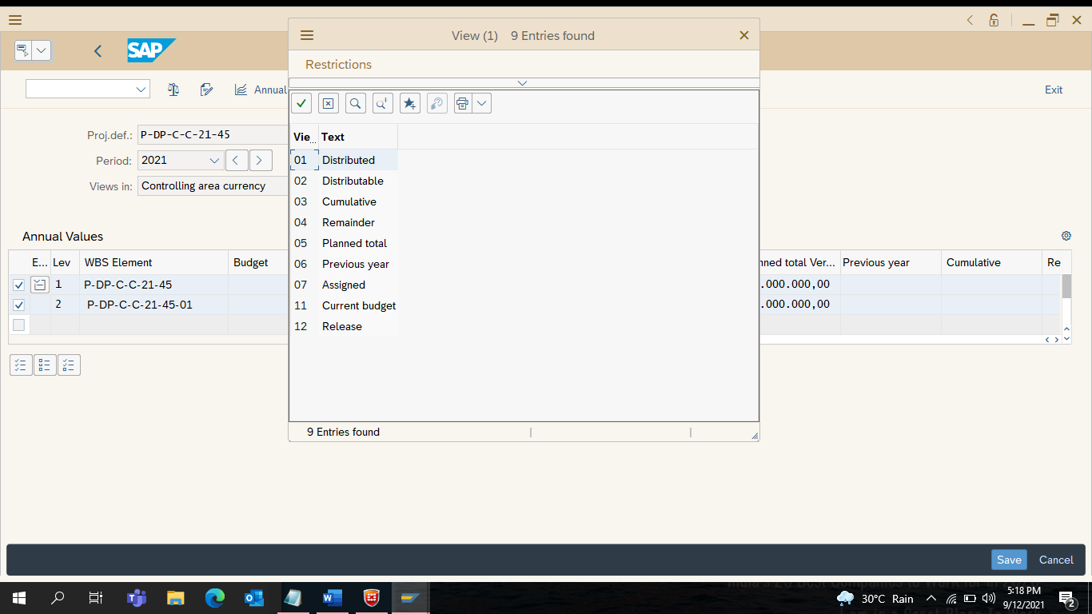

73) Select Add and [ _/ ] Continue

Click on Save
Click on Exit
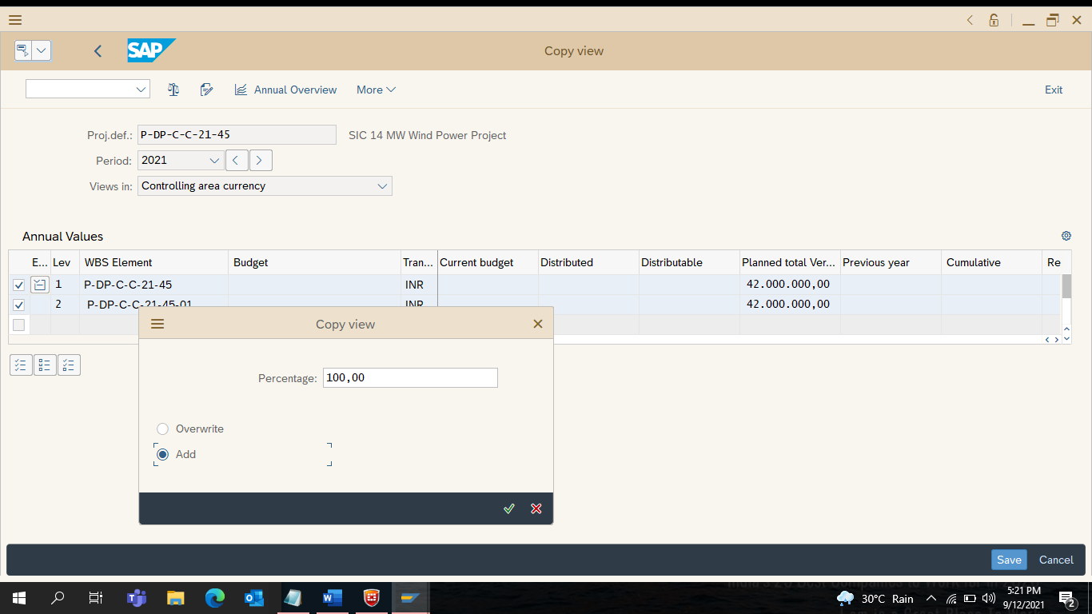

74) Enter CJ20N
Click on Enter

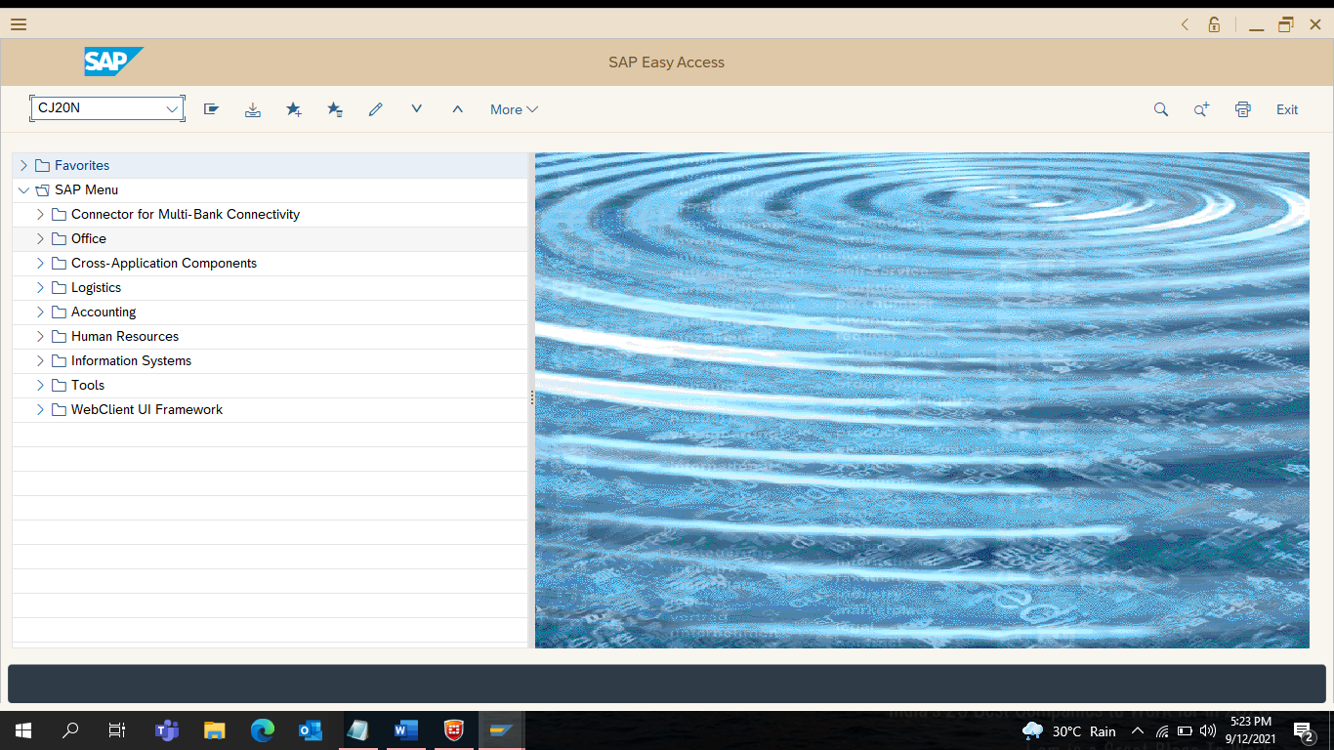

75) Select Project Definition

Go to More
Select Project…. Edit… Status…. Release
Click on Intermediate Save

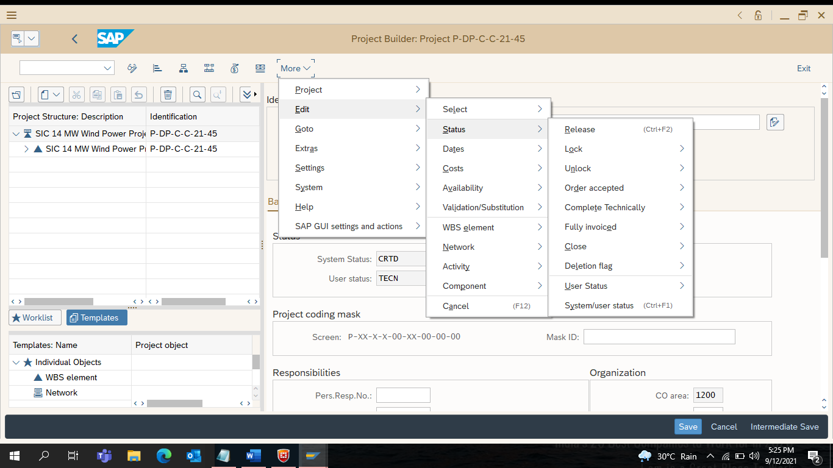

76) Click on Services (or) Materials

Purchase Requisition Number Generates

