दीनदयाल पोर्ट ट्रस्ट
DEENDAYAL PORT AUTHORITY
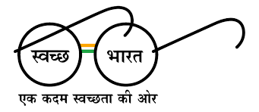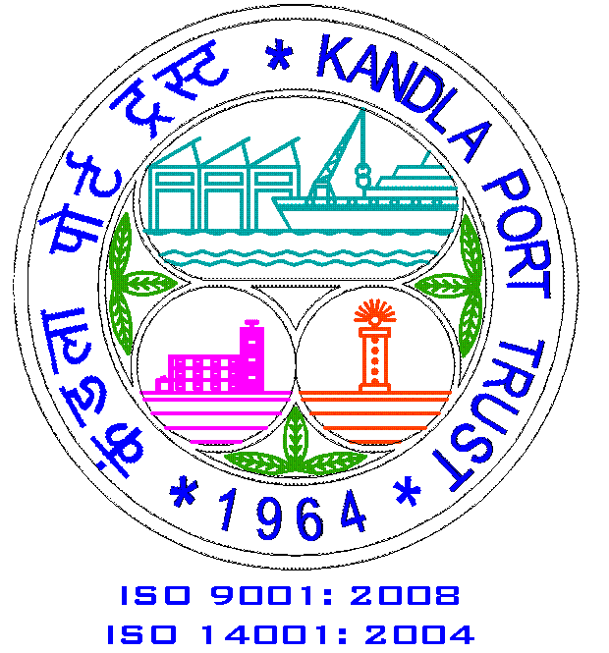
Office of the Executive Engineer (R), Administrative Office Building,
Post Box No. 50, Gandhidham–Kachchh
www.deendayalport.gov.in

******************************************************************************
No: RW/WK/7820/EOI Date: 02/01/2023

To,
__________________________,
__________________________,
__________________________,

Expression of Interest.

Name of Work: Maintenance Contract of Sanitation for New Port Colony, New Kandla. For Two Years.

Sir,

Deendayal Port Authority intends to carry out the subject work of ROAD Division of Civil Engineering Department for a period of 02 years.

Kindly submit your Expression of Interest along with budgetary offer for the items considered in preparation of the estimate under Annexure-I.

The rates quoted must be inclusive of all taxes, duties for performing scope of work & exclusive of GST. The GST applicable shall be shown separately, which shall not be considered for evaluation purposes.

Your Expression of Interest along with budgetary offer for the above work should reach to the following address on or before 09/01/2023 by 15:00 Hrs.

Address:-
Office of the Executive Engineer (ROAD),
ROAD Division, Administrative Office Building,
Ground floor, Room No.128, Annexe,
P.O. Box No. 50, Gandhidham – Kachchh.
Email: xenroadskpt@gmail.com

Thanking you,

Yours faithfully,
Sd/-
Executive Engineer (R)
Deendayal Port Authority

BUDGETARY OFFER Annexure-I
Sr.  No. | Description of Item | Rate | Unit
 | Disposal of wet & dry garbage, sludge, debris by sweeping and accumulating at various places in Colony by Tractor / Trolley with capacity of 2.83m3 including excavation wherever necessary with all labour, tools, loading, unloading etc., from the dust bins situated at different locations, small heaps collected at intervals of approximate 100 mts obtained from the mass cleaning work, trees, dead branches, grass and horticulture garbage collected at intervals in heaps at different places complete up to lead of 2 km. and beyond at appropriate place or as directed by Engineer in charge. |  | Trip
2 | Disposal of dead body of animals including loading, unloading, manually/mechanically, disposing the same by appropriate mode of transportation and at place within lead of 10 km including all labour, tools, machinery required complete as directed by Engineer in charge.
a | Cow, buffalo, bullock, donkey, camel, etc. |  | Each
b | Dogs, Goat, Sheep, Cat etc. |  | Each
3 | Cleaning & disposal of deposited waste, sludge, garbage debris, every month from the gully trap, inspection chamber and manhole at various locations in new port colony, and disposal of the same by appropriate mode of transport upto lead of 10 km at appropriate place including all labour, tools, machinery required complete as directed by Engineer in charge. (Mode of measurement- Each.)
a | Gully Trap |  | Each
b | Inspection Chamber |  | Each
c | Main Hole |  | Each
4 a | Cleaning and sweeping of stair case, landing, balconies daily including removal of waste from house dust-bin and collecting into nearest main dustbin as directed by Engineer-in-charge. (Mode of measurement- Each.) |  | Each
4 b | Removing including brooming collecting and disposing of the waste stuff such as slack & torn / contaminated waste bagages, packages, and any other material including dead birds or cats or rats etc. collecting the garbage in nearby dust bins from the Cement concrete flooring between two blocks of quarters and on ground floor front area of CC flooring between two compound walls and back side of building near staircase, at various locations of New Port Colony complete or as directed by Engineer-in-charge. |  | Each
5 a | Cleaning of Toilet / Bath blocks at various places in Port Colony area daily by cleaning the entire toilet blocks and its surroundings consisting of bathrooms, channels, floor, drainage chamber, W.C., urinals including cost of labour, water, phenyl, acid, tools, etc. complete as directed. (Mode of measurement- Each) |  | Each
5 b | Cleaning and sweeping of public toilet blocks daily in Port Colony area by cleaning entire toilet block and its surrounding consisting of W.C., floor, channels, drainage chambers and drainage lines, etc. with water and chemical agents including cost of labour, water transportation, phenyl, acid, tools, etc. complete as directed. 4 Blocks of 20 toilet Unit each. (Mode of measurement- Each) |  | Each
6 A | Disposing including brooming collecting and disposing of the waste stuff debris including slack & torn/damage contaminated waste bag/packages/packaged material, etc. from residential and non residential building of Port Colony area laying in roads / berms / plants / edges of storm water drains start from end of Shopping Complex road and SWD side north of Shopping Complex to road west of BVM School compound to corner of KPT Hospital to road and berms upto compound wall of Hospital to compound wall of Institution Hall, south corner of Hospital road to road upto Bapat Bazar and road from west of Bapat Bazar to north of Bapat Bazar and concrete portion of bazar inside Bapat Bazar, north of all shops of Bapat Bazar, Ambica Society between Ambica Society & Fire Brigade Colony to end of C type Qtr and at west portion from Vegetable Market compound wall, inside Vegetable Market, Fish Market upto F type building start from Sunday Bazar east end to E type building as shown in drawing and keep collected all waste into nearest dust bin or collect at regular interval to be taken by Tractor by follow up complete or as directed by Engineer-in-charge ( Main market area ) |  | Day
6 B | Cleaning, brooming and sweeping the complete area of Port Colony details of areas mentioned below and upkeeping the open areas clean by collecting garbage, waste stuff including slack and torn/damaged material, etc. and collecting garbage at small interval distance in small debris to be collected by Tractor in Item no. 01 as directed by Engineer-in-charge (CC flooring cleaning are not included in this work) (once in a week) Balance colony Area). |  | Each
a | Complete area of Fire Brigade colony including roads and complete area of sides of SWD upto C type quarter road and road berm upto Ambika society and compound wall of C type quarter.
b | E type buildings (15 buildings) and back side CC road and sides of road and SWD (all area within road and SWD all four sides) start from Sunday Bazar to last E type building and Booster Colony entire area.
c | Complete area of F type building ( 12 buildings) road and SWD sides (all area within road and SWD all four sides)
d | Complete area of F type and E type (4 buildings) surrounding area of F type buildings (4 buildings) road and SWD and open plot and surrounding of Fisheries Colony
e | Complete area of E type, D type and C type area near Hanuman Mandir (02 C type, 06 D type, 02 F type buildings) (all area within road and SWD all four sides)
f | Complete area of B type building and C type building and E type building (03 B type, 01 C type and 02 E type buildings).
7 | Cleaning, brooming and sweeping the open area (except buildings) of Bhartiya Vidhya Mandir and Hospital within & outside the compound wall, up keeping the area and collecting the waste stuff, garbage, debris including slack and torn / damaged contaminated waste bag / packages / packaged material / horticulture garbage and deposit in small heaps at regular intervals and disposing the same on same day by means of Tractor trolley considered in Item no. 01 complete or as directed by Engineer-in-charge.
a | Inside & outside compound wall of Bhartiya Vidhya Mandir complete including ground and surroundings.  Once in a month and additional on Republic day and Independence day. |  | 1 Time
b | CC flooring, surrounding of school building upto compound and open stage inside BVM School complete.  once in a week |  | 1 Time
c | Surrounding of Hospital building complete including ground and flooring.once in a week |  | 1 Time
8 | Cleaning & removal of deposited waste sludge / garbage debris etc. from manhole / chamber of chocked underground sewage pipeline. dechocking of under ground sewage pipe line of various dia i.e.200 mm dia / 300 mm dia / 450 mm dia in between manhole/ chamber for easy flow of sewage, works incuding cost of labour safety materials etc. complete or as directed by Engineer in charge. (Mode of measurement- Each) |  | Each
9 a | Dechocking and cleaning of existing underground drainage line of various dia by providing Suction Jeting machine 2200 PSI machine including POL and operator and then passing khepati of bamboos or MS rod from chamber to chamber cleaning of drainage line, opening of the choked portion of line, removing of chocked materials from liner with all labour and material etc,. complete as directed by Engineer-in-charge. (Mode of measurement- Hours) |  | Hours
9 b | Supplying and operating of dewatering pump set of capacity 4000 liters/hour on site including operator and all the other necessary attachments i.e. suction pipe, footwall, delivery pipe of required length including transporting, for smooth operation of dewatering work as directed by Engineer in charge. This includes the routine maintenance cost of the pump.  Considering approx. 30 days in a year  (Mode of measurement- Day) |  | 1 Day
9 c | Hiring of Hydraulic Excavator including driver and fuel various works such as excavation and refilling of trenches for laying pipelines of sewage water disposal, jungle cutting, leveling & dressing and any other work assigned, complete as directed by Engineer in charge.  Consider 25 days in a year  (Mode of measurement- Day) |  | - Day
10 | Providing and engaging worker per day working for maximum of eight hours in a day as and when required for removing and cutting of thick jungle bushes, grass, levelling and dressing or any other work to be carried out in the Port Colony Area wherever required, collection of waste and loading the same including all tools & plants required to be incurred for execution of the job or as directed by Engineer-in-charge. (Mode of measurement- Time) |  | Time
11 | Providing, laying & jointing PVC pipes of required working pressure as per I.S.I. 4985 including cutting and jointing the pipe ends as per manufacturer's instructions including the cost of specials wherever required and, excavation and refilling of the trenches or fixing on walls or similar structures with clamps and testing the joints etc. complete as directed.
a | Pipe 110 mm outer dia. working pressure 6 kg/cm2. Internal lines from G.T. to I.C. |  | Rmt.
b | Pipe 160 mm outer dia. working pressure 6 kg/cm2. Internal lines from I.C. to I.C |  | Rmt.
Total Rupees _____________Only.

