DEENDAYAL PORT AUTHORITY

An ISO 9001:2008 & ISO 14001:2004 Certified Port
Mobile: 9825227048 Office of the Executive Engineer (E)
Mail: xenedpt@gmail.com Ground Floor, P & C Building,
New Kandla – Kachchh,
Pin.370210-Gujarat.
No.: EL/AC/2488 Date: 01/11/2022
EXPRESSION OF INTEREST
(This Notice is issued only to elicit Expression of Interest from the parties interested in the work and does not constitute any binding commitment from the Deendayal Port Trust to proceed with the work or invite any or all the parties in the subsequent bidding process. The Open Tenders will be issued subsequently)
To,
____________
____________
____________.

Sub: “Set up Renewable Energy Power Plant (Solar/ Wind/ Hybrid) at Deendayal Port Authority, Kandla, Gujarat.”
Sir,
You are requested to submit for Global Invitation for Expression of Interest (EOI) “To set up Renewable Energy Power Plant (Solar/ Wind/ Hybrid) at Deendayal Port Authority, Kandla, Gujarat.” as per Scope included.
The Expression of Interest should reach to this office on or before 22/11/2022.
Yours faithfully
Sd/-
Executive Engineer (E)
Deendayal Port Authority

Scope:
Global Invitation for Expression of Interest (EOI) to set up Renewable Energy Power Plant (Solar/ Wind/ Hybrid) at Deendayal Port Authority, Kandla, Gujarat
Deendayal Port Authority (DPA), erstwhile Kandla Port Trust (KPT), is one of the major ports of India under Ministry of Shipping & Waterways, Government of India and the main activity of the DPA is to facilitate trade for cargo handling operation. DPA's journey began in 1931 with construction of RCC Jetty by MaharaoKhengarji. After partition, Deendayal Port's success story has continued, and it rose to become the No. 1 Port in India in the year 2007-08 and has since then retained the position for the 13thconsecutive year.
DPA has large parcels of land available and would like to make use of these land for developing RE Parks. The land parcels identified for RE Parks are inter-tidal lands.DPA invites EOI from prospective RE (Renewable Energy) Developers who would set up Solar/ Wind/ Hybrid Power Plant in the land available in DPA area, Kandla, Gujarat.The agencies interested in site visit may send their request on xenedpa@gmail.com/xenedpt@gmail.com. Necessary support/permission will be provided by DPA.
Stakeholder Consultation is scheduled on 15/11/2022 through Video Conferencing. Interested parties may submit their request for participation in Stakeholder Consultation at P & C Building, Kandla.
Required land details are in Annexure-1
Submission of Applications:
Interested parties can submit their expression of interest providing the following details within 3 weeks from the date of advertisement by submitting the documents through e-mail to xenedpa@gmail.com/xenedpt@gmail.com.
Sl No. | Information Required | Details
1. | Detailed Proposal | - Proposed Capacity  - Type of RE Park  - Preliminary Cost estimates for the project cost etc.
2. | Details of Applicant | - Full name of organization  - Address for correspondence  - Country of Incorporation  - Registered office address  - Details of Directors/Principals  - Business profile  - Contact details of point of contact
3. | Financial Requirement | - Developer must have positive net worth as on 31.3.2022 (Preceding 3 Years Audited Financial Statements)
4. | Technical Experience | - Developer must have an experience of installation and commissioning of atleast 100 MW of RE Project / RE Park.
Selection Process:
The shortlisted applicant would be required to submit their financial offers in line with the RFP issued to the shortlisted bidders.
Disclaimer:
- This Expression of Interest (EOI) document is not an agreement or offer by the issuer to the prospective Bidders or any other party. The purpose of this EOI is to provide interested parties with information to assist them in submission of their EOI Bid to enable DPA in finding suitable developer for Setting up of Solar/Wind/Hybrid Power Plant of 150 MW capacity. This EOI is based on material and information available in public domain.
- This EOI document, along with its Formats, is not transferable. The EOI document and the information contained therein are to be used only by the person to whom it is issued. In the event that the recipient does not continue with its involvement in the bidding process in accordance with this EOI, this EOI must be kept confidential.
- While this EOI document has been prepared in good faith, neither the issuer, nor its employees nor advisors/ consultants make any representation or warranty express or implied as to the accuracy, reliability or completeness of the information contained in this EOI document.
- Neither the issuer, its employees nor its advisors / consultants will have any liability to any Bidder or any other person under the law of contract, tort, the principles of restitution or unjust enrichment or otherwise for any loss, expense or damage which may arise from or be incurred or suffered in connection with anything contained in this EOI document, any matter deemed to form part of this EOI document, the process , the information supplied by or on behalf of Procurer or its employees, any advisors/consultants or otherwise arising in any way from the selection process for the said supply of power.
Annexure-I
- Land Coordinates is enclosed at Drawing -1 and total land area available is 4000 Acres
- As per office record there is no Encroachment at the site
- This are falls under the CRZ – 1A – 50 mtrs mangrove buffer zone.
- The rate of Padana village is approximately Rs. 30.6 per sq. mtrs/per anum

Sd/-
Signature & Seal of Contractor Executive Engineer (E)
Deendayal Port Authority

Drawing - 1
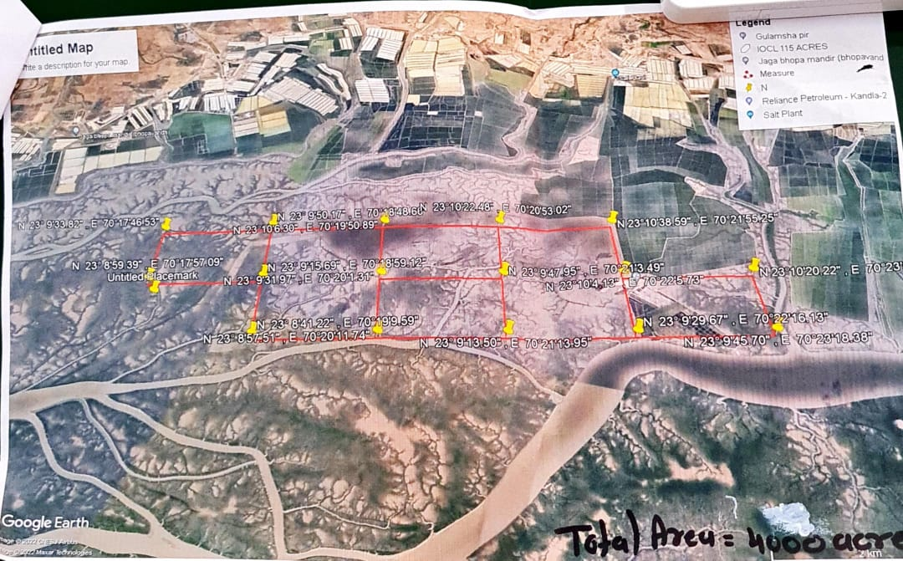

sd/

Signature & Seal of Contractor Executive Engineer (E)
Deendayal Port Authority

