Indian Ports Association (IPA)
Implementation of Port EBS Project
Enterprise Business System

Business Process Manual for
Single Tender

Submitted by:

Plot No. 58 A & B,
Noida Special Economic Zone,
Uttar Pradesh-201305

www.techmahindra.com

This document is a desk reference tailored to the Procurement Specialists. It is intended to provide information that will be helpful to support the Tendering processes.
All rights reserved. Passing on and copying of this document, use and communication of its contents not permitted without written authorization
Document History:
Authors & Participants
Role | Name
SRM Solution Architect | Abhay Gade

Revision History
Date | Document  Version | Document Revision  Description | Author
19.07.2020 | 1.0 | Initial Draft | Abhay Gade / Sudhakar M S

Reviewed and Approved By
Name | Title | Date | Approved

Contents:
1. Portal Logon 4
1.1. EBS Portal & SSO to SRM Portal 4
2. Strategic Purchasing 7
3. Carry Out Sourcing 8
4. RFX Creation – Edit RFx 12
4.1. RFx Parameters 12
4.2. Bidders Tab 17
4.3. Maintain RFx Parameters 18
4.4. Maintain Tender Committee 19
4.5. Item Tab 22
4.6. Approval Tab 23
4.7. C-Folder Attachment 24
4.8. Tracking Tab 28
4.9. Publish RFx with Digital Signature 29
4.10. Approving the RFx 34
5. Technical RFx Response Activity 36
5.1. Initiate Technical RFx Response Opening 36
5.2. Technical Comparative Statement 39
5.3. Approving TCR 44
6. Price RFx Response Activity 47
6.1. Initiate Price RFx Response Opening 47
6.2. Price Comparative Statement 51
6.3. Approving PCR 55
7. Award Response 58
8. RFx Response Approval 62
9. Create Purchase Order 63

Portal Logon

EBS Portal & SSO to SRM Portal

    - Access the URL URL https://10.9.7.22:8001/ebs-portal/ in IE browser. Below screen will be displayed.

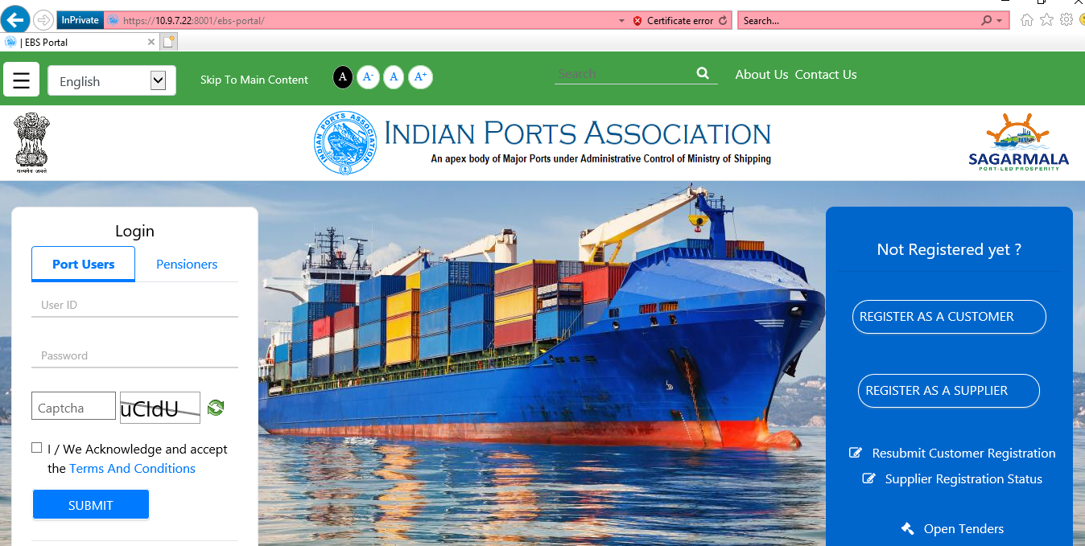

    - Under “Port Users” tab provide your user-id and password.

    - Input the captcha as mentioned and then check the “Terms and Conditions” statement.

    - Click on “Submit” button.

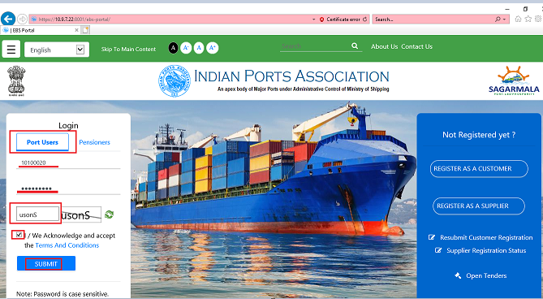

    - A new window will be displayed and it will prompt to enter the OTP. OTP will be sent to your registered mobile.

    - Input the OTP and click on “Verify OTP” button. Please see screenshot below.

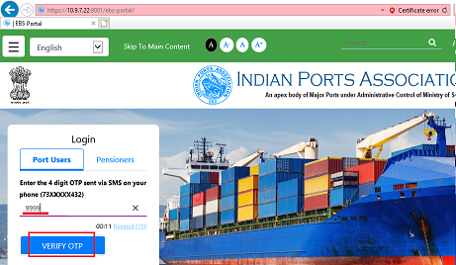

    - Once system verifies the OTP a new window will be displayed. Select “Other EBS Application” tab and click on “SRM Portal” link. Please see screenshot below.

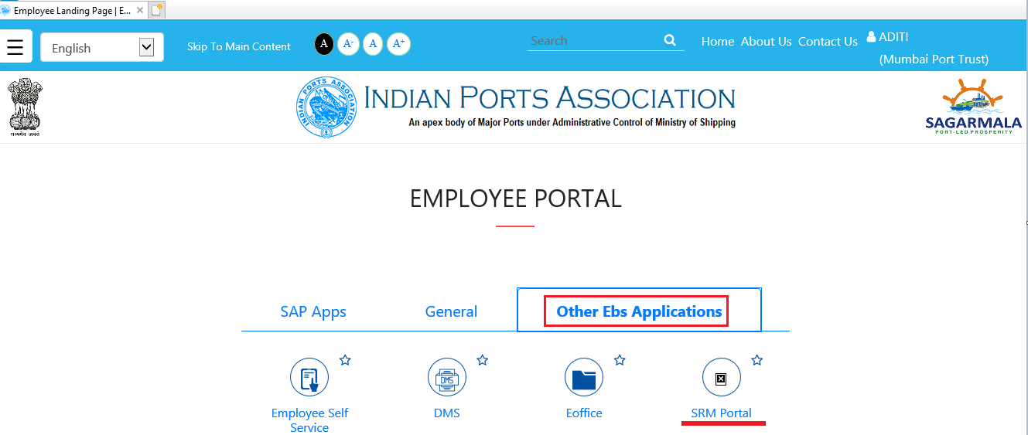
    - A new window will be opened wherein you will be redirected to the SRM portal through SSO. The screen will be displayed as shown below.

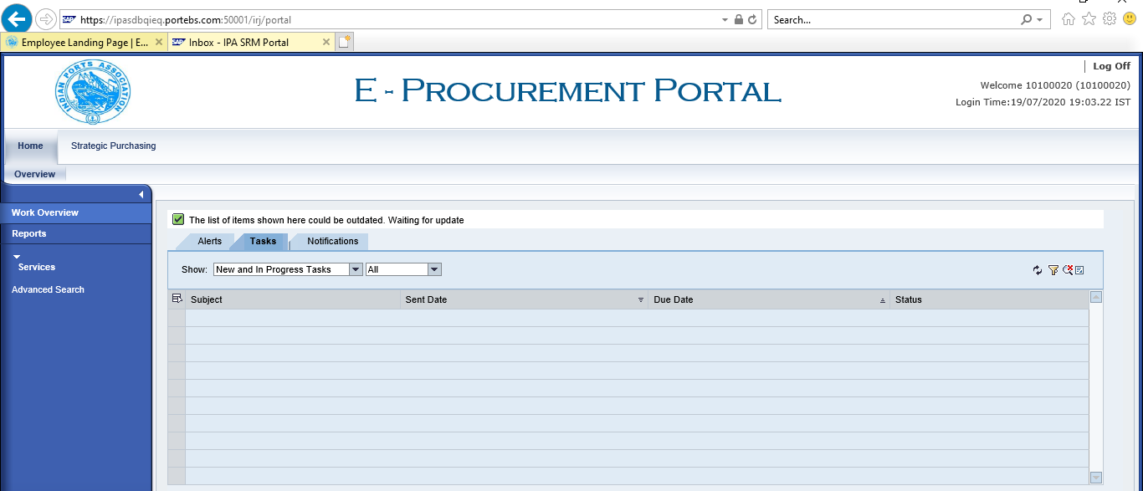

    - The screen contains the information of User id / Name and logon time at the right corner. The “Home” tab will be displayed on the left corner of the screen.

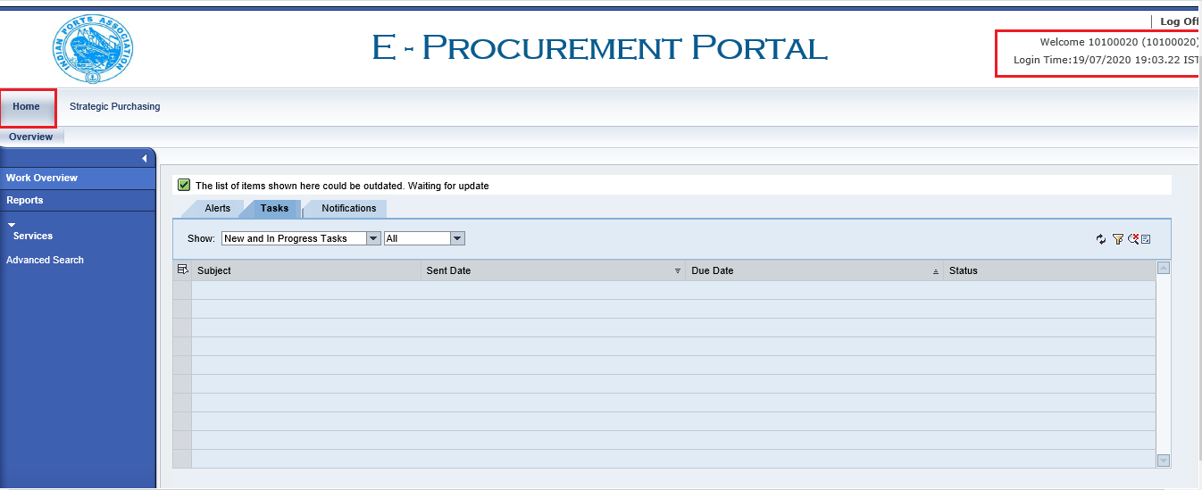

Strategic Purchasing

  - Select “Strategic Purchasing” tab then click on “Strategic Sourcing” link. At the right side panel, user will be able to see the list of RFx’s with various status.

This is basically a dashboard where the user can view and act upon the tender’s created using their user-id’s.

There are different search criteria’s provided by system to search the Tender’s created.

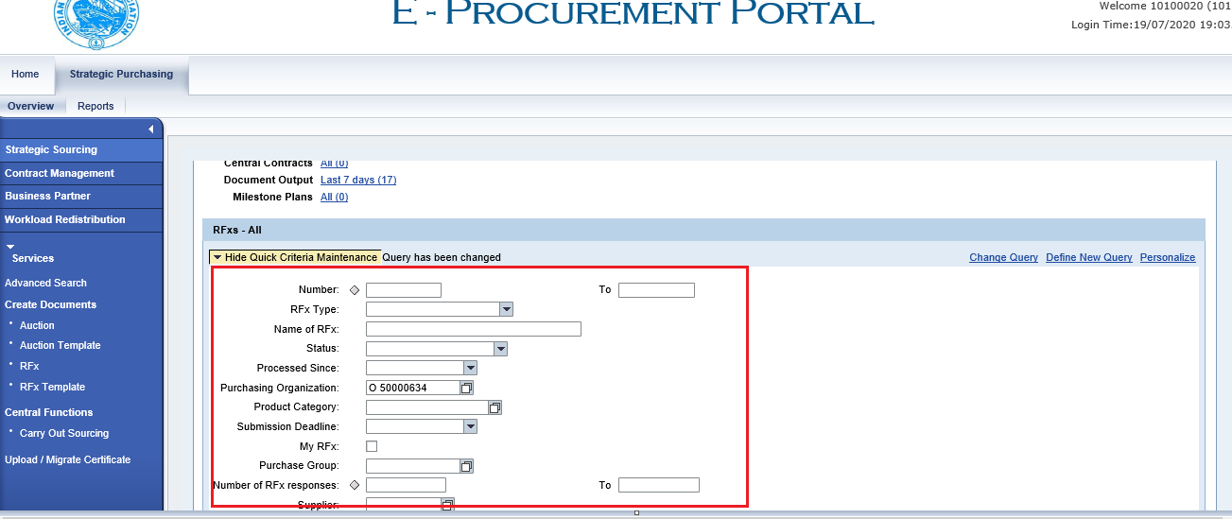

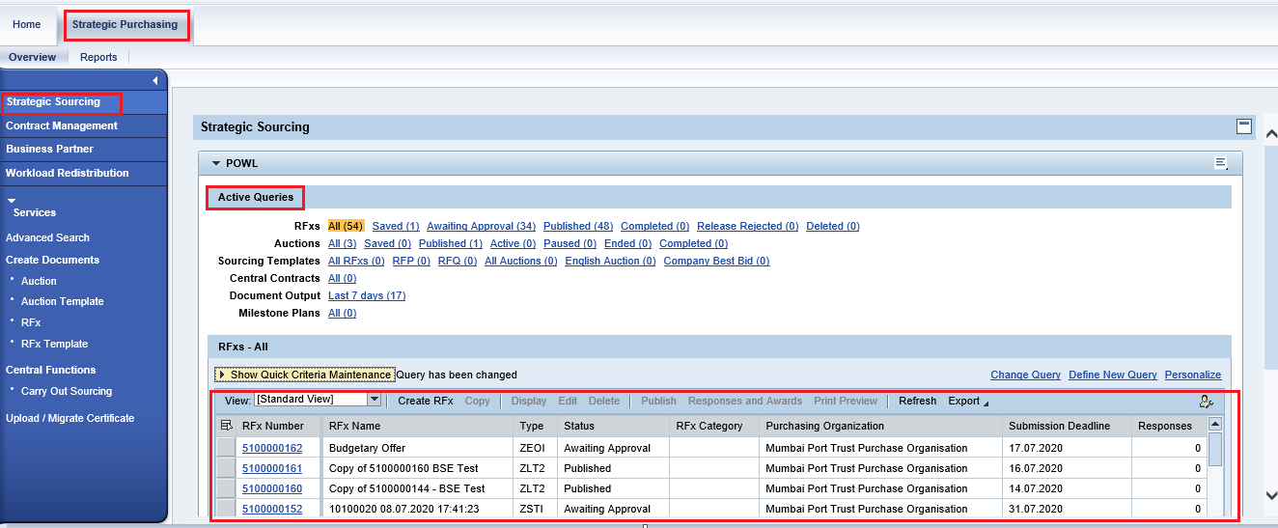

Carry Out Sourcing

  - To see the list of purchase requisition’s replicated from the backend HANA system & create tender’s against them, user need to go to Carry Out sourcing option. Follow below steps.

  - Select “Strategic Purchasing” tab then click on “Strategic Sourcing” link. Under “Central Function” click on “Carry Out Sourcing” link.
Steps would be as Strategic Purchasing Strategic Sourcing Central Functions Carry Out Sourcing.

Please see the screenshot below.

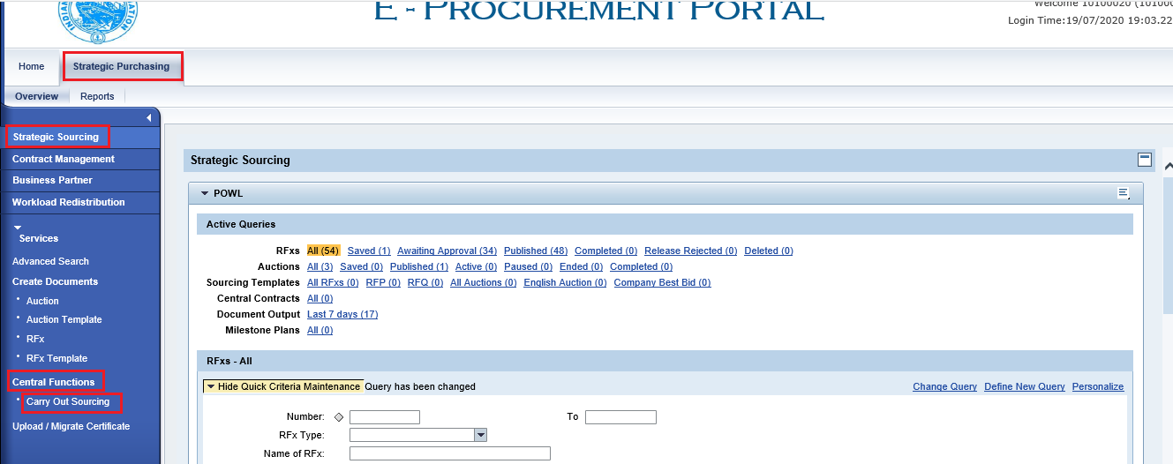
  - A new window will get displayed as shown below. This is the first step of searching the Purchase requisitions. There are various search criteria’s provided through which you can search the purchase requisitions.

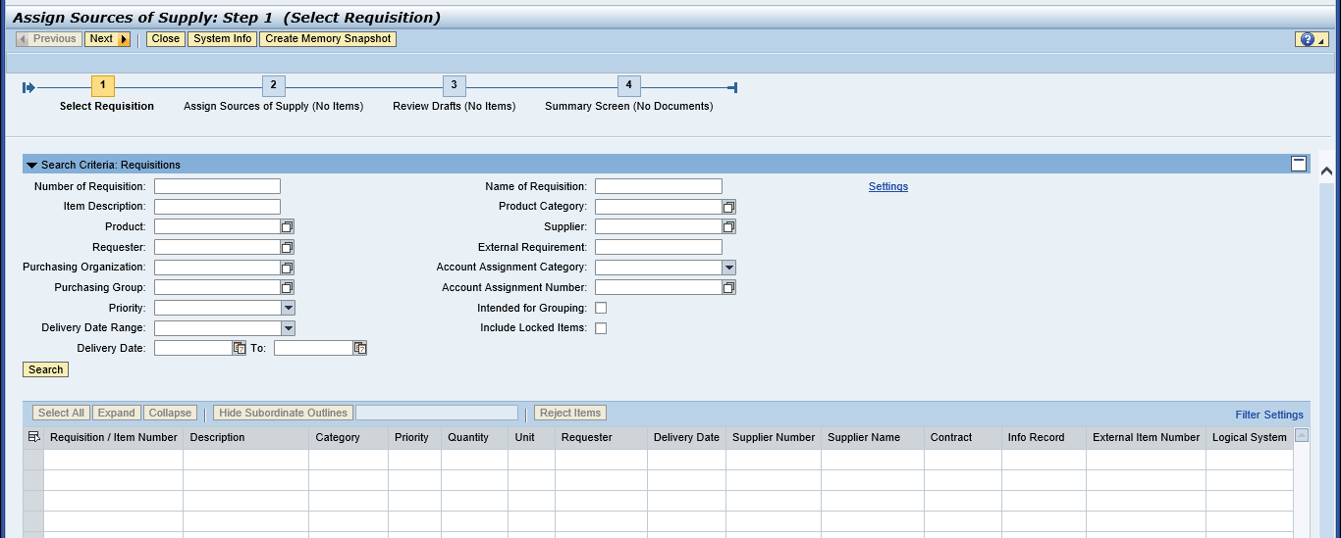

  - If you know the PR number, then enter SAP Purchase Requisition in “External Requisition” field and click on “Search” button. Purchase Requisition Line items shows below
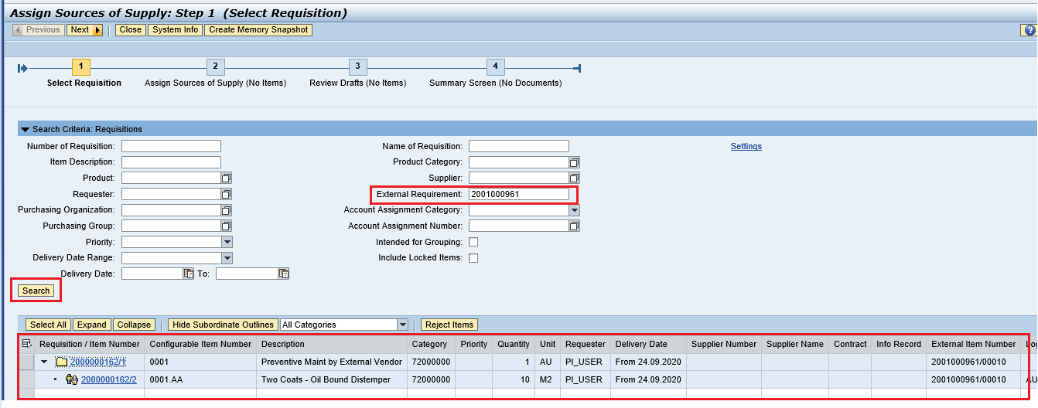
  - Click on “Select All” button and click on “Next” button.
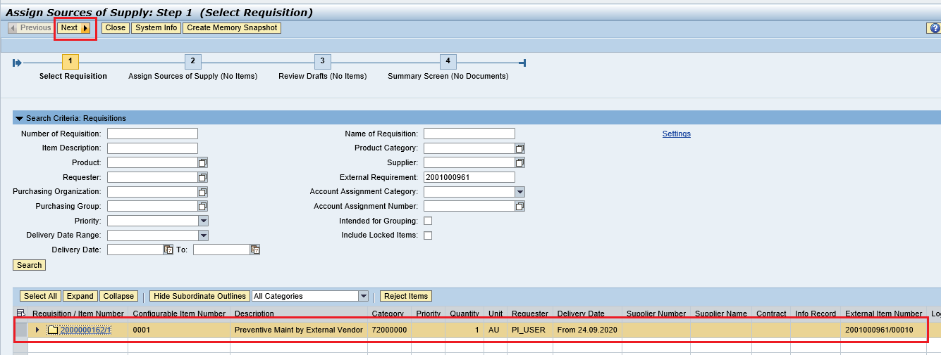
  - Once you click on “Next” button, system will direct to next step#2 of selecting the Draft document to be created.
Once again click on “Select All” button to ensure all the PR’s and line items are properly selected.

Then click on the “Create Draft” button and select “RFx” from the drop down list as shown in below screenshot.
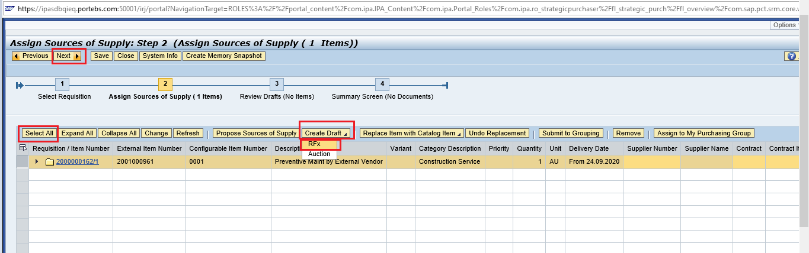
  - Once you click on “Next” button, system will direct to next step#3 of selecting the Transaction Type for the tender to be created.

From the drop down list select “ZSTI – Single Tender” option.
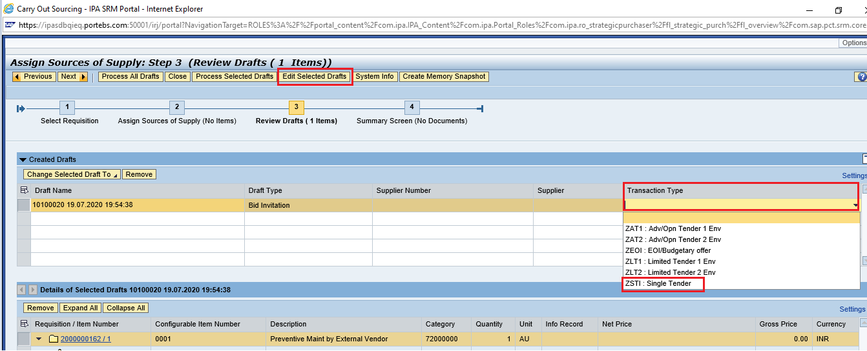
  - Once the tender type is selected, click on the “Edit Selected Drafts” button as shown below.

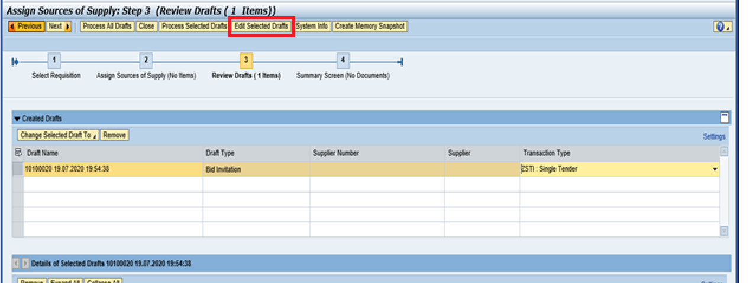

  - A new window will get opened with all the details required for RFx creation.

Details are explained in next section#4 – RFx Creation. Simultaneously system will automatically move to next step#4. Click on the “Close” button to close this screen.
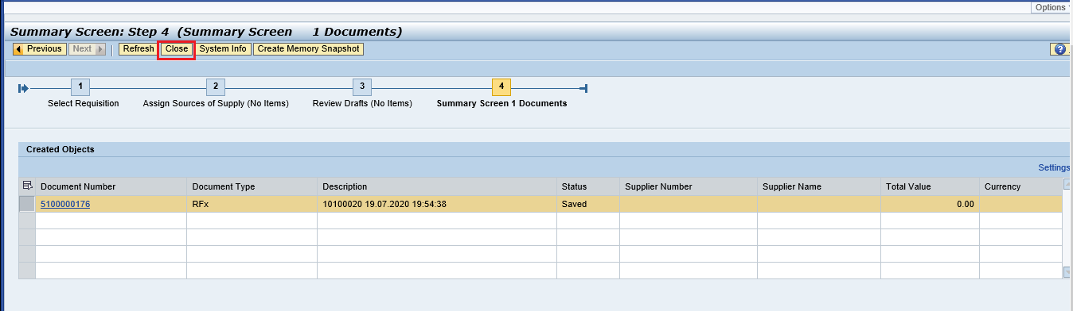

RFX Creation – Edit RFx

RFx Parameters

    - The RFx screen will be in Edited mode. The RFx number will get generated automatically and it is an incremental unique number generated by system. The panel at the top displays the RFx number, RFx Name (40 characters), type of RFx and created by & creation date and time information. Please see the screenshot below.
    - The RFx name is defaulted by system in the format of “User Id, Date, Time”. The RFx Name can be modified if required by the Tender Creator with some meaningful short description of the tender.

Please see the screen shot below.
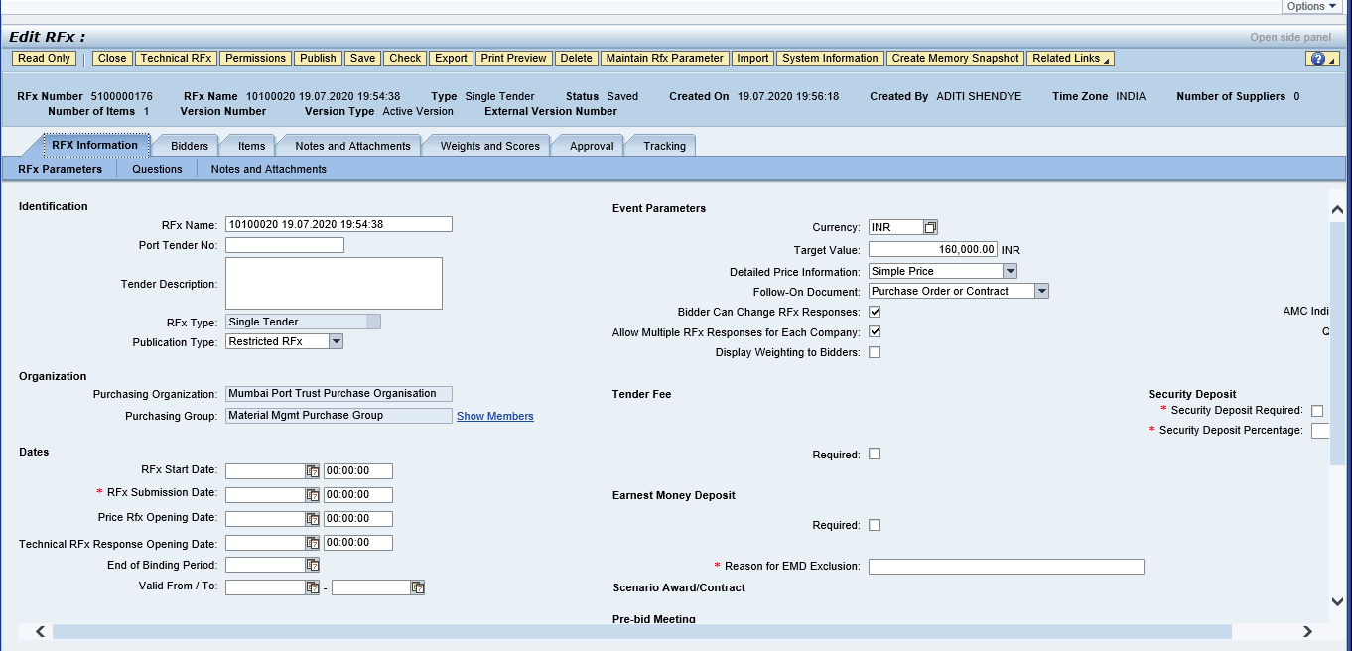
There are various fields provided on the RFx screen as below. Details description of the fields available for maintaining the data is given in table below.
RFx Information RFx Parameters

Identification

Field | Description | Field Status
Port Tender No | Enter the internal port tender number followed by the respective Port. | Editable
Tender Description | This is 256 character in length. Used for entering the long description of the Tender | Editable
RFx Type | Type of Tender | Non-Editable
Publication Type | System Defaulted – Restricted RFx | Editable
Organization

Purchasing Organization | System defaulted | Non-Editable
Purchasing Group | System Defaulted | Non-Editable
Dates

RFx Start Date | Date from which the Tender process will start after it is approved and published | Editable
RFx Submission Date | Date by which the Bidder should submit the response | Editable
Price Rfx Opening Date | RFx Price Opening Date | Editable
Technical RFx Response Opening Date | RFx Technical Opening Date | Editable
Valid From / To | Binding period of the tender | Editable
Event Parameters

Currency | System Defaulted as INR. Not to be changed | Editable
Target Value | System defaulted based on the estimates in the Purchase requisition. Not to be modified. | Editable
Detailed Price Information | System defaulted. Not to be changed | Editable
Follow-on Document | Defaulted by system. The document to be created i.e. either a Purchase Order or Contract against the L1 bidder response. Not to be changed. | Editable
Bidder can change RFx Response | Will be checked by default. This allows the bidder to change the submitted responses until the RFx submission deadline date is not reached. If unchecked, response once submitted cannot be modified by the Bidder. Not to be changed. | Editable
Allow multiple RFx Response for each company | Will be checked by default. This allows the bidder to change the submitted responses multiple times, until the submission deadline date is not reached. If unchecked, Bidder cannot modify & re-submit the responses. Not to be changed. | Editable
AMC Indicator | Is applicable for the AMC tenders. If checked TCR with ALR/AVR will be generated | Editable
QSBC | Currently not available | Editable
Tender Fee

Tender Fee Required | Check this field if tender fee needs to be collected from the Bidder | Editable
Tender Fee Percentage | Enter the percentage of amount to be collected from the Bidder. System automatically calculates the tender fee and displays in the Tender Fee field | Editable
Tender Fee | Buyer can input the amount here instead of entering the % | Editable
Submission Deadline | Tender Fee is required to be submitted before this Date and Time by the Bidder without which the Bidder will not be able to create & submit the responses | Editable
Earnest Money Deposit

Required | Check this field if EMD fee needs to be collected from the Bidder | Editable
EMD Percentage | Enter the percentage of amount to be collected from the Bidder. System automatically calculates the EMD fee and displays in the EMD Fee field | Editable
Amount | Buyer can input the amount here instead of entering the EMD % | Editable
Submission Deadline | EMD Fee is required to be submitted before this Date and Time by the Bidder without which the Bidder will not be able to create & submit the responses | Editable
Pre-Bid Meeting

Pre-Bide Meeting Required | Check this box if pre-bid meeting needs to be conducted with the Bidders. | Editable
Pre-Bid Start Date & Time | Provide the start date & time for the pre-bid meeting to be started | Editable
Pre-Bid End Date & Time | Provide the end date & time for the pre-bid meeting discussion | Editable
Pre-Bid Location | Location of the meeting that was held. | Editable
Pre-Bid Remarks | Mention the concluded points in the column. This is 256 characters in length. | Editable

    - Enter all the applicable details required for the tender to be published.

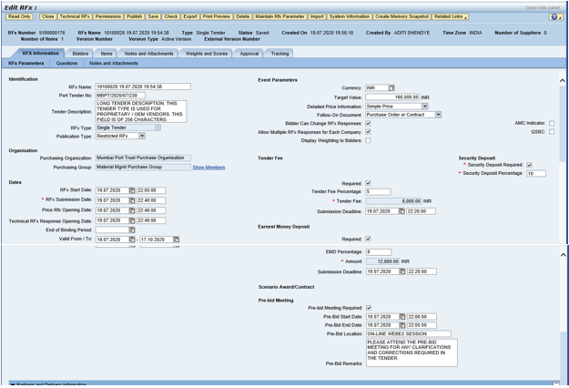

    - Click on the “Check” button. Any errors will be displayed in red color as highlighted below.

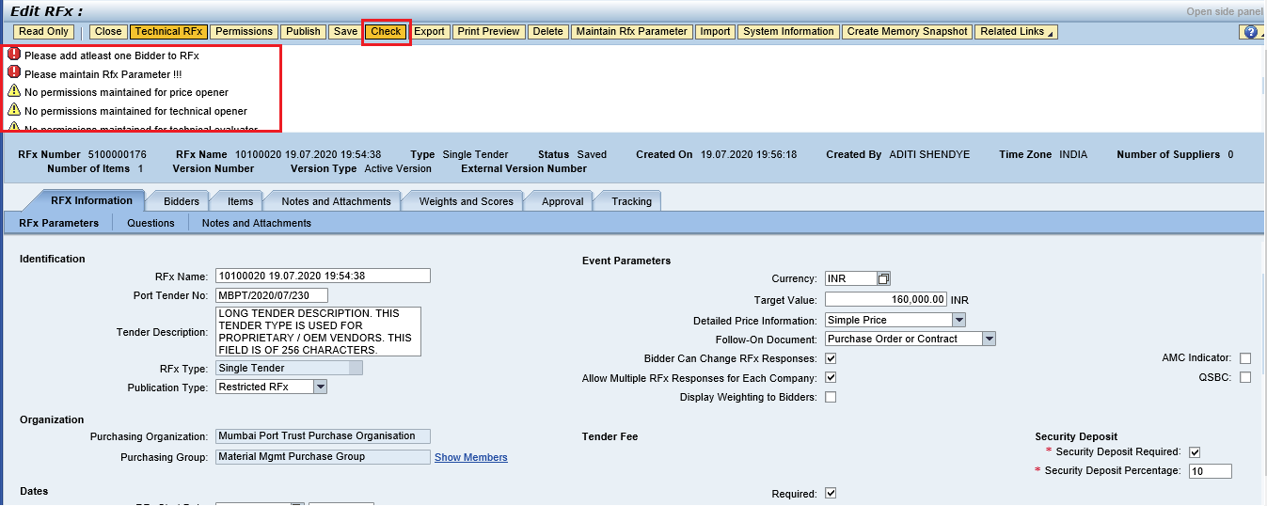

Bidders Tab

    - Under the “Bidders” tab, Buyer would be able to add the bidder id. Buyer can either provide the Bidder id directly and then click on “Add” button.

Buyer also can click on “Search for Bidder” button to search the Bidders to be invited for the tendering activity.

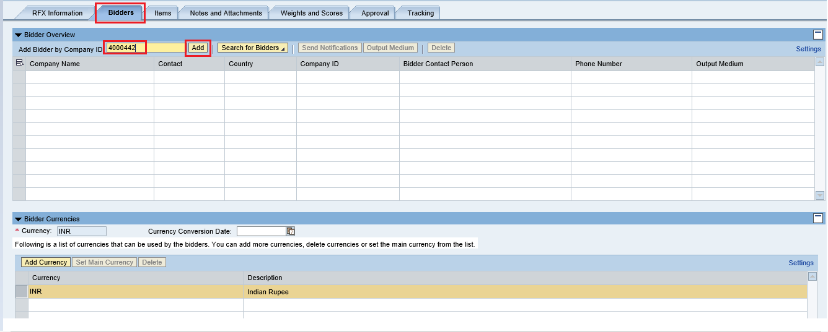

    - New confirmation window will be displayed and system will prompt for confirmation. Click on “Ok” button.

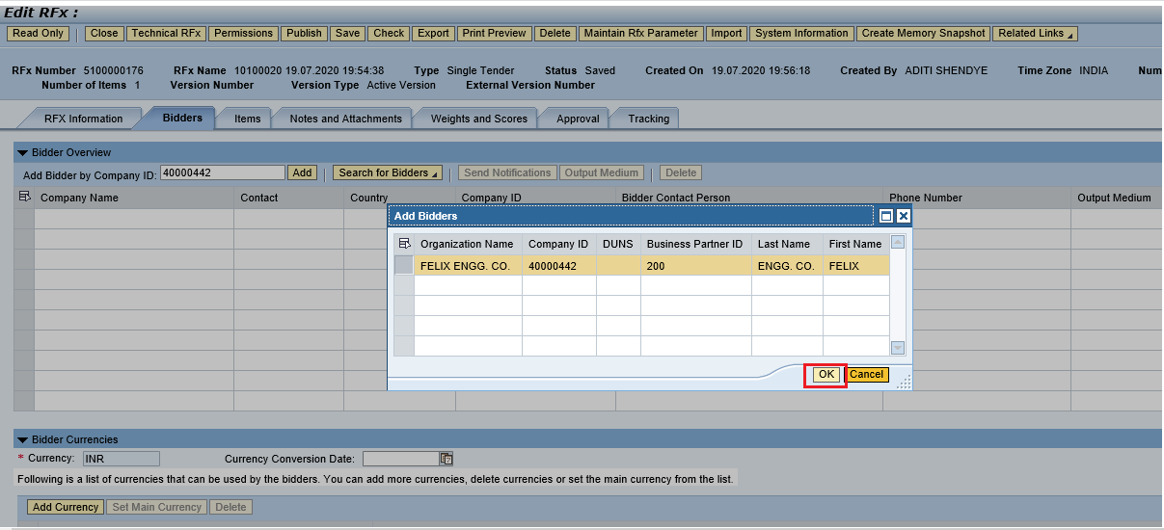
Bidder id will get added as shown in screen shot below.

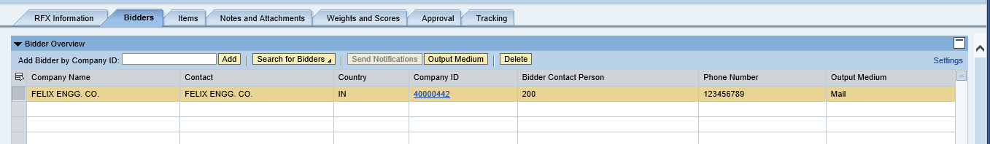

Maintain RFx Parameters

It’s mandatory to maintain RFx parameters for any of the tender type.

    - Click on the button “Maintain RFx Paramter” as shown below.

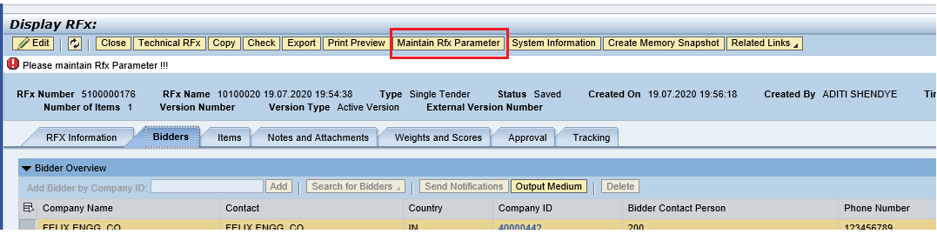

    - A new screen will be displayed. User can either add his own questionnaires or it can be selected from the available repository. Click on “Import” button to select questions from available repository. A new window will get displayed. Select multiple questions and then click on “Transfer” button.

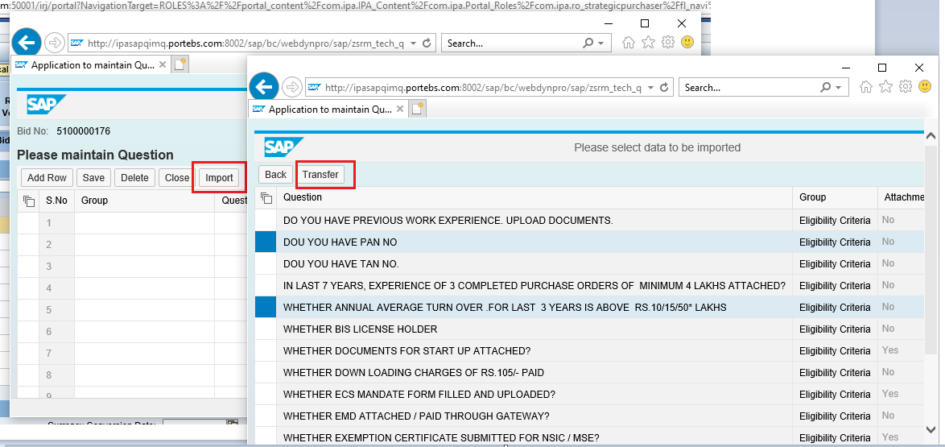

Click on “Save” and then click on “Close” button to close the window. Please see screenshot below.

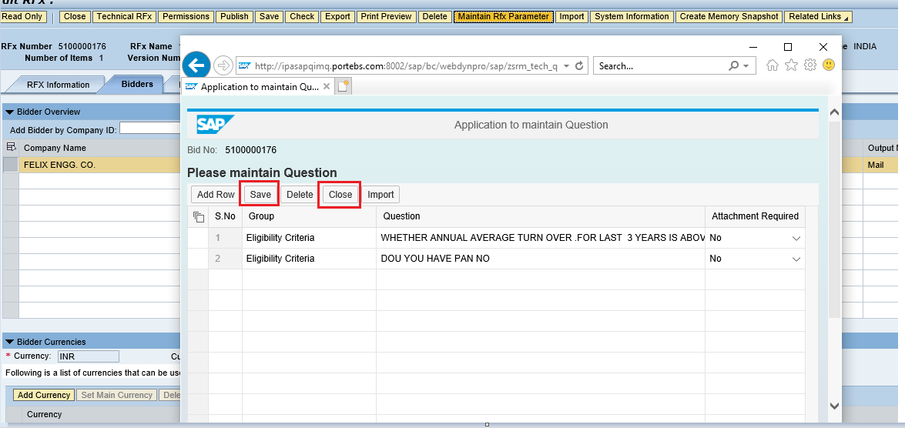

Maintain Tender Committee

In this section we will see how the tender committee is maintained and will be responsible for performing the technical and commercial scrutiny and evaluation activities.
We have different roles defined in system that decides the activity to be performed by the individual user’s.
    - Click on “Permission” button and add user-ids under the Tech Scrutiny, Price Opener, Tech Evaluator, Price Scrutiny and Price Evaluator roles

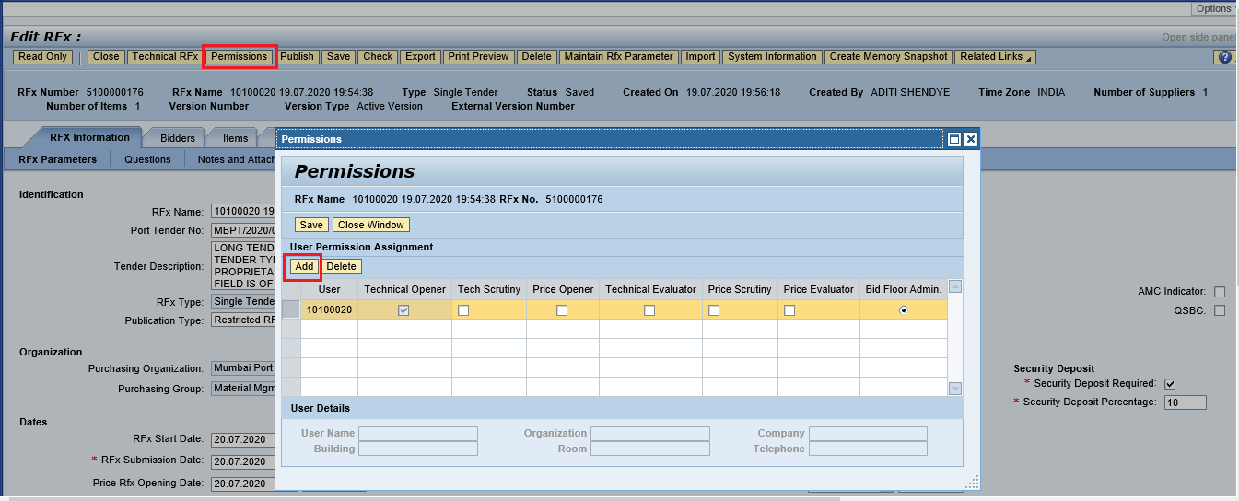

    - Once you click on “Add” button, Buyer needs to provide the user id and the then click on the “Search” button. System will display the user details. Select the row and then click on “Transfer” button. Please see screenshot below.

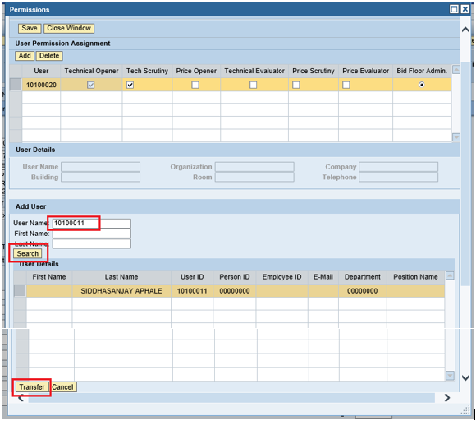

    - Similarly, Buyer can add multiple users in the Permission tab and assign appropriate roles for performing the activities in SRM. After adding the user’s & assigning respective roles the permission tab details will look like below.

Please refer below table for the roles and its functionality.
Permission Tab (Tender Committee)

Role Name | Role Description | Field Status
Bid Floor Admin | This role is assigned by default to the user creating the Tender i.e. the Buyer. Its recommended not to change | Editable
Technical Opener | User assigned under this role is responsible for opening the technical responses received. In Single Tender process, system will default this role to the Buyer creating the tender. | Non-Editable
Tech Scrutiny | User’s responsible for performing the technical scrutiny | Editable
Technical Evaluator | User’s responsible for performing the evaluation or reviews on the details submitted by the scrutiny team | Editable
Price Opener | User’s responsible for performing the Price opening of the tender’s once it is initiated by the Bid Floor Admin | Editable
Price Scrutiny | User’s responsible for performing the price scrutiny | Editable
Price Evaluator | User’s responsible for performing the evaluation or reviews on the details submitted by the scrutiny team | Editable

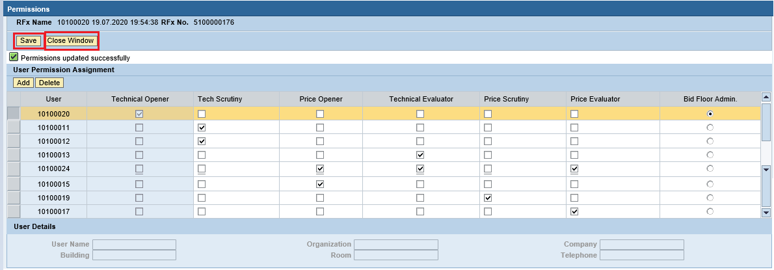

Item Tab

    - Click on he “Items” tab of the RFx document. This tab contains all the BOQ items mentioned in the purchase requisition. All the items will be replicated from the purchase requisition automatically.

    - To see the details of the item’s click on the “Details” button. System will display all the details pertaining to the material / services as shown in the screenshot below.

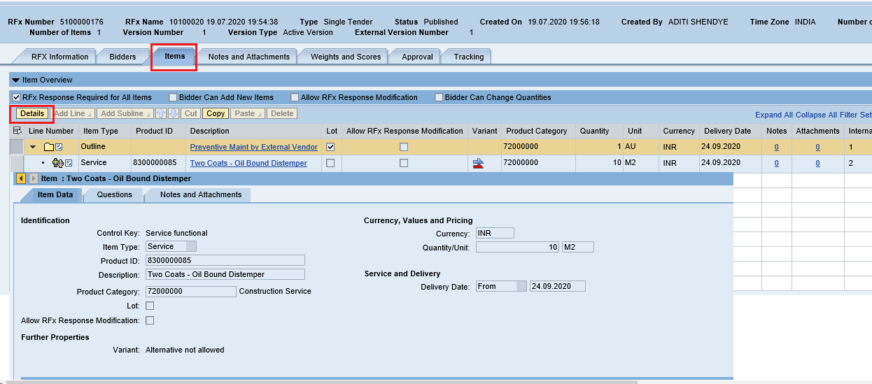

Approval Tab

    - Under this tab, Buyer will be able to see the Approver’s determined by the system. Depending on the value and type of the Tender the levels of approvals may vary.

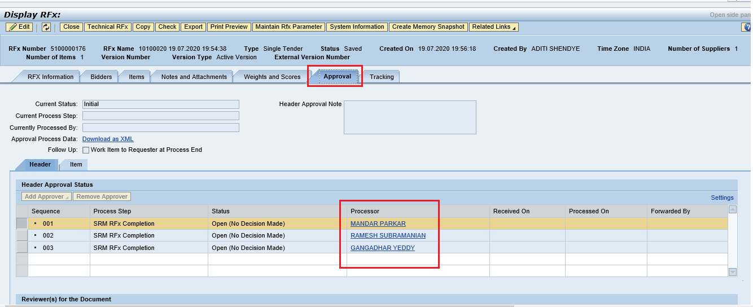

C-Folder Attachment

    - Before publishing the tender’s there are many supporting documents to be uploaded. Such as NIT document, Technical Specifications, Drawings etc. These documents are useful for the Bidder to understand the requirements and submit the technical and commercial responses accordingly.

    - Please refer below table detailing about the standard folder’s available for uploading the documents and their purpose.
C-Folder

Folder | Folder Description | Used By
External Area | Contains documents that are to be shared with the RFx respondents.  NIT document has to be uploaded in the this area. | Buyer/Tender Creator
Collaboration | Used by RFx respondents and evaluators to exchange information, for example, the RFx respondents can ask questions that are answered by the evaluators. | Buyer / Bidder
Internal Area | Contains documents that are only to be viewed by users from the purchasing organization. | Port Users
Evaluation | Contains evaluator comments | Evaluators
Technical Bid | When the RFx respondent creates an RFx response, a folder is created under Technical_Bids in which the RFx respondent can store technical RFx response documents. | Bidder

    - To upload the documents in C-folder and digitally sign the uploaded documents, click on the “Notes and Attachment” tab located under “RFx Parameter” option. Scroll down and click on “Add Attachment” button

Please see the screenshot below.
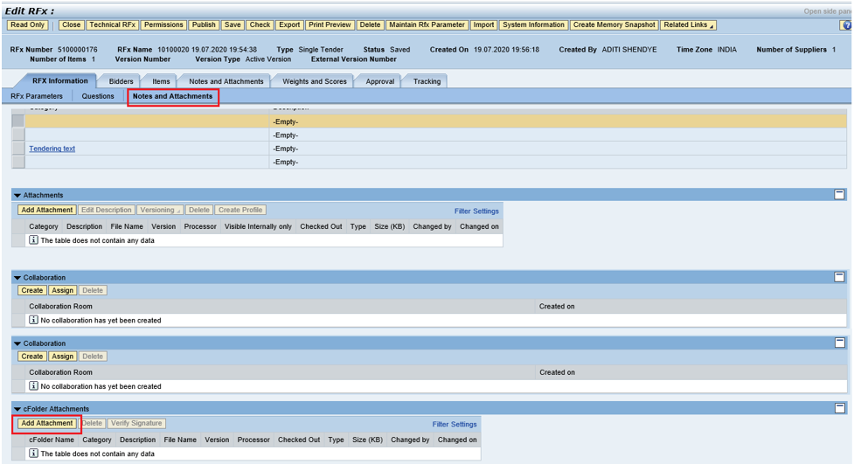

    - A new window will be displayed and system prompts to select the folder in which the document has to be uploaded. Select “External Area” and then click on “Browse” button as shown in the screenshot below.

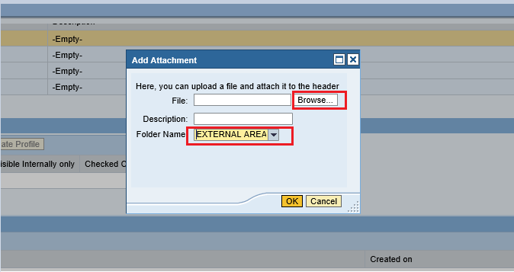

    - Select the document from the respective folder on your PC/Laptop and then click on the “Open” button.

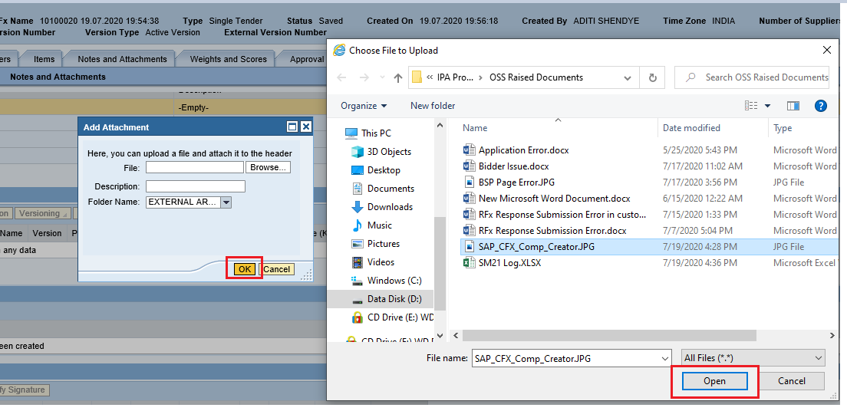

    - Once the file is uploaded the screen will be displayed as below. Click on “Ok” button to proceed further.

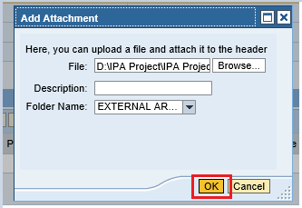

    - System prompts for digitally signing the uploaded document. A window will be prompted and then click on “Ok” button as shown in screenshot below.

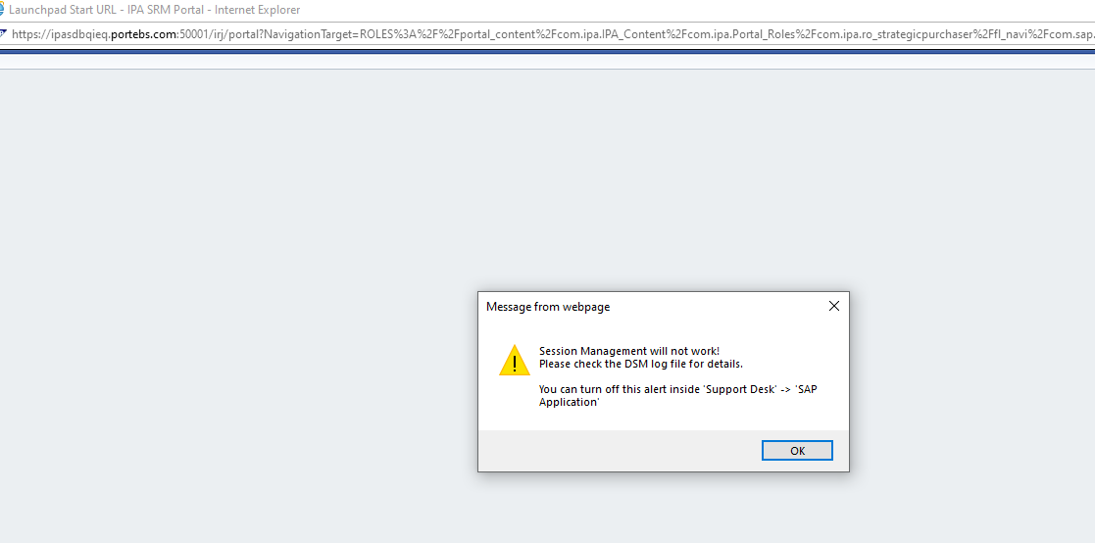
    - Another window will be prompted, where the buyer needs to select the correct digital signature and then click on “Sign” button.

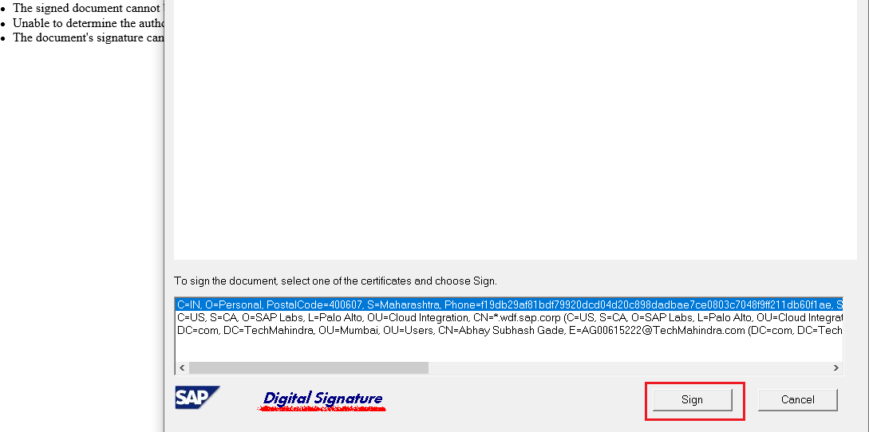

    - Enter the password in the window prompted and then click on “Ok” button.

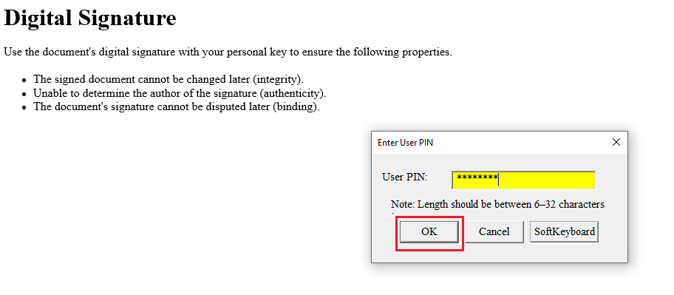

    - Once the password is successfully verified, system will display a confirmation window. Click on “Ok” button as shown below.
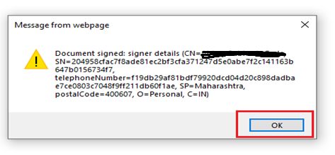
    - Similarly, Buyer can add multiple documents following the same steps. The size of the individual file should not exceed 5 mb. Buyer can upload multiple documents in the External Area folder and Collaboration folder as shown below.

All the uploaded documents needs to be digitally signed by the Buyer.

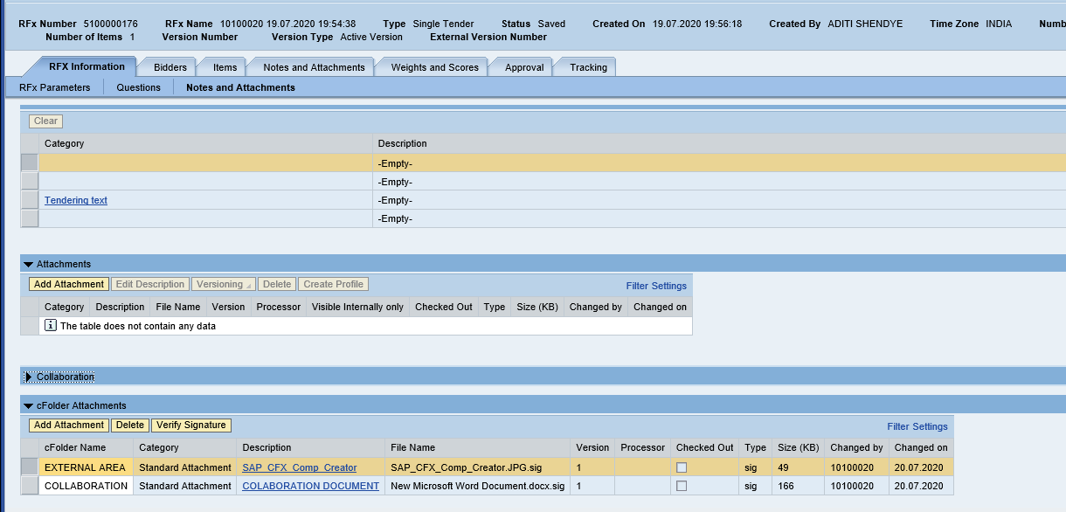

Tracking Tab

    - Under this tab, Buyer can check all the history related to this RFx i.e. the Backend purchase requisition, Shopping Cart that got created against this backend document and the RFx that has been created.

Any changes to the RFx can be seen here in this tab under the “Version Overview” option.

All the updates can be checked under this tab. Please see screenshot below.

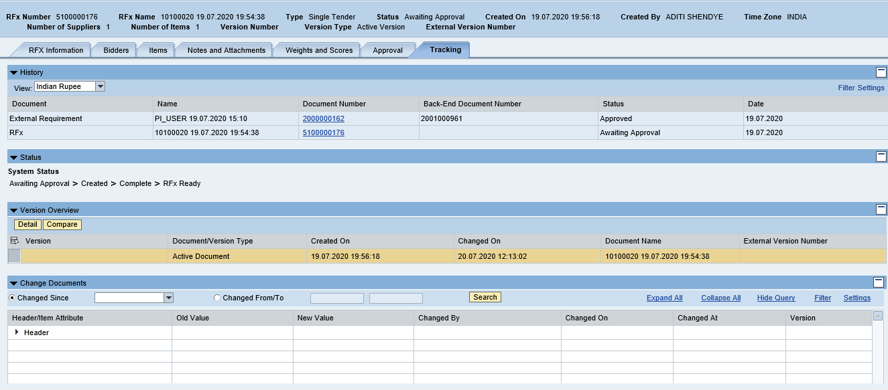

Publish RFx with Digital Signature

    - Once all the details are entered in the RFx click on the “Check” button. If there is any mandatory information left out to be filled, system will display an error message in red color. Else system will display message as below in green color.

“RFx is complete and contains no errors”
    - Please ensure that you have inserted the digital signature token in your PC/Laptop USB.

    - Click on “Publish” button as shown in screenshot below.
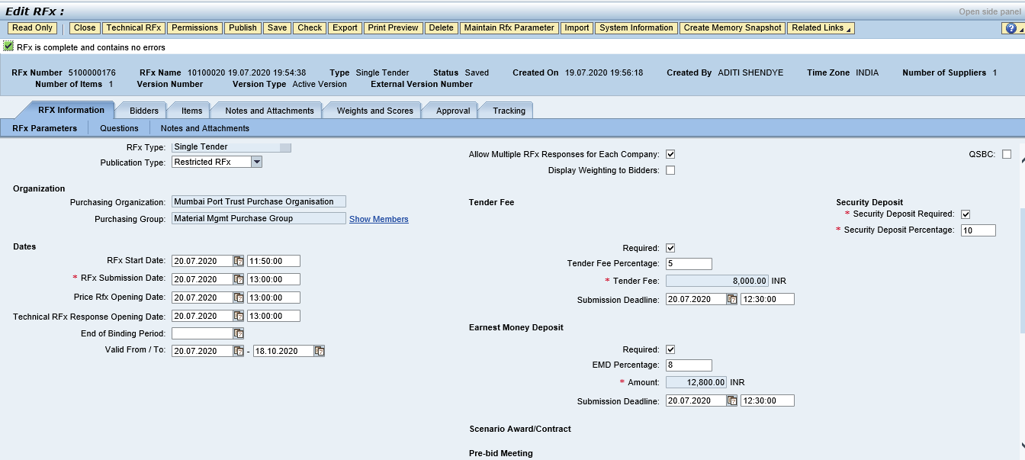

    - Once you click on this button as pop-up window will be displayed as below. Click on “Ok” button.

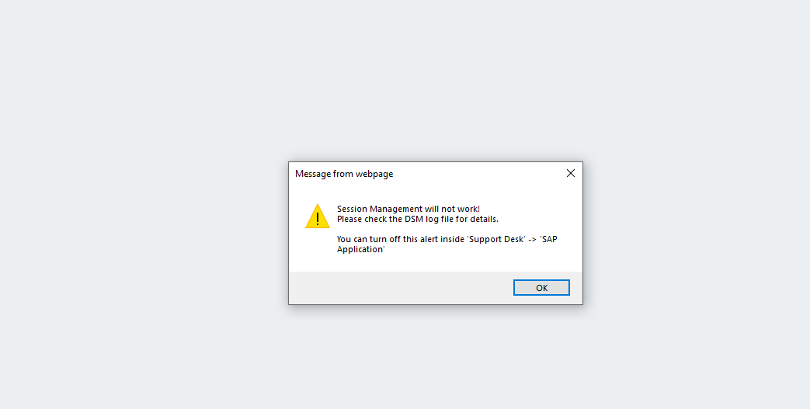

    - A new window will be displayed prompting the select the digital signature. Select the signature and click on “Sign” button as shown in screenshot below.

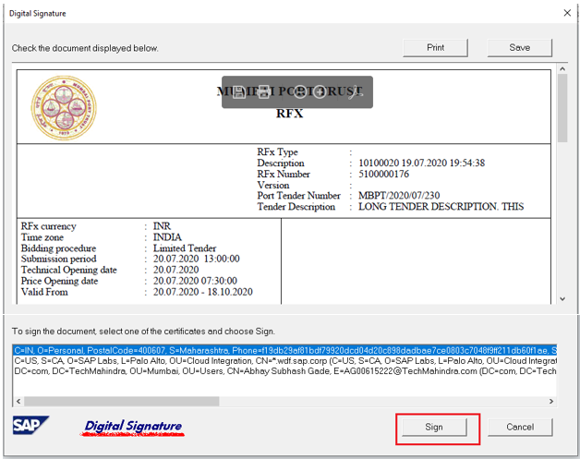

    - System further prompts to enter the password. Input the password and click on “Ok” button as highlighted in below screenshot.

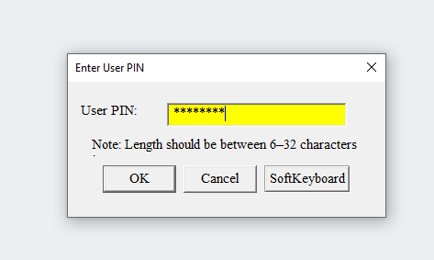

    - Again system will prompt a new pop-up window with the message that the RFx has been digitally signed by the user. See the screenshot below.
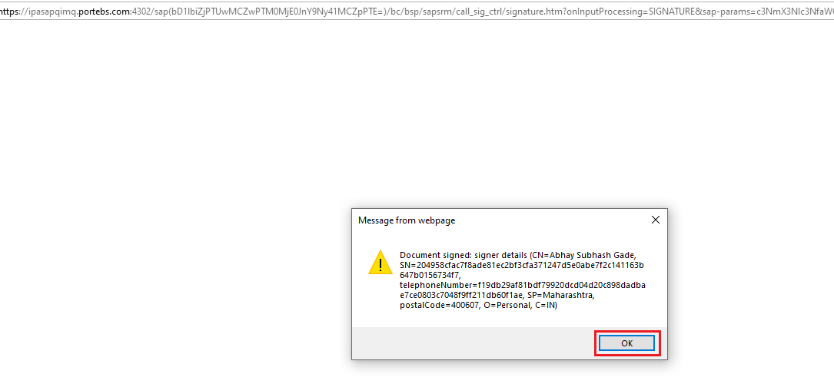

    - System displays message as “RFx xxxxx xxxx xxxx has been published”.

Please note that by clicking on Publish button, this RFx will not be available for the Bidder to create response.

Based on the approvers maintained, system will follow the approval process. Once the RFx is approved at all the levels then only it will be available to Bidder to submit his responses.

As seen in the screenshot below the status of RFx is “Awaiting Approval”

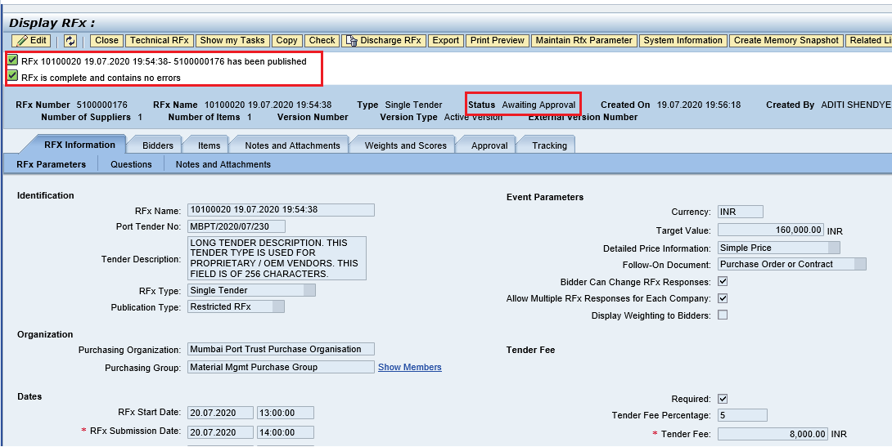

    - System will trigger email to the approvers as shown in screenshot below.

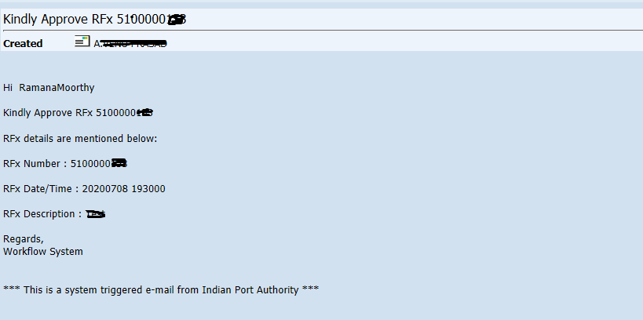

Approving the RFx

    - Please follow the step mentioned under Section 1.1 EBS Portal for logging to EBS

portal. Once the approver is redirected to the SRM portal through SSO, below SR screen will be displayed.
    - Select “Home” tab and the click on “Work Overview” link. Go to the “Tasks” tab. Here all the documents which are pending for approval will be visible.

    - Select the appropriate document and click on the link as shown in screenshot below.

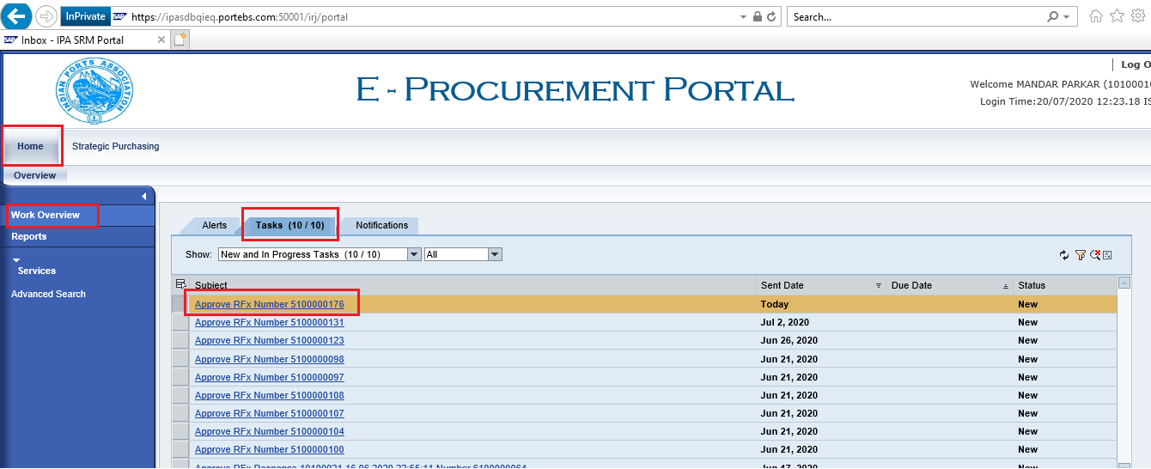

    - A new window will be opened. The RFx details will be visible in display mode. Approver will not be able to modify or change the tender created by the Buyer.

Click on “Approve” button to approve the RFx. In this case the RFx will be approved and will move to the next stage of approver.

Click on “Reject” button to reject the RFx. If the RFx is rejected, approver needs to input the reason for rejection. This document will go back to the tender creator i.e the Buyer.

Buyer needs to take appropriate action and re-trigger the workflow again.

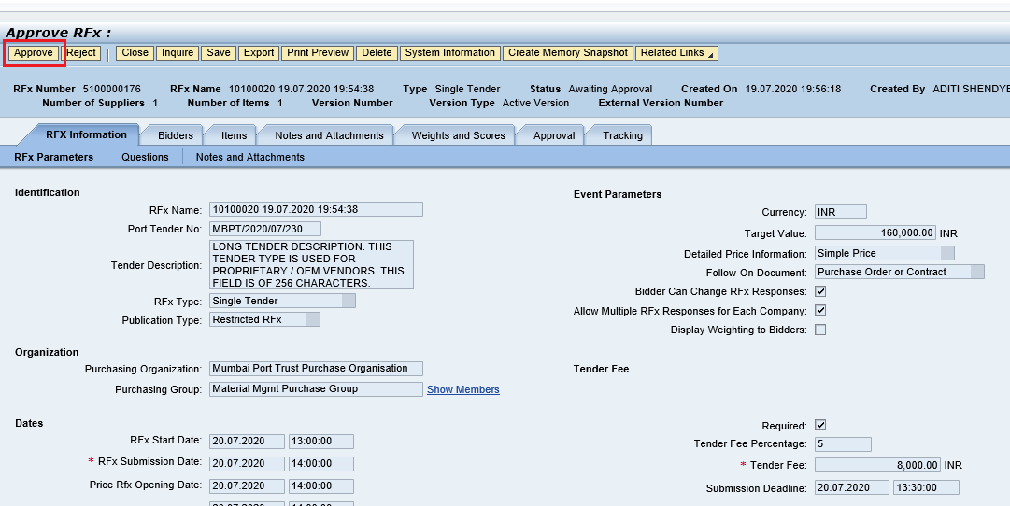

    - Once the RFx is approved message “Publication of RFx (Number 51xxxxxxxx) was approved, as shown in the screenshot below.

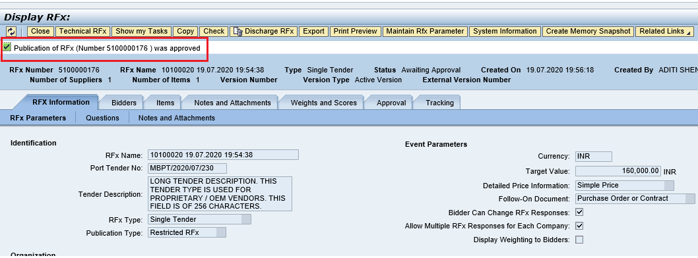
    - Documents approved will disappear from the “Tasks” tab.

    - Similarly, the remaining approvers can follow the above mentioned steps and approve the RFx.

    - RFx once approved at all the stages, the status will change to “Published” from “Awaiting Approval”

    - A mail will be triggered to the Supplier about the publication of the RFx. See the screenshot below.

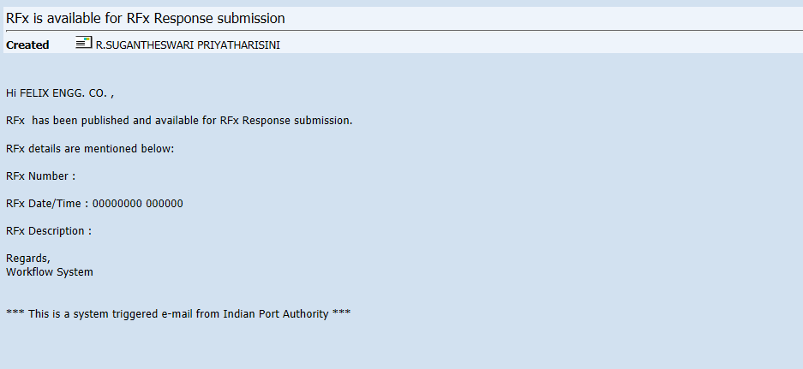

Technical RFx Response Activity

Initiate Technical RFx Response Opening

    - Buyer needs to login first to the EBS portal. Please refer to section number 1.1 for login to EBS portal & SSO to SRM portal & follow the steps.

Click on “Strategic Purchasing” tab and then click on “Strategic Sourcing” link. At the right side panel in the Search criteria screen provide the RFx number and then click on “Apply” button.

This particular RFx will be displayed, select the RFx and click on “Display” button. Simultaneously you can also click on the RFx number to open the RFx.

Please see the screenshot below.

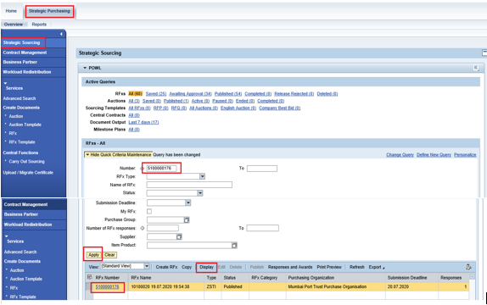

    - RFx will be visible in another window and it will be in display mode. Click on the “Initiate Technical RFx Response Opening” button. This button will be active once the Technical RFx Response Opening Date & time is reached.

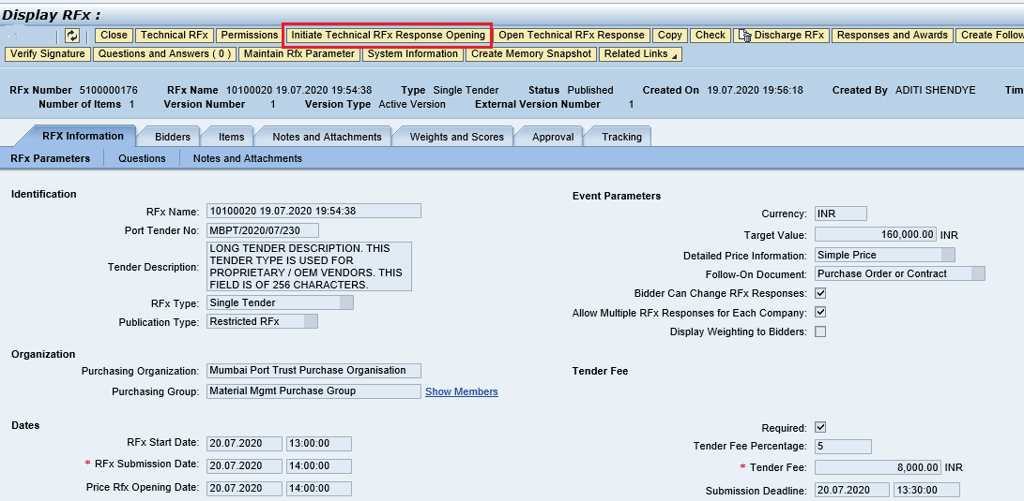
    - A new window will get opened. Here the Buyer needs to provide the password to proceed further. Click on “Acknowledge” button. System will start the technical opening process.

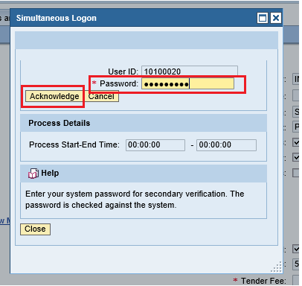

    - Below screen will be displayed. Click on “Close” button to close this window.

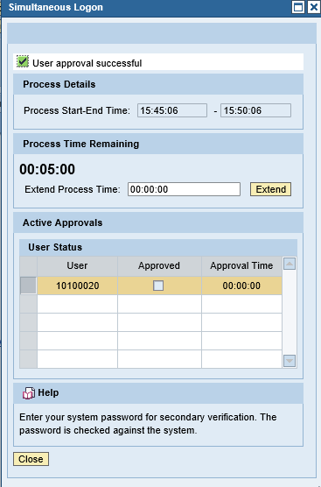
    - Since this is a Single tender i.e. proprietary / OEM tender, system will automatically perform the opening of the technical rfx response. Buyer needs to proceed to perform the TCR report related activities as explained in next section.

Technical Comparative Statement

    - Now we need to perform the TCR activity as this is a common process to be performed for all tender types.

There is always as possibility that the tender committee members may be required to change due to non-availability or transfer etc. In such scenarios, Buyer can always modify the user’s in the Permission Tab. New users can be added or for the existing user’s the roles can be modified.

To access the TCR report, click on “Response and Awards” button as mentioned in the below screenshot.

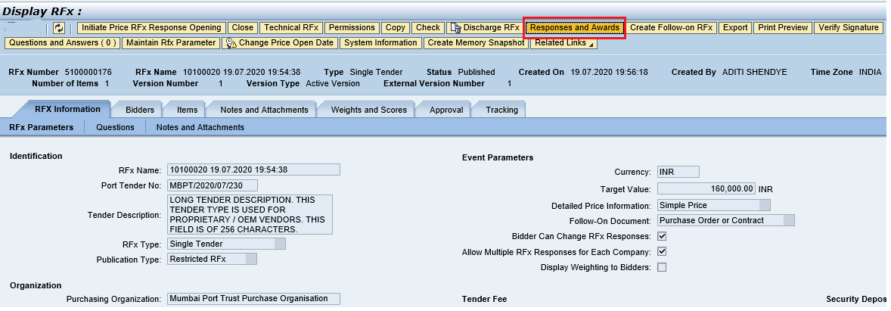

    - A new window will get opened. Select the “Technical Response Activity” tab and click on the “TCR Report” button.

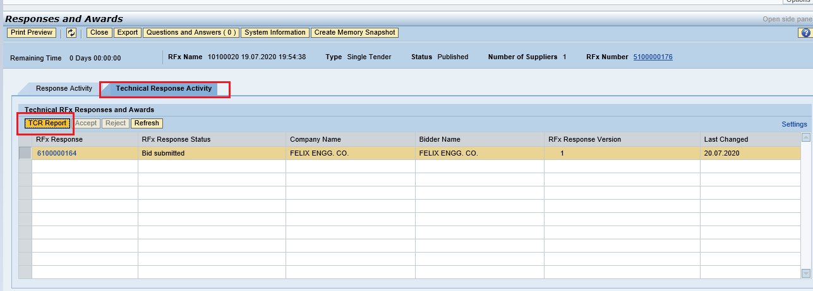

    - A new window will be displayed. Here in this screen, the details provided by the Bidder’s against the question maintained by the Buyer will be displayed. Buyer needs to provide his findings under the “Buyer comments for 61xxxxxxx” for all the line items.
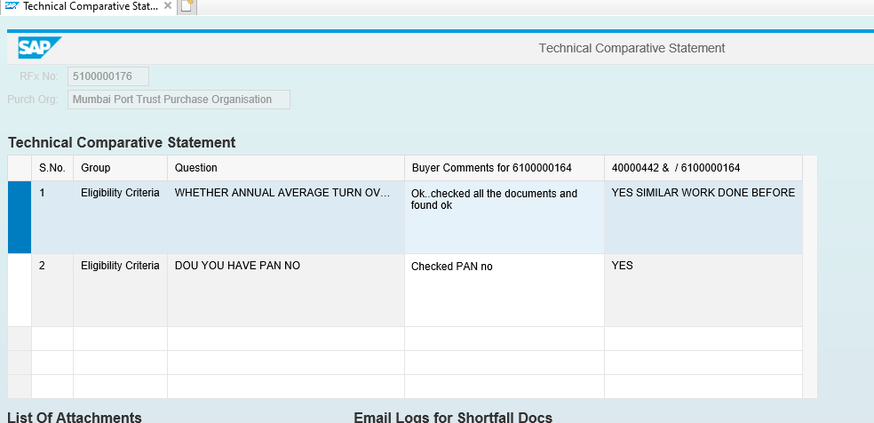

    - For any shortfall documents, Buyer needs to intimate the Bidder to submit the same. To perform this step, click on “Short Fall Docs” button as shown in screenshot below.

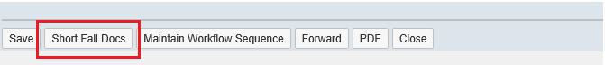

    - A new window will get displayed as shown below. Here buyer need to provide the mail content and then select the respective response and then click on “Send Mail”.

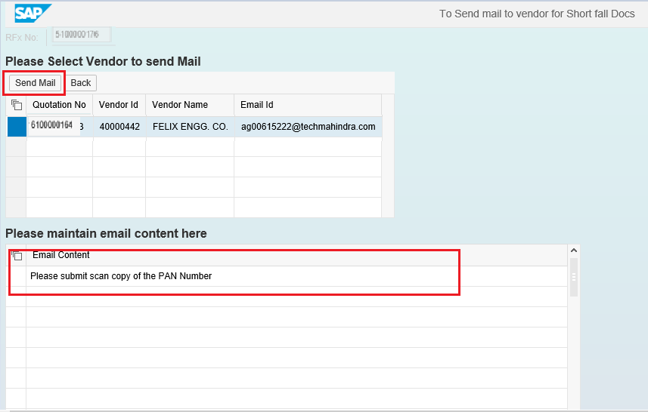

    - Mail will get triggered and system will display the success message as shown in screenshot below.

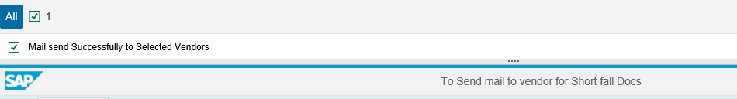

    - Once Buyer has performed his preliminary scrutiny and received all the shortfall documents, it is mandatory to maintain the overall comments and forward it to the scrutiny and review committee team.

It has to be noted that, the user’s having the Tech Scrutiny role (assigned in Permission tab) assigned will be displayed under the “Scrutiny’s Team Comment” section.
Likewise, user’s having the Technical Evaluator role (assigned in the Permission tab) will be displayed under the “Observation/Recommendation committee’ section.

If a new user/s are added or any modifications done in the role assignment the same details will get replicated in the TCR screen.

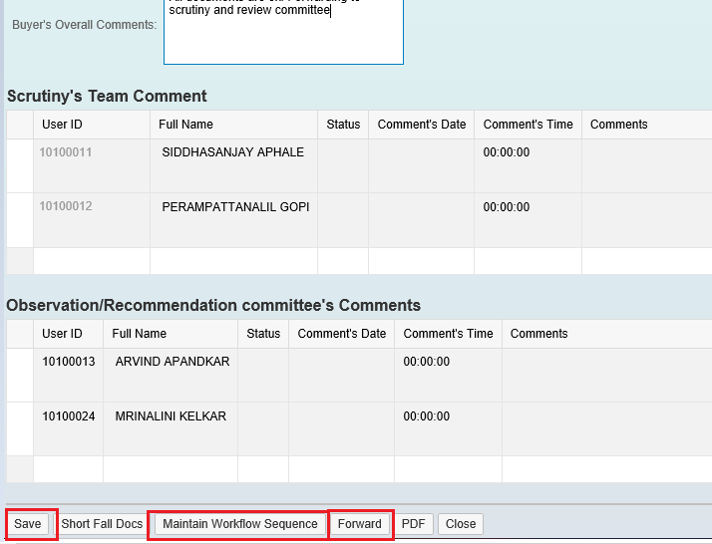

Buyer need to maintain the overall comment’s and then click on “Save” button. It is mandatory for Buyer to provide his overall comments.

    - The list of user’s displayed here are not in proper sequence since system picks the user’s from the permission tab. For this reason, Buyer needs to maintain the sequence for how the workflow should get triggered. Here Buyer can decide the sequence in which the TCR report should flow.

    - A new window will be opened consisting the list of user’s based on their role assignment will be displayed as shown in screenshot below.
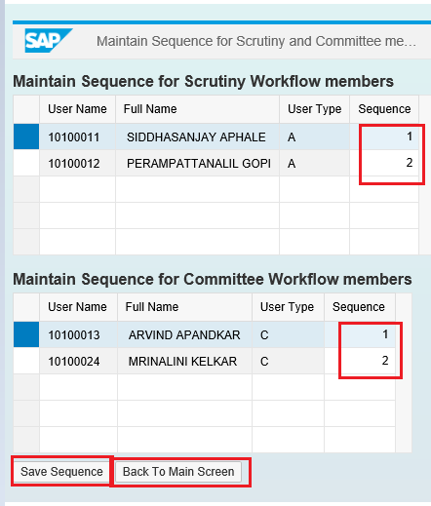

    - Provide the sequences and then click on “Save Sequence” button. Then click on “Back to Main Screen” button. The window will get closed and user will be re-directed to the main TCR report screen.

    - Now Buyer needs to click on “Forward” button as shown below.

System will display message as shown in below screenshot.

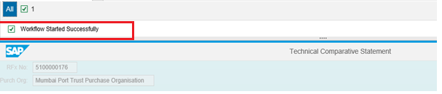

    - Email notification will be triggered to the respective users to approve the TCR report.

Approving TCR

    - Follow the process of logging to EBS portal as detailed in section 1.1

    - Once the user is redirected to the SRM portal through SSO, below screen will be displayed. Here the TCR report approver needs to navigate to “Home” tab and then click on “Tasks” tab. Under “Tasks” system will display

Click on the work item displayed in the tasks list as shown below.

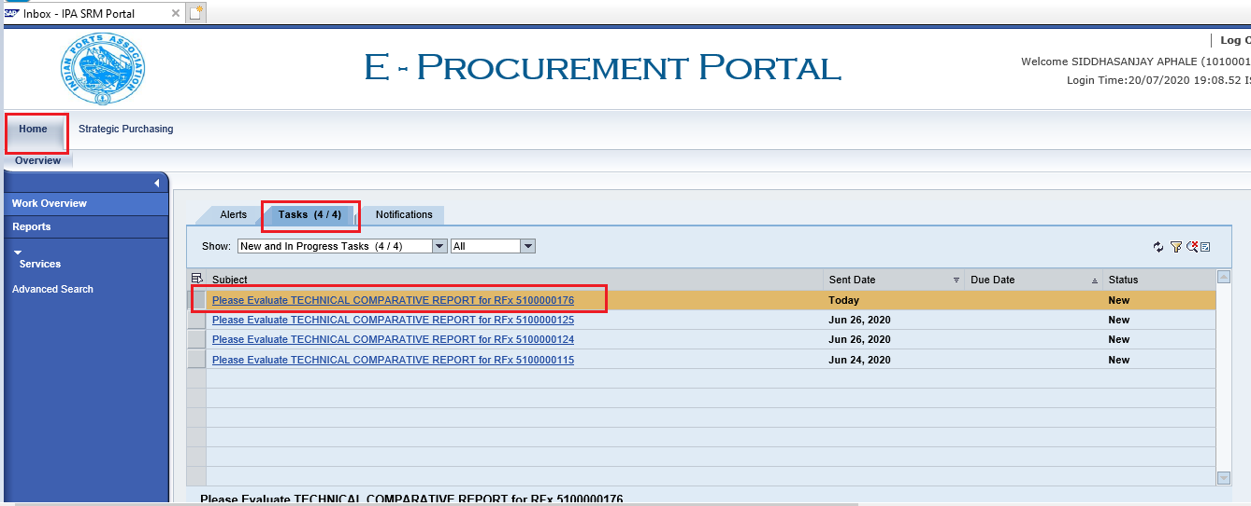

    - A new window will get displayed as shown below.

Scrutiny member can input his comments and either click on “Submit” button to provide his acceptance.

If there are some clarifications required from Buyer, then the scrutiny member needs to click on “Return” button. The workflow will be re-triggered back to Buyer and Buyer is required to provide satisfactory justification and then again trigger the workflow.

Scrutiny team also can view the comments provided by the previous members by clicking on the “TCR pdf” button. System will display the report in pdf format.
Click on the “Close” button to close this screen.

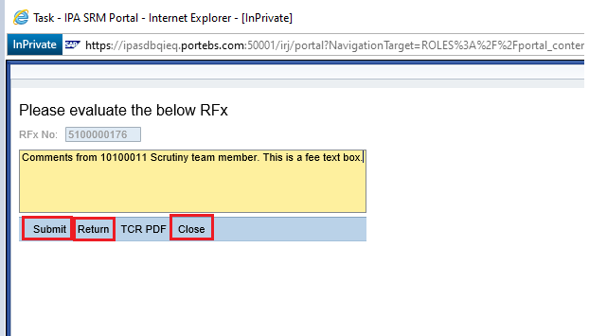

    - Once the comments are submitted or the work-item is returned message “Data updated successfully” will be displayed. Please see the screenshot below.

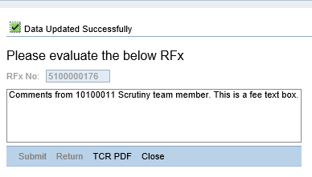
    - Based on the number of user’s selected for performing scrutiny activities the workflow will get triggered to the subsequent user’s.

    - Similar steps need to be repeated by the scrutiny members to login to EBS portal and submit their recommendation’s.

    - Once all the scrutiny members have completed their activities, the workflow will get triggered to the Review Committee members based on the sequence maintained by the Buyer.

    - Review committee members need to follow the steps as mentioned above from point#5.3.1 to point#5.3.5

    - Once all the activities are performed and all the details captured, below screenshot will be displayed.

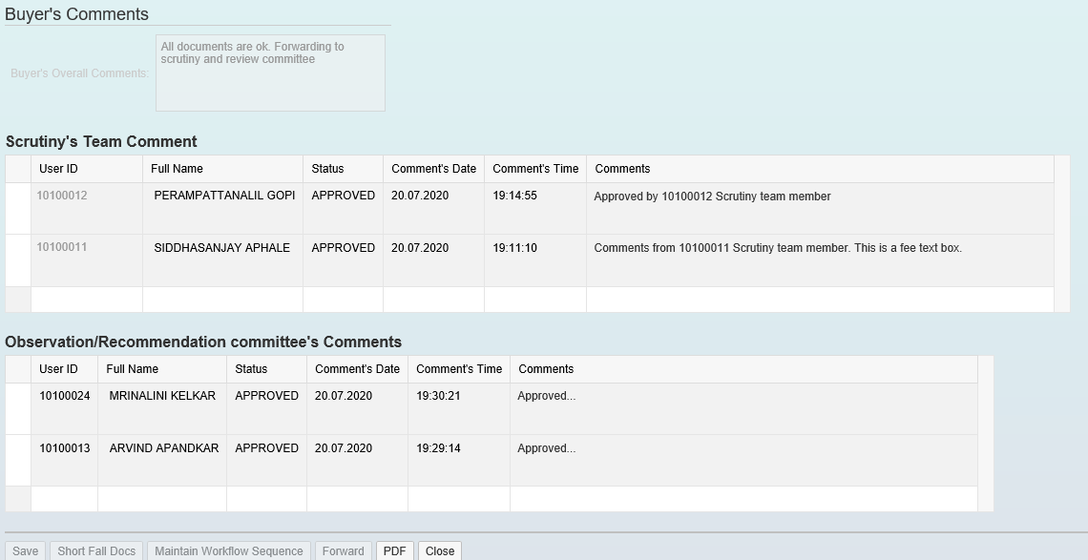

    - Accept/Reject buttons will get activated once the technical comparative statement/report activities are completed. Click on “Accept” button as shown below.

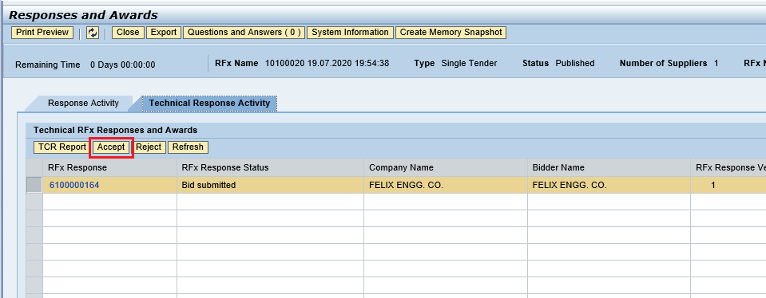

    - Once the response is technically accepted, status will get changed from Bid Submitted to Tech Bid Accepted. Please see the screenshot below.

Since this is a single tender i.e proprietary / OEM type of bid, Buyer need not click on Reject button.

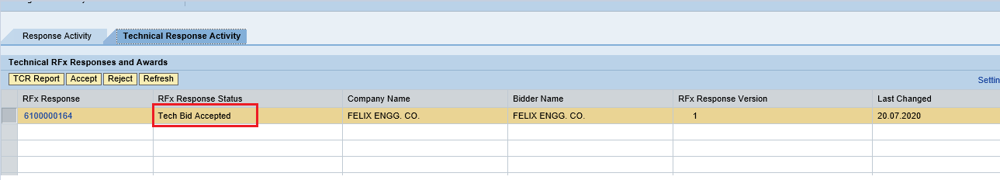

Once all the above technical activities are completed, system will automatically enable a button for initiating the price opening activity. The same is explained in the subsequent section.

Price RFx Response Activity

Initiate Price RFx Response Opening

    - Buyer needs to login first to the EBS portal. Please refer to section number 1.1 for login to EBS portal & SSO to SRM portal & follow the steps.

Click on “Strategic Purchasing” tab and then click on “Strategic Sourcing” link. At the right side panel in the Search criteria screen provide the RFx number and then click on “Apply” button.

This particular RFx will be displayed, select the RFx and click on “Display” button. Simultaneously you can also click on the RFx number to open the RFx.

Please see the screenshot below.

    - RFx will be visible in another window and it will be in display mode. Click on the “Initiate Price RFx Response Opening” button. This button will be active, once the Price RFx Response Opening Date & time is reached and the technical response activities are completed.

A new window will get popped-up. Provide the password and click on “Acknowledge” button.

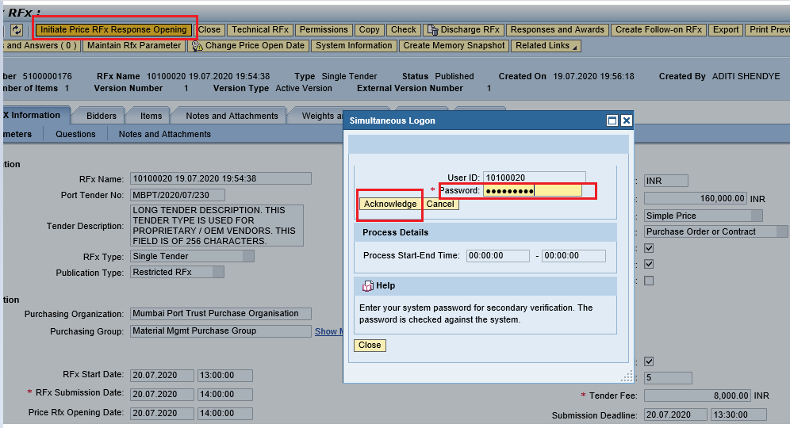
    - Below screen will get displayed and it will display the list of user’s responsible for Opening the price RFx response. Click on “Close” button to close this window.

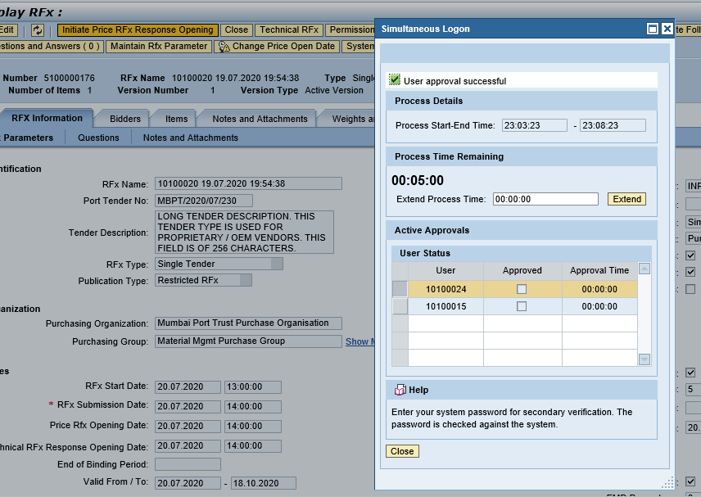

    - Email notification will be triggered to the user’s for performing the price RFx response activity.

    - User need to follow the steps mentioned in Section#1.1 to login to EBS portal & SSO to SRM portal.

Click on “Strategic Purchasing” tab and then click on “Strategic Sourcing” link. At the right side panel in the Search criteria screen provide the RFx number and then click on “Apply” button.

This particular RFx will be displayed, select the RFx and click on “Display” button. Simultaneously you can also click on the RFx number to open the RFx.

Please see the screenshot below.

    - RFx will be visible in another window and it will be in display mode.

Click on the “Open Price RFx Response Opening” button. This button will be active, once Buyer has initiated the price opening process.

A new window will get popped-up. Provide the password and click on “Acknowledge” button.

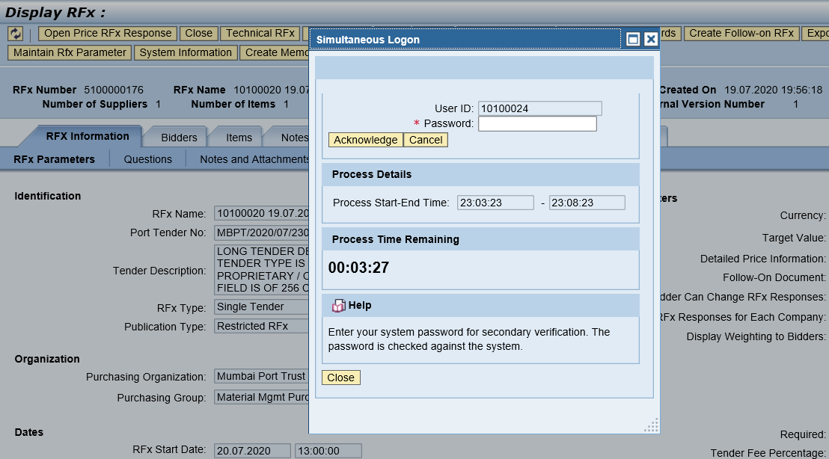
    - Provide the password and click on “Acknowledge” button. Below message will be displayed and then click on “Close” button to close this window.

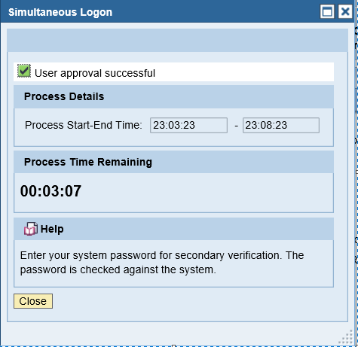

    - Similarly, other users can perform their activity of acknowledging the price RFx response opening. The above process is through Simultaneous logon i.e. multiple users can login and perform the activity simultaneously.

Price Comparative Statement

    - Now we need to perform the PCR activity as this is a common process to be performed for all tender types.

There is always as possibility that the tender committee members may be required to change due to non-availability or transfer etc. In such scenarios, Buyer can always modify the user’s in the Permission Tab. New users can be added or for the existing user’s the roles can be modified.

To access the PCR report, click on “Response and Awards” button as mentioned in the below screenshot.

    - A new window will get opened. Select the “Response Comparison” tab and click on the “PCR Report” button. Please see screenshot below.

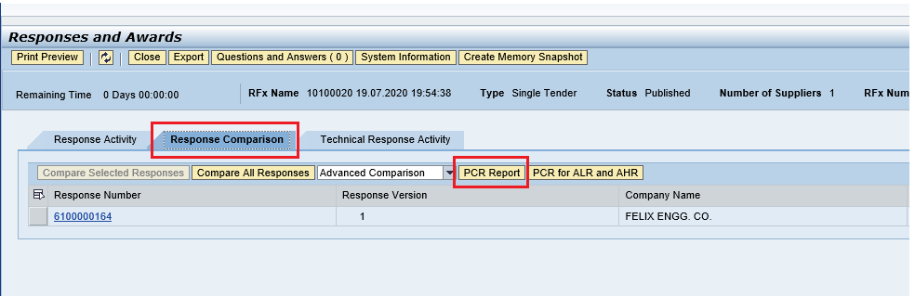

    - A new window will be displayed as shown below. Buyer needs to maintain his comments in the “Overall Comments” column and then click on “Save” button.

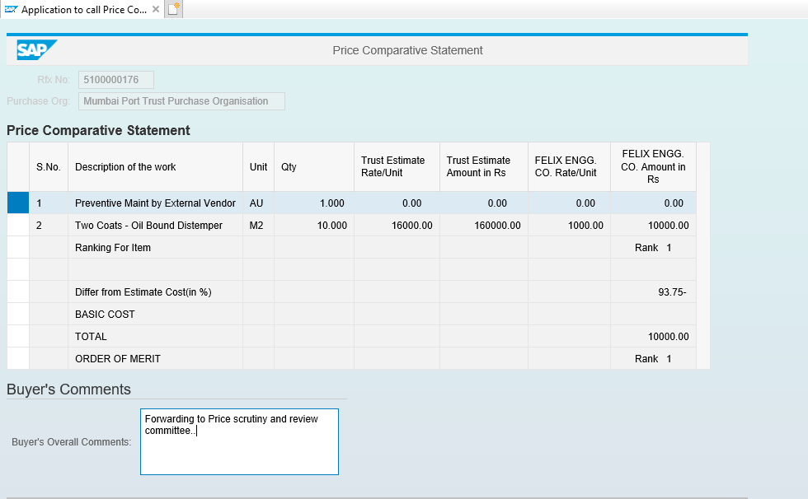

    - The price comparative report also contains the list of user’s responsible for performing the Scrutiny and review committee activities.

These users are determined based on those maintained in Permission tab.

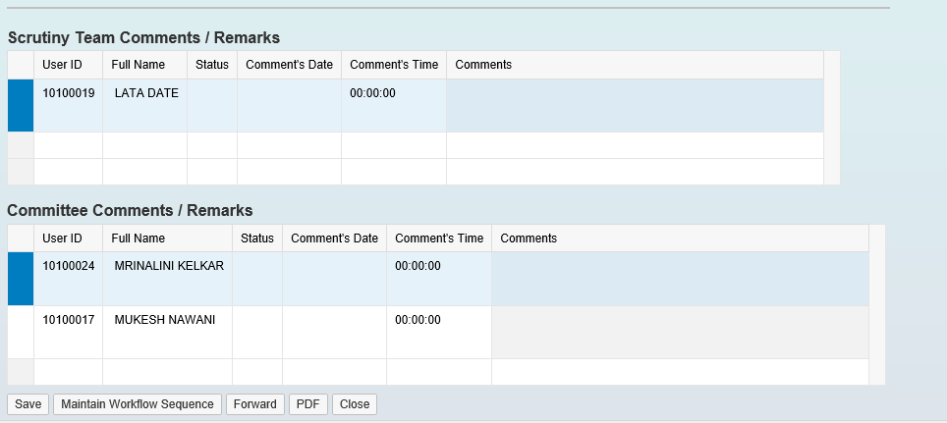
    - Once the overall comments are saved, Buyer needs to click on “Maintain Workflow Sequence” button.

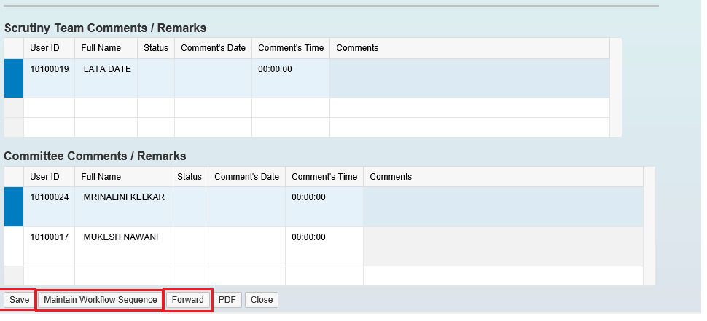

    - A new window will get opened. Provide the sequences and then click on “Save Sequence” button. Then click on “Back to Main Screen” button. The window will get closed and user will be re-directed to the main PCR report screen.

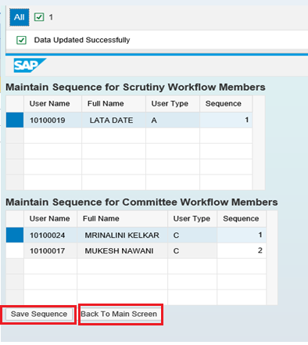
    - Now Buyer needs to click on “Forward” button as shown below to trigger the workflow.

System will display message as shown in below screenshot.

Approving PCR

    - Follow the process of logging to EBS portal as detailed in section 1.1

    - Once the user is redirected to the SRM portal through SSO, below screen will be displayed. Here the PCR report approver needs to navigate to “Home” tab and then click on “Tasks” tab. Under “Tasks” system will display

Click on the work item displayed in the tasks list as shown below.

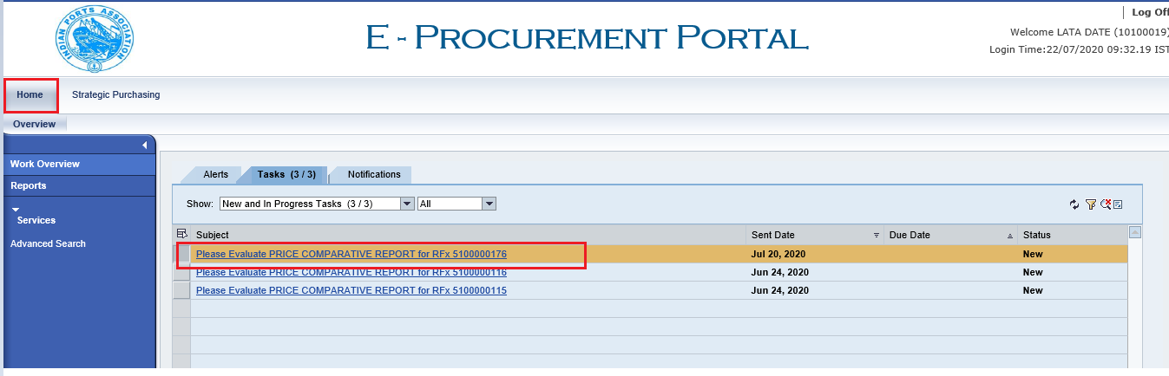

    - A new window will get displayed as shown below.

Scrutiny member can input his comments and either click on “Submit” button to provide his acceptance.
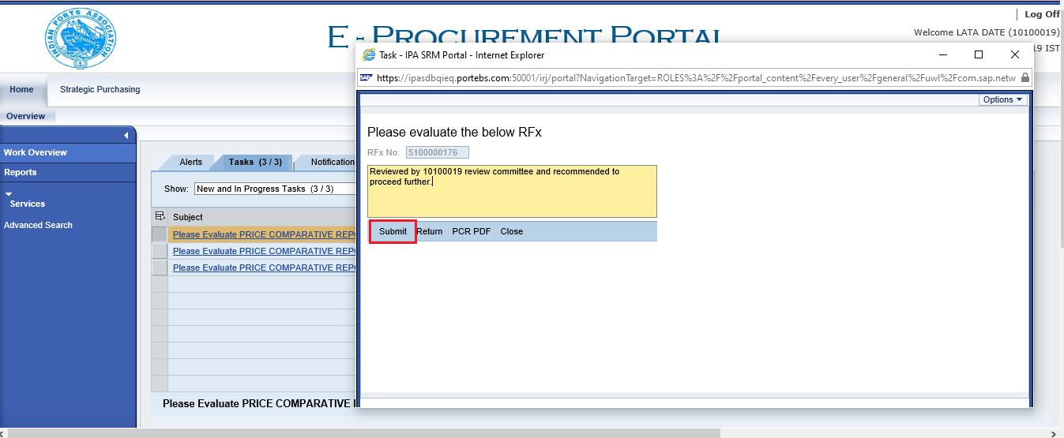

If there are some clarifications required from Buyer, then the scrutiny member needs to click on “Return” button. The workflow will be re-triggered back to Buyer and Buyer is required to provide satisfactory justification and then again trigger the workflow.

Scrutiny team also can view the comments provided by the previous members by clicking on the “PCR pdf” button. System will display the report in pdf format.

Click on the “Close” button to close this screen.

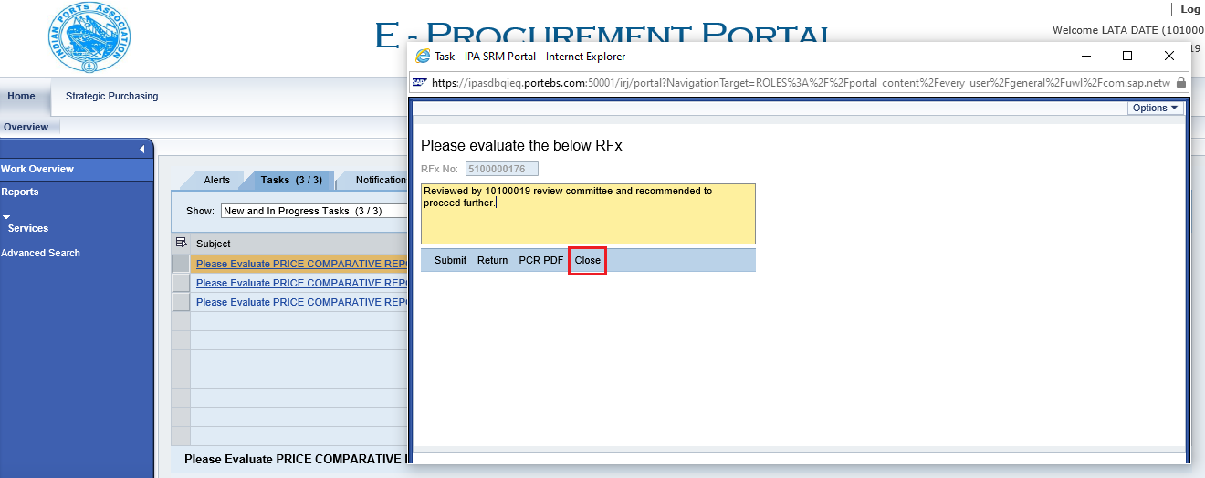

    - Once the comments are submitted or the work-item is returned message “Data updated successfully” will be displayed. Please see the screenshot below.

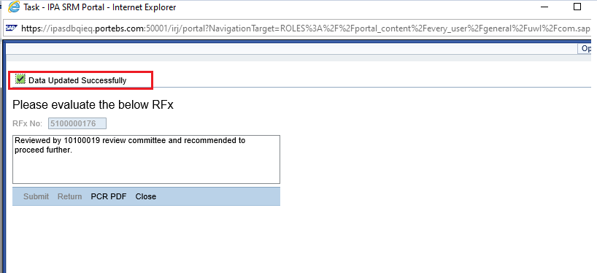

    - Based on the number of user’s selected for performing review committee activities the workflow will get triggered to the subsequent user’s.

    - Similar steps need to be repeated by the other review committee members to login to EBS portal and submit their recommendation’s.

    - Once all the review committee members have completed their activities, the PCR process will be completed.

    - Based on the comments received from the review committee, Buyer i.e. the tender creator has to perform the further activities of initiating the awarding for the L1 bidder.

    - Initiation for awarding is explained in the next section.
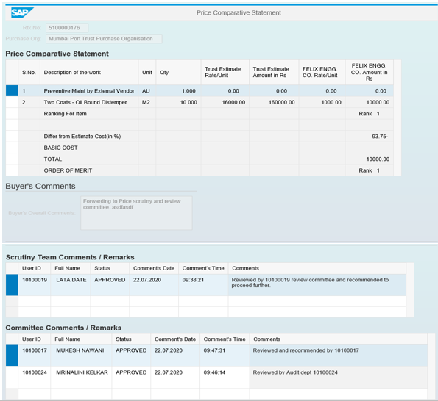

Award Response

  - Buyer i.e. tender creator once receives review comments and recommendations from the committed the next step is to initiate for awarding the L1 bidder.

  - To do this activity, Buyer needs to login to the EBS portal by following the steps mentioned in section 1.1

  - Under the POWL screen, user can search for the particular RFx or select the particular RFx from the dashboard and click on “Display” button. The other way, is to click on the RFx number link to display the RFx.

  - RFx will be displayed in another screen. Click on the “Response and Awards” button as shown below.

  - A new screen will be displayed as shown below. Go to the “Response Comparison
tab and click on “Compare All Responses” button.

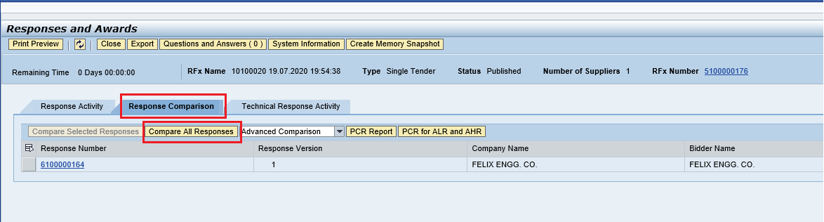

  - A new screen will be displayed as shown below. Click on “Edit” button to proceed further to award the RFx response.

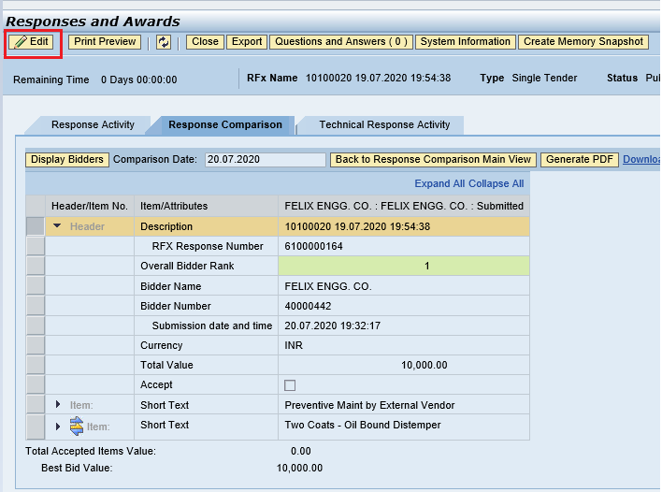

  - After user Edit’s, Accept field check box will be enabled. Check the box and then click on “Award” button as shown below.

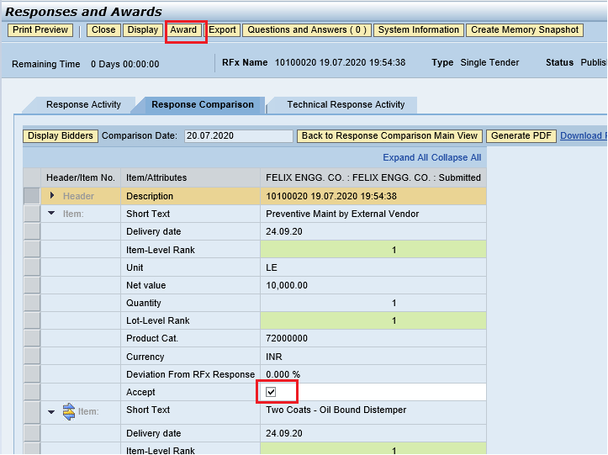

  - The response will be accepted in the system and it will follow an approval process. Below message will be displayed once the RFx response is awarded in system.

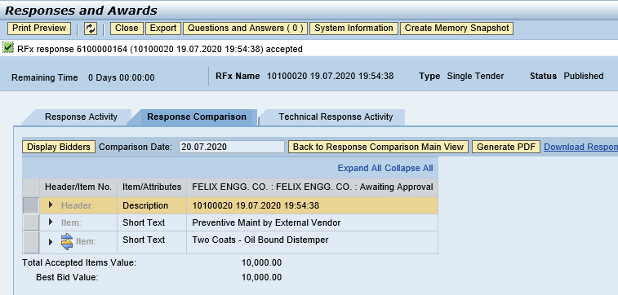

  - Buyer can check the approvers under the “Approval” tab as shown in screenshot below.

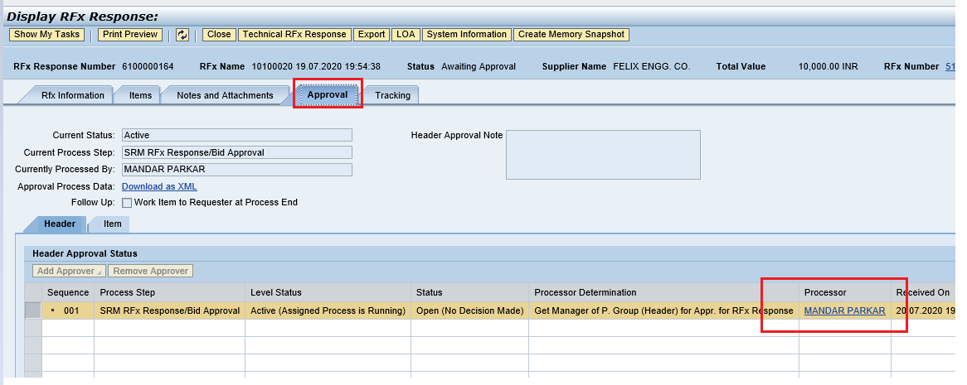

RFx Response Approval

  - Approver needs to login to EBS portal and follow steps mentioned in section 1.1

  - RFx Response Approver need to navigate to “Home” tab and then select the “Tasks” tab. The work item will be visible as shown below.

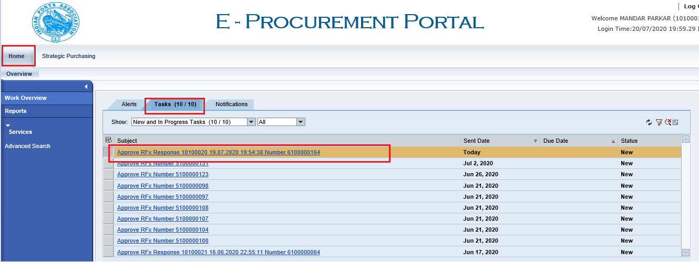

  - Click on the “Approve RFX Response 61xxxxxxx“ link. A new screen will get displayed. Click on “Approve” button. Once approved, Buyer i.e. tender creator will be able to create Purchase Order or Contract against this L1 response.

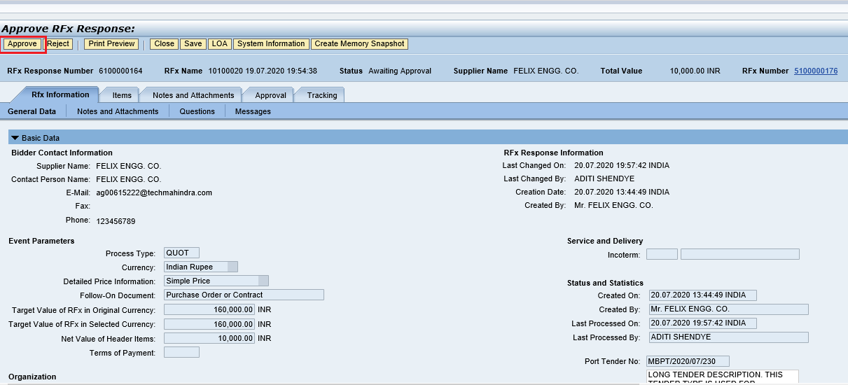

Create Purchase Order

  - This is a final step wherein Buyer will be converting the response for the L1 bidder to either Purchase order / Service Order or Contract.

  - To perform this activity, Buyer needs to login to the EBS portal by following the steps mentioned in section 1.1

  - Under the POWL screen, user can search for the particular RFx or select the particular RFx from the dashboard and click on “Display” button. The other way, is to click on the RFx number link to display the RFx.

  - RFx will be displayed in another screen. Click on the “Response and Awards” button as shown below.

  - A new screen will be displayed as shown below. Go to the “Response Comparison
tab and click on “RFx Response number” link.

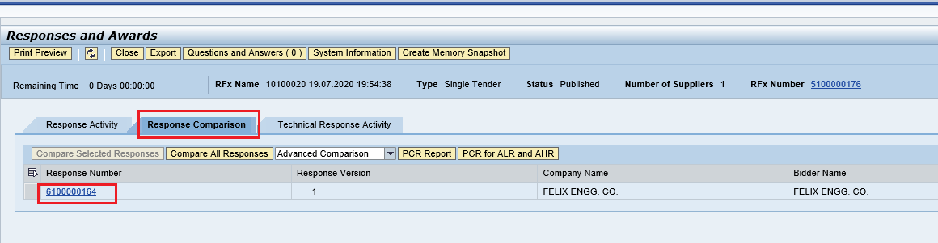

  - RFx response will get displayed in another screen as shown below.

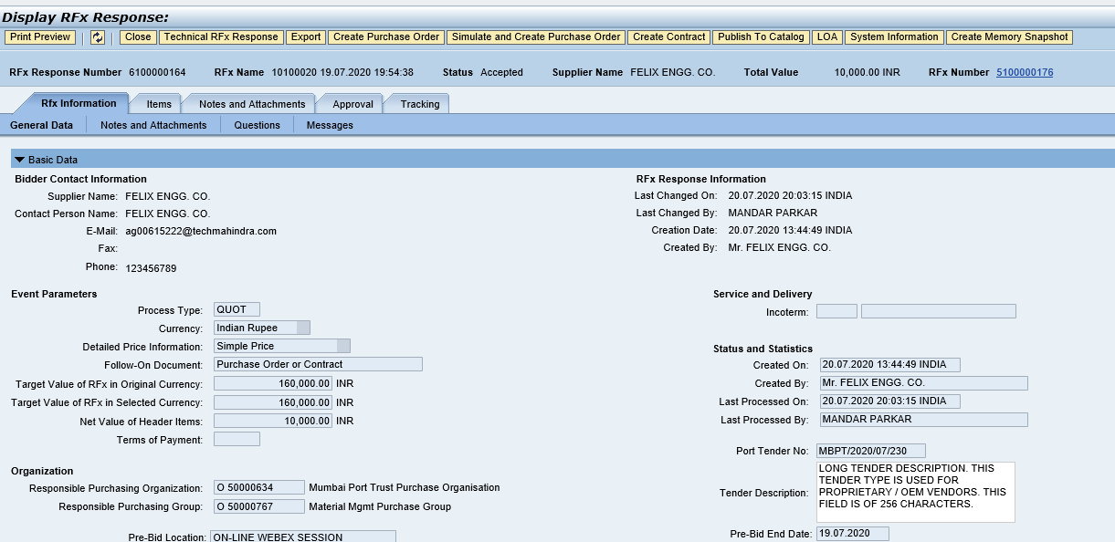

  - Click on “Create Purchase Order” button as shown in screenshot below.

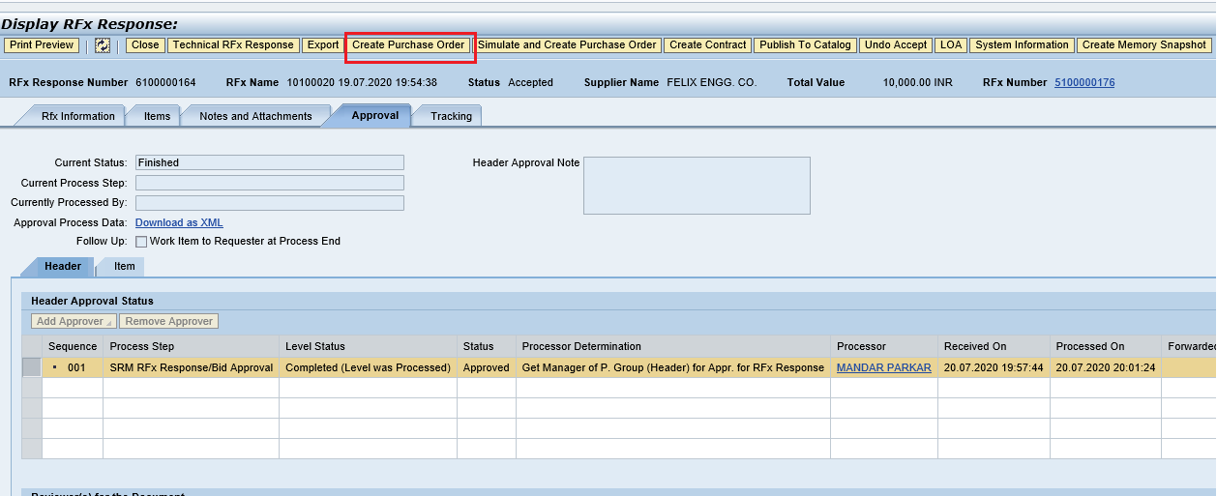

  - A new window will be popped-up, Select the transaction type and then click on “Create Purchase Order” button.

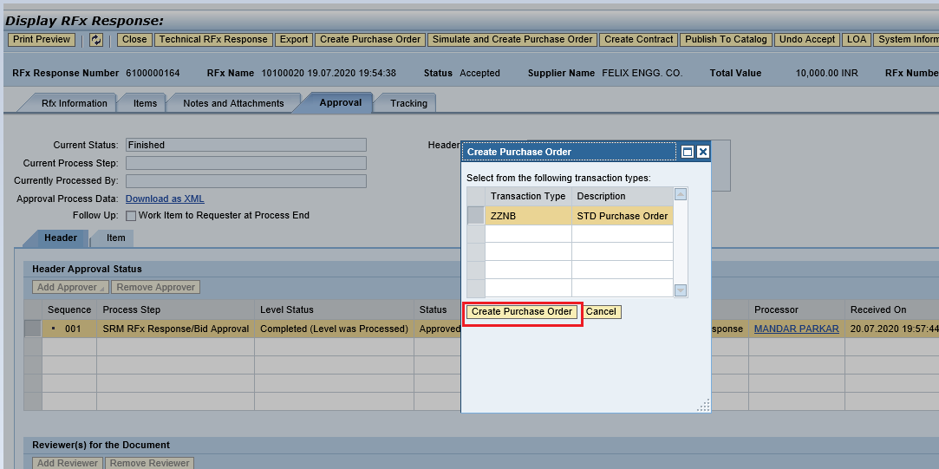

  - PO will be created and replicated to backend system.

System will display message as “PO 4xxxxxxxx” is in the process of transfer to back-end system” as shown in screenshot below

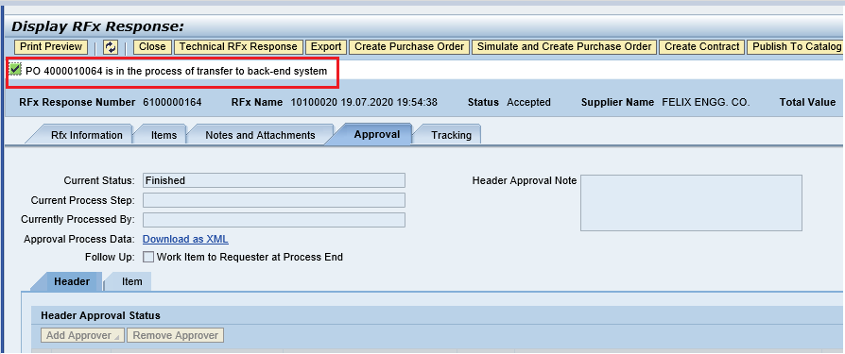
Please see the screenshot below of the PO that has got replicated to backend Hana system. This PO will be available for further processing.

