Indian Ports Association (IPA)
Implementation of Port EBS Project
Enterprise Business System

Business Process Manual for
Single Tender

Submitted by:

Plot No. 58 A & B,
Noida Special Economic Zone,
Uttar Pradesh-201305

www.techmahindra.com

This document is a desk reference tailored to the Procurement Specialists. It is intended to provide information that will be helpful to support the Tendering processes.
All rights reserved. Passing on and copying of this document, use and communication of its contents not permitted without written authorization
Document History:
Authors & Participants
Role | Name

Revision History
Date | Document  Version | Document Revision  Description | Author
01.07.2020 | 1.0 | Initial Draft | Sudhakar M S

Reviewed and Approved By
Name | Title | Date | Approved

Contents:
1. Buyer Logon 4
2. Sourcing 5
3. RFX Creation ` 8
4. Publish RFx 10
5. Add Permission 10
6. Open Technical RFx 11
7. Display Technical Comparative Statement 13
8. Security & Committee Evaluation 15
9. Open Technical Response 17
10. Open Price Response 18
11. Display PCR Report 21
12. Create Purchase Order 22

Buyer Logon
  - Login to SRM Portal
  - Enter User ID and Password
  - Enter OTP from your registered mobile number

- Go to on Other Ebs Application and click “SRM Portal”
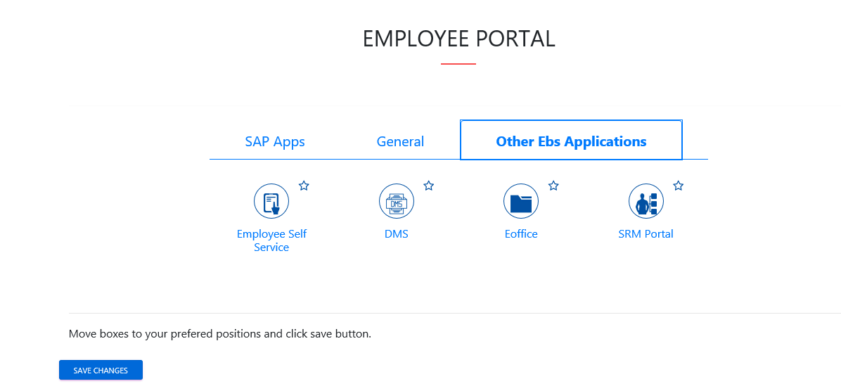

Sourcing

Sourcing
    - Click on Strategic Purchase -> Strategic Sourcing -> Carryout Sourcing

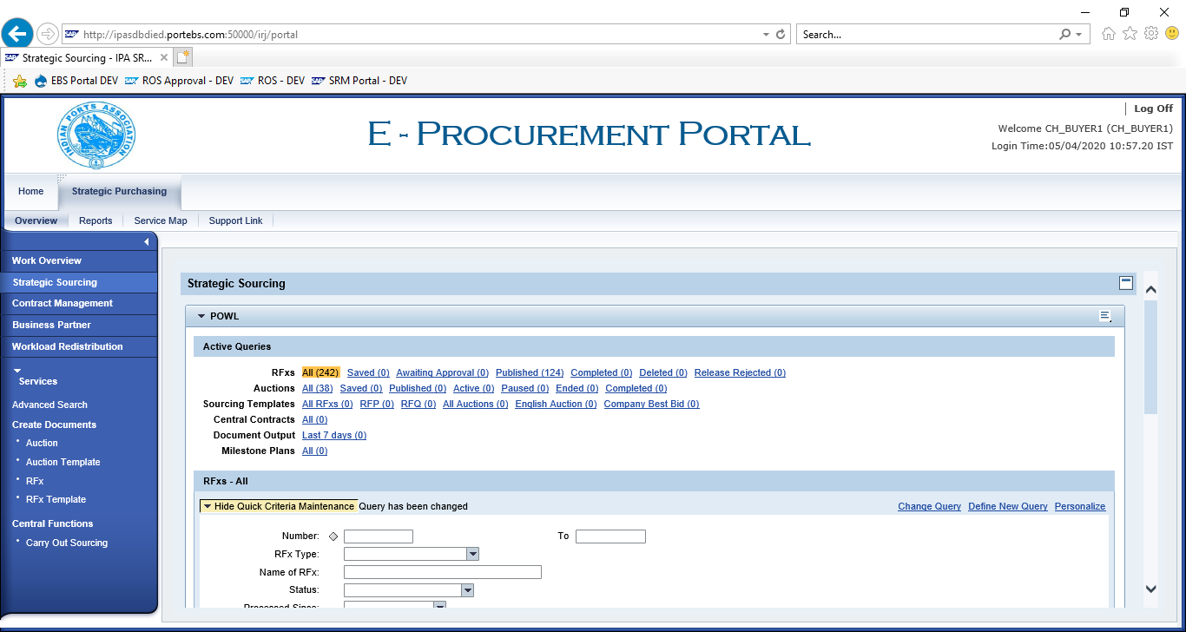

    - Enter SAP Purchase Requisition in “External Requisition” and click on “Search”. Purchase Requisition Line items shows below.

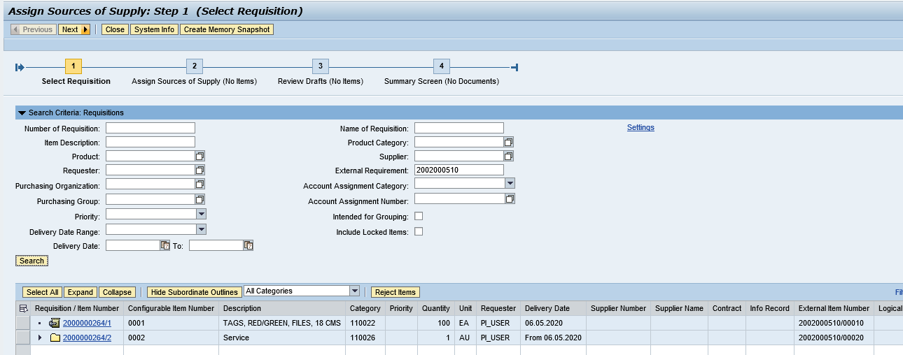
    - Click on “Select All” button and click on “Next” button.

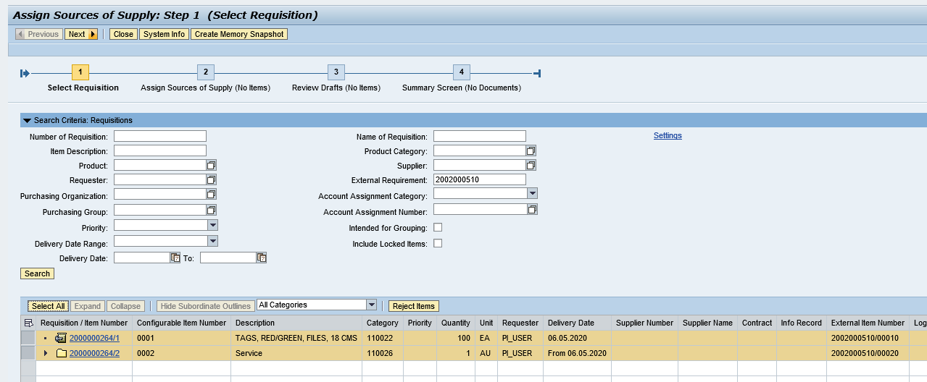
    - Click on “Select All” and Select “Create Draft” as “RFx”

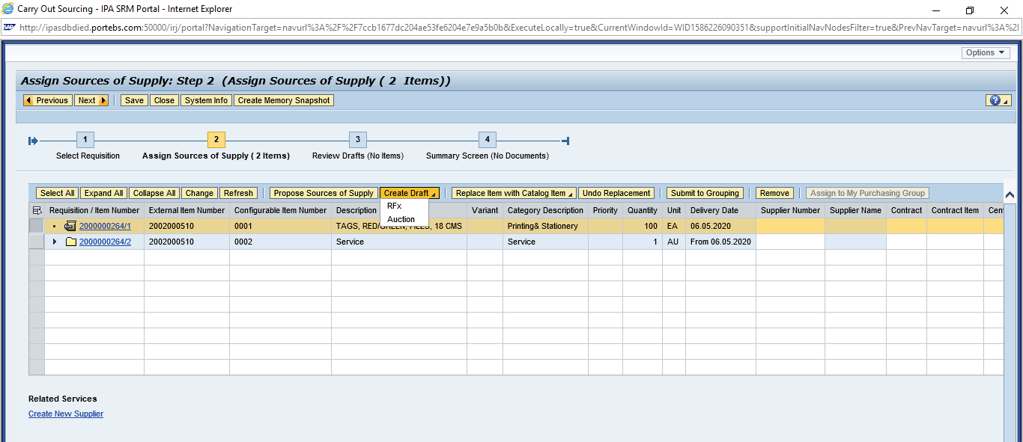
    - Select “Transaction Type” as “ZST1 – Single Tender

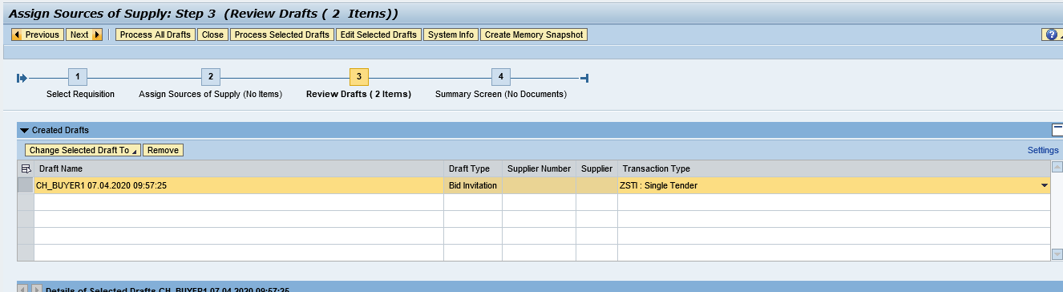

RFX Creation `
  - Display RFx
  - Go to “Strategic Purchasing” -> Strategic Sourcing”
  - Click on “EDIT” and enter
    - RFx Number
    - Port Tender No
    - Tender Description
  - Enter RFx Dates
    - RFx Start Date
    - RFx Submission Date
    - Technical RFx Response Opening Date
    - Price RFx Opening Date
Enter Tender Fee, EMD and Security Deposit payment detail
- Tender Fee
      - Check Required checkbox
      - Enter Tender Fee Percentage or Tender Fee amount
      - Submission Deadline
- Earnest Money Deposit (EMD)
      - Check Required checkbox
      - Enter EMD Percentage or amount
      - Submission Deadline
- Security Deposit
      - Check Security Deposit checkbox
      - Security Deposit Percentage

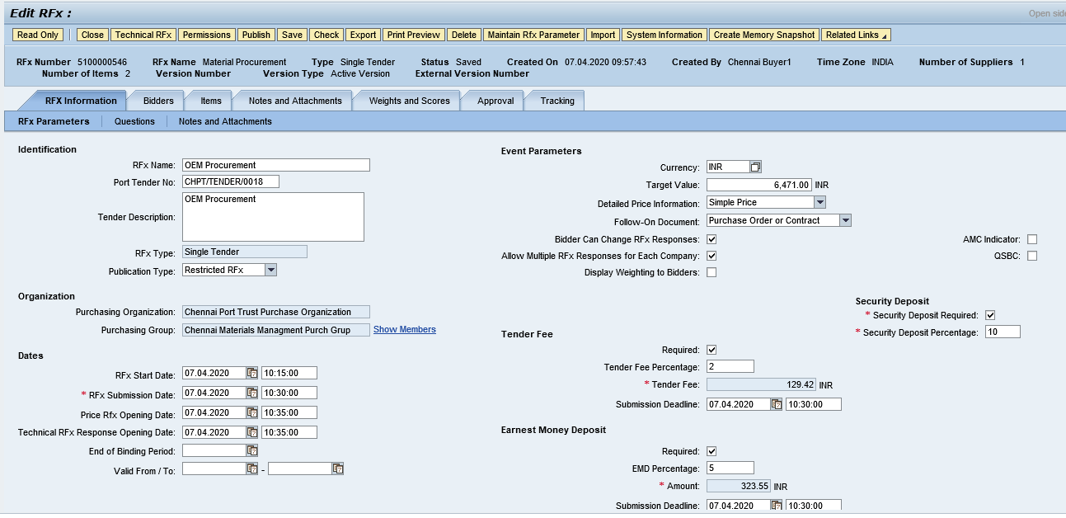
    - Add Bidder(s) to participate in Tendering

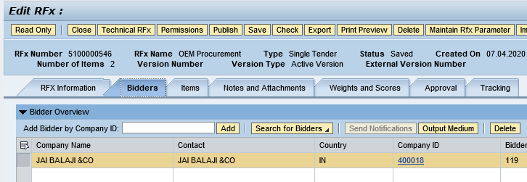

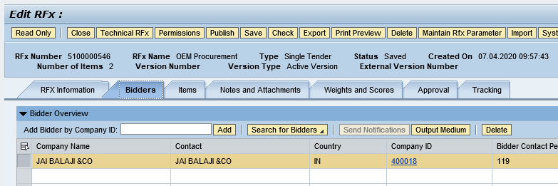

Publish RFx
    - Click on “Publish” to initiate for approval process.

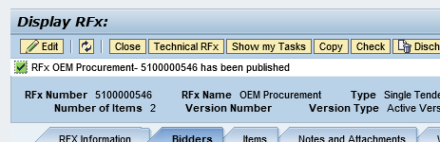

Add Permission
    - Click on “Permission” button and add Tech Opener, Tech Scrutiny, Price Opener, Tech Evaluator, Price Scrutiny and Price Evaluator

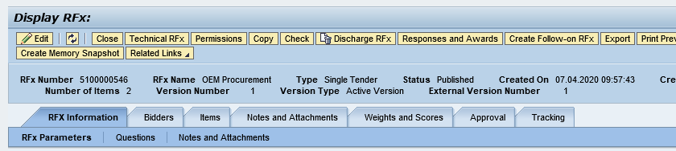
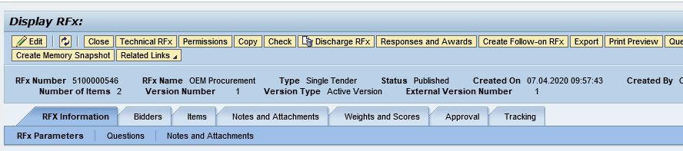

    - All Members are added successfully
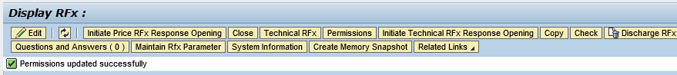

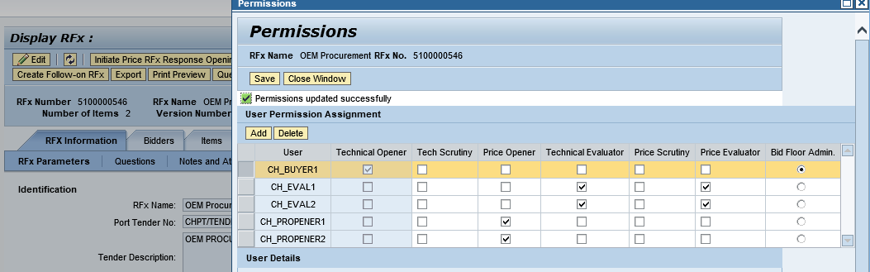

Open Technical RFx
    - Click on “Initiate Technical RFx Response Opening” button and enter Password.

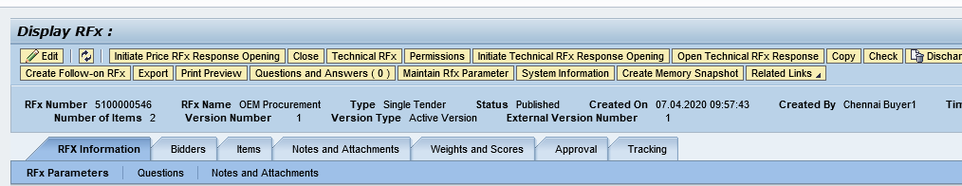
    - Enter Password

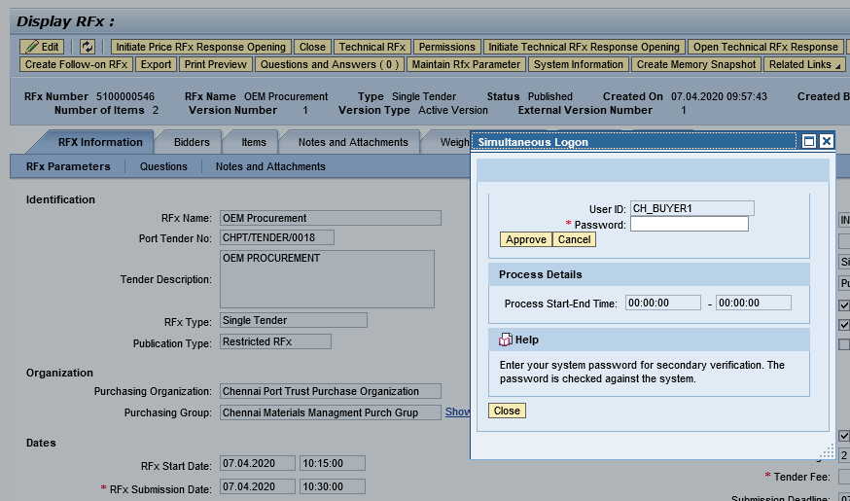

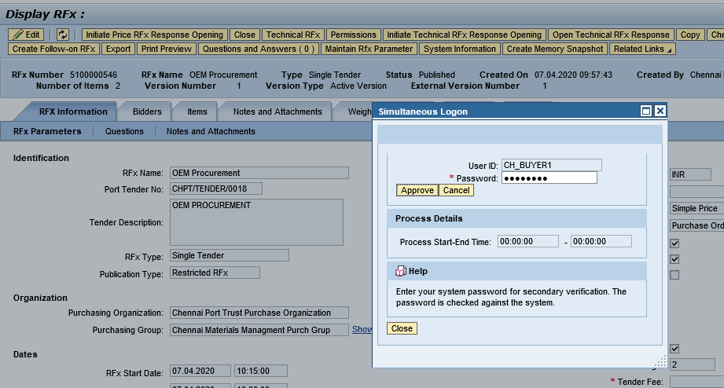

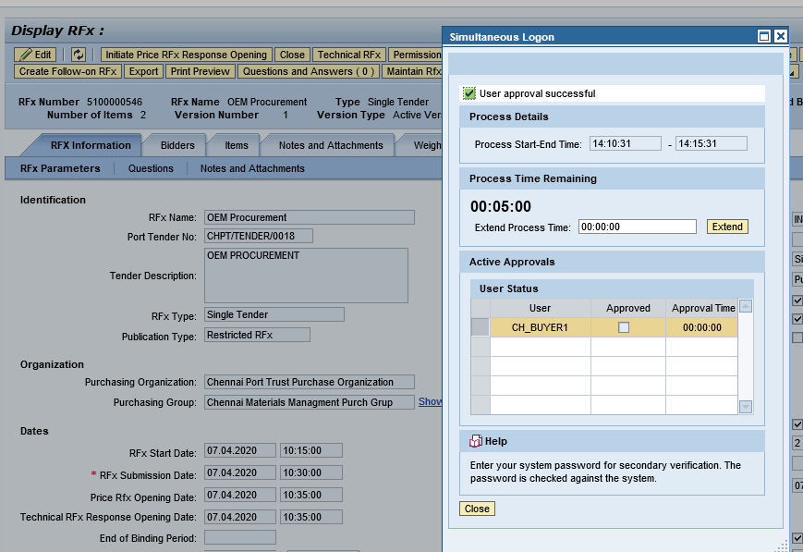

    - Go to RFx number and display RFx
    - Click on “Open Technical RFx Response” button

Display Technical Comparative Statement
    - Click on “Response and Award” button

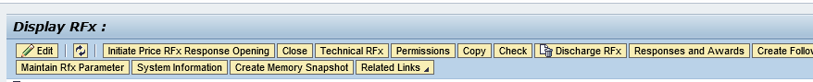
    - Select “Technical Response Activity” Tab and click “TCR Report”

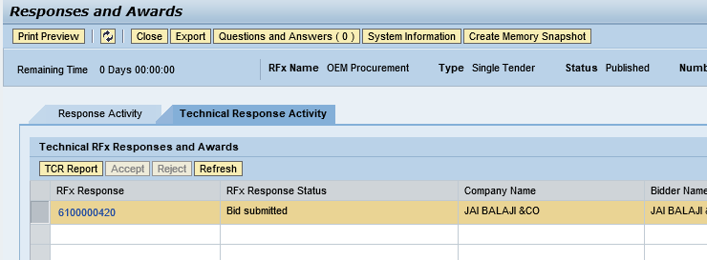
    - Enter Buyer comments for each line item and over all comment.
    - Click on “Forward” button to send TCR Report to Scurrility and Committee Members

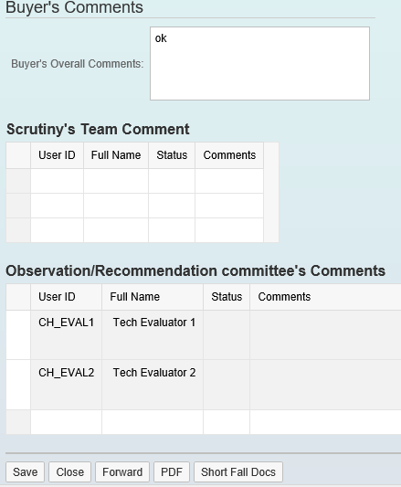

Security & Committee Evaluation

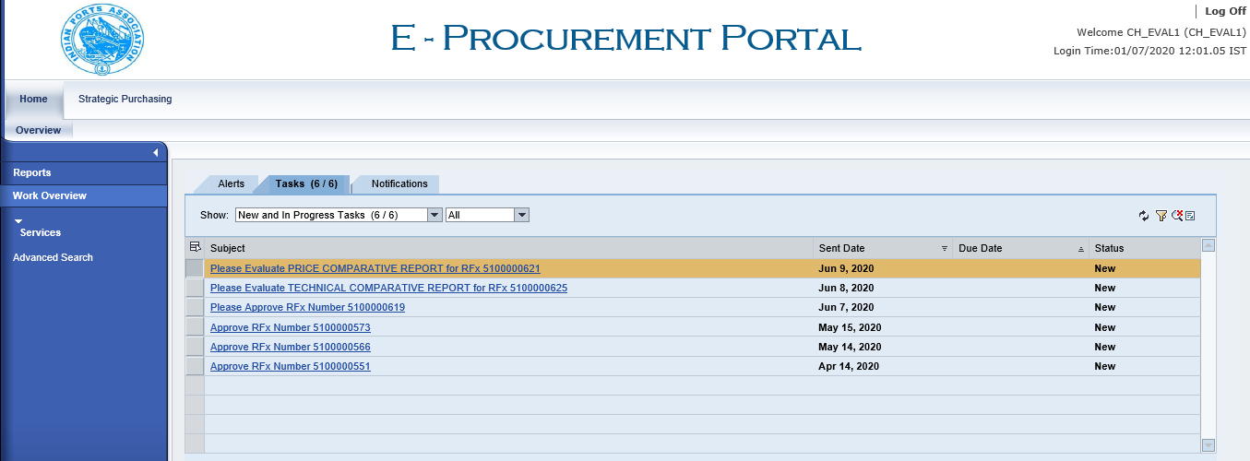

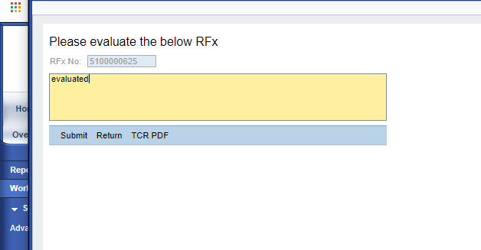

Open Technical Response
Click on “Initiate Technical Response Opening” button

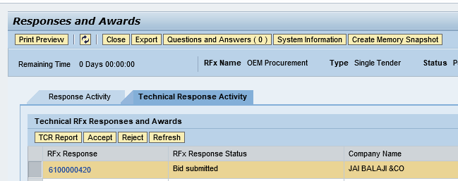

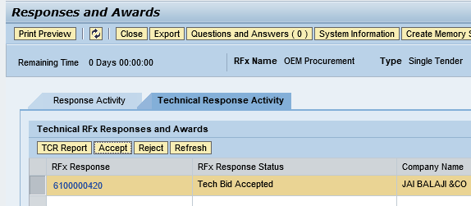

Open Price Response
    - Click on “Initiate Price Response Opening” button

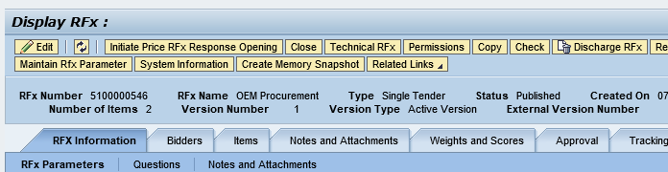
    - Enter Password

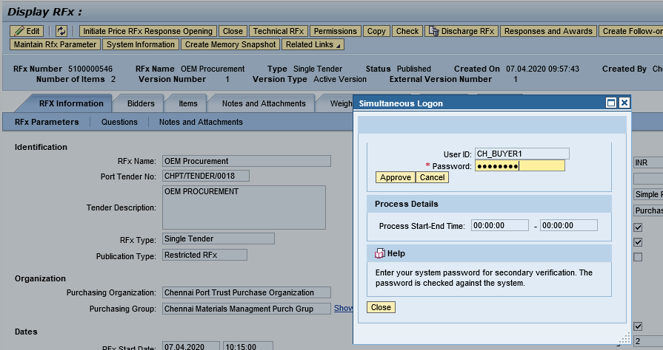

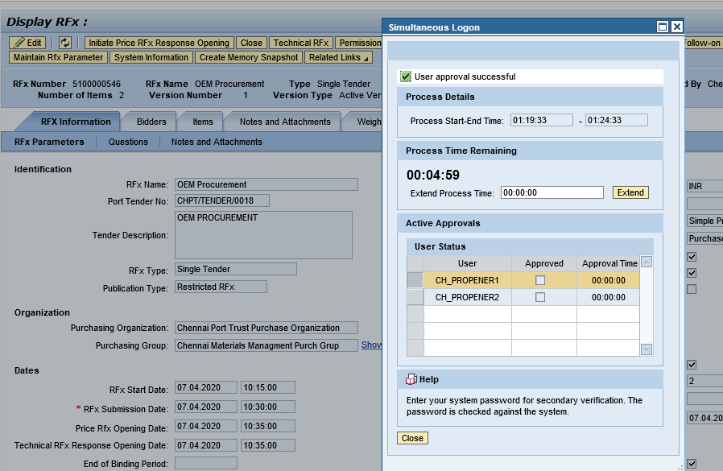
    - Login as Price Opener and “Open Price RFx Response”

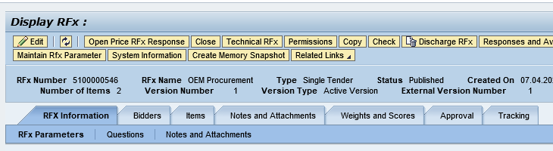

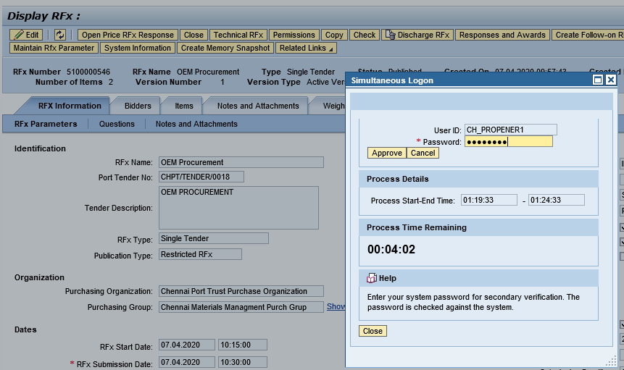

Display PCR Report

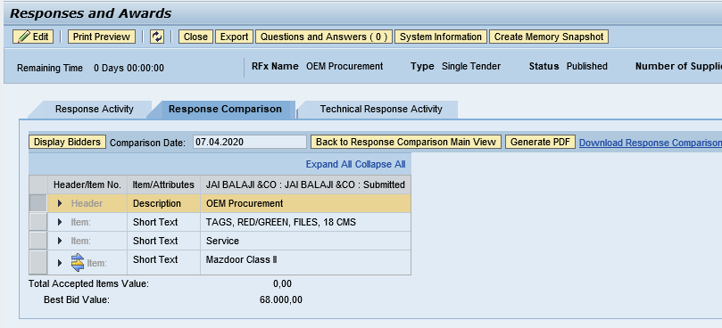
    - Accept/Reject Price Response

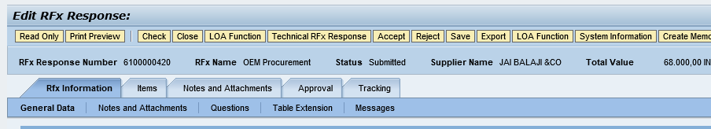

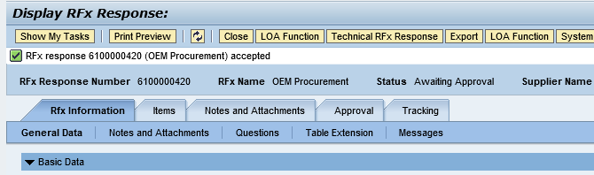

Create Purchase Order

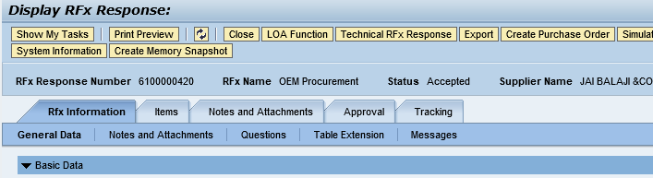
    - Select Transaction Type ZZNB and click “Create Purchase Order”

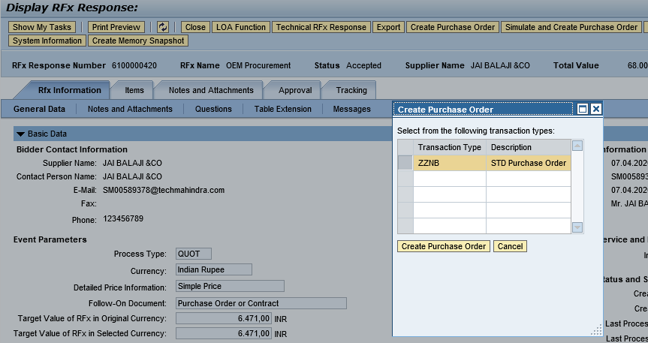
    - Purchase Order created successfully and transfer to HANA system.

