Indian Ports Association (IPA)
Implementation of Port EBS Project
Enterprise Business System

Business Process Manual for
Limited Tender – Two Bid System

Submitted by:

Plot No. 58 A & B,
Noida Special Economic Zone,
Uttar Pradesh-201305

www.techmahindra.com

This document is a desk reference tailored to the Procurement Specialists. It is intended to provide information that will be helpful to support the Tendering processes.
All rights reserved. Passing on and copying of this document, use and communication of its contents not permitted without written authorization
Document History:
Authors & Participants
Role | Name

Revision History
Date | Document  Version | Document Revision  Description | Author
01.07.2020 | 1.0 | Initial Draft | Sudhakar M S

Reviewed and Approved By
Name | Title | Date | Approved

Contents:
1. Buyer Logon 4
2. Sourcing 5
3. RFX Creation ` 8
4. Publish RFx 10
5. Add Permission 11
6. Open Technical RFx 12
7. Display Technical Comparative Statement 14
8. Security & Committee Evaluation 16
9. Accept Technical Response 17
10. Open Price Response 18
11. Create Purchase Order 23

Buyer Logon
  - Login to SRM Portal
  - Enter User ID and Password
  - Enter OTP from your registered mobile number

- Go to on Other Ebs Application and click “SRM Portal”
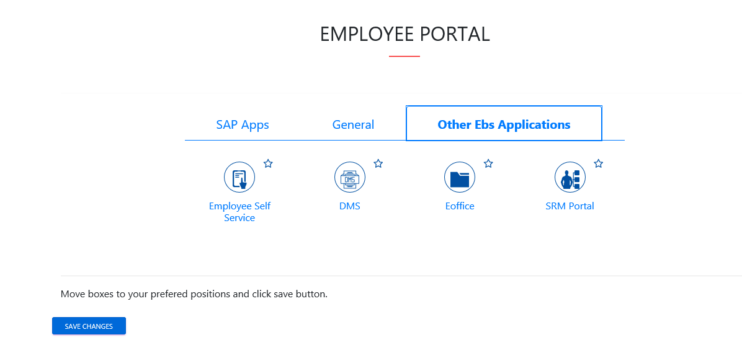

Sourcing
    - Click on Strategic Purchase -> Strategic Sourcing -> Carryout Sourcing
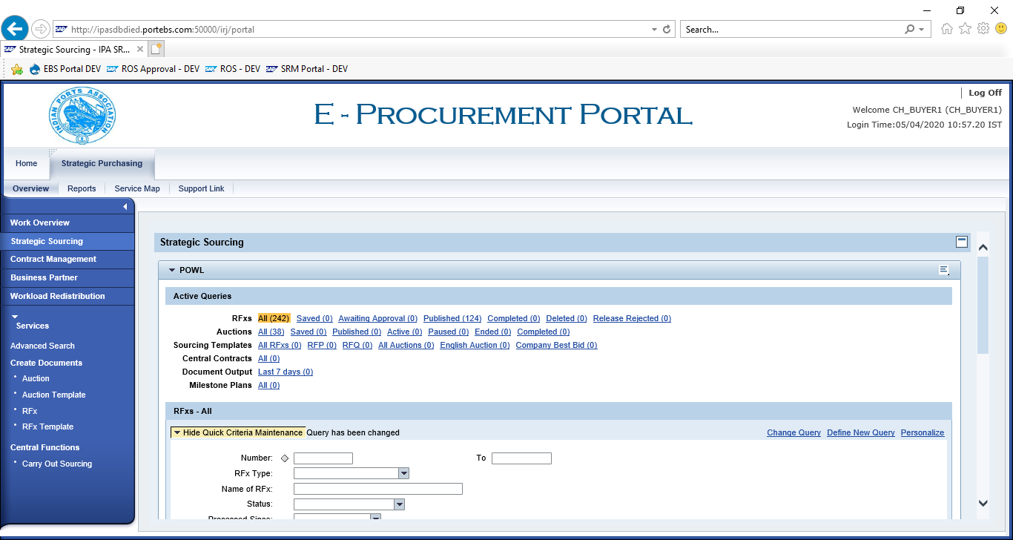
    - Enter SAP Purchase Requisition in “External Requisition” and click on “Search”. Purchase Requisition Line items shows below.

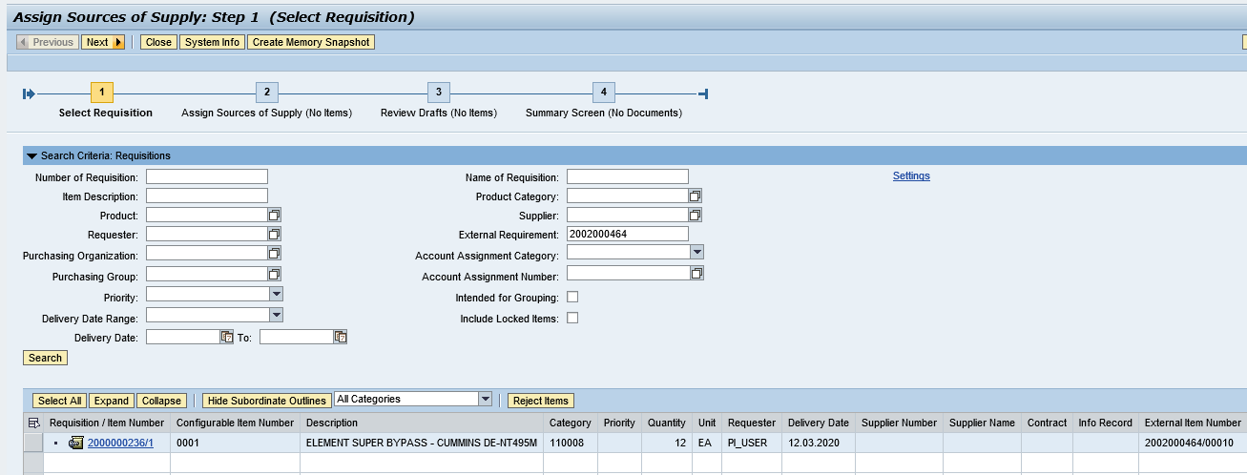
    - Click on “Select All” button and click on “Next” button.

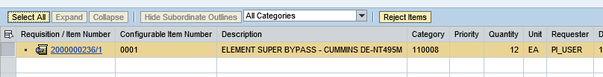
    - Click on “Select All” and Select “Create Draft” as “RFx”

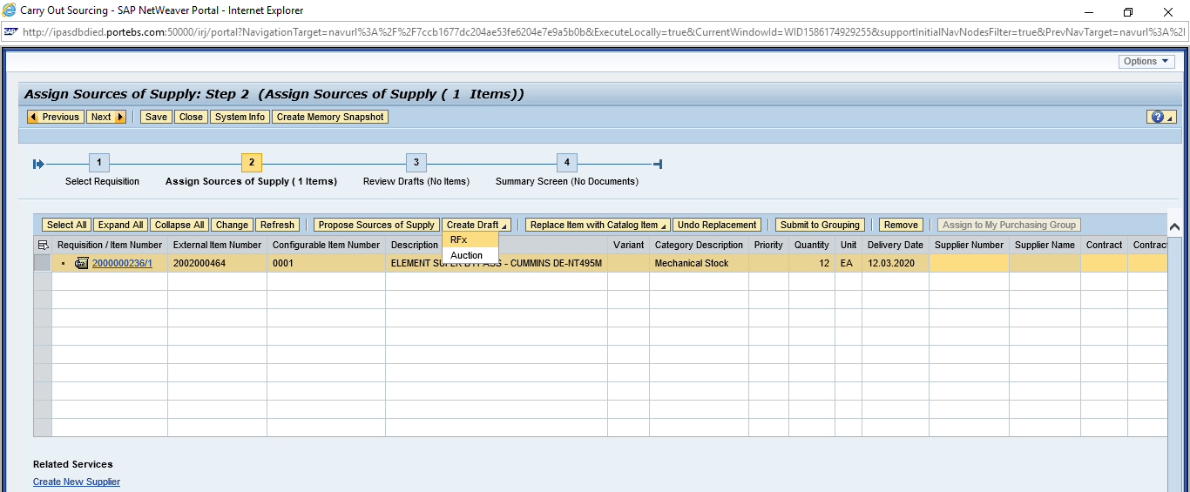
    - Select “Transaction Type” as “ZLT2 – Limited Tender 2 Env”

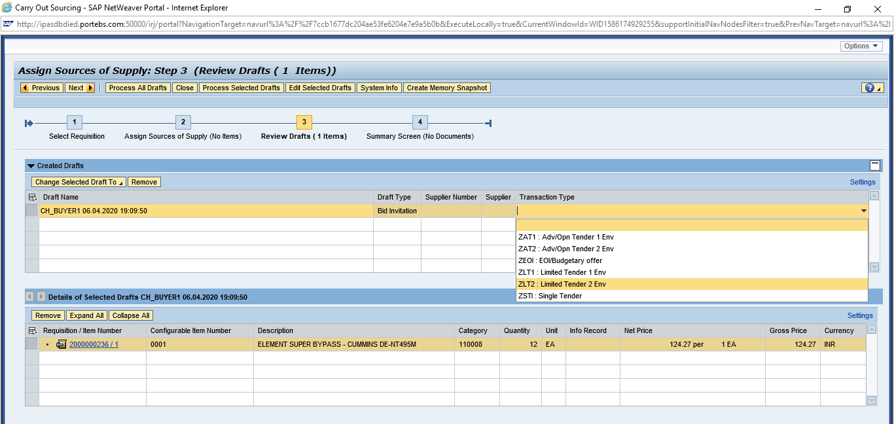
    - Click on “Process Selected Drafts”

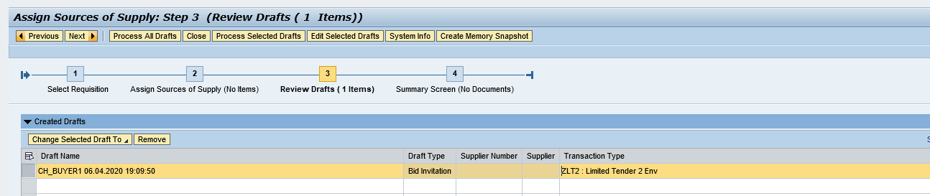

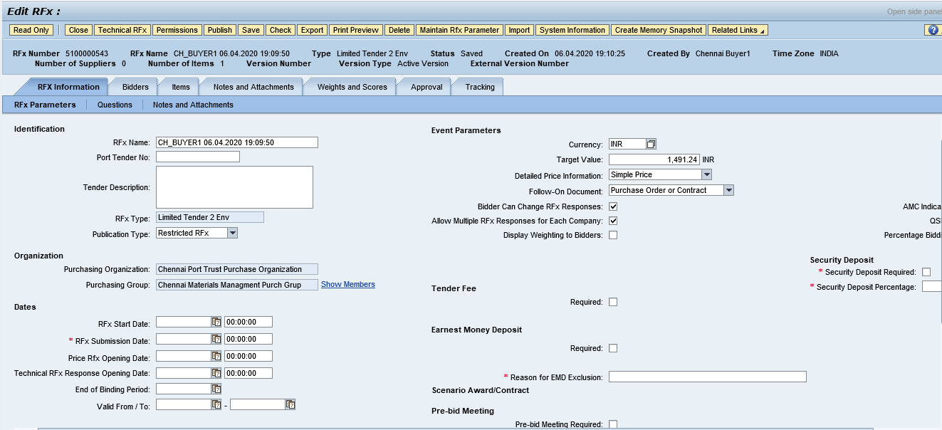

RFX Creation `
  - Display RFx
  - Go to “Strategic Purchasing” -> Strategic Sourcing”
  - Click on “EDIT” and enter
    - RFx Number
    - Port Tender No
    - Tender Description
  - Enter RFx Dates
    - RFx Start Date
    - RFx Submission Date
    - Technical RFx Response Opening Date
    - Price RFx Opening Date
Enter Tender Fee, EMD and Security Deposit payment detail
- Tender Fee
      - Check Required checkbox
      - Enter Tender Fee Percentage or Tender Fee amount
      - Submission Deadline
- Earnest Money Deposit (EMD)
      - Check Required checkbox
      - Enter EMD Percentage or amount
      - Submission Deadline
- Security Deposit
      - Check Security Deposit checkbox
      - Security Deposit Percentage

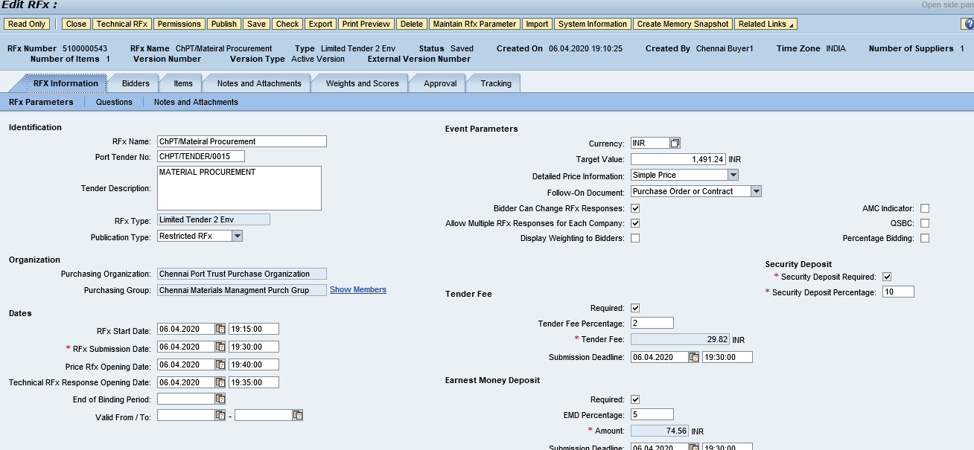
    - Add Bidder(s) to participate in Tendering
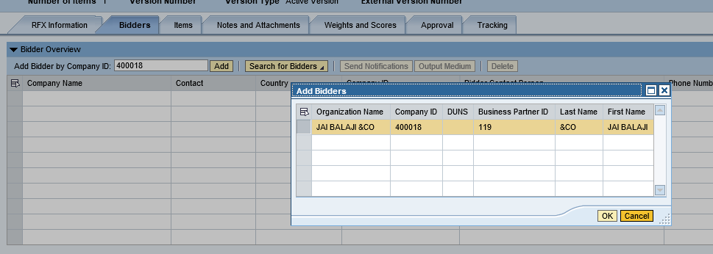
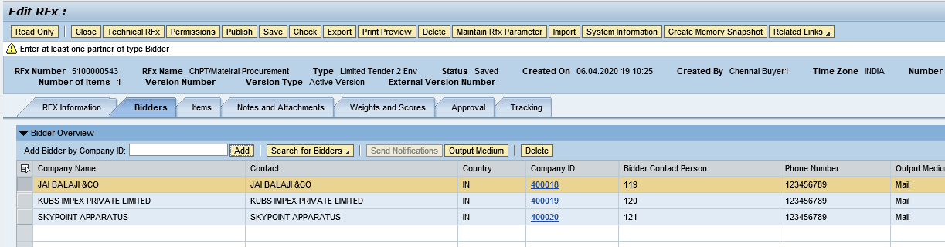

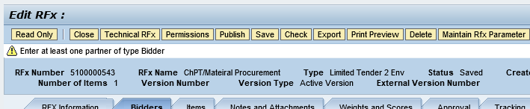

Publish RFx
    - Click on “Publish” to initiate for approval process.
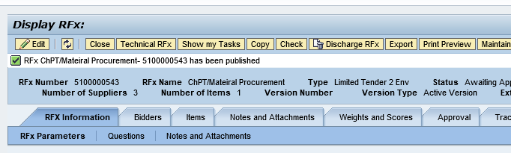

Add Permission
    - Click on “Permission” button and add Tech Opener, Tech Scrutiny, Price Opener, Tech Evaluator, Price Scrutiny and Price Evaluator

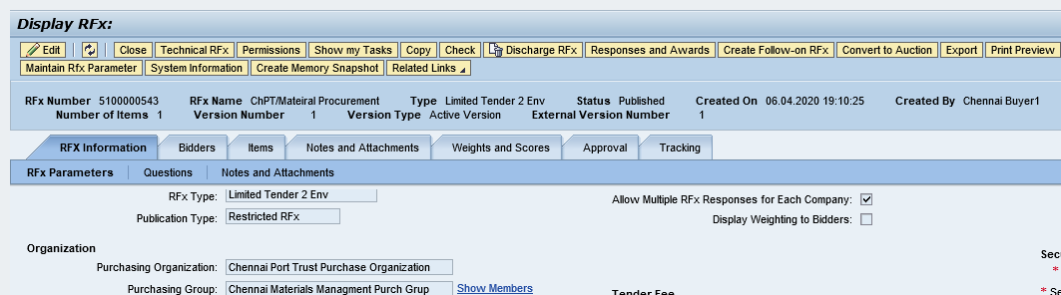
    - All Members are added successfully

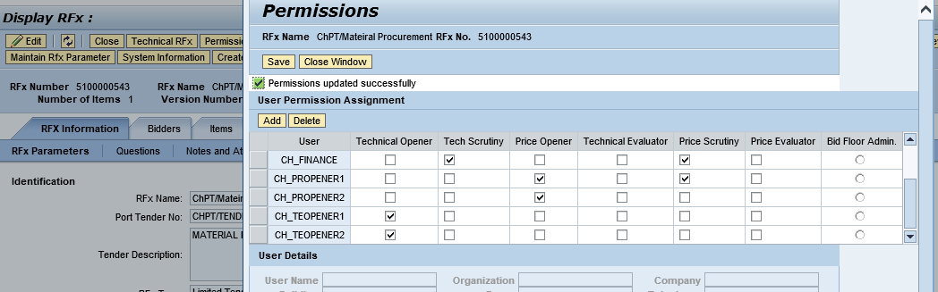

Open Technical RFx
    - Click on “Initiate Technical RFx Response Opening” button and enter Password.

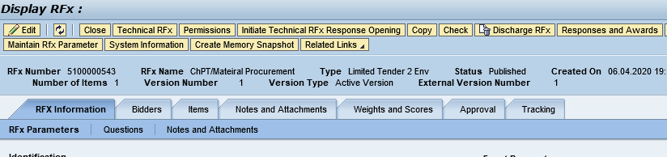

    - Enter Password

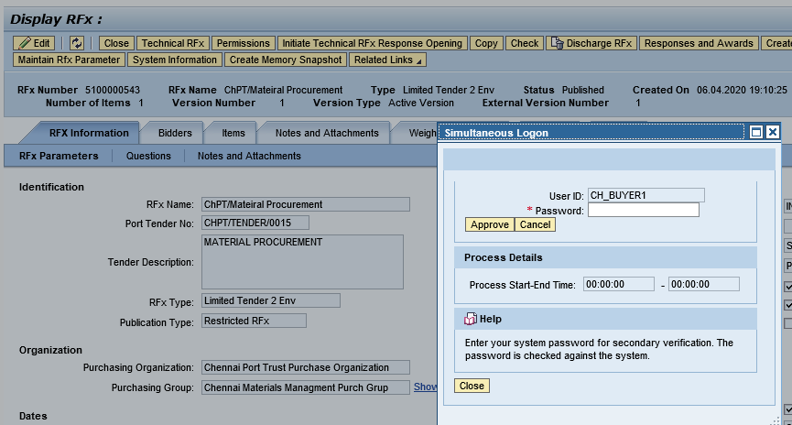

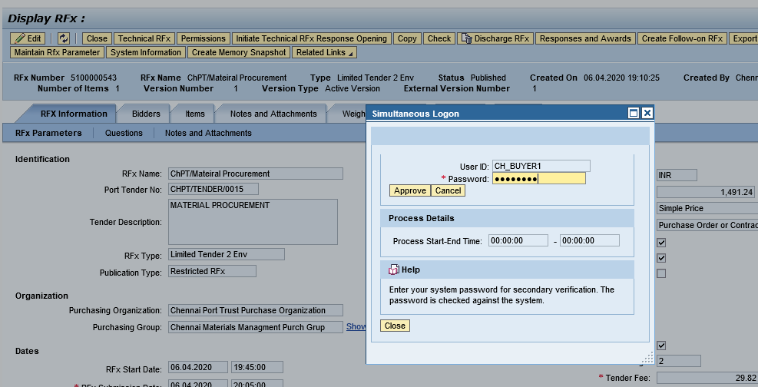

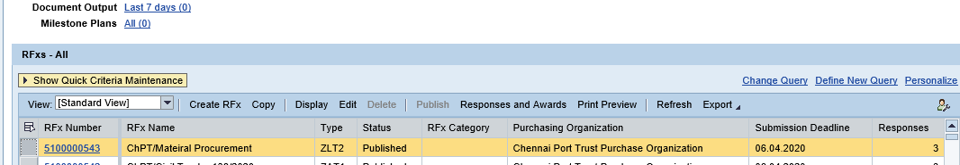

    - Go to RFx number and display RFx
    - Click on “Open Technical RFx Response” button

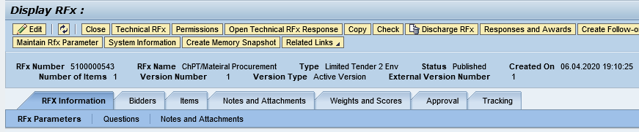

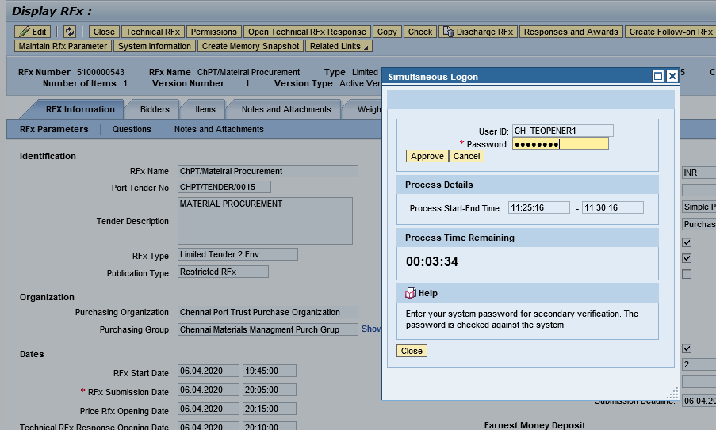

Display Technical Comparative Statement
    - Click on “Response and Award” button

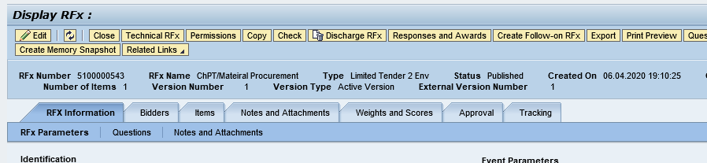
    - Select “Technical Response Activity” Tab and click “TCR Report”

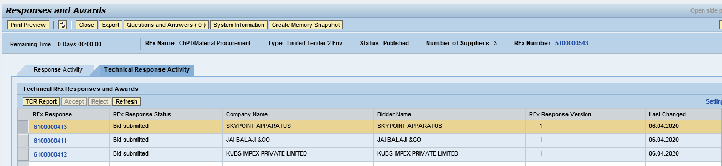
    - Enter Buyer comments for each line item and over all comment.
    - Click on “Forward” button to send TCR Report to Scurrility and Committee Members
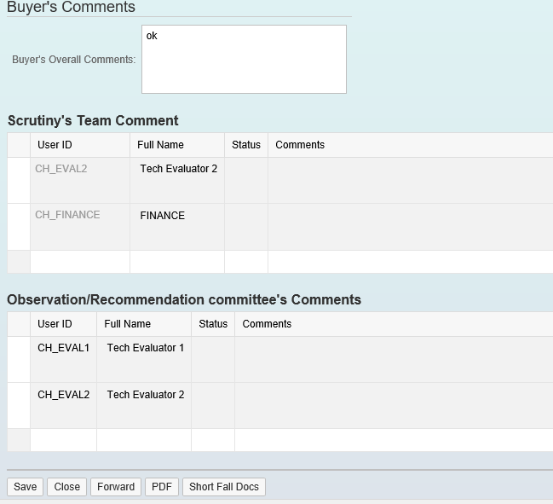

Security & Committee Evaluation

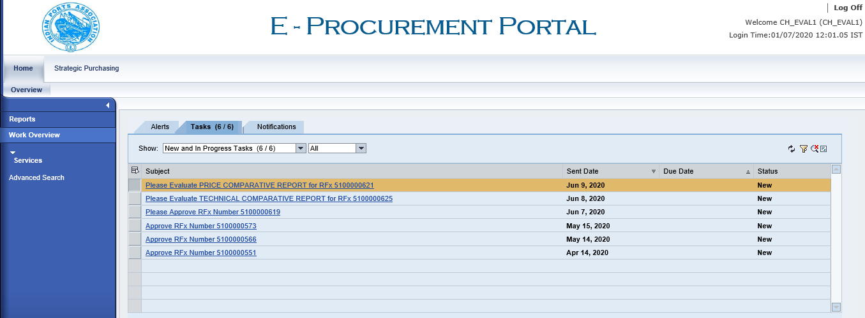

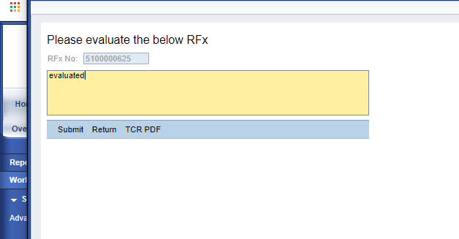

Accept Technical Response
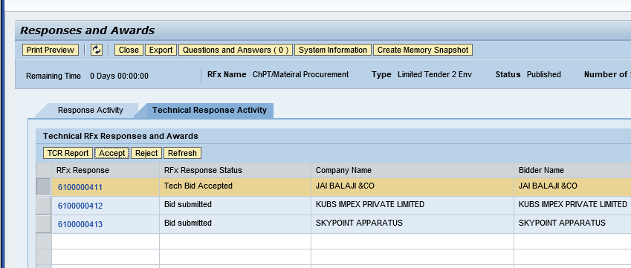

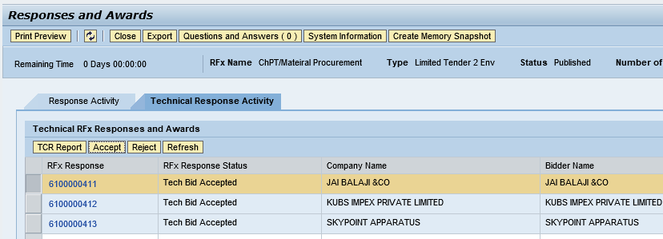

Open Price Response
    - Click on “Initiate Price Response Opening” button
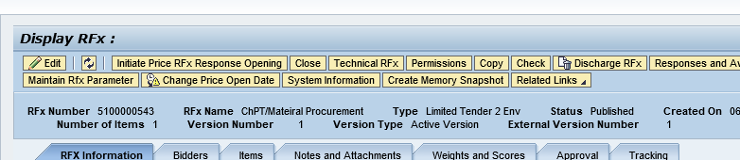
Enter Password
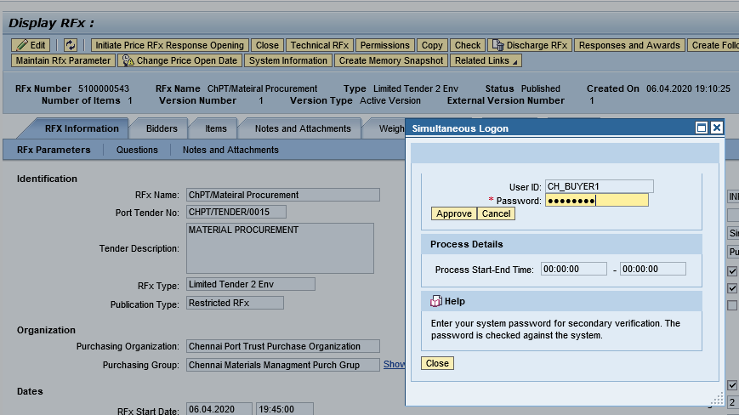

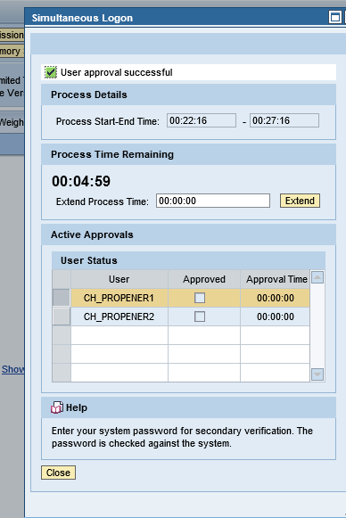
    - Login as Price Opener and “Open Price RFx Response”
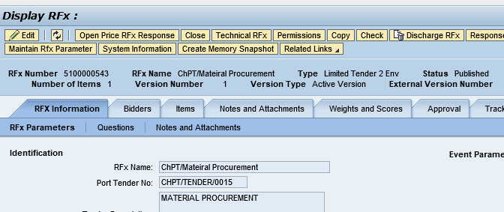
    - Enter Password

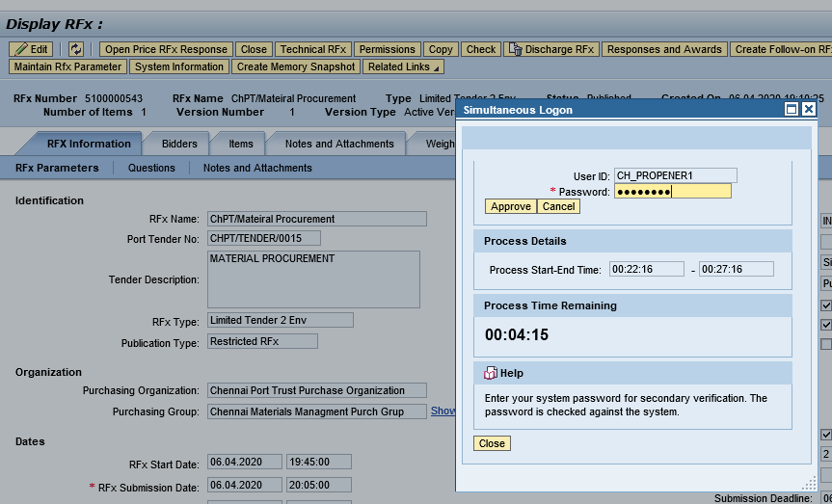

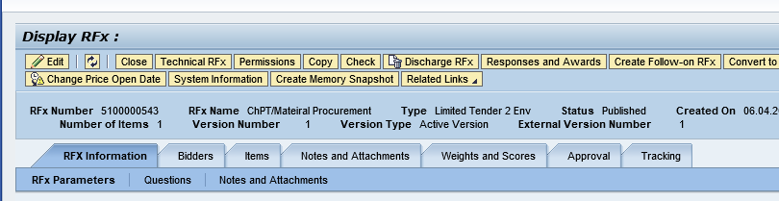

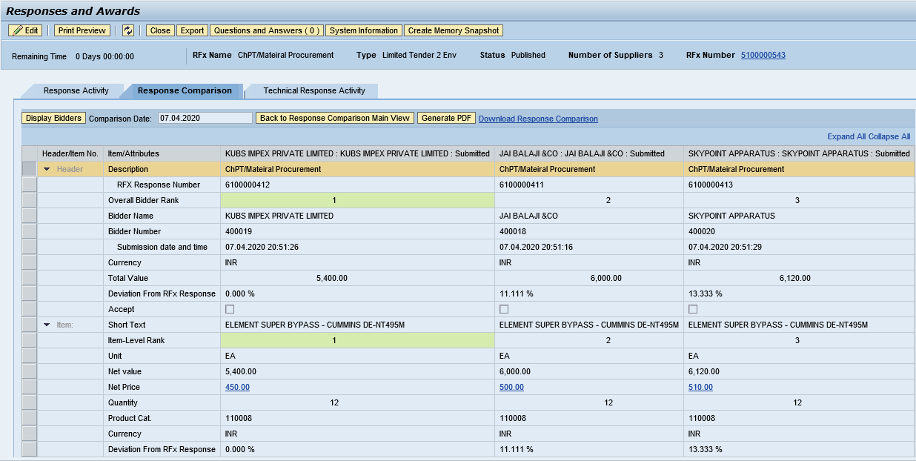
    - Accept/Reject Price Response

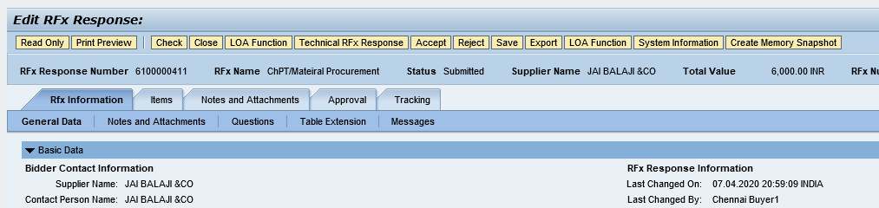

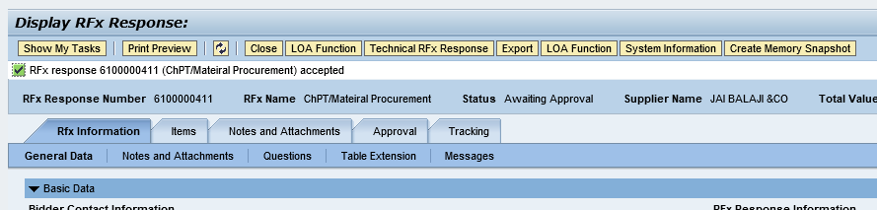
    - Accept/Reject Price Response

Create Purchase Order

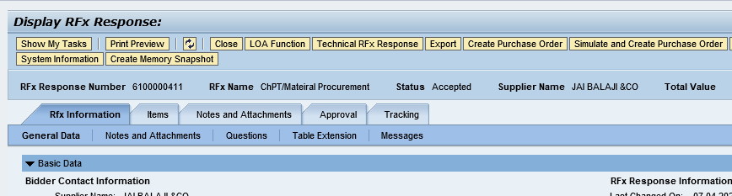
    - Select Transaction Type ZZNB and click “Create Purchase Order”

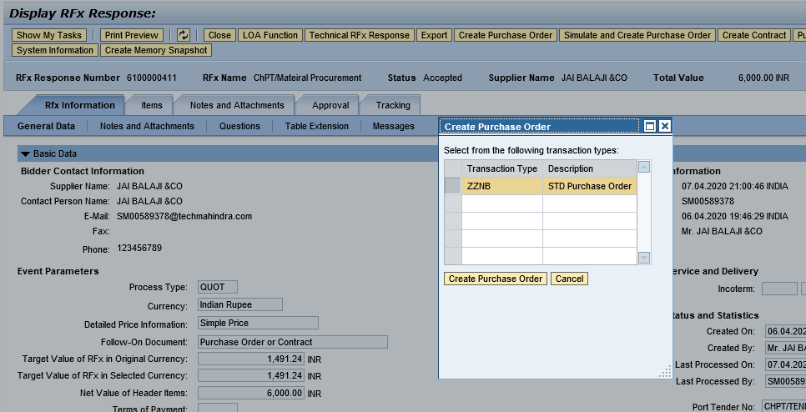
    - Purchase Order created successfully and transfer to HANA system.

