Indian Ports Association (IPA)
Implementation of Port EBS Project
Enterprise Business System

Business Process Manual for
EOI/Budgetary Offer

Submitted by:

Plot No. 58 A & B,
Noida Special Economic Zone,
Uttar Pradesh-201305

www.techmahindra.com

This document is a desk reference tailored to the Procurement Specialists. It is intended to provide information that will be helpful to support the Tendering processes.
All rights reserved. Passing on and copying of this document, use and communication of its contents not permitted without written authorization
Document History:
Authors & Participants
Role | Name

Revision History
Date | Document  Version | Document Revision  Description | Author
01.07.2020 | 1.0 | Initial Draft | Sudhakar M S

Reviewed and Approved By
Name | Title | Date | Approved

Contents:
1. Buyer Logon 4
2. Sourcing 5
3. RFX Creation ` 9
4. Publish RFx 10
5. Display Price Comparative Statement 11

Buyer Logon
  - Login to SRM Portal
  - Enter User ID and Password
  - Enter OTP from your registered mobile number

- Go to on Other Ebs Application and click “SRM Portal”
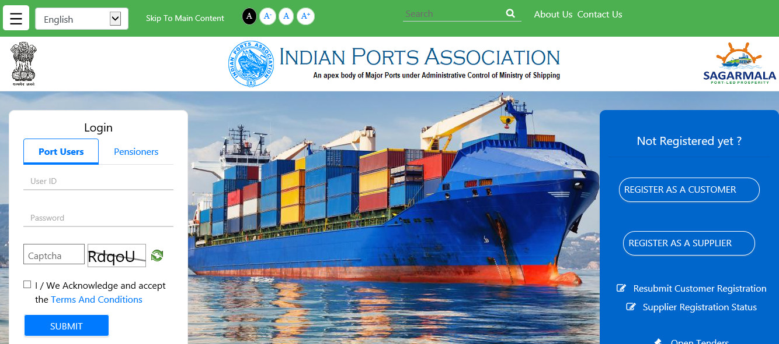
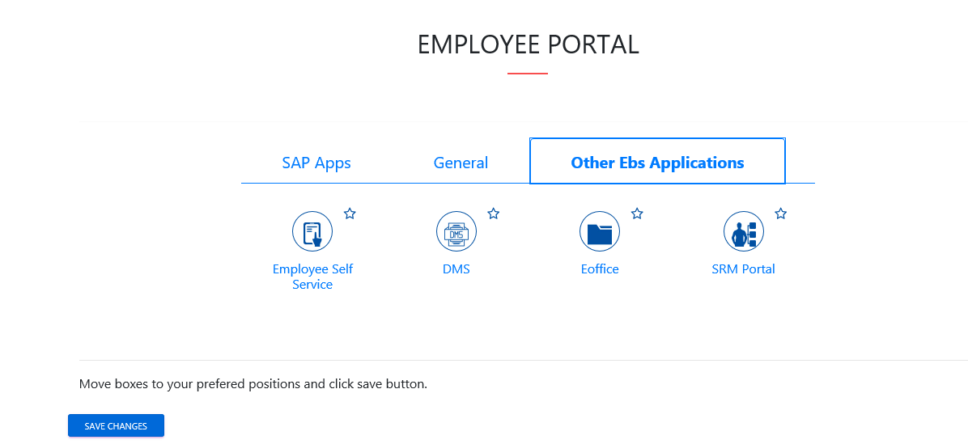

Sourcing
    - Click on Strategic Purchase -> Strategic Sourcing -> Carryout Sourcing

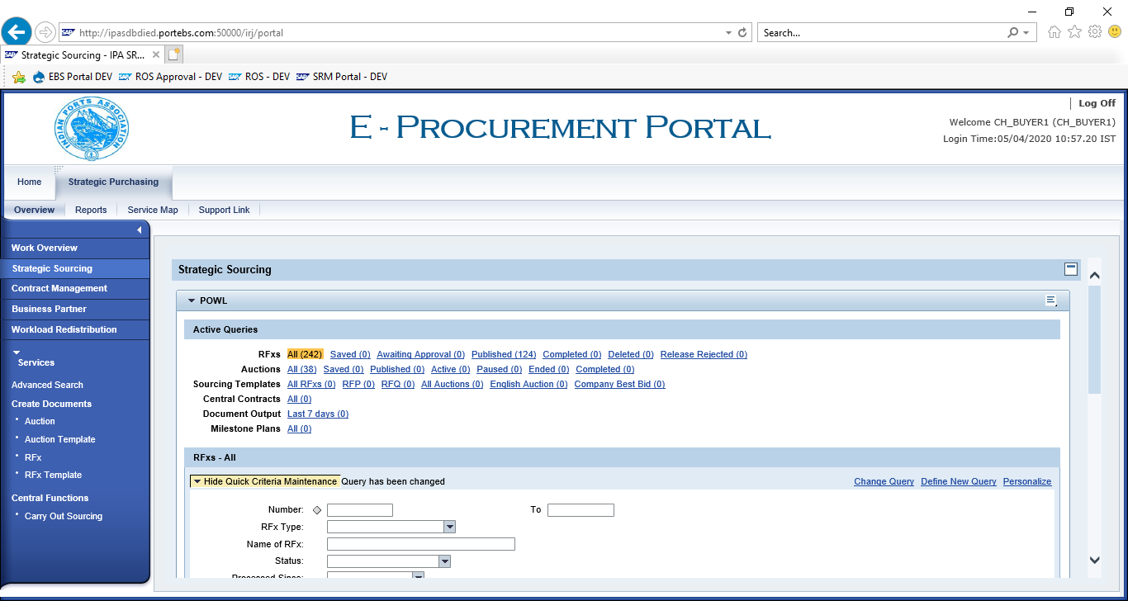
    - Enter SAP Purchase Requisition in “External Requisition” and click on “Search”. Purchase Requisition Line items shows below.

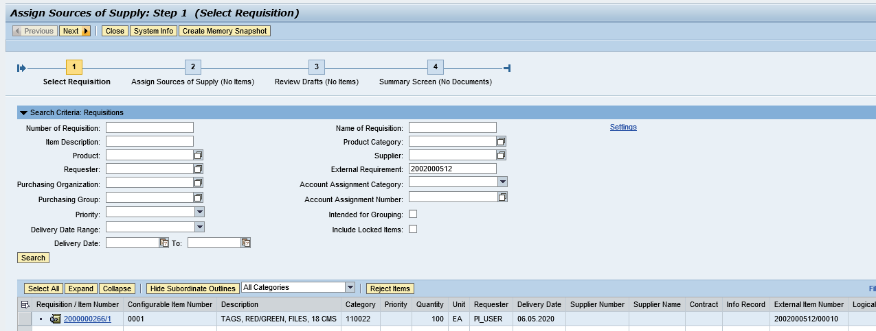
    - Click on “Select All” button and click on “Next” button.

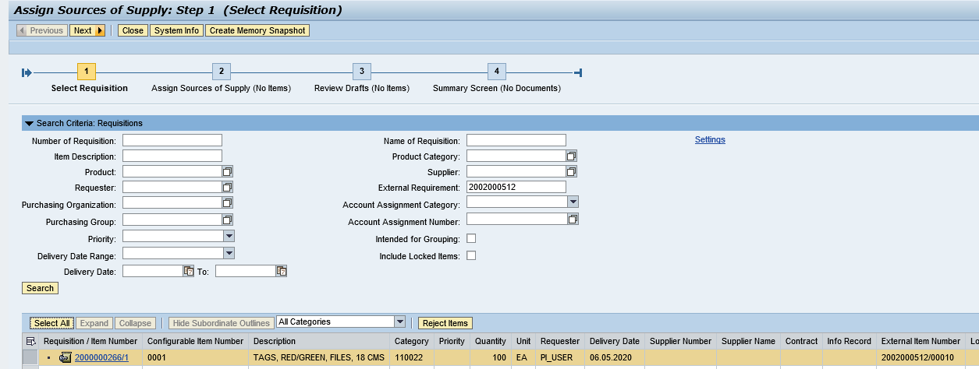
    - Click on “Select All” and Select “Create Draft” as “RFx”

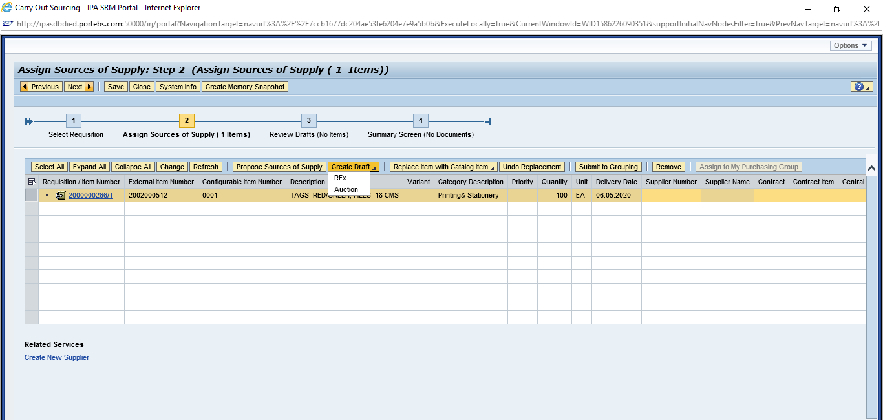

    - Select “Transaction Type” as ZEOI – EOI/Budgetary Offer”

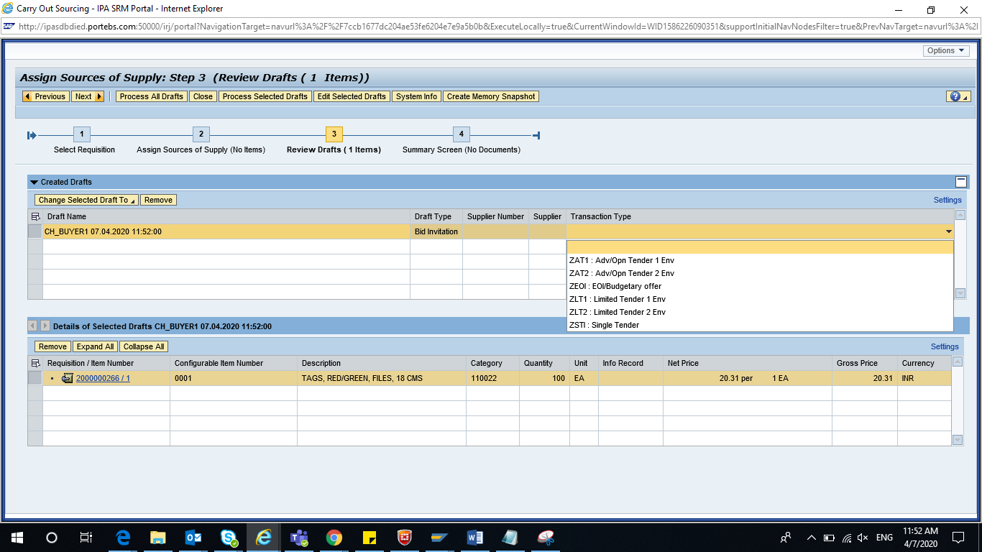
    - Click on “Process Selected Drafts”

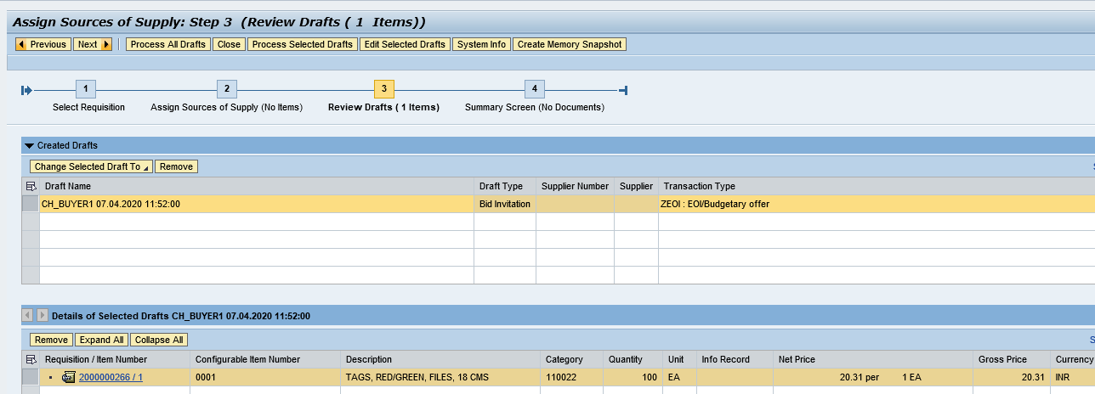

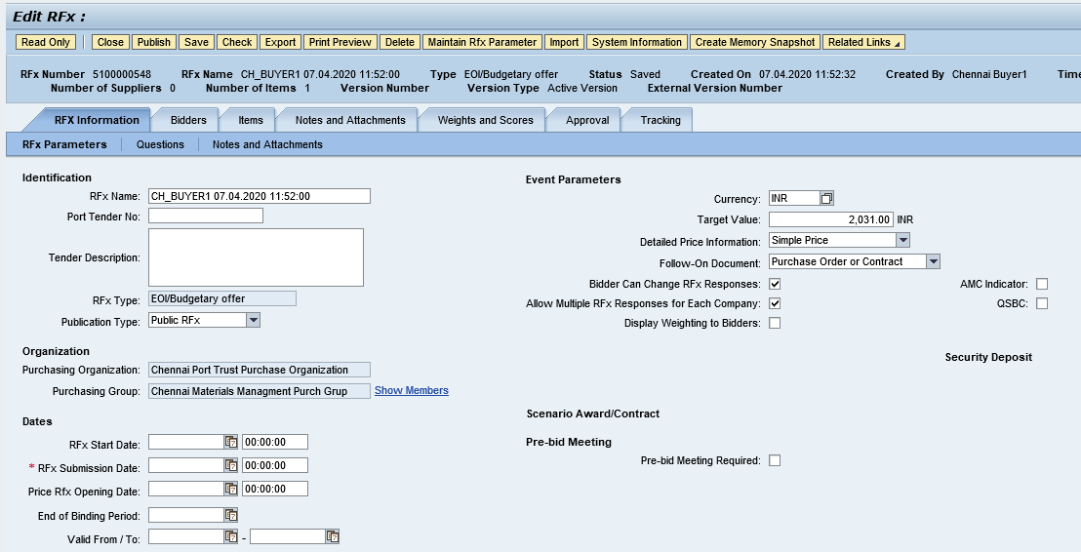

RFX Creation `
  - Display RFx
  - Go to “Strategic Purchasing” -> Strategic Sourcing”
  - Click on “EDIT” and enter
    - RFx Number
    - Port Tender No
    - Tender Description
  - Enter RFx Dates
    - RFx Start Date
    - RFx Submission Date
    - Price RFx Opening Date

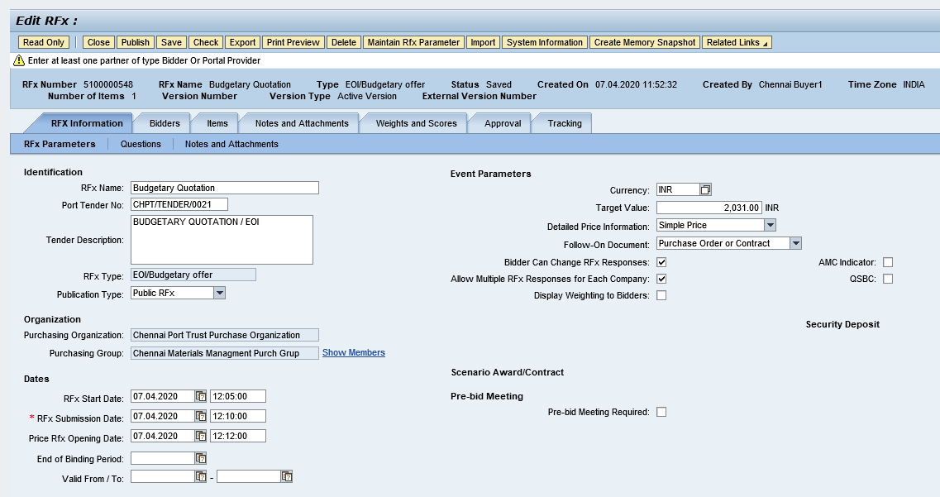

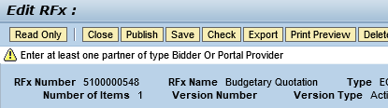

Publish RFx
    - Click on “Publish” to initiate for approval process.

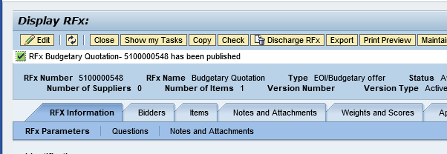

Display Price Comparative Statement

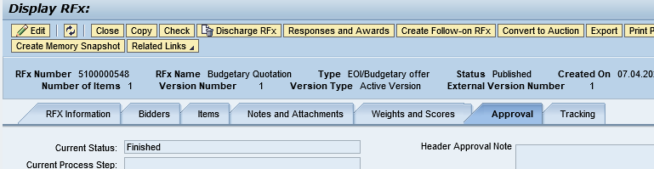
- Display EOI Report

