Indian Ports Association (IPA)
Implementation of Port EBS Project
Enterprise Business System

Bidder Manual for
Tendering Process

Submitted by:

Plot No. 58 A & B,
Noida Special Economic Zone,
Uttar Pradesh-201305

www.techmahindra.com

This document is a desk reference tailored to the Procurement Specialists. It is intended to provide information that will be helpful to support the Tendering processes.
All rights reserved. Passing on and copying of this document, use and communication of its contents not permitted without written authorization
Document History:
Authors & Participants
Role | Name
SRM Solution Architect | Abhay Gade

Revision History
Date | Document  Version | Document Revision  Description | Author
01.07.2020 | 1.0 | Initial Draft | Abhay Gade / Sudhakar M S

Reviewed and Approved By
Name | Title | Date | Approved

Contents
1. Portal Logon 4
1.1. EBS Portal & SSO to SRM Portal 4
1.2. Tender Fee & EMD Fee Submission 8
1.3. Create RFx Response 13
1.4. C-folder Attachments 15
1.5. Maintaining the Price 18
1.6. Response Submission 19

Portal Logon

EBS Portal & SSO to SRM Portal

    - Access the URL URL https://10.9.7.22:8001/ebs-portal/ in IE browser. Below screen will be displayed.

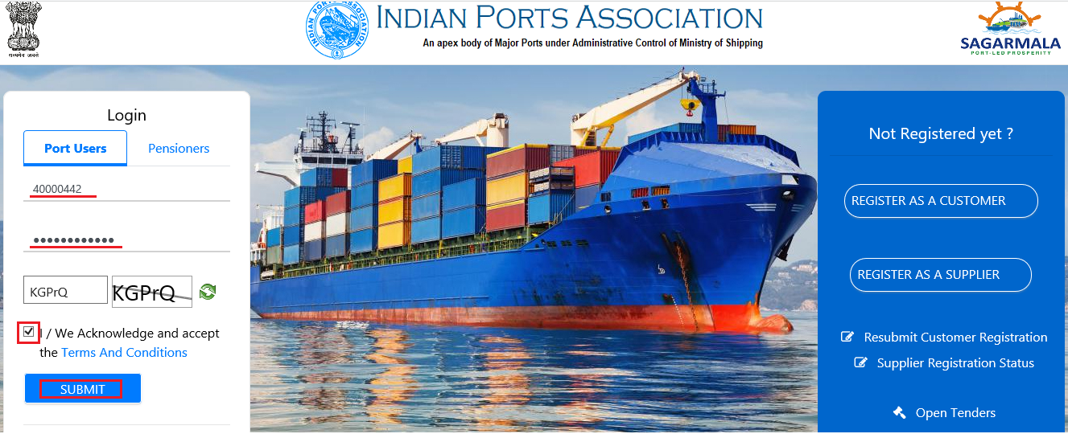

    - Under “Port Users” tab provide your user-id and password.

    - Input the captcha as mentioned and then check the “Terms and Conditions” statement.

    - Click on “Submit” button.

    - A new window will be displayed and it will prompt to enter the OTP. OTP will be sent to your registered mobile.

    - Input the OTP and click on “Verify OTP” button. Please see screenshot below.

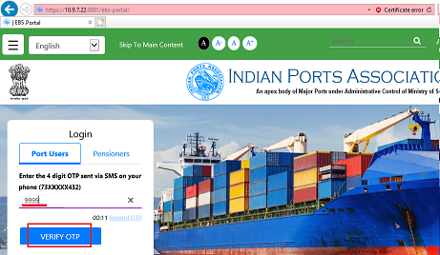
    - Once system verifies the OTP a new window will be displayed. Select “Other EBS Application” tab and click on “SRM Portal” link. Please see screenshot below.

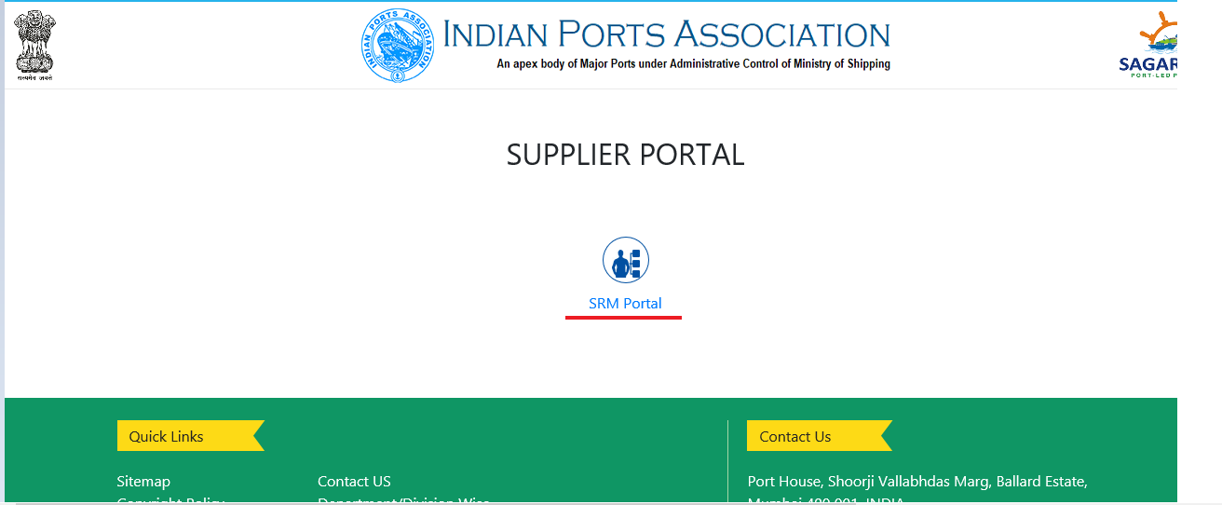

    - A new window will be opened wherein you will be redirected to the SRM portal through SSO. The screen will be displayed as shown below.

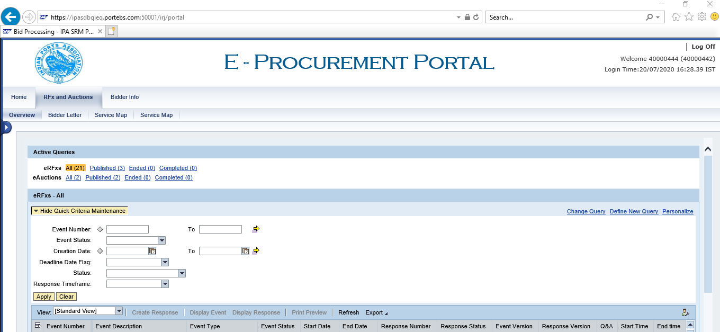

    - Select “RFx and Auctions” tab and then click on “RFx and Auctions” link. At the right side a dashboard will be displayed wherein the Bidder can see the list of tender’s that were responded or are yet to be responded.
Select the appropriate RFx number from the available POWL list and click on the RFx number link. Simultaneously you can also select the complete row and click on “Display Event” button.

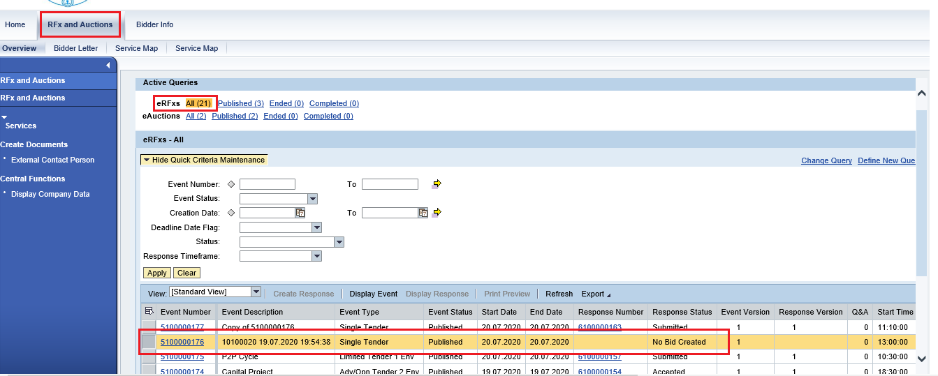

    - A new window will be displayed. Click on “Participate” button to intend for your participation in the tendering process. This is not a mandatory step.

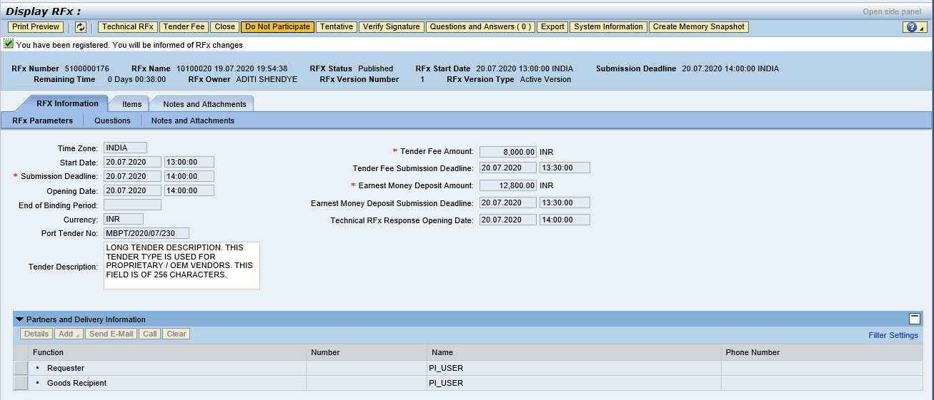

    - All the relevant information of the RFx is visible to the Bidder, such as the Tender Fee & EMD fee details, RFx submission deadline dates etc. See the screenshot below.

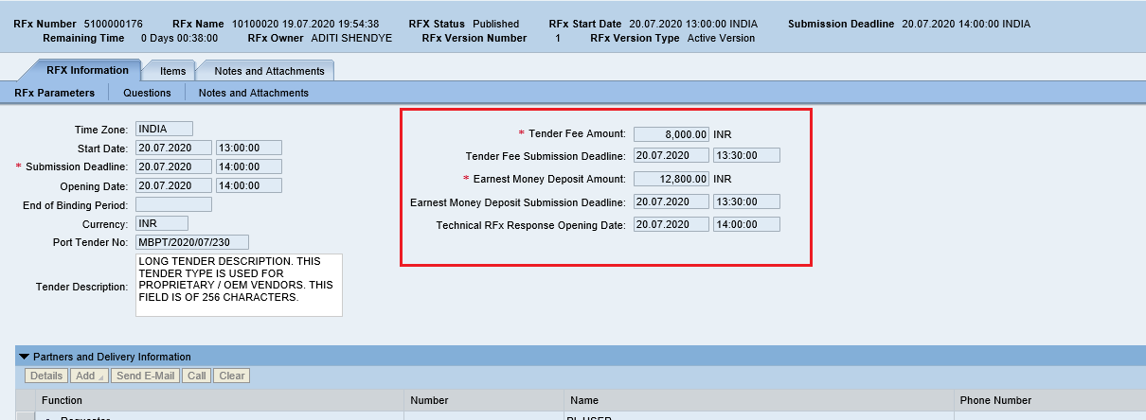

Tender Fee & EMD Fee Submission

    - As a first step, Bidder needs to pay the Tender Fee first. For this click on “Tender Fee” button as mentioned in the screenshot below.

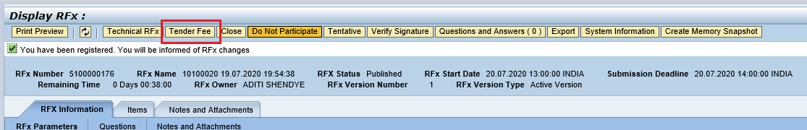

    - A new pop-up window will be displayed. From the dropdown list select the payment type as highlighted below.

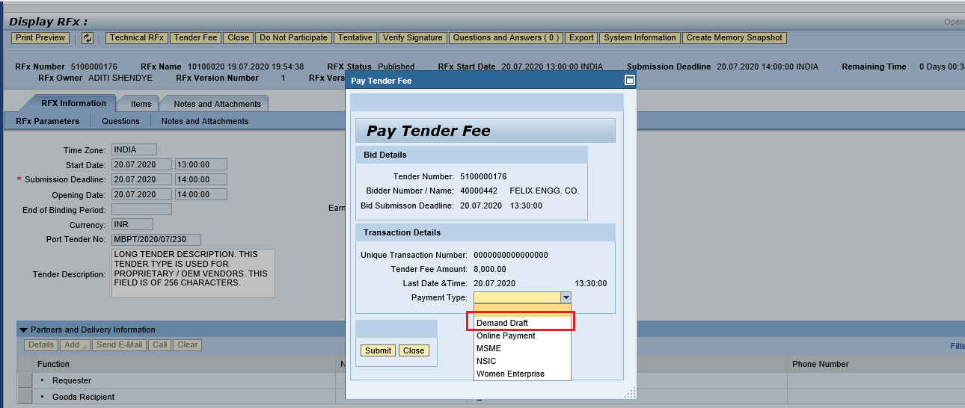

Below is the table indicating the payment type and document that needs to be submitted.

Payment Type | Payment Mandatory / Details required | Document to Upload
Demand Draft | Yes. Provide DD details | Yes
MSME | No | Yes
NSIC | No | Yes
Women Enterprise | No | Yes
Online Payment

    - Provide all the mandatory information required to fill as shown in screenshot below. Click on the “Upload” button to upload the scan copy of demand draft.

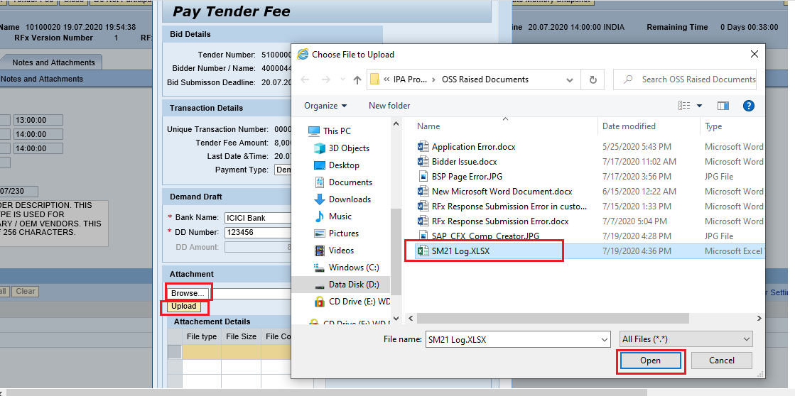

    - Once all the details are filled and document uploaded click on “Submit” button. A unique transaction number will be generated as shown below.

Click on “Close” button to close this window.

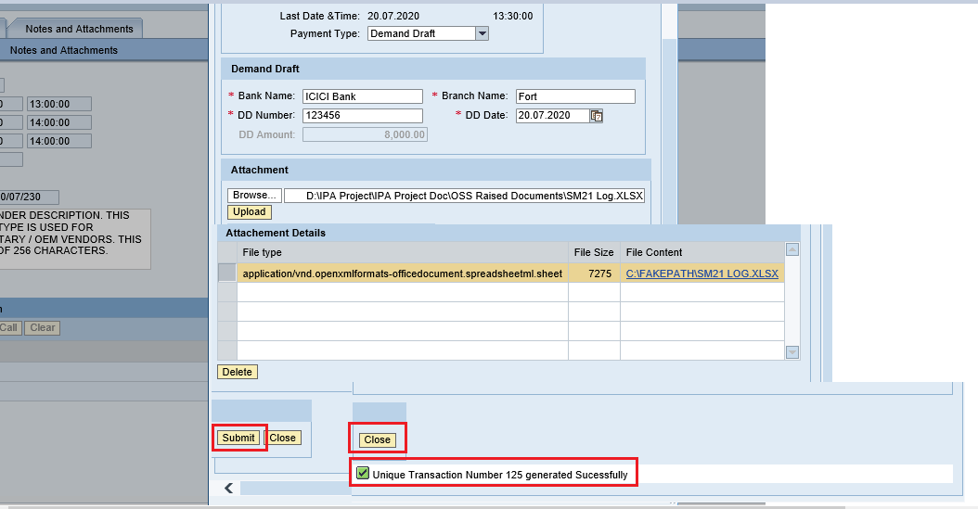

    - After paying and submitting documents required for tender fee, click on “Refresh” button. A new button “Pay EMD” button will be activated as shown in screenshot below.

    - Click on “Pay EMD” button. A new window will be displayed. There are various payment type options provided in the drop-down list. Select appropriate option.

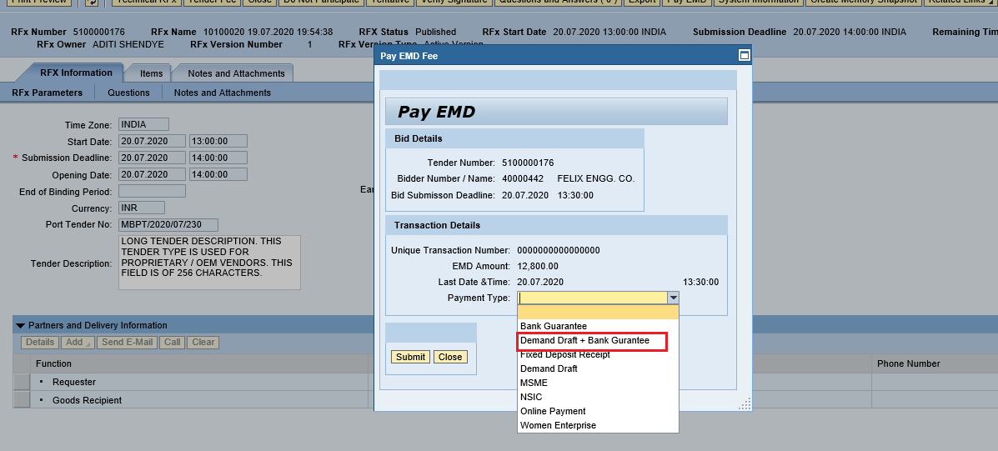

Payment Type | Payment Mandatory / Details required | Document to Upload
Demand Draft | Yes. Provide DD details | Yes
Demand Draft – Bank Guarantee | Yes. Provide DD & Bank Guarantee details | Yes
Fixed Deposit | Yes. Provide FD details | Yes
Bank Guarantee | Yes. Provide Bank Guarantee Details | Yes
MSME | No | Yes
NSIC | No | Yes
Women Enterprise | No | Yes
Online Payment

    - Provide all the required details as shown in screenshot below.

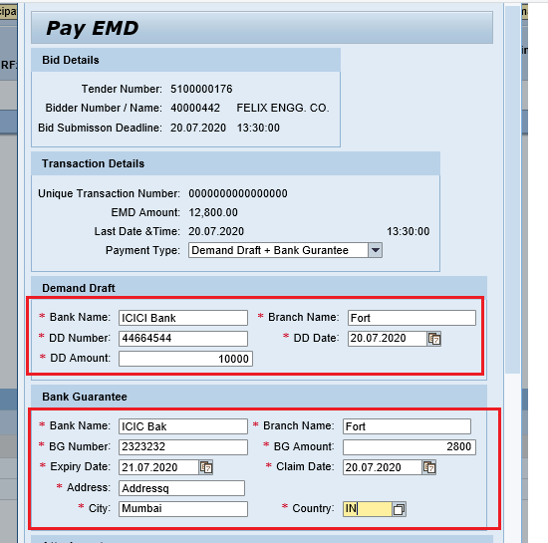

    - It’s mandatory to upload relevant supporting scan documents. Click on “Browse” button.

A new window will get opened. Select the appropriate scan copy and click on “Open” button.

Click on “Upload” button, document will get uploaded and saved.

Click on “Submit” button.

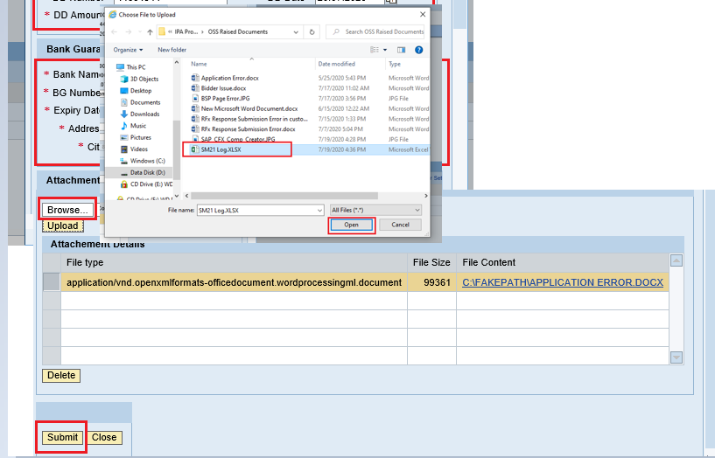

    - Once clicked on “Submit” button a unique transaction number will be generated. Note this number and then click on “Close” button to close this screen/window.

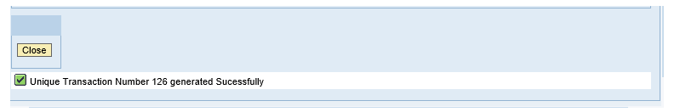

Create RFx Response

    - Once the tender and EMD Fee are submitted “Create Response” button will be visible automatically. Click on “Create Response” button as shown in screenshot below.

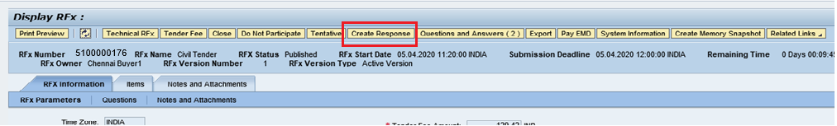

    - A new window will be displayed. Click on “Answer to RFx Parameter” button as shown in below screenshot.

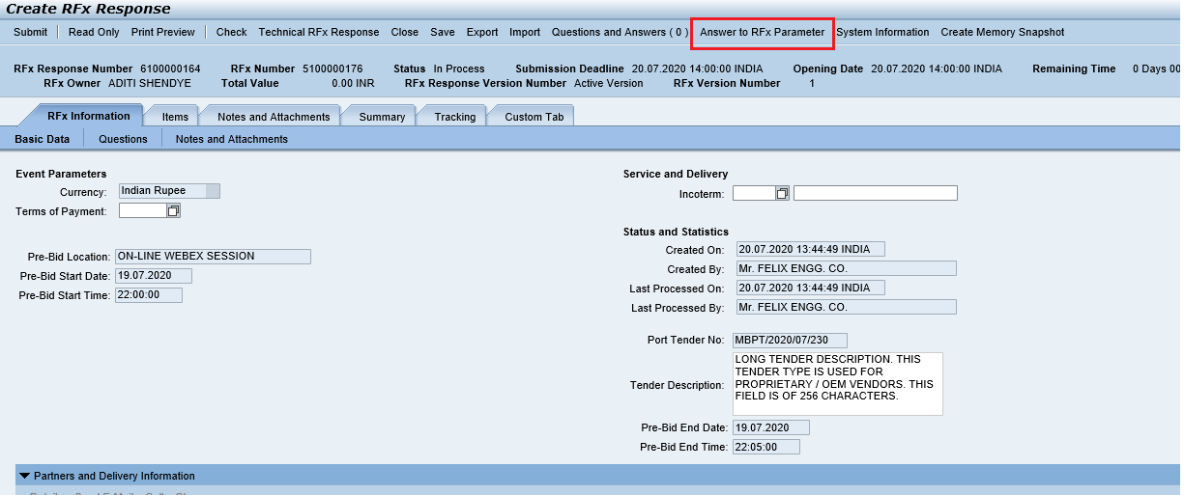

    - A new window will be displayed. Answer the questions, click on “Save” button & then click on “Close” button to close the window.

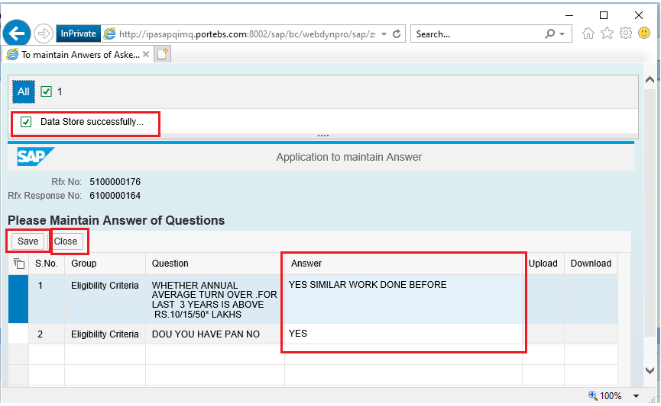

C-folder Attachments

    - To upload the documents, select “Notes and Attachments”. Click on “Add Attachment” located under the c-Folder Attachments option.

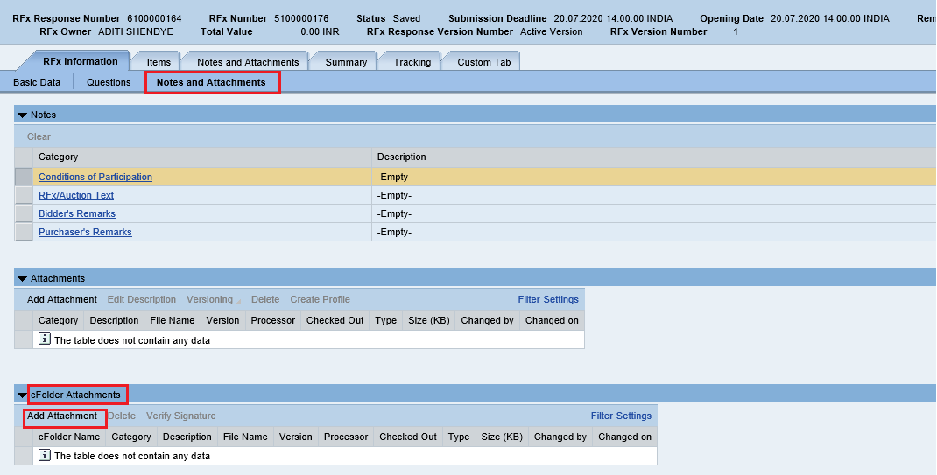

    - A new window will be opened. Select the folder as “Technical Bid” and then click on “Browse” button

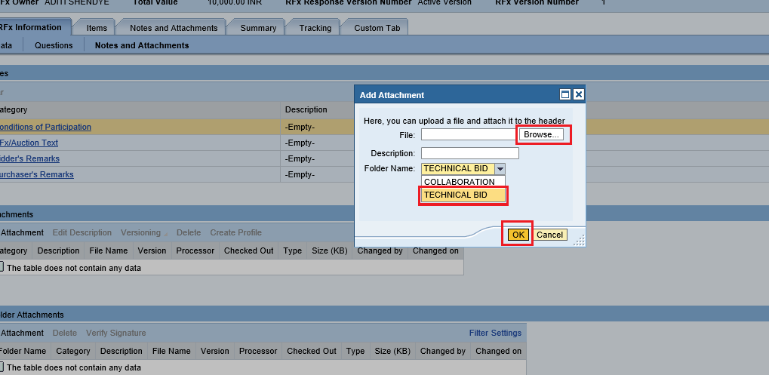
    - Select the relevant document and click on Ok button.

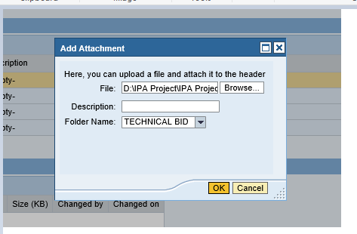

    - System will prompt to digitally sign the document. A new window will be displayed. Click on “Ok” button.

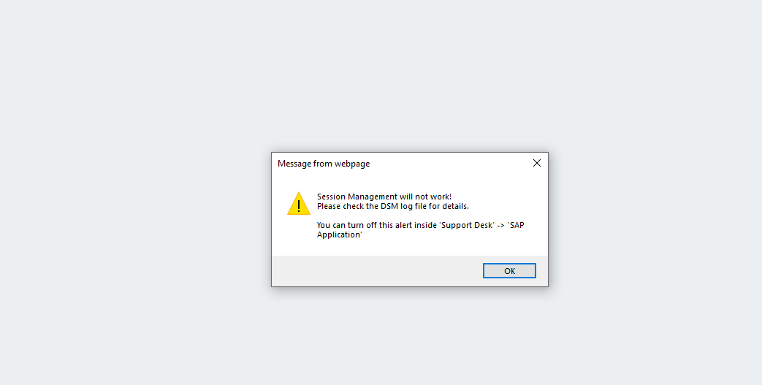

    - A new window will be pop-up. Select the digital signature and click on “Sign” button.

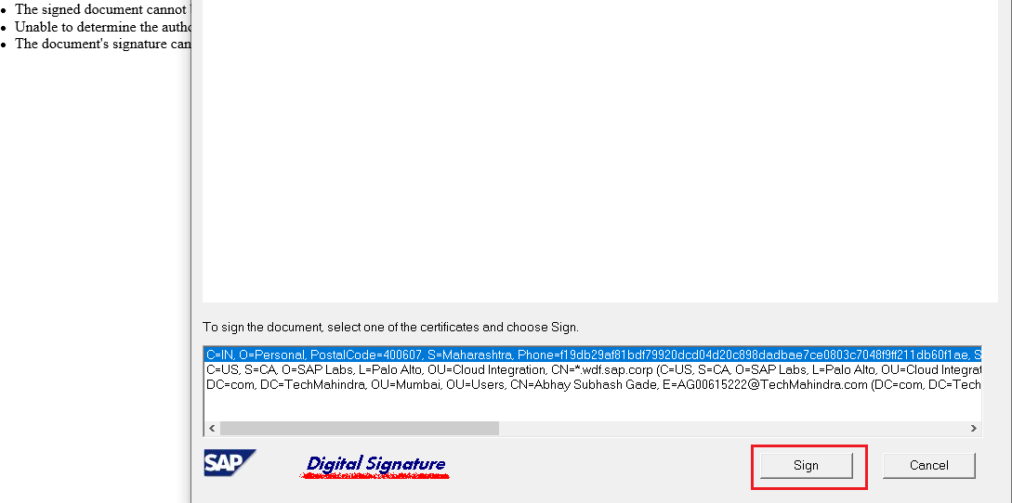

    - System further prompts to enter the password. Input the password and click on “Ok” button as highlighted in below screenshot

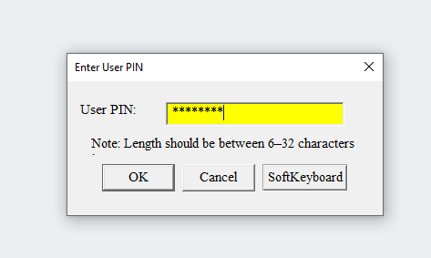

    - Again system will prompt a new pop-up window with the message that the document has been digitally signed by the user. See the screenshot below.

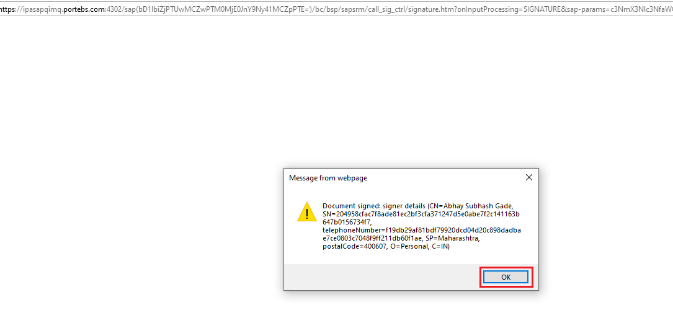

    - Similarly, you can upload the any other documents that may be required and are relevant.

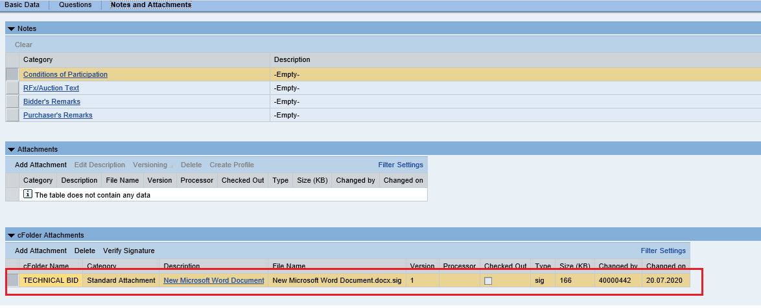

Maintaining the Price

    - To enter the price for the materials/services, select “Items” tab and input the amount under the “Price” column.

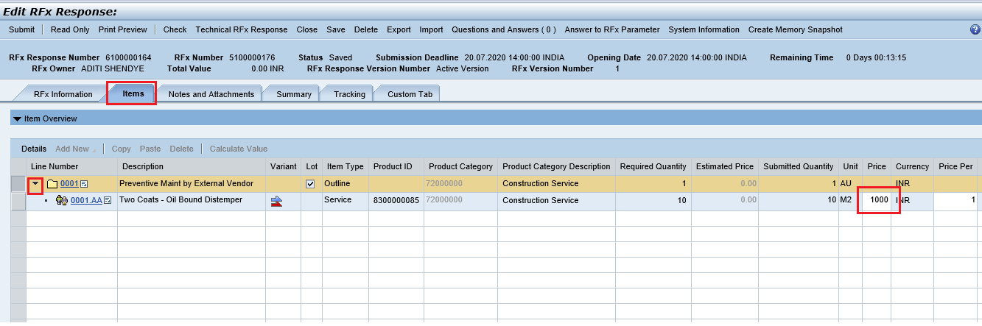

Response Submission

    - To check for any errors, click on the “Check” button. If any errors, system will prompt it in red color. Click on “Submit” button if no errors prompted by system.

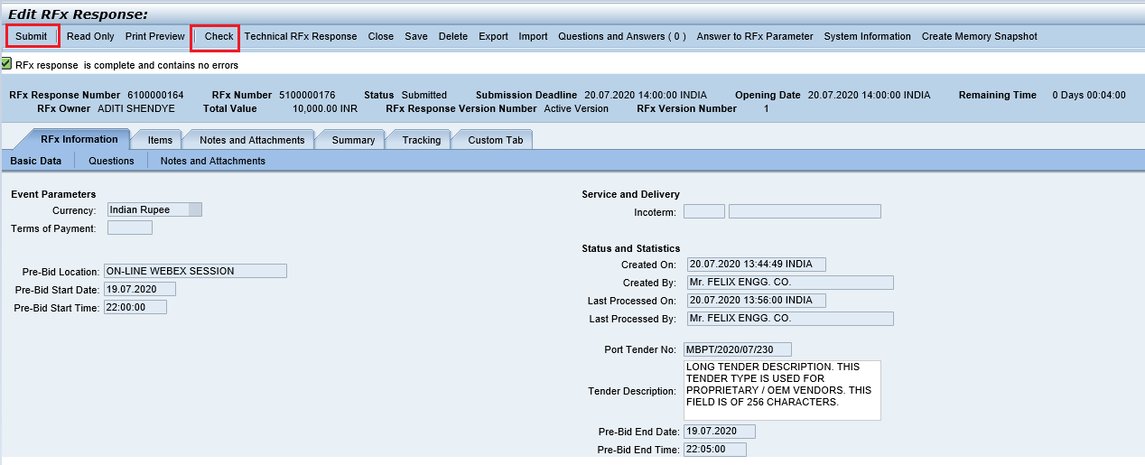

    - Once you click on this button as pop-up window will be displayed as below. Click on “Ok” button

    - A new window will be displayed prompting the select the digital signature. Select the signature and click on “Sign” button as shown in screenshot below

    - System further prompts to enter the password. Input the password and click on “Ok” button as highlighted in below screenshot

    - Again system will prompt a new pop-up window with the message that the RFx has been digitally signed by the user. See the screenshot below

    - System displays message as “RFx Response 61xxxxxxxx submitted”.

