Indian Ports Association (IPA)
Implementation of Port EBS Project
Enterprise Business System

Business Process Manual for
Manager Self Service

Submitted by:

Plot No. 58 A & B,
Noida Special Economic Zone,
Uttar Pradesh-201305

www.techmahindra.com

Document History:

Authors & Participants
Role | Name

Revision History
Date | Document  Version | Document Revision  Description | Author
18.03.2020 | 1.0 | Initial Draft | Divya

Reviewed and Approved By
Name | Title | Date | Approved

Introduction:
The purpose of the document is to give awareness of the complete cycle of processes in Manager Self Service (MSS) portal to the respective users.
Summary:
Contents
- Employee/Manager Login Portal: 5
1.1 Manger Overview Page 5
- Home Page: 6
- Work overview: 7
- Team: 7
- Talent Management: 8
- Planning: 9
- Project: 10
- Budget: 10
- Organization: 11
- Reports: 12
- Substitution Overview: 12
- Approvals tab 14
12.1 Attendance Approval: 14
12.2 Claims Approval: 14
12.3 Loan Approvals: 17

Abbreviations
Abbreviation | Description
ESS | Employee Self Service
MSS | Manager Self Service
EG | Employee Group
ESG | Employee sub group
PA | Personnel area
PSA | Personnel Sub area
P | Position
CM | Content Management
IT | Info type
EE | Employee
PE | Pensioner
FRS | Functional Requirement Specification
OM | Organizational Management
LSO | Learning Solutions

Employee/Manager Login Portal:

Employees have to log in with their own ID and Password. Once the employee logged in then the home page appears

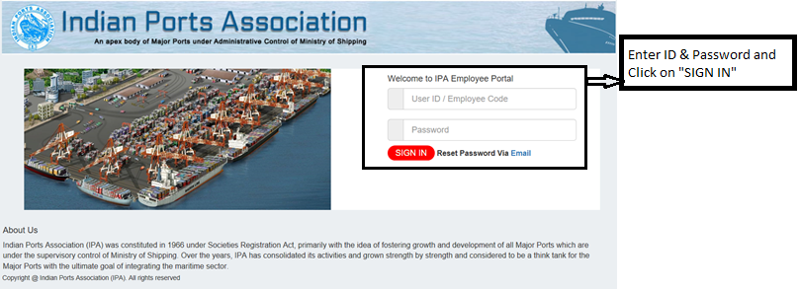

1.1 Manger Overview Page
When manager or employee logs in the home page appears. It will have both ESS and MSS tabs. In ESS tab manager can use employee service’s and in MSS tab, he can see all his employee request and project details etc. top right corner will be Employee name and time stamp details.

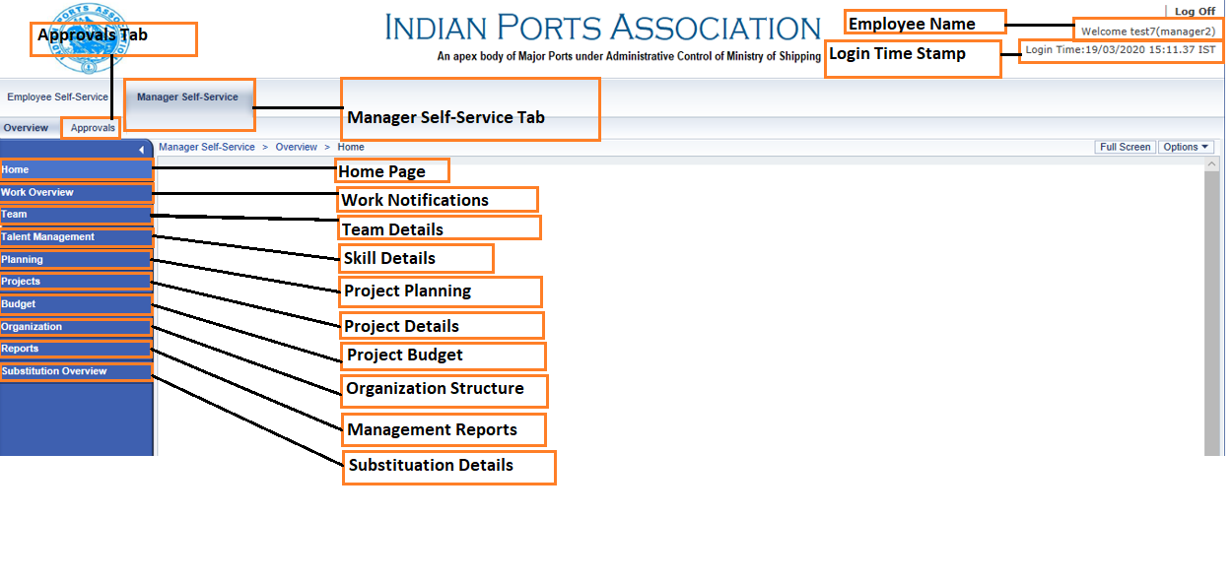

Home Page:
In Home page manager can see his reporting employee’s birthday and anniversaries notifications.it has shortcut for team calendar details.

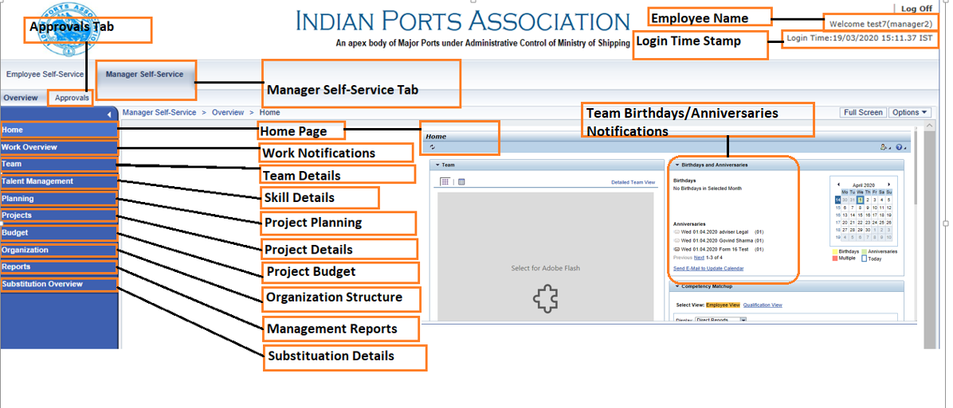

Work overview:
In Work, overview page manager can see all the UWL components of his reporting employee request like Leave request, Lost/Damaged Id card request etc. manager can approve or reject form here. Manager can also see his tasks assigned and alerts if any.

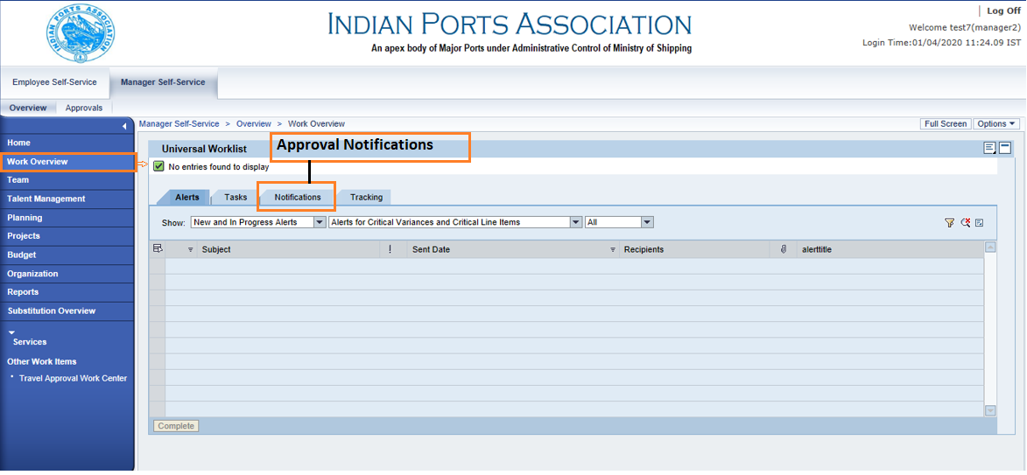

Team:
Manager can see all his team details like their leaves, status of attendance, calendar etc.
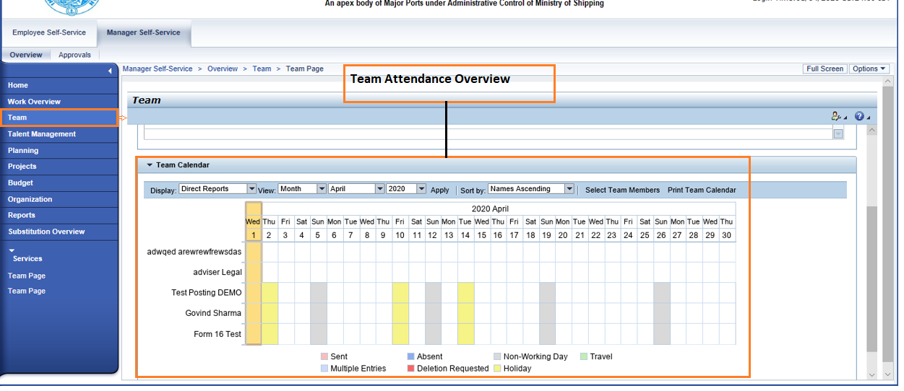
Attendance Overview
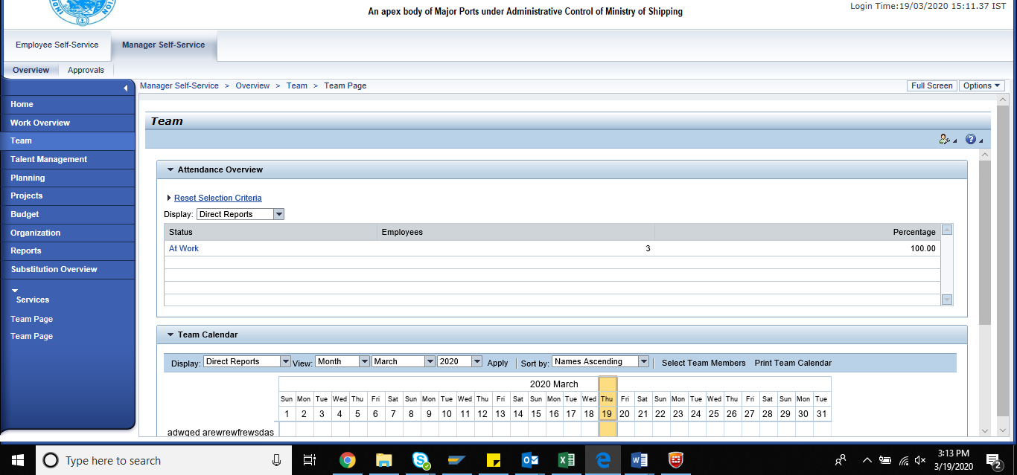

Talent Management:
It has reports to analyze employee skills according to the requirement. Manager can view his tem skills employee wise, qualification and assign work accordingly. 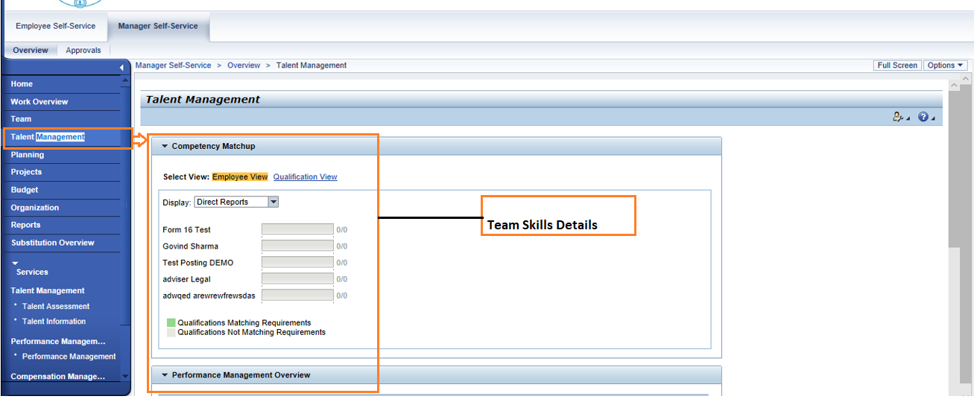

Planning:
Project planning details will be available in planning. It has services like planning rounds and report on the project.
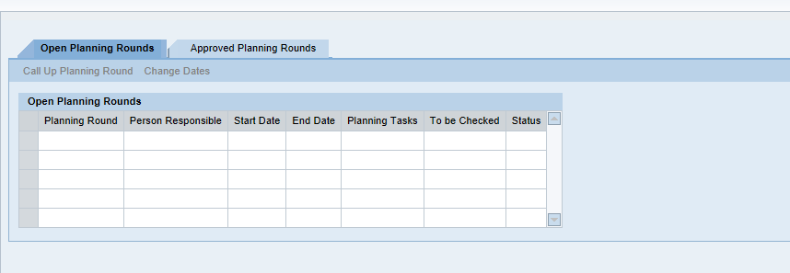
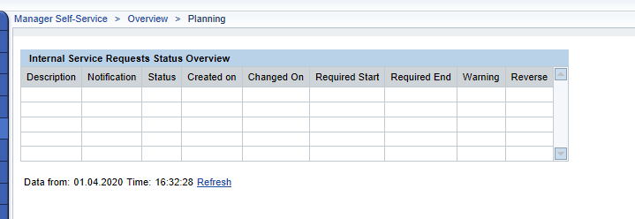

Project:
Manager can view the details of the project which he is handling and can view report on them.
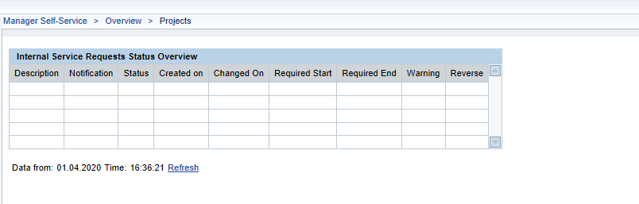

Budget:
Manager can view report on the budget allocated for each project he is handling.

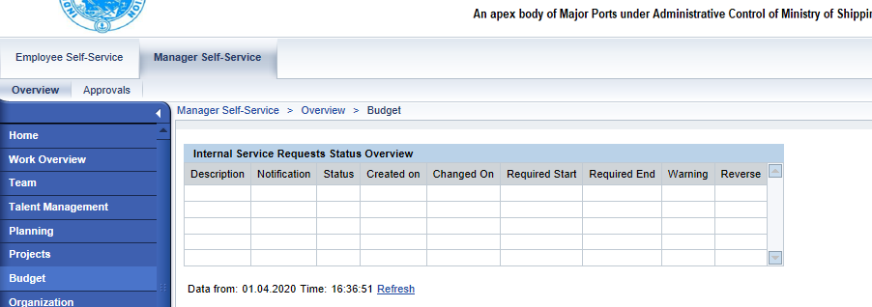

Organization:
Manager can view his department’s organization structure and can decide on the position handling for his department.
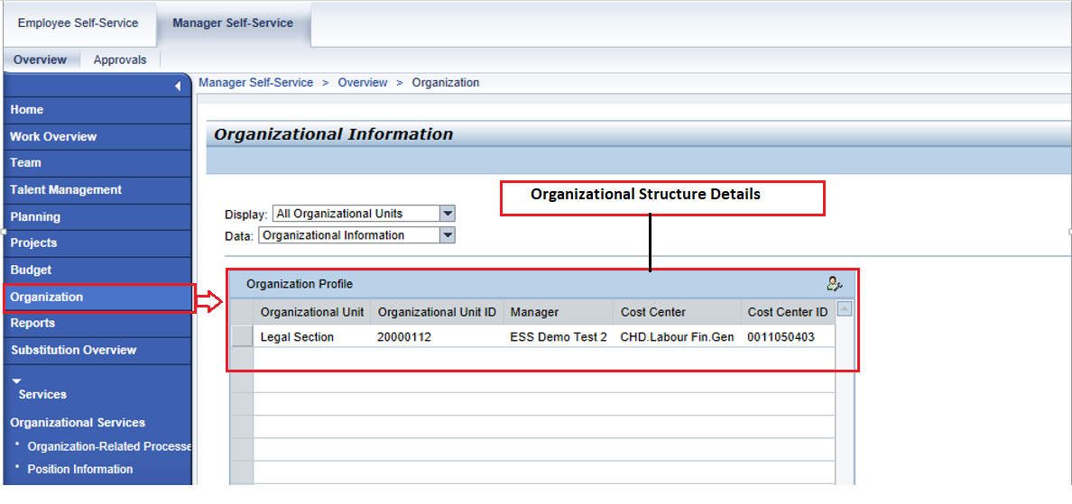

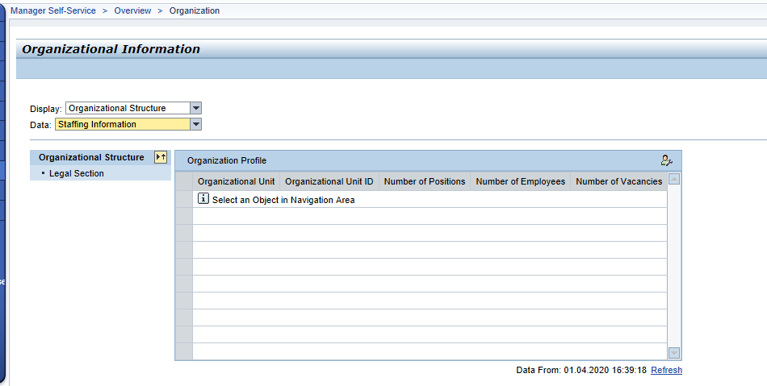

Reports:
Project required reports are available here. Reports like Position strength in the department, Personal data of his employees, Employee skill reports etc.

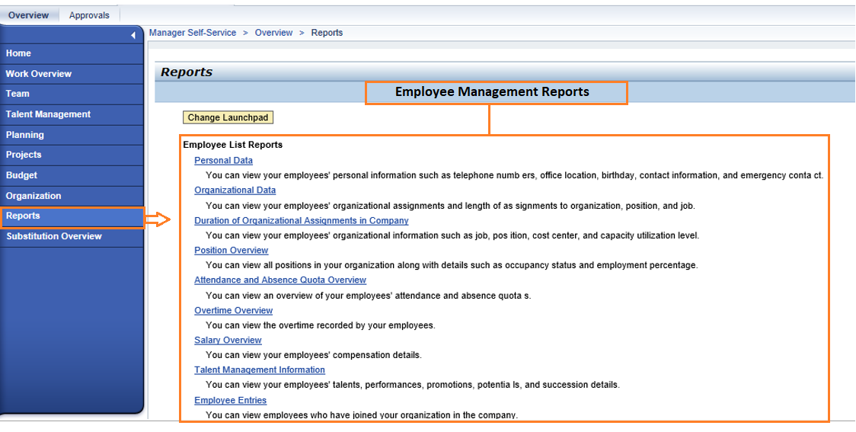

Substitution Overview:

Substitution report are available here. Manager can view the overview of substitution for a particular period. It also has services like manager substitution rules. Manager can create rules according to the requirement.
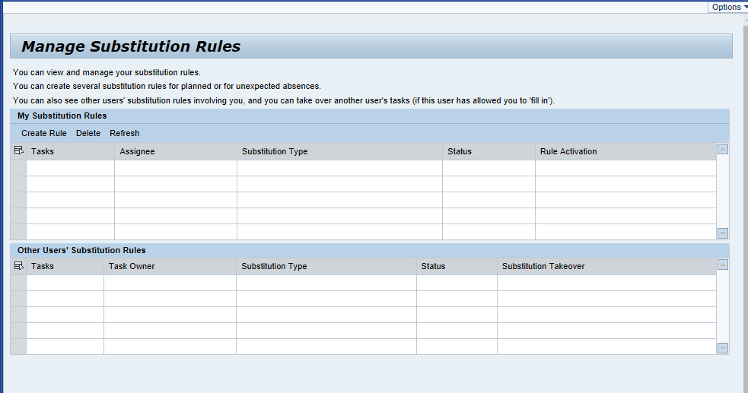
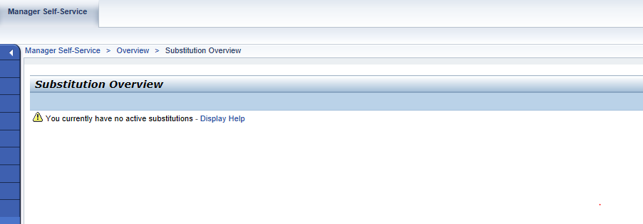

Approvals tab
Manager has separate tab for Loans, claims, and Attendance approvals.

12.1 Attendance Approval:

Based on the employee biometric if the employee worked for over time or employee is substituting his work or employee if working on a holiday it requires manager approval. Manager can view all these type of request and Approve or Reject accordingly.

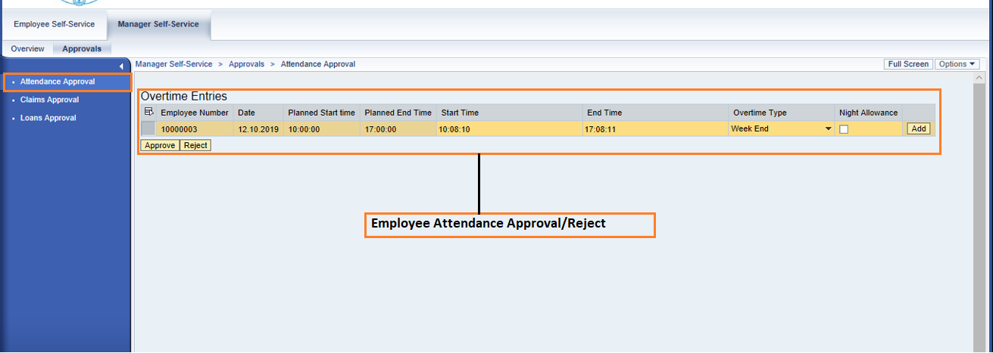

The list contains the employee number, his start time and end time and f it is overtime them overtime type. Manager can change overtime type from single to double or any other accordingly. Manager can change by clicking on add button on specific employee row. If manager wants to give night shift allowance for a specific employee, he has to check the Night allowance on employee record.

12.2 Claims Approval:

Manger can view the list of reimbursements his employees raised. Manager can edit the details based on the eligibility and Approve or reject employees claim. On selecting the employee record and clicking on change button, a new window will be opened with details. Manager can edit and Approve or reject.
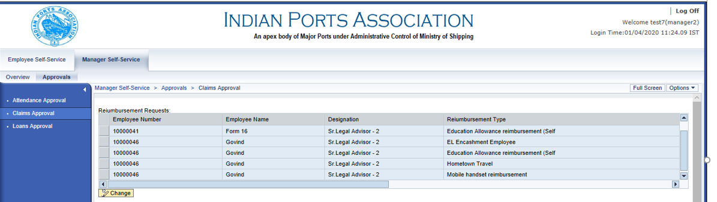

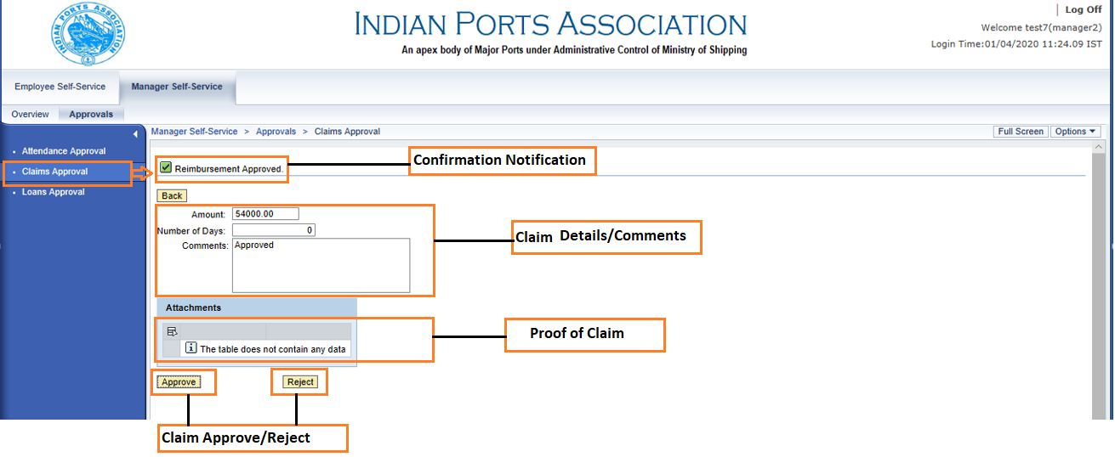
Manager can give comments in comments section and approve or reject. Confirmation notification is seen after Approve or reject and mail notification is sent to the employee.

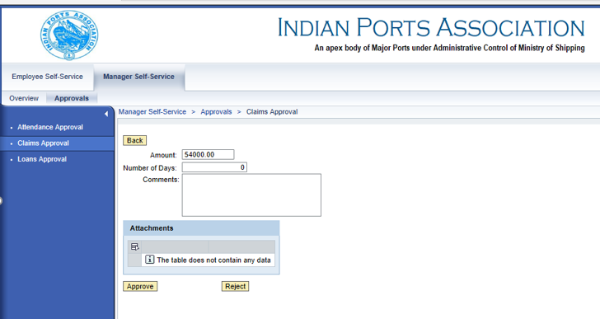

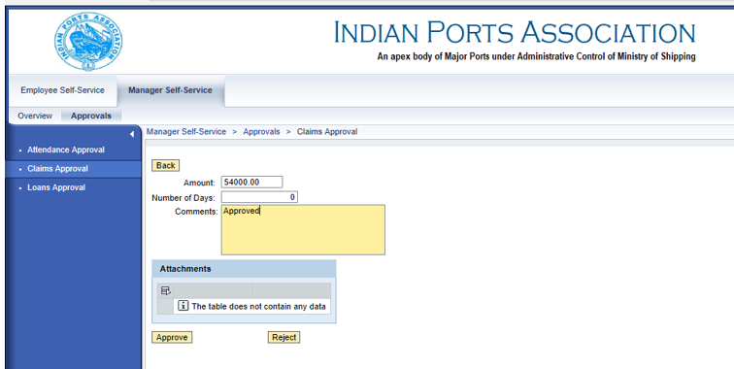

Based on the approval the claim will be stored in SAP and will be processed in payroll.

12.3 Loan Approvals:
Manger can view the list of Loans/Advances his employees raised. Manager can edit the details based on the eligibility and Approve or reject employees Loan. On selecting the employee record and clicking on change button, a new window will be opened with details. Manager can edit and Approve or reject.
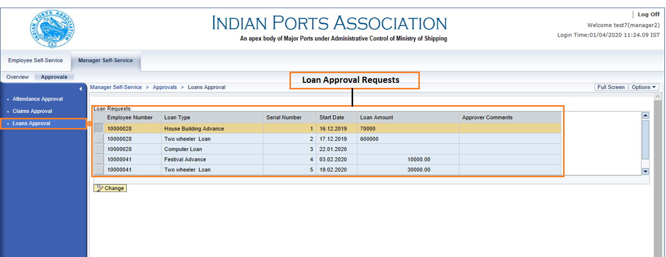

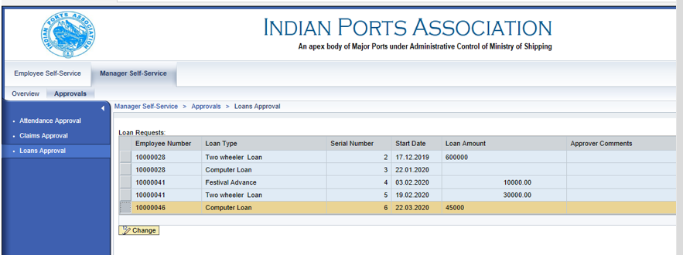

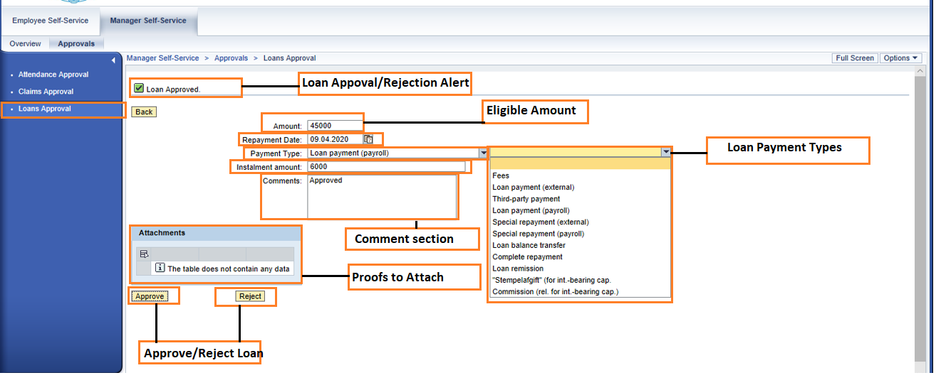
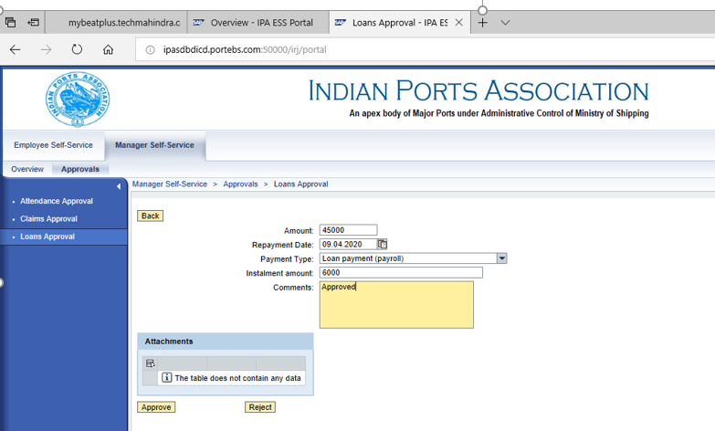
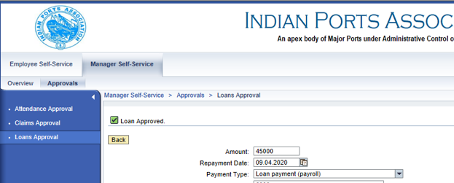

Based on the Approval the loan record will get stored in SAP and processed accordingly.

If rejected, Notification message will be seen.

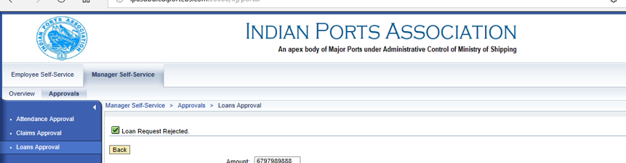

Disclaimer:

Tech Mahindra Limited, herein referred to as TechM provide a wide array of presentations and reports, with the contributions of various professionals. These presentations and reports are for informational purposes and private circulation only and do not constitute an offer to buy or sell any securities mentioned therein. They do not purport to be a complete description of the markets conditions or developments referred to in the material. While utmost care has been taken in preparing the above, we claim no responsibility for their accuracy. We shall not be liable for any direct or indirect losses arising from the use thereof and the viewers are requested to use the information contained herein at their own risk. These presentations and reports should not be reproduced, re-circulated, published in any media, website or otherwise, in any form or manner, in part or as a whole, without the express consent in writing of TechM or its subsidiaries. Any unauthorized use, disclosure or public dissemination of information contained herein is prohibited. Unless specifically noted, TechM is not responsible for the content of these presentations and/or the opinions of the presenters. Individual situations and local practices and standards may vary, so viewers and others utilizing information contained within a presentation are free to adopt differing standards and approaches as they see fit. You may not repackage or sell the presentation. Products and names mentioned in materials or presentations are the property of their respective owners and the mention of them does not constitute an endorsement by TechM. Information contained in a presentation hosted or promoted by TechM is provided “as is” without warranty of any kind, either expressed or implied, including any warranty of merchantability or fitness for a particular purpose. TechM assumes no liability or responsibility for the contents of a presentation or the opinions expressed by the presenters. All expressions of opinion are subject to change without notice.

