Indian Ports Association (IPA)
Implementation of Port EBS Project
Enterprise Business System

Business Process Manual for
Employee Self Service

Submitted by:

Plot No. 58 A & B,
Noida Special Economic Zone,
Uttar Pradesh-201305

www.techmahindra.com

Document History:

Authors & Participants
Role | Name

Revision History
Date | Document  Version | Document Revision  Description | Author
18.03.2020 | 1.0 | Initial Draft | Divya

Reviewed and Approved By
Name | Title | Date | Approved

Introduction:
The purpose of the document is to give awareness of the complete cycle of processes in Employee Self Service (ESS) Portal to the respective users.
Summary:

Abbreviations
Abbreviation | Description
ESS | Employee Self Service
MSS | Manager Self Service
EG | Employee Group
ESG | Employee sub group
PA | Personnel area
PSA | Personnel Sub area
P | Position
CM | Content Management
IT | Info type
EE | Employee
PE | Pensioner
FRS | Functional Requirement Specification
OM | Organizational Management
LSO | Learning Solutions

Contents
1. Employee Login Portal: 4
1.1 Employee Home Page: 5
2. Personal Information: 7
2.1 Identification Type: 7
2.2 Address Types : 8
2.3 Communication Types: 9
2.4 Personal information : 9
2.5 Family Details: 10
2.6 Bank Details 11
3. Working Time: 13
3.1 Create Leave Request 13
3.2 Display Leave: 15
3.3 Change Leave Request: 16
3.4 Cancel Leave Request: 17
3.5 Leave Entitlements 18
4. Benefits and Payments: 19
4.1 Cafeteria Allowance: 19
4.2 Form16 Display: 21
5. Employee Request: 22
5.1 Lost/Damaged ID card: 22
5.2 Reimbursement request : 23
5.3 Loan Request : 27
5.4 Voluntary Provident fund Request : 28
6. Property Declarations: 29
7. Authorizing table: 31

Employee Login Portal:
Employees have to log in with their own ID and Password. Once the employee logged in then the home page appears.
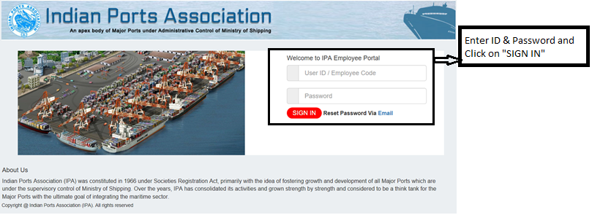

1.1 Employee Home Page:

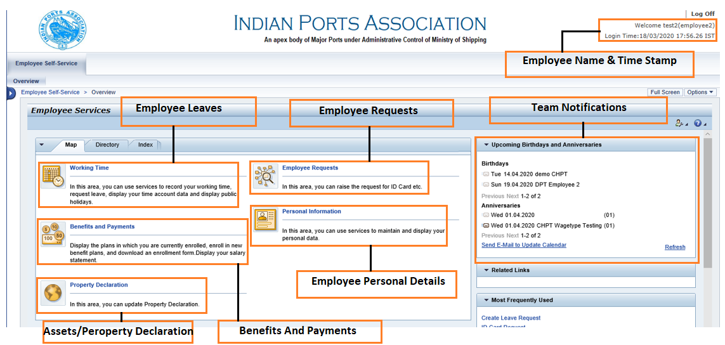
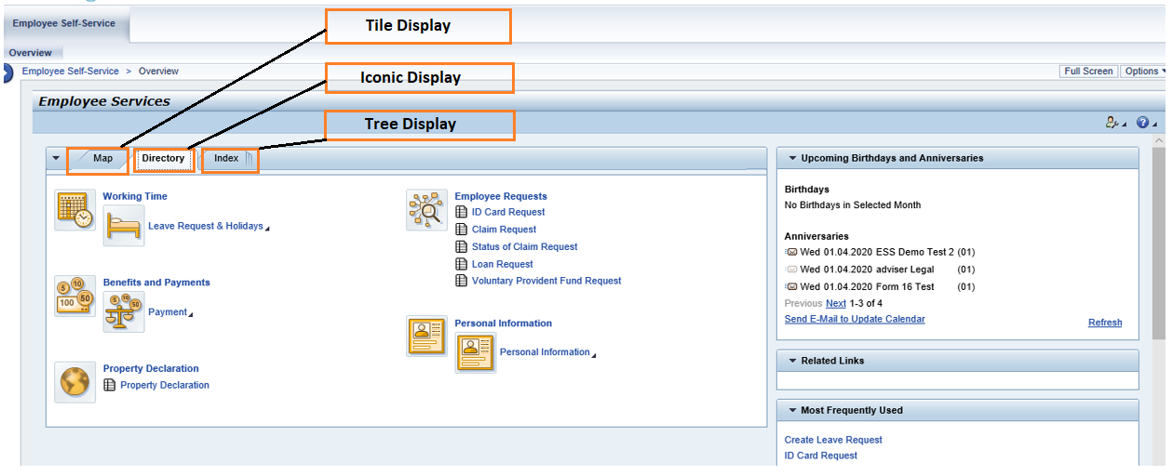

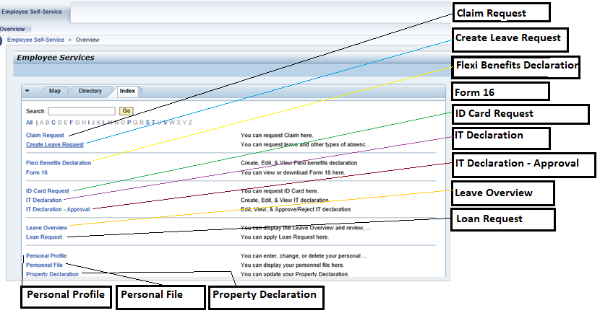

All request type will be there in their respective tiles and Login details will be there in the right corner.

Personal Information:
Employee related data would be displayed here. Employee can edit his details from here. Edit or delete will be applicable based on authorizations.
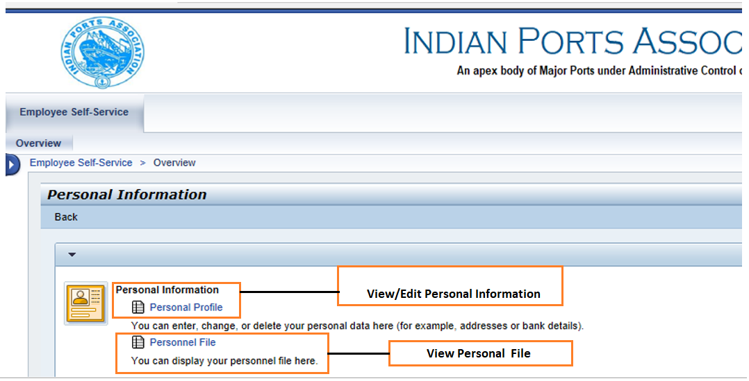

2.1 Identification Type:
Different types of ID are available here like PAN/ Aadhaar/ TAN. Employee can vie/edit/delete the details.
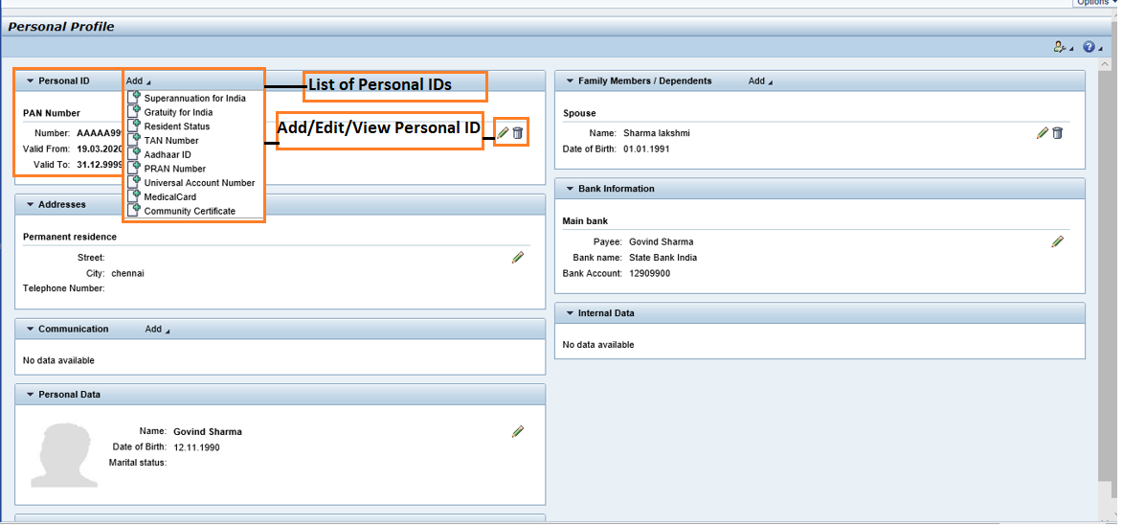

Edit any ID type
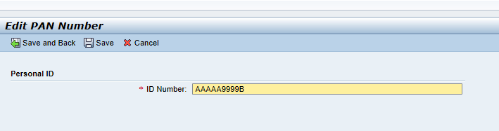
When clicked on save
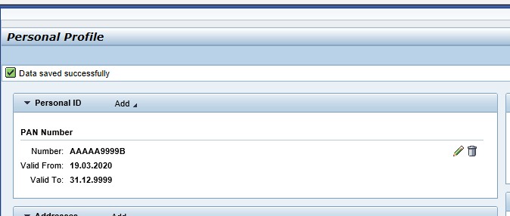

2.2 Address Types :
Address Types like permanent / temporary/ office are available. Employee can view/edit/delete the details.
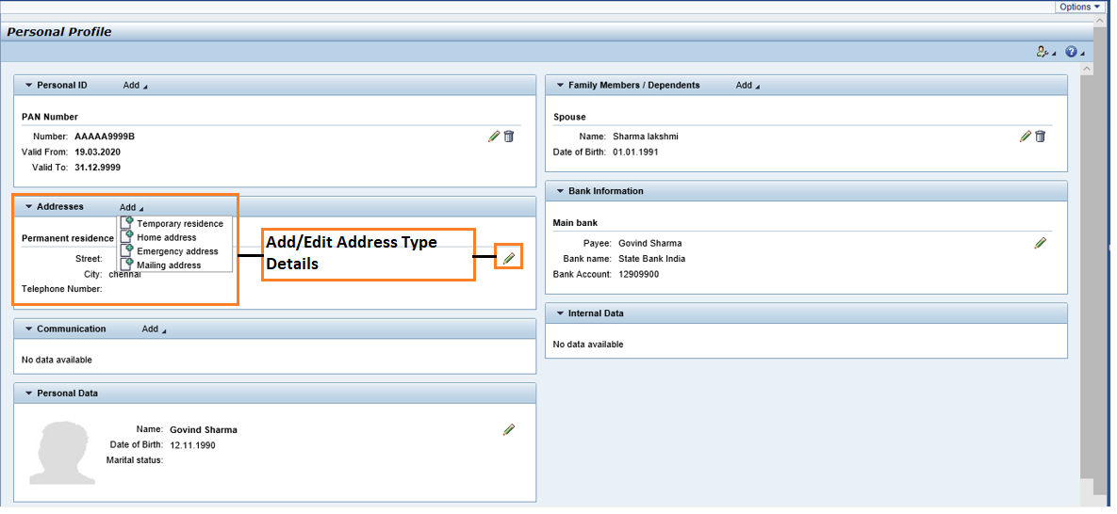

2.3 Communication Types:
Communication types like Email ID/ Telephone number are available. . Employee can view/edit/delete the details.
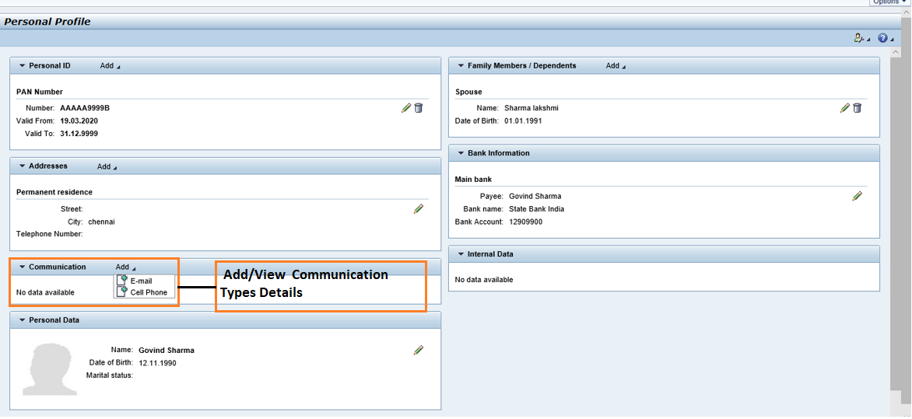

2.4 Personal information :
Personal information like Employee name /Date of Birth/Employee Photo are available. Employee can view/edit/delete the details.
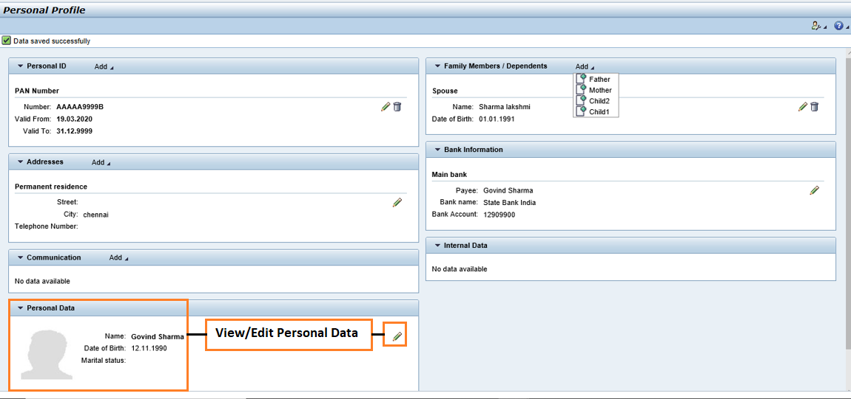
If you want to edit any personal details
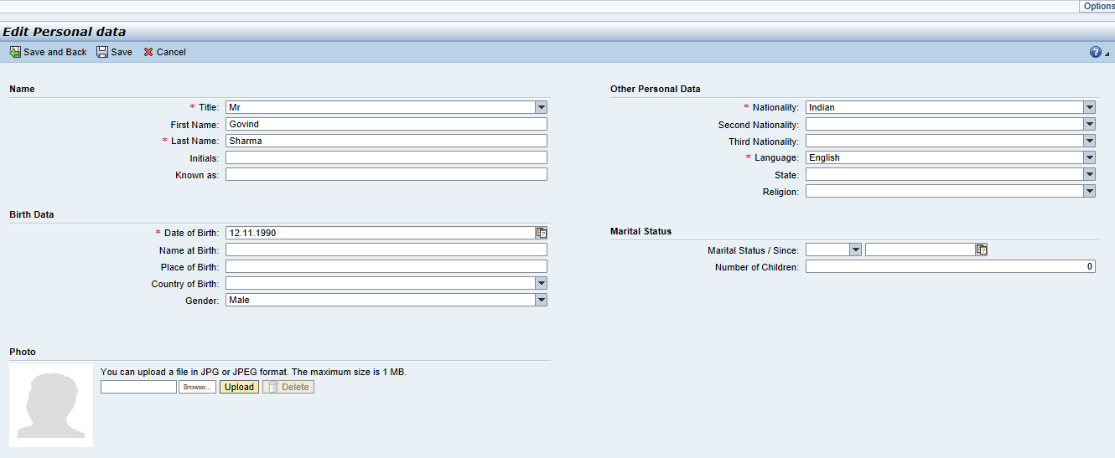
When clicked on save ,success message will be displayed.

2.5 Family Details:

Employee Family details like Spouse/child1/child2/Father/Mother details are available. .Employee can view/edit/delete the details.
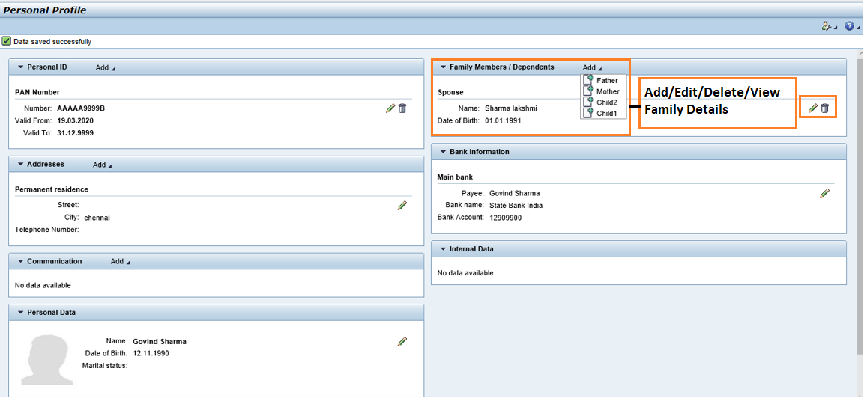
Edit any family details
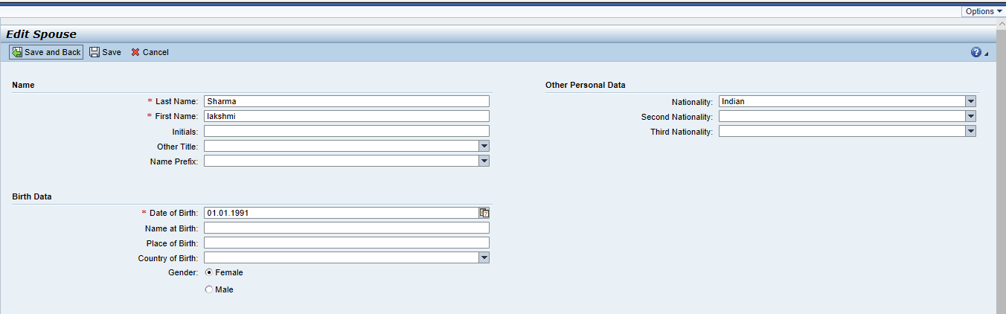
Success message will be display if we click on save.

2.6 Bank Details
Employee bank details like main bank name /branch name/A/c number are available. .Employee can view/edit/delete the detail
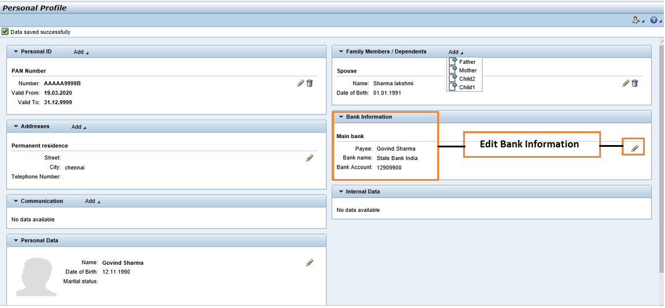

Success message will be display when clicked on SAVE.

Working Time:
Employee leave related information will be seen in Working time Tile .It will have details for creating leave, Changing leave ,Cancelling Leave , leave history, and leave entitlements . Holiday calendar is also available.

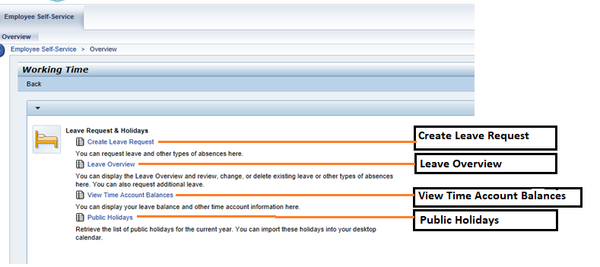

3.1 Create Leave Request

Employee can raise a leave request from here. He can choose the dates and give the reason in the note section. Eligibility check differs based on leave types.
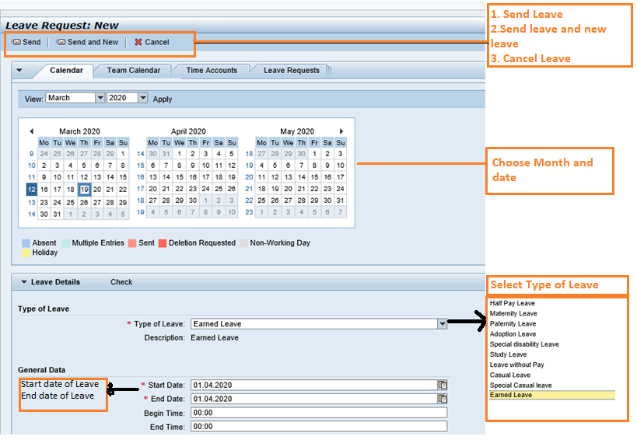
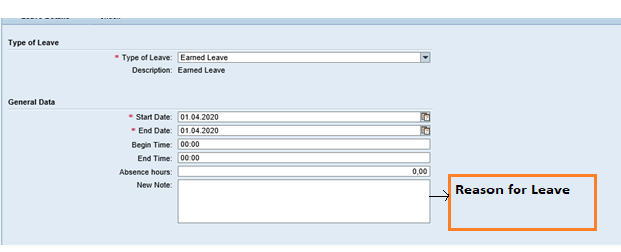
When clicked on send it will ask for the confirmation. Once sent, we can view applied leave in Leave request Or Leave Overview.
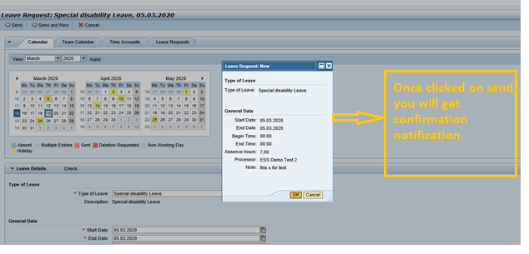
Success message for successfully applying a leave.
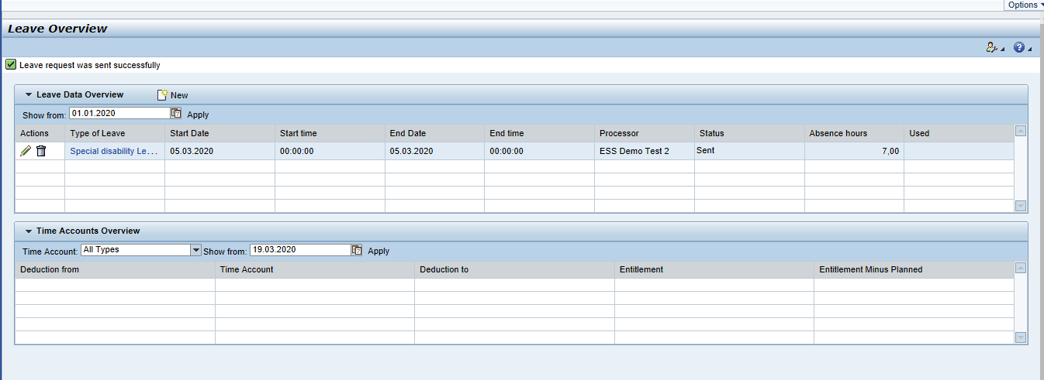

3.2 Display Leave:
Employee can check the leave history in Leave Request Tab while applying for new leave Or cen view in Leave overview tab.
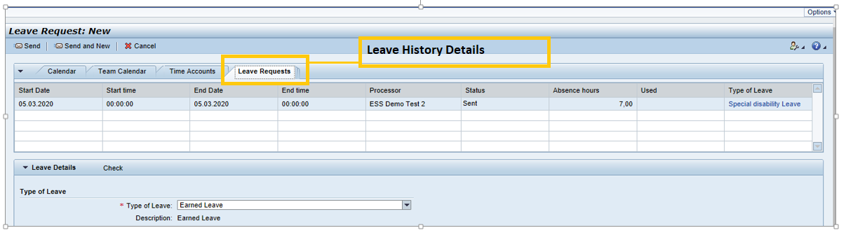

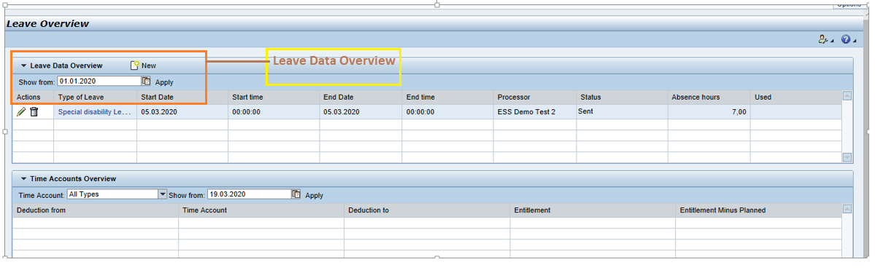

3.3 Change Leave Request:
Employee can change the dates of the applied leave. If employee wants to change the dates for already approved leave then for changing, it will again require for different levels of approval.
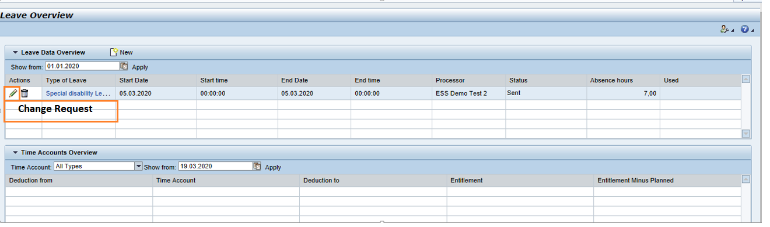
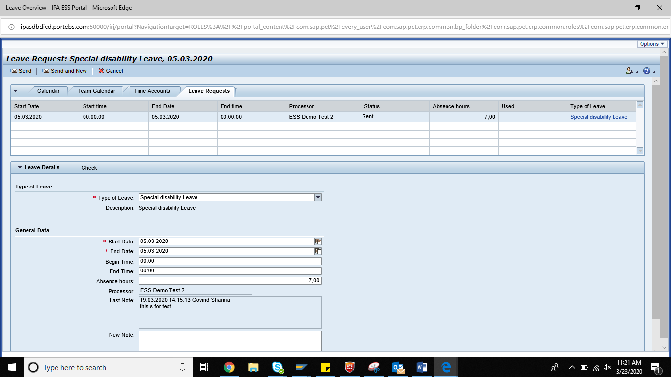

3.4 Cancel Leave Request:
Employee can delete the applied leave. If employee wants to delete for already approved leave then for deleting, it will again require for different levels of approval.
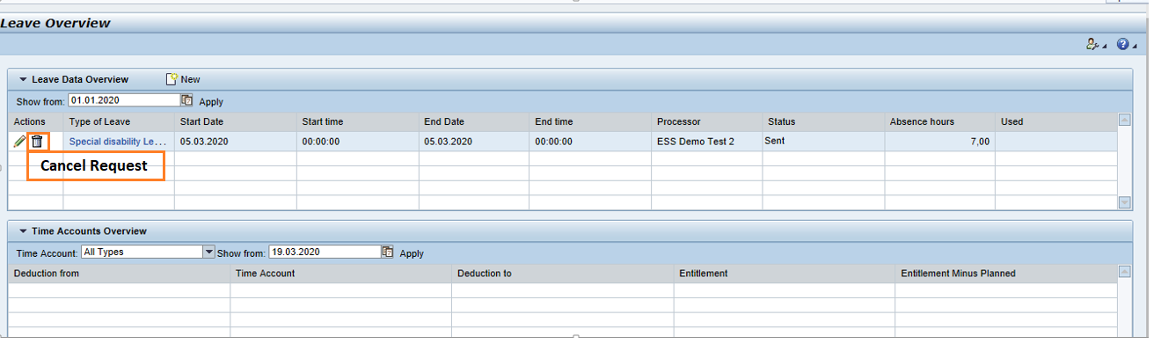
For Cancel, confirmation message will be displayed.
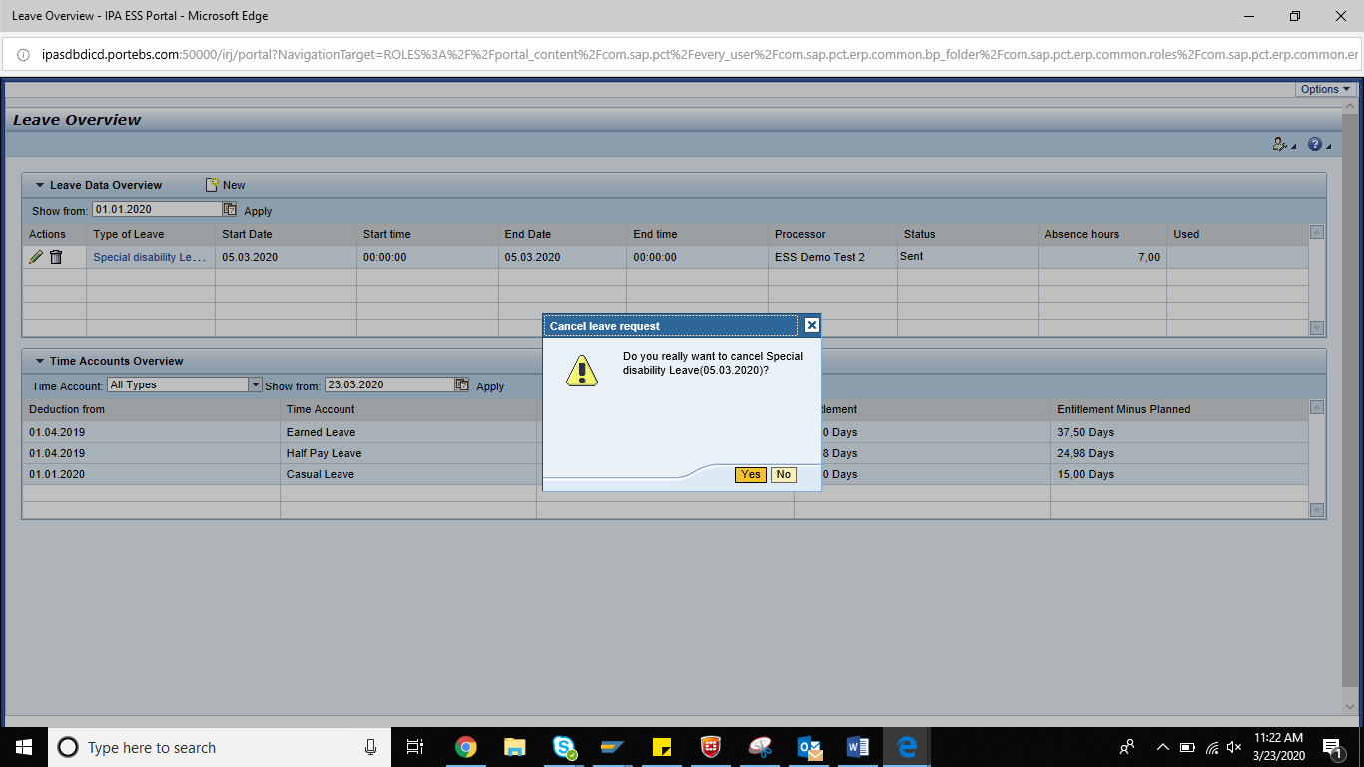

3.5 Leave Entitlements
Employee Leave entitlements will only be there for Earned /half-pay/casual leave. These details we can see in Time account tab.

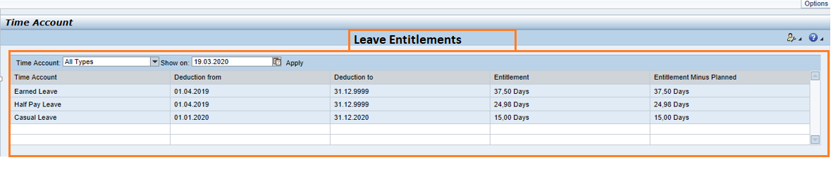

Benefits and Payments:
Employee Payment details like payslip, form16, Cafeteria allowance and IT declarations for tax will be available here.

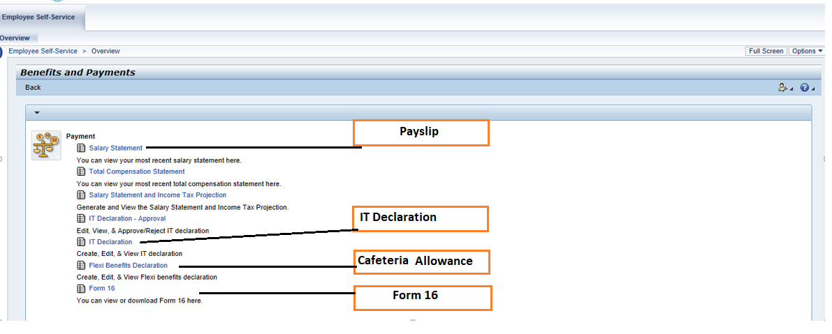

Cafeteria Allowance:
This is applicable for only class I and Class II employees. They can choose the required allowance type from the predefined list.
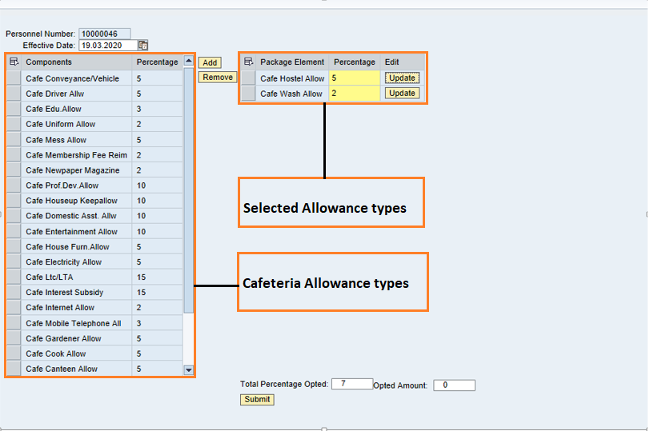
Success message will be display once submitted and the corresponding info types will be updated.
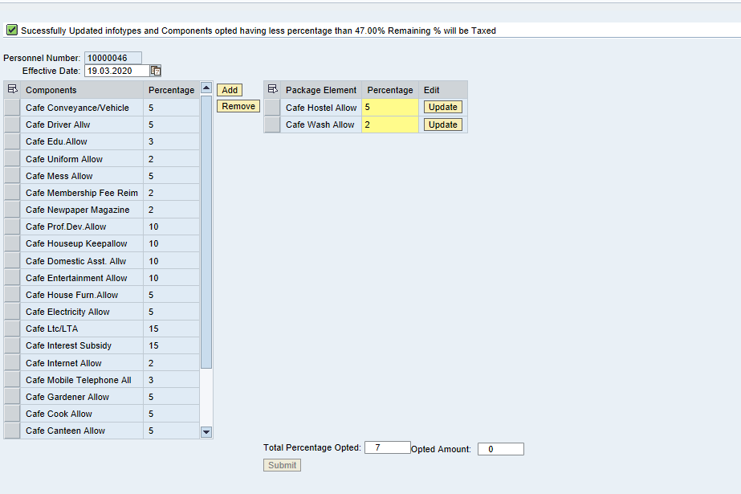

4.2 Form16 Display:
Employees Form 16 are available employee can chose the year for specific Form 16.

Employee Request:
Employees request for Reimbursement (Festival advance/ PF withdrawal/telephone/education etc.), Loan (vehicle loan,PF ,Computer etc. ), VPF declaration , status of request will be available in employee request tile.
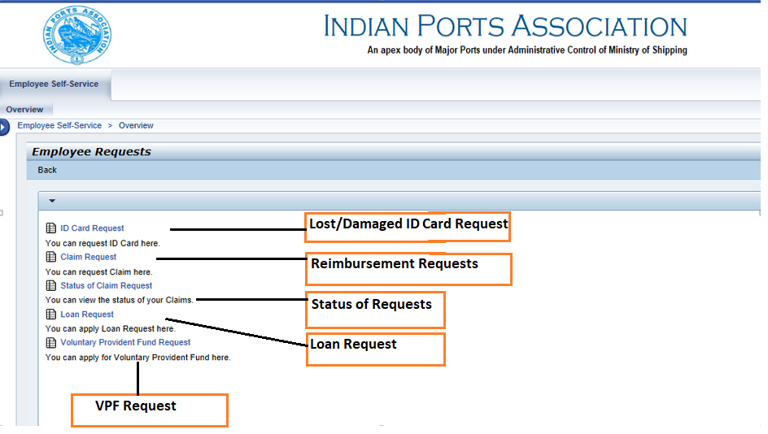

5.1 Lost/Damaged ID card:
If employee wants to raise for Lost or damaged ID card, this will be raised from here. Once raised it will go for approval and once approved notification will be send to specific department for issuing new ID.For lost or damaged, there will be a port specific deduction in payroll.

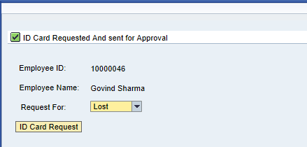

5.2 Reimbursement request :
Employee can raise different types of reimbursements and the checks are specific to reimbursement type.
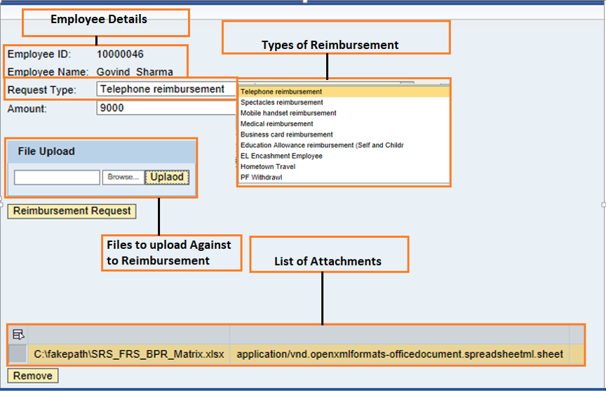
Reimbursement will be submitted once we clicked on Reimbursement Request. If success , success message will be displayed.
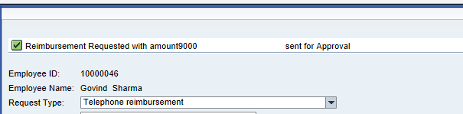
Eg : other reimbursement request
Leave Encashment:
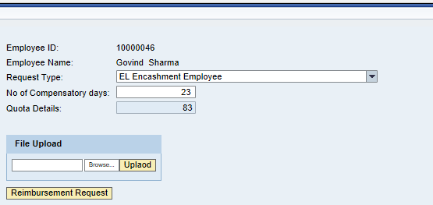

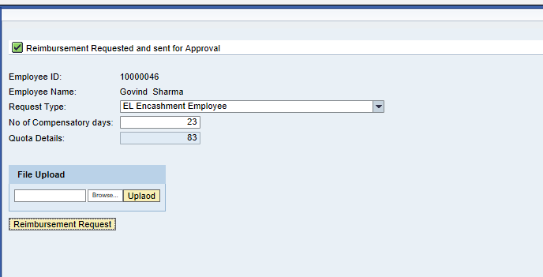
b. Education allowance:
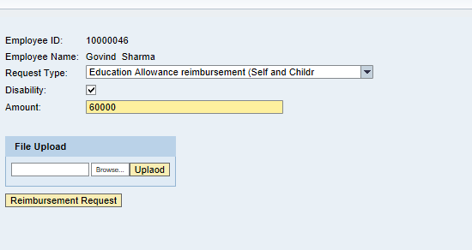
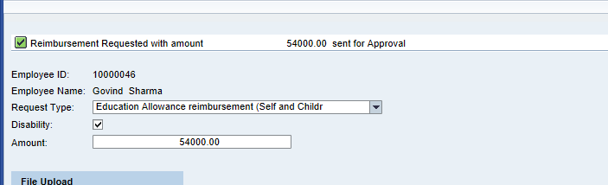

c. PF withdrawal
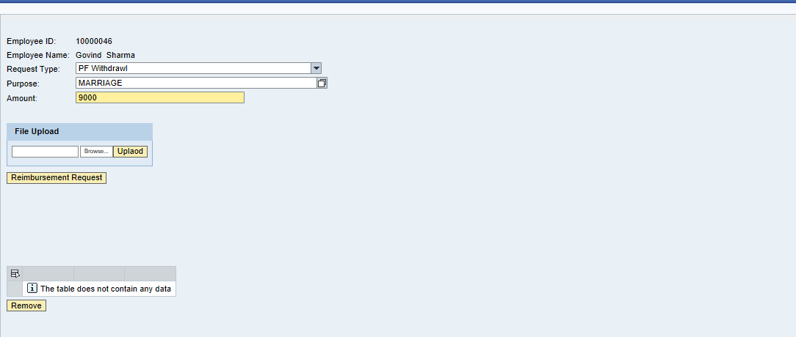
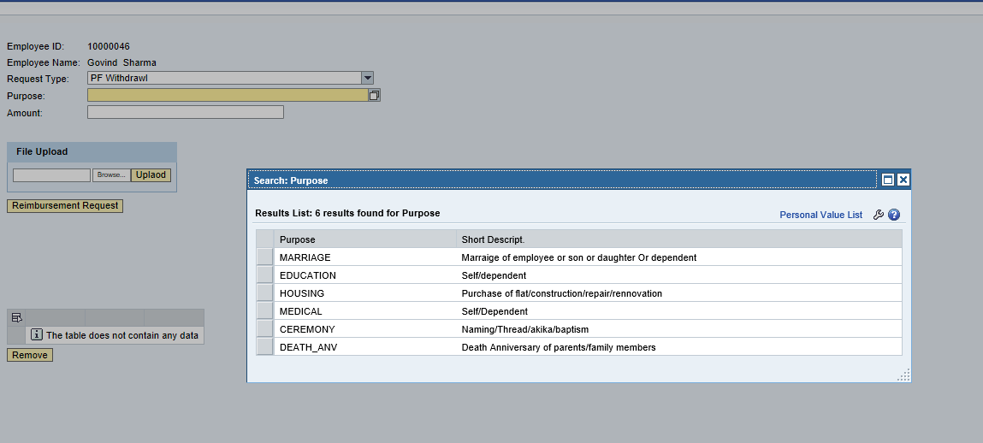
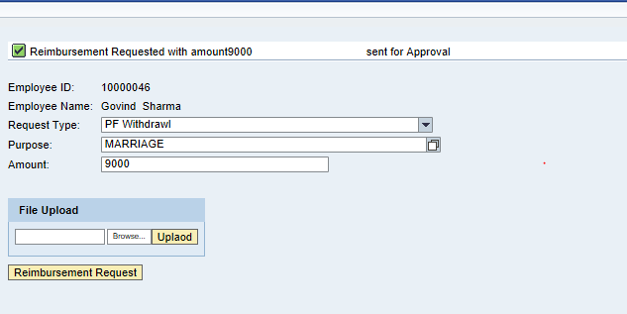

5.3 Loan Request :
Employee can raise the loan request from here and eligibility differs for each loan types.
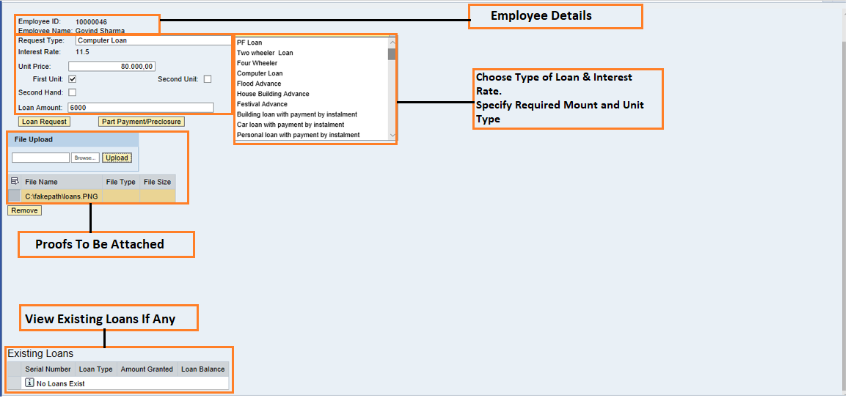

5.4 Voluntary Provident fund Request :
Employee can opt for voluntary provident fund percentage and this will be raised over here.
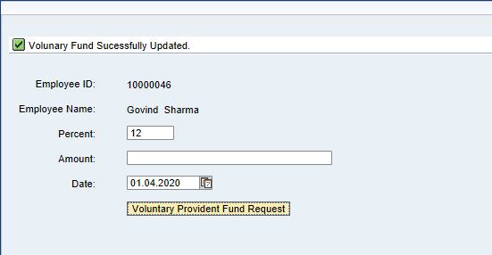

Property Declarations:

Employee can declare their property declarations every year in the property declaration tab.
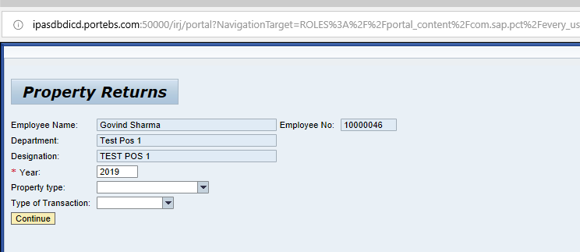

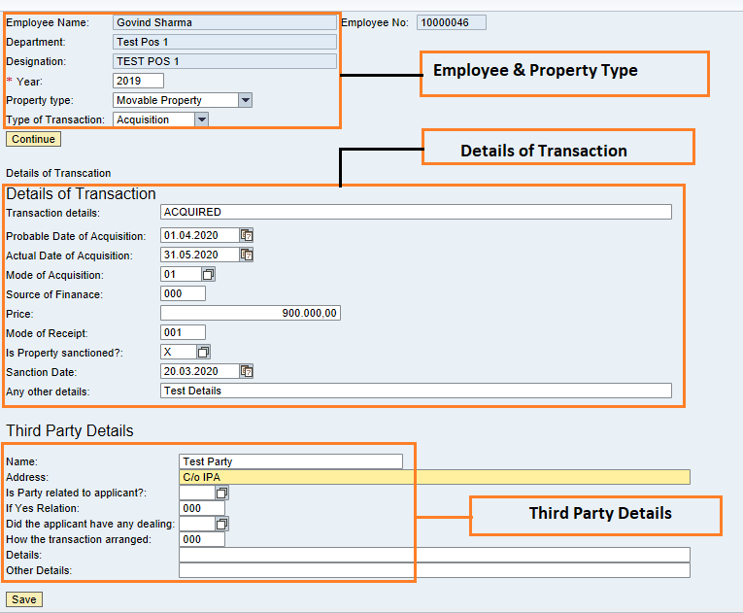
Confirmation while saving the record and success message after successful record update.
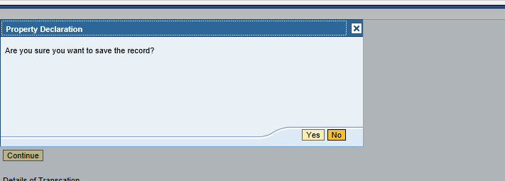

Authorizing table:
Employee request will be sent to Managers based on the Approval table. Each port is having Separate approval table.
Maintenance view of the approval Table. View is common for all ports.
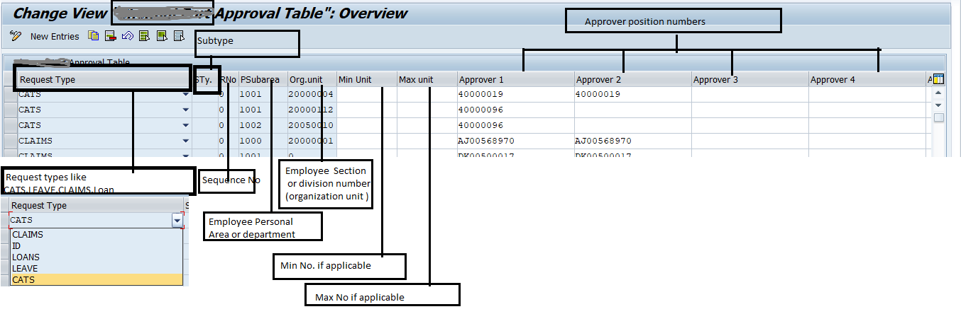

Request types: To define approvers based on the type of Request like
1. CATS for attendance and overtime approval
2. Leave for employee leave
3. Claim for employee reimbursement
4. Loans for employee loans and advances.
Subtype: Subtype if applicable for eg. In leave, we have different type of leaves, we can define different approved based on type like Earned leave one set of approver and for Sports one set of approvers. If nothing is specified approvers are applicable for all type of leaves.
R.No Or Sequence Number: Sequence number if applicable .it’s to differentiate with same type and subtype of request.
For eg : If in Earned leave it self if the number of days are less than 5 then one set of approvers and if leave number is more than other set of approvers then to differentiate we use sequence number.
Min Unit: Minimum number of days to be specified.
Max Unit: Maximum number of days to be specified.
Approver: Position number of approver to be specified. if the approver field is filled it specifies the level of approval . if two approver field are filled it specified the level of approval is two level.

Disclaimer:

Tech Mahindra Limited, herein referred to as TechM provide a wide array of presentations and reports, with the contributions of various professionals. These presentations and reports are for informational purposes and private circulation only and do not constitute an offer to buy or sell any securities mentioned therein. They do not purport to be a complete description of the markets conditions or developments referred to in the material. While utmost care has been taken in preparing the above, we claim no responsibility for their accuracy. We shall not be liable for any direct or indirect losses arising from the use thereof and the viewers are requested to use the information contained herein at their own risk. These presentations and reports should not be reproduced, re-circulated, published in any media, website or otherwise, in any form or manner, in part or as a whole, without the express consent in writing of TechM or its subsidiaries. Any unauthorized use, disclosure or public dissemination of information contained herein is prohibited. Unless specifically noted, TechM is not responsible for the content of these presentations and/or the opinions of the presenters. Individual situations and local practices and standards may vary, so viewers and others utilizing information contained within a presentation are free to adopt differing standards and approaches as they see fit. You may not repackage or sell the presentation. Products and names mentioned in materials or presentations are the property of their respective owners and the mention of them does not constitute an endorsement by TechM. Information contained in a presentation hosted or promoted by TechM is provided “as is” without warranty of any kind, either expressed or implied, including any warranty of merchantability or fitness for a particular purpose. TechM assumes no liability or responsibility for the contents of a presentation or the opinions expressed by the presenters. All expressions of opinion are subject to change without notice.

