Indian Ports Association (IPA)

Implementation of Port EBS Project

Enterprise Business System

Business Process Manual for

Time Management

**Submitted by:**



Plot No. 58 A & B,

Noida Special Economic Zone,

Uttar Pradesh-201305

www.techmahindra.com

**Document History:**

|  |  |
| --- | --- |
| Authors & Participants | |
| Role | Name |
|  |  |
|  |  |
|  |  |
|  |  |

|  |  |  |  |
| --- | --- | --- | --- |
| Revision History | | | |
| Date | Document  Version | Document Revision  Description | Author |
| 02.04.2020 | 1.0 | Initial Draft | Senthil |
|  |  |  |  |
|  |  |  |  |
|  |  |  |  |
|  |  |  |  |

|  |  |  |  |
| --- | --- | --- | --- |
| Reviewed and Approved By | | | |
| Name | Title | Date | Approved |
|  |  |  |  |
|  |  |  |  |
|  |  |  |  |
|  |  |  |  |
|  |  |  |  |

GLOSSARY

|  |  |
| --- | --- |
| **Abbreviation** | **Description** |
| SAP | S/4 HANA System |
| EG | Employee Group |
| ESG | Employee Sub-Group |
| PA | Personnel Area |
| PSA | Personnel Subarea |
| IT | Info Type |
| EE | Employee |
| OM | Organizational Management |
| FI | Finance |
| TTY | Transaction Type |
|  | Save |
|  | Overview |
|  | Copy |
|  | Back / Previous Menu |
|  | Header |
|  | Details |
|  | Execute |
|  | Change |
|  | Create |
|  | Display |
|  | Delete |
|  | Delimit |

PURPOSE

The Time Management component offers the user to support in performing all human resources

Processes involving the time recording leave management system and valuation of employee’s work

Performed, absence times, Compensatory Offs and Over Time.

Employee quota, leave data is stored in SAP as separate Infotypes. These Infotypes are logical groupings of information.

This document describes the typical procedure required to update quota, book different leaves of employee into your organization.

TARGET AUDIENCE

* Time Administrators
* Time Keepers

Contents

1. Planned Working Time Infotype (IT0007) 6

2. Time Evaluation 9

3. Absence Quota 12

4. Absences Infotype (IT2001) 16

5. Attendances Infotype (IT2002) 18

6. Biometric Integration: 21

# Planned Working Time Infotype (IT0007)

**Objective:** To maintain the work schedules for every employee in IT0007.

|  |  |
| --- | --- |
| Menu Path | Human Resources -> Personnel Management-> Administration-> HR Master Data-> PA30- Maintain |
| Transaction Code | PA30 |

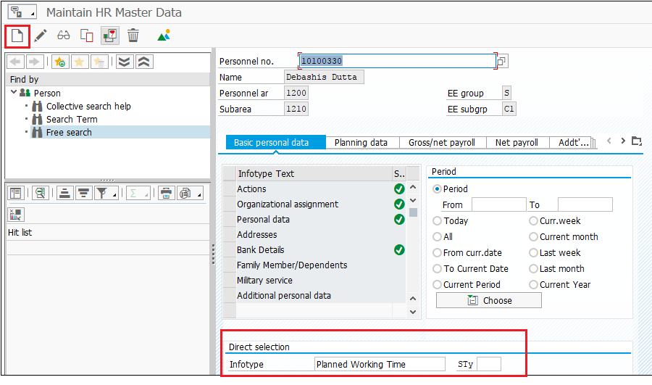

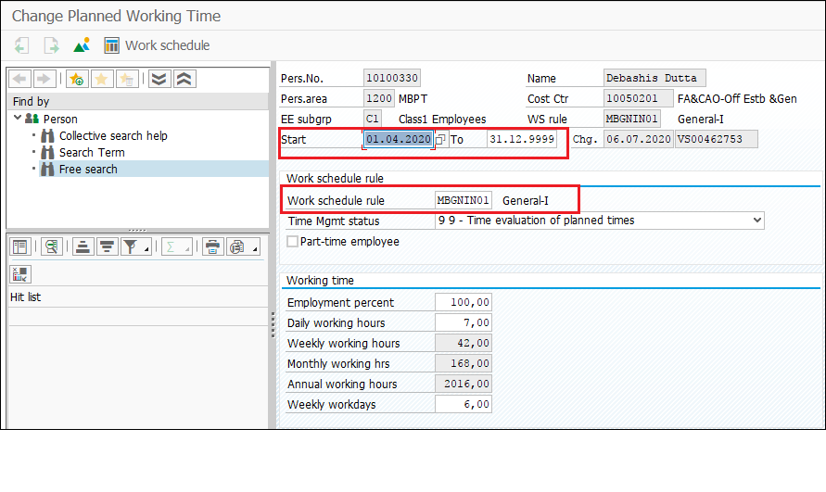

|  |  |  |
| --- | --- | --- |
| **S.No.** | **Field Name/Activity** | **Description** |
| 1. | Start Date | Enter the effective date. |
| 2. | Work Schedule Rule | Select the respective Work Schedule of an employee from the drop down menu. |
| 3. | Time Mgmt status | Select the status – “9-Time evaluation of planned times” |
| 4. | Employment Percent | It comes by default. |
| 5. | Save | Enter the  icon to save the information. |

If the work Schedule icon  in the above screen shot is chosen then the employee’s daily shifts can be seen month wise for present month, previous month and next month. The screen shot is given below.

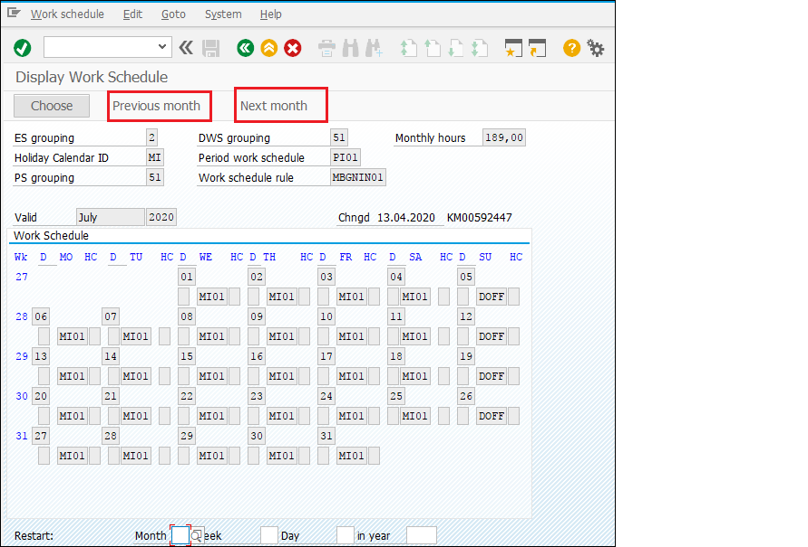

**Output:** Work schedule maintained.

# Time Evaluation

**Objective:** To maintain the Absence (leave) quota for all employees.

|  |  |
| --- | --- |
| Menu Path | Human Resources -> Time Management-> Administration-> Time Evaluation-> Time Evaluation |
| Transaction Code | PT60 |

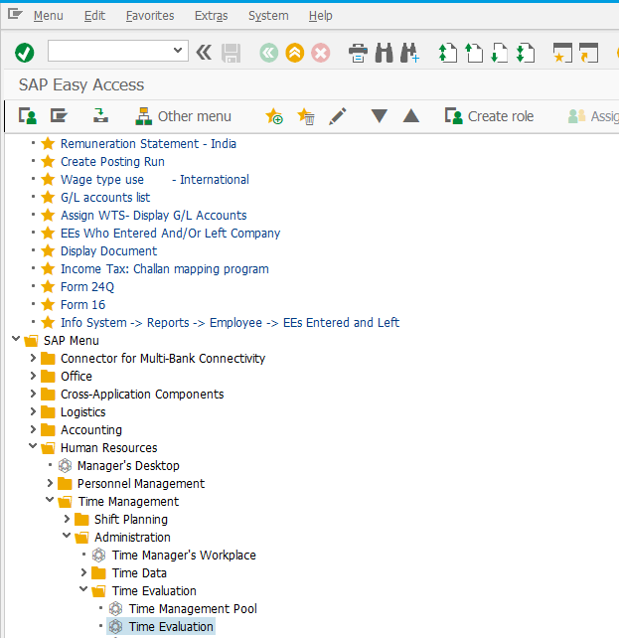

Press enter; below window will open

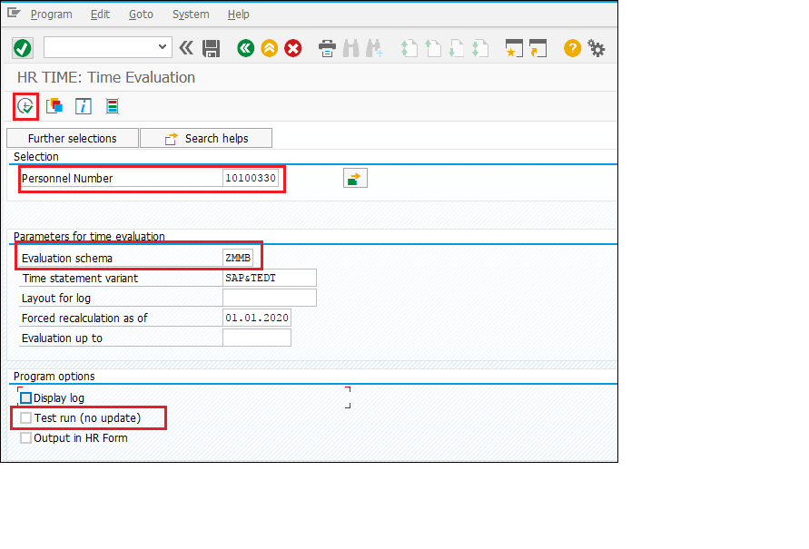

|  |  |  |
| --- | --- | --- |
| **Field Name** | **Description** | **User Action and Values** |
| Personnel No. | Personnel No. (or the Employee No.) selection | Select single /multiple for which Time evaluation has to run. |
| Evaluation Schema | The personnel calculation schema (schema) defines the steps, which are involved in time evaluation. | Administrator has to select the Port-Specific Schema from the drop-down menu. Refer table given below. |
| Evaluation up to | Enter the date on which time evaluation must end in this field. If you do not make an entry, the system sets the current date. | Select the appropriate date. |
| Display Log | Tick the check box if want to see the detailed log. | Check or Un-check |
| Test run (no update) | In the test run, tables will not update. This is used for simulation purpose. Only in live run, database is updated | Check or Un-check |
| Execute | Select the ‘ ’ execute button to run the program. | Execute |

**Time Evaluation Schema:**

|  |  |
| --- | --- |
| CHPT | ZC04 |
| MBPT | ZMMB |
| DPT | ZD04 |
| DPT OOT - VADINAR | ZD04 |
| KDS | ZK04 |
| HDC | ZH04 |
| PPT | ZP04 |

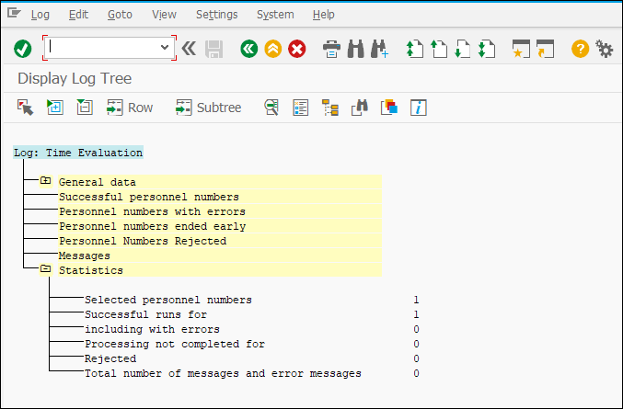

If the test run is successful without any error, “Uncheck the Test run” and run the program again to update the tables in backend.

Once Time Evaluation completed, Time balances (Overtime, SOT, DOT etc.,) and Absence entitlement will be generated and updated. Time balances will be the input for remuneration in Payroll.

**Output:** Absence (Leave) quota generated and updated.

# Absence Quota

**Objective:** To check the Absence (leave) quota at Infotype level that it is correctly generated or not.

After successful time evaluation run, check Absence quota Infotype to view employee’s absence quota/entitlement

|  |  |
| --- | --- |
| Menu Path | Human Resources -> Personnel Management-> Administration-> HR Master Data-> PA30- Maintain |
| Transaction Code | PA30 |

Steps

* Enter Transaction code **PA30** in command field.
* Press **ENTER** button.
* Enter Employee Number of an employee.
* Enter info type 2006 directly or search option of info type is available on the right side of info type box.
* Select subtype from the search option available:

01 – Earned Leave

02 – Half Pay Leave

03 – Casual Leave

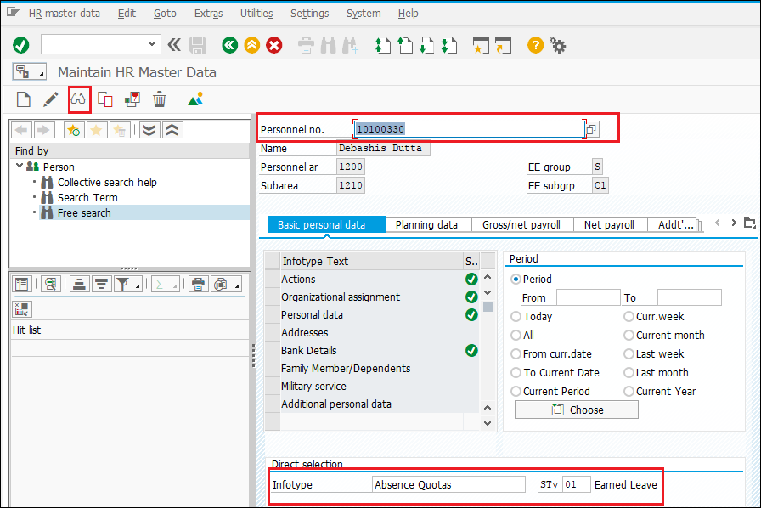

**Earned leave Quota**

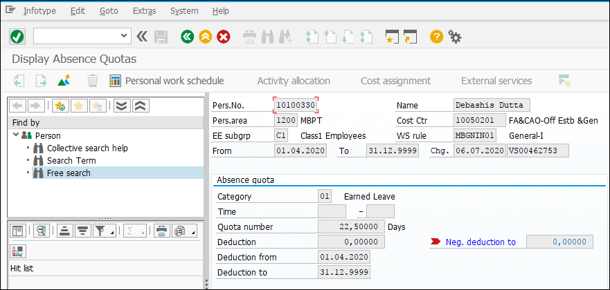

**Half Pay Leave Quota**

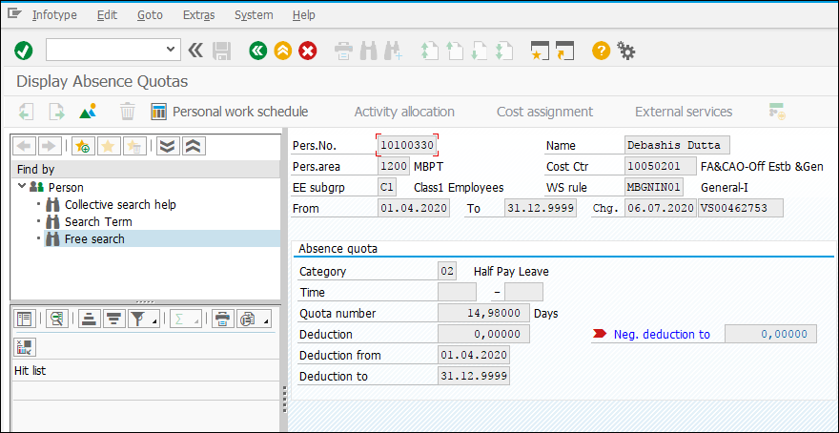

**Casual Leave Quota**

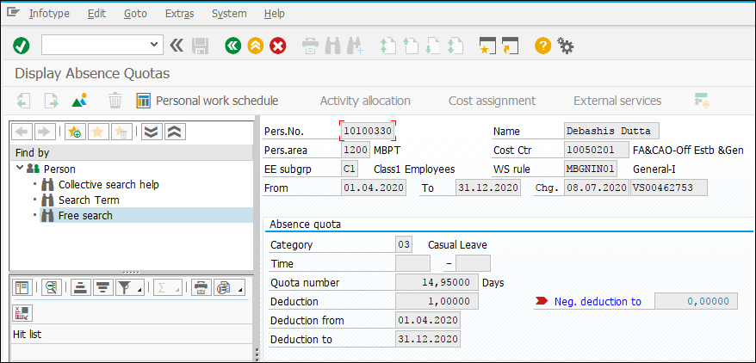

**Output:** Leave quota generated at Infotype level.

# Absences Infotype (IT2001)

**Objective:** In case of leave application thru ESS then after Manager’s approval, it should reflect in the required Infotype.

|  |  |
| --- | --- |
| Menu Path | Human Resources -> Personnel Management-> Administration-> HR Master Data-> PA30- Maintain |
| Transaction Code | PA30 |

Steps

* Enter Transaction code **PA30** in command field.
* Press **ENTER** button.
* Enter Employee Number of an employee.
* Enter info type 2001 directly or search option of info type is available on the right side of info type box.
* Select subtype from the search option available:
* Click on the create button.

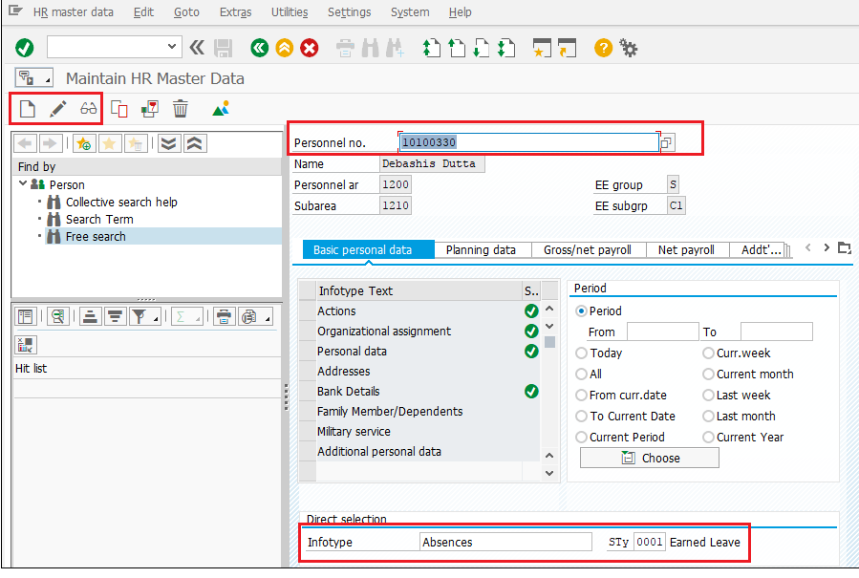

The next screen is shown as below

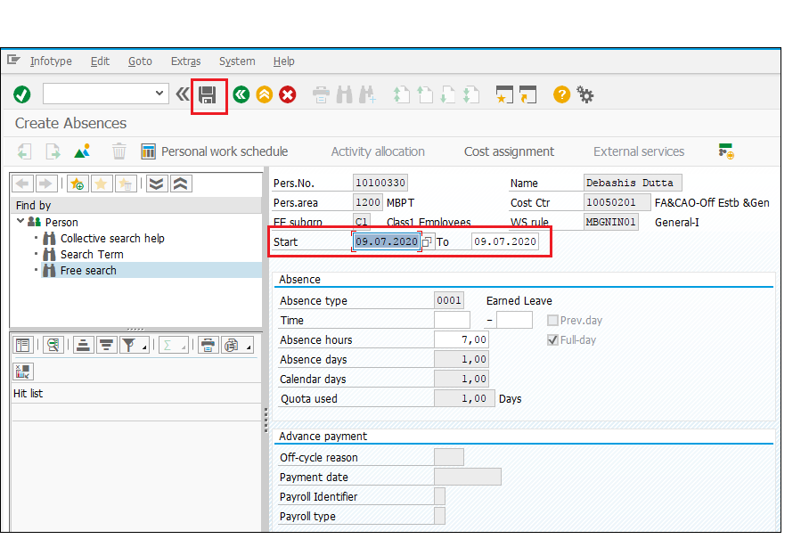

|  |  |  |
| --- | --- | --- |
| **S.No.** | **Field Name/Activity** | **Description** |
| 1. | Start Date & End Date | Enter the Leave Start and End date. |
| 2 | Start Time and End Time | Maintain Time, |
| 3 | Save | Click  icon to save the record |

**Output:** Leave updated at Infotype level.

# Attendances Infotype (IT2002)

**Objective:** In case of any attendances other than the regular one (System not working, Employee on outside training etc.) then after Manager’s approval, it should reflect in the required Infotype.

|  |  |
| --- | --- |
| Menu Path | Human Resources -> Personnel Management-> Administration-> HR Master Data-> PA30- Maintain |
| Transaction Code | PA30 |

Steps

* Enter Transaction code **PA30** in command field.
* Press **ENTER** button.
* Enter Employee Number of an employee.
* Enter info type 2002 directly or search option of info type is available on the right side of info type box.
* Select subtype from the search option available:
* Click on the create button.

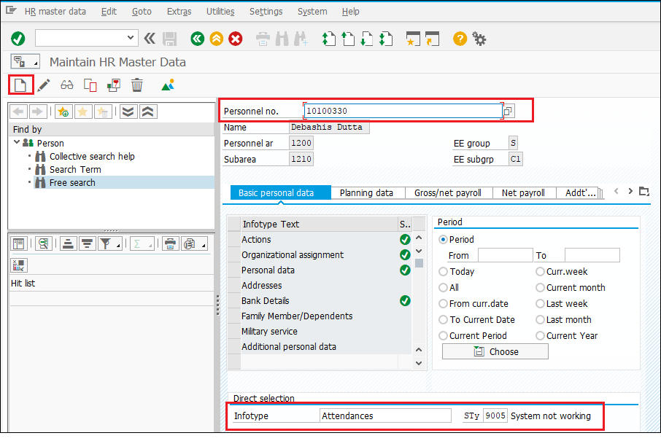

The next screen is shown as below

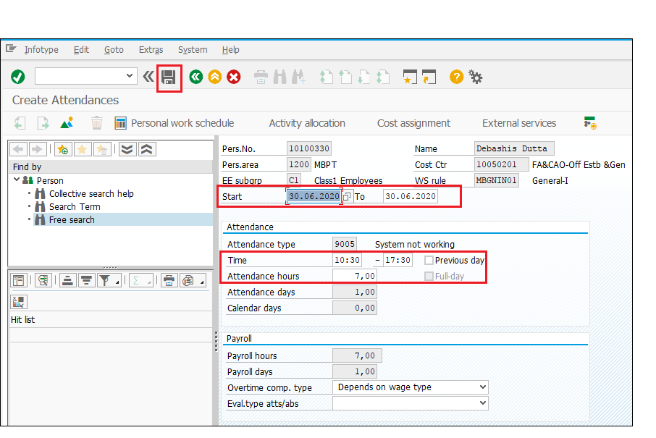

|  |  |  |
| --- | --- | --- |
| **S.No.** | **Field Name/Activity** | **Description** |
| 1. | Start Date & End Date | Enter the Leave Start and End date. |
| 2 | Start Time and End Time | Maintain Time, |
| 3 | Save | Click  icon to save the Record |

**Output:** Attendance type updated at Infotype level.

# Biometric Integration:

**Objective: To show the biometric integration with SAP to capture attendances.**

The data file from biometric devices at regular intervals will be called thru API (Application Program Interface) to reach at SAP application server to run the backend report in CATS. The shift timings where no deviation is there as per the assigned work schedules will directly updated in the time infotypes. Only the shift timings with the deviations will route to concerned Manager’s approval in MSS (Manager’s Self Service). After the Manger’s approval, the data will updated to various Time Infotypes.

**Output:** Biometric attendance data updated in Infotype.