Indian Ports Association (IPA)
Implementation of Port EBS Project
Enterprise Business System

Business Process Manual for
Payroll Processing

Submitted by:

Plot No. 58 A & B,
Noida Special Economic Zone,
Uttar Pradesh-201305

www.techmahindra.com

Document History:
Authors & Participants
Role | Name

Revision History
Date | Document  Version | Document Revision  Description | Author
01.04.2020 | 1.0 | Initial Draft | Senthil

Reviewed and Approved By
Name | Title | Date | Approved

GLOSSARY

Abbreviation | Description
SAP | S/4 HANA System
EG | Employee Group
ESG | Employee Sub-Group
PA | Personnel Area
PSA | Personnel Subarea
IT | Info Type
EE | Employee
PE | Pensioner
OM | Organizational Management
FI | Finance
TTY | Transaction Type
 | Save
 | Overview
 | Copy
 | Back / Previous Menu
 | Header
 | Details
 | Execute
 | Display Form / Remuneration Statement
 | Change
 | Create
 | Display
 | Delete
 | Delimit

PURPOSE
Payroll is one of the key components in SAP HR module and is used to process payroll of employees in an organization. SAP Payroll system calculates the gross pay and the net pay. It consists of payments for each employee and deductions made during a payroll period. All payments and deductions are included in the remuneration calculation using different wage types.
Payroll calculation considers an employee’s attendance, bonus, overtime, tax rules and other information to generate the pay slip of that employee. Payroll can be run daily, weekly, bi-weekly, monthly depending on the salary cycles of the organization.

TARGET AUDIENCE
- Payroll Executives
- Payroll Managers
- Payroll Administrators
- Other Staff who maintained the master data related to payroll

Contents

1. Master Data (Infotype) Maintenance for Employees and Pensioners 6
1.1 Basic Pay Infotype (IT0008) for Employees 7
1.2 Basic pay Infotype (IT0008) for Pensioner 9
1.3 Bank Details Infotype (IT0009) 10
1.4 Recurring Payments/Deductions Infotype (IT0014) 11
1.5 Additional Payments Infotype (IT0015) 13
1.6 Membership Fees Infotype (IT0057) 14
1.7 Previous Employment Tax Details Infotype (IT0580) 15
1.8 Housing (HRA / CLA / COA) Infotype (IT0581) 16
1.9 Income from Other Sources Infotype (IT0584) 17
1.10 Section 80 Deductions Infotype (IT0585) 19
1.11 Section 80C Deductions Infotype (IT0586) 20
1.12 Provident Fund Contribution Infotype (IT0587) 21
1.13 Other Statutory Deductions Infotype (IT0588) 23
1.14 Nominations Infotype (IT0591) 25
2. TIME AND PAYROLL INTEGRATION 27
3. PAYROLL RUN 30
3.1 Control Record 30
3.2 Simulation Payroll Processing 37
3.3 Live Payroll Run 42
3.4 Payroll Results 47
4. WAGETYPE REPORTER 48
5. BANK REPORT 51
6. PAYROLL POSTING 54

Master Data (Infotype) Maintenance for Employees and Pensioners

Menu Path | Human Resources -> Personnel Management-> Administration-> HR Master Data-> PA30- Maintain
Transaction Code | PA30

Upon Execution of PA30, below screen will be shown. Here, we can create / maintain all the Infotypes which are used to run the payroll.
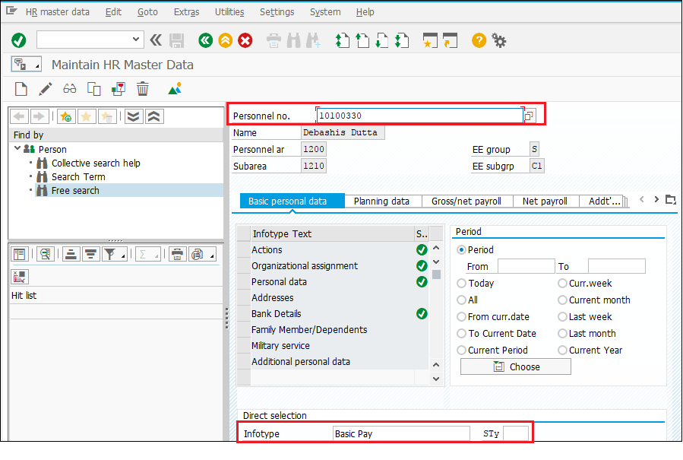
Field | Value
Personnel No. | Enter the Employee No. / Pensioner No.
Infotype | Enter the Infotype Number of Name
Subtype (Sty) | Enter the Subtype Number

Instructions while maintaining the Infotypes:
- The fields, which are already grayed out, are non-editable and already having values.
- Infotype must be created, while creating the Infotype, use the ‘’ button.
- Infotypes, which are already created, can only be changed. While changing use ‘’ button.
- After creating / editing, click the Save ‘’ button.
- Overview of Infotype record(s) can be viewed by
- Infotype record(s) can be displayed sequentially using

Basic Pay Infotype (IT0008) for Employees

S.No. | Field/Activity | Value
1. | Start date | Start date of the Record
2 | End date | Always 31.12.9999, which will be populated by the system
3 | Reason | Choose from the list
4 | Pay scale Type | Populated by the system
5. | Pay scale Area | Populated by the system
6 | Pay scale Group & Level | Select from drop-down menu based on the Employee Class & Payscale.
7 | Wage type | WT “1000”- Basic Pay Populated by the system
8 | Amount | System populates the basic pay amount
9 | Save | Enter the icon to save the information

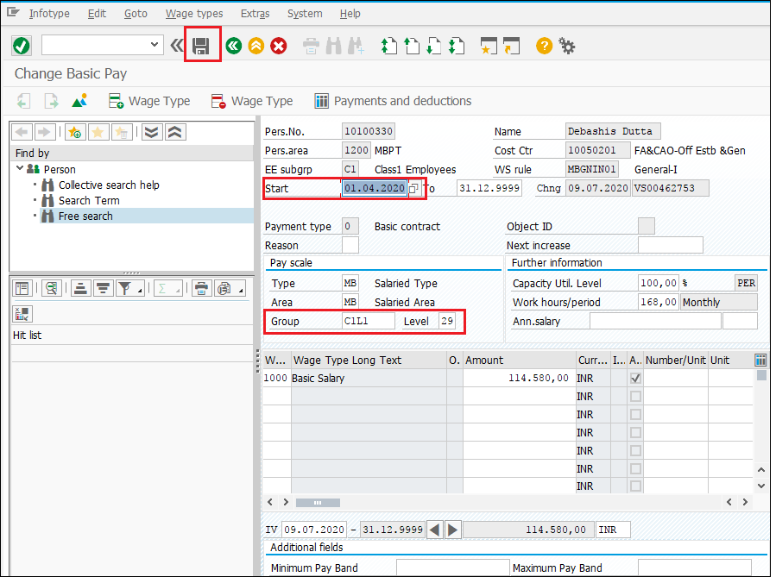

Basic pay Infotype (IT0008) for Pensioner

S.No. | Field/Activity | Value
1. | Start date | Start date of the Record
2 | End date | Always 31.12.9999, which will be populated by the system
3 | Reason | Choose from the list
4 | Pay scale Type | Populated by the system
5. | Pay scale Area | Populated by the system
6 | Pay scale Group & Level | Select from drop-down menu based on the Pensioners Class & Payscale.
7 | Wage type | Populated by the system
8 | Amount | Maintain the amount
9 | Save | Enter the icon to save the information.

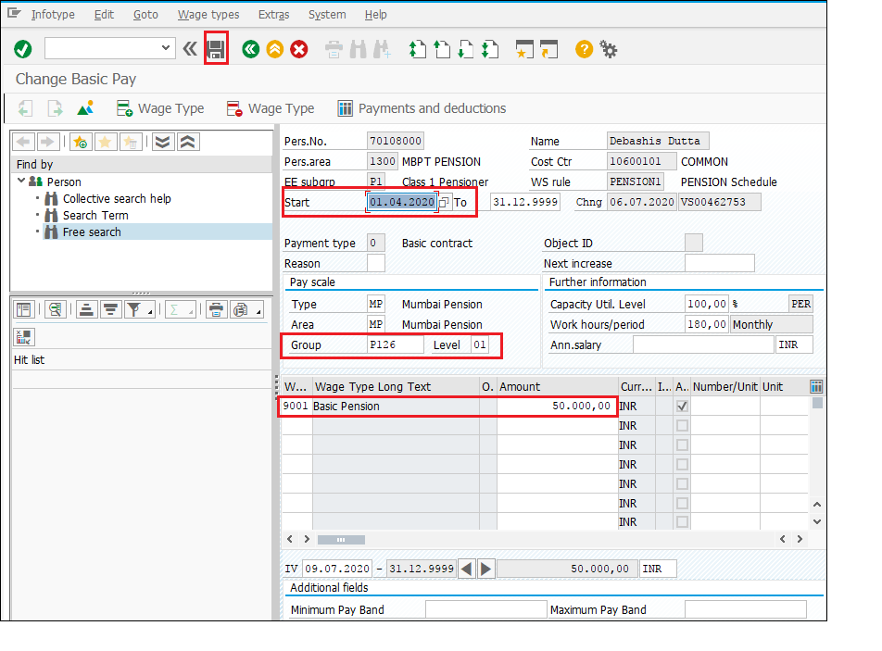

Bank Details Infotype (IT0009)

This Infotype used to maintain the Bank details of Employees and Pensioners.
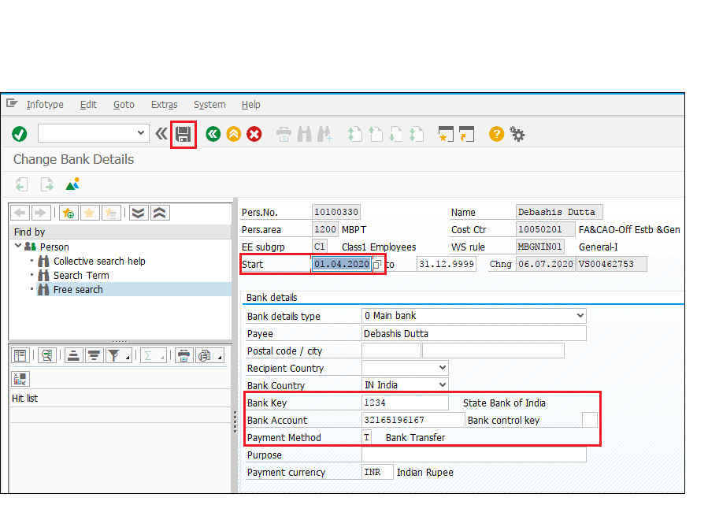
S.No. | Field/Activity | Value
1. | Start Date | Enter the effective date.
2. | Bank Details Type | Choose from the list
3. | Bank Key | Choose from the list
4. | Bank Account | Enter the Bank account details of Employees / Pensioners
5. | Payment Method | Choose from the list
6. | Save | Enter the icon to save the information.

Recurring Payments/Deductions Infotype (IT0014)

This Infotype is used to maintain wage types (Earnings / Deductions), other than regular salary (IT0008). Each port specific wage types are created and available as dropdown value for employee and pensioners. For few wage types, system will populate the amount and no need to maintain any amount.

Wagetype-1
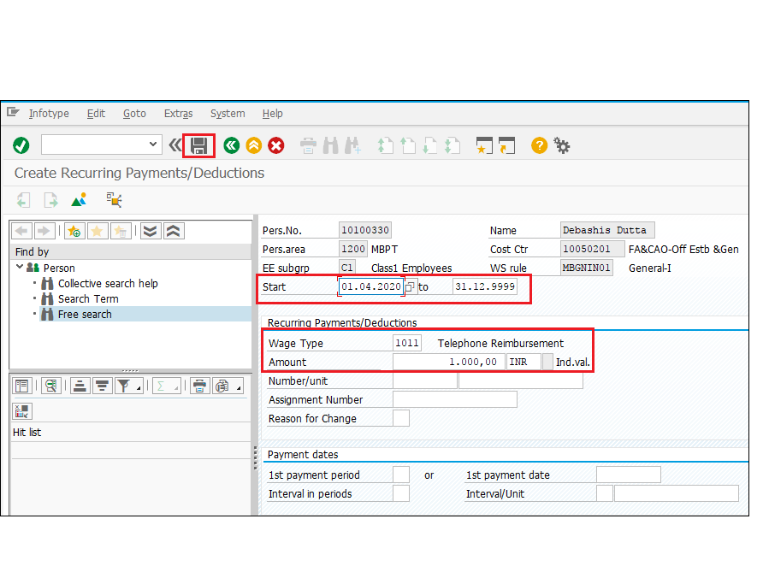

Wagetype-2
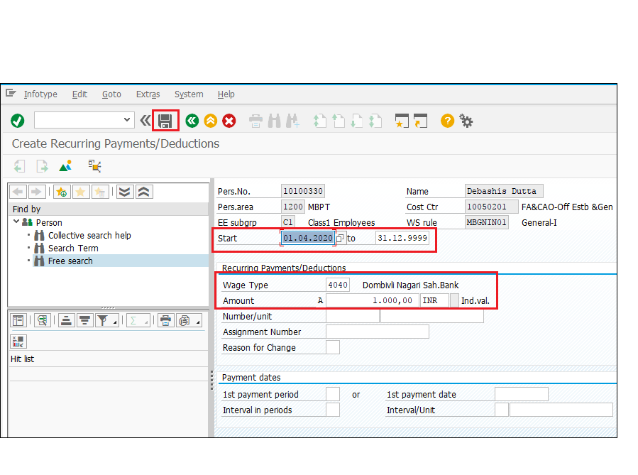
S.No. | Field/Activity | Value
1. | Start Date | Enter the effective date.
2. | End Date | Maintain the end date
3. | Wage type | Wagetypes are port specific and is available in the drop-down values.
4. | Amount | Maintain the amount or System will populate
5 | Save | Enter the icon to save the information.

Additional Payments Infotype (IT0015)

This Infotype used for payment or deduction for the particular payroll period. Each port specific wage types are created and available as dropdown value for employee and pensioners. For few wage types, system will populate the amount and no need to maintain any amount.
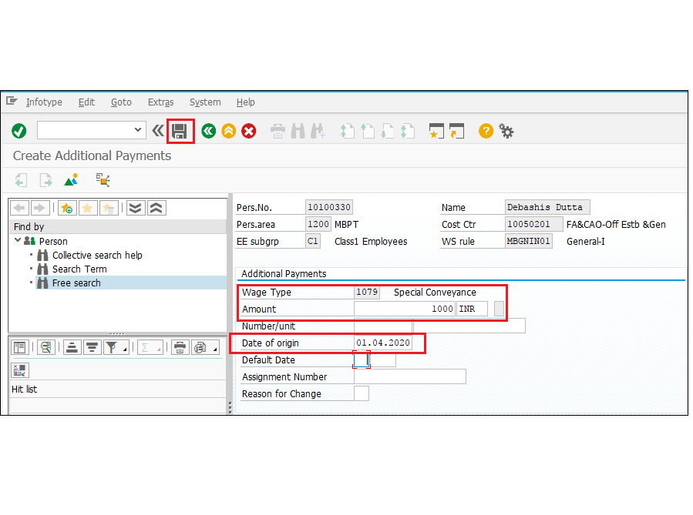

S.No. | Field/Activity | Value
1. | Wage type | Wagetypes are port specific and is available in the drop-down values.
2. | Amount | Maintain the amount or system will populate
3. | Date of origin | Enter the effective date.
4. | Save | Enter the icon to save the information.

Membership Fees Infotype (IT0057)

This Infotype is used to store any membership information for an employee. An employee can enrol in membership, Sports club, Medical and Union. This will have Payee information also.

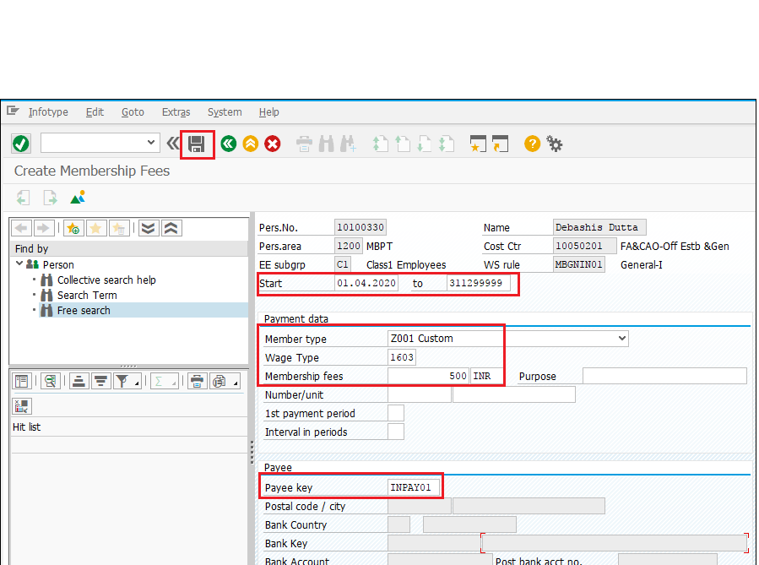
S.No. | Field/Activity | Value
1. | Start & End Date | Enter From and To effective date
2. | Member Type | Choose from the list
3. | Wage type | Wagetypes are port specific and is available in the drop-down values.
4. | Membership fees | Enter the amount
5. | Payee Key | Choose the Payee Key
6. | Save | Enter the icon to save the information.

Previous Employment Tax Details Infotype (IT0580)

The previous employer income and tax details have to be entered. This Infotype would be valid for those employees, who join in the middle of a financial year and have worked in some other organization. Salary details perceived in previous organization maintained.

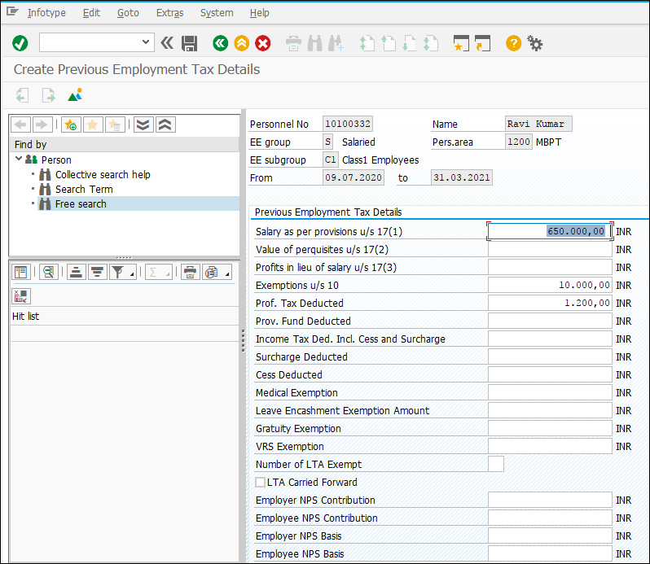

Housing (HRA / CLA / COA) Infotype (IT0581)

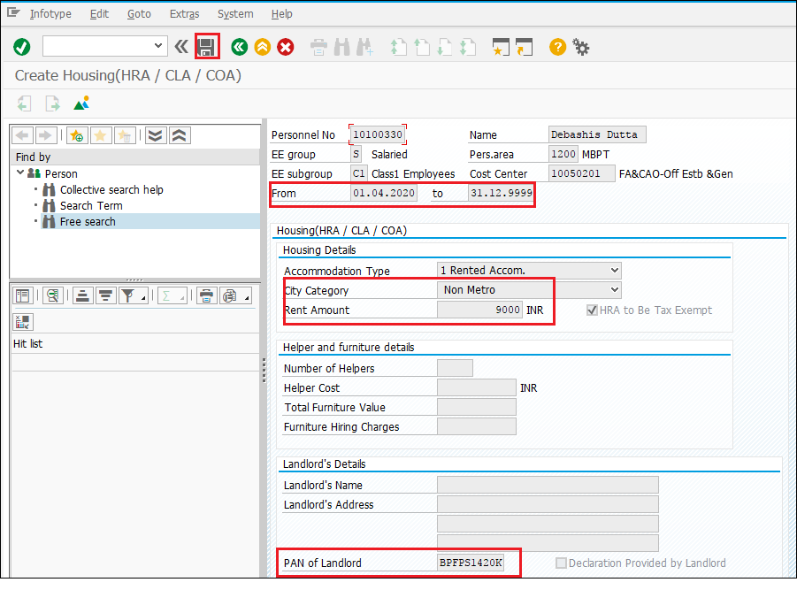
S.No. | Field/Activity | Value
1. | Start Date | Enter effective date
2. | Accommodation Type | Choose from the list
3 | City Category | Choose Metro or Non Metro
4 | Rent Amount | Enter the Amount
5 | HRA to be Exepted | Check to get HRA Exemption
6 | Landlord PAN | Maintain if Rent paid is more than 1 Lac/year
7 | Save | Enter the icon to save the information.

Income from Other Sources Infotype (IT0584)

- House Property

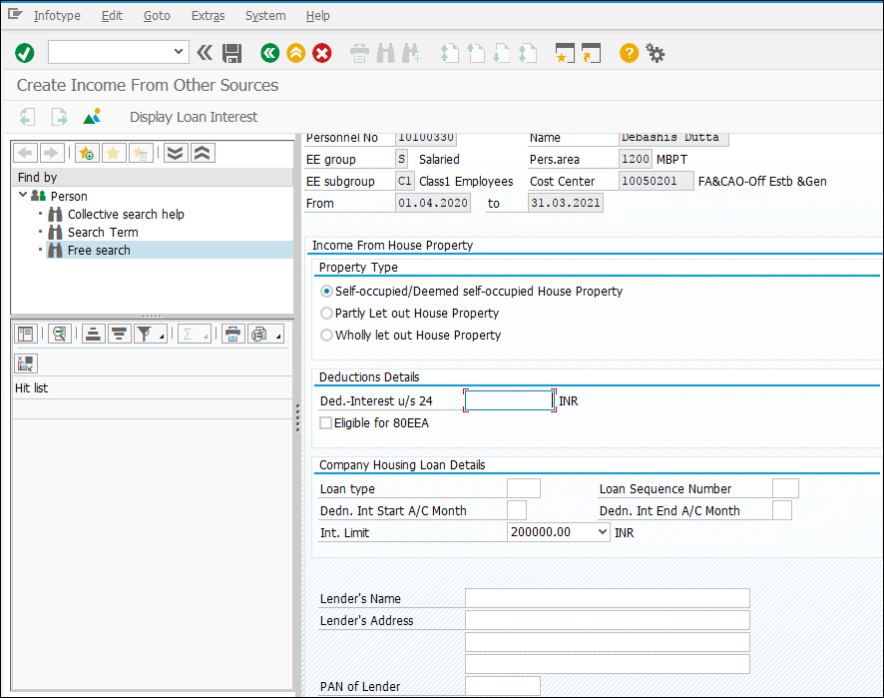

S.No. | Field/Activity | Value
1. | Property Type | Check box the respective property type:  - Self-occupied / Deemed Self-occupied  - Partly Let out  - Wholly Let out
2. | Deduction Details | Enter the Deduction- Interest u/s 24.
3. | Company Housing Loan Details | Enter the Housing Loan details –  Loan Type, Sequence No., Deduction Interest Start and End Month
4. | Lender Details | Enter the Lender details including Name, Address, PAN card and Lender’s type.
5. |  | Enter the icon to save the information.

- Other Sources

This subtype is used if an employee has an income from some other sources listed below. The income used for calculating the legal deductions of that financial year
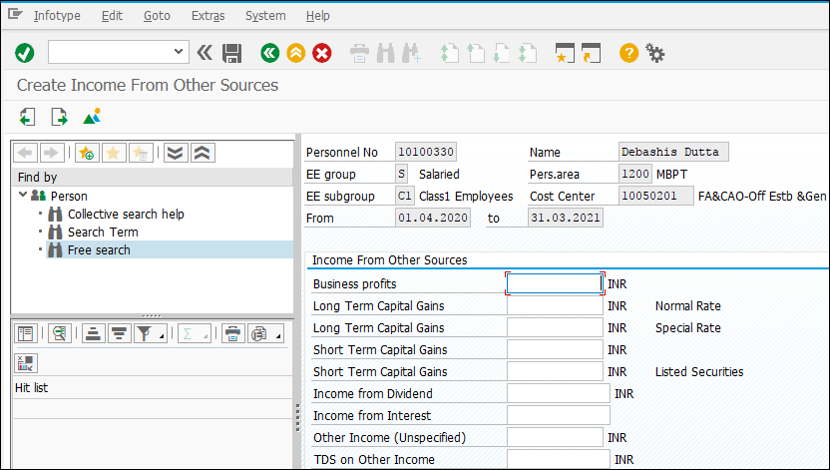

Section 80 Deductions Infotype (IT0585)

This Infotype is used to keep the record of investments done by Employees under Sec. 80 of Income Tax Act. An Employee can submit the proposed contributions under various schemes where he wants to invest to avail the tax benefit at the starting of the financial year thru ESS/ ESC. Based on his proposed contributions, TDS will be deducted from his monthly salary.
Employee has to submit the actual proof of investments during end of the financial year example December / January and in case of any difference between the proposed and actual contributions, TDS will be deducted accordingly from payroll.

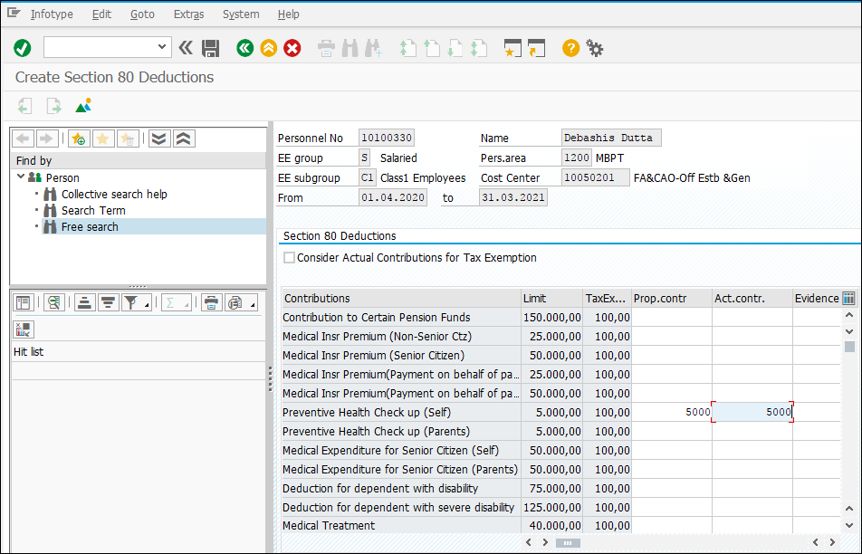

Section 80C Deductions Infotype (IT0586)

This Infotype is used to keep the record of investments done by Employees. An Employee can submit the proposed contributions under various schemes where he wants to invest to avail the tax benefit at the starting of the financial year thru ESS/ ESC. Based on his proposed contributions, TDS will be deducted from his monthly salary.
Employee has to submit the actual proof of investments during end of the financial year example December / January and in case of any difference between the proposed and actual contributions, TDS will be deducted accordingly from payroll.

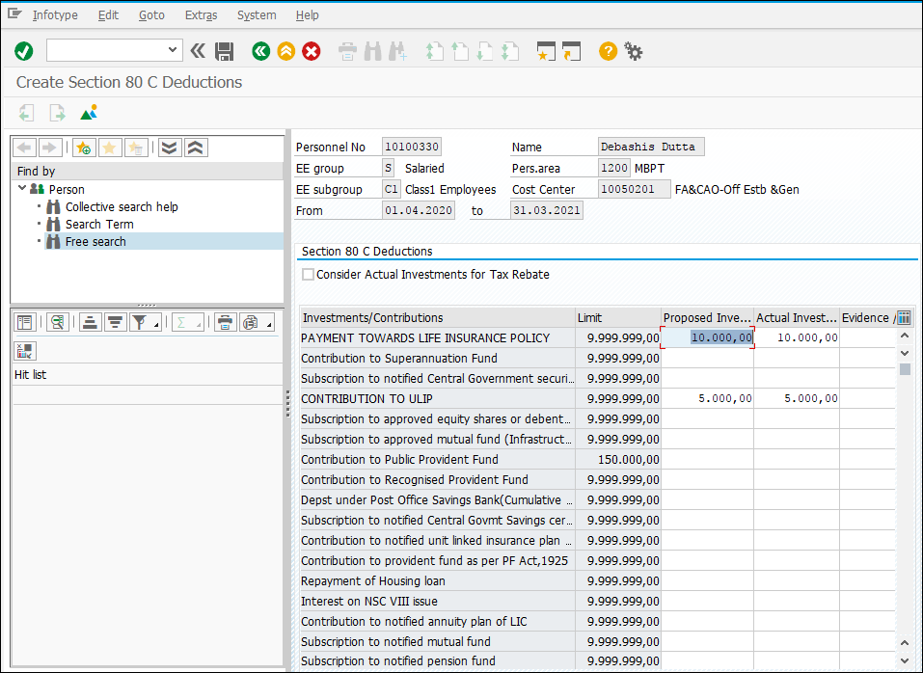

Provident Fund Contribution Infotype (IT0587)

This Infotype is used to capture the details related to PF, VPF and NPS.

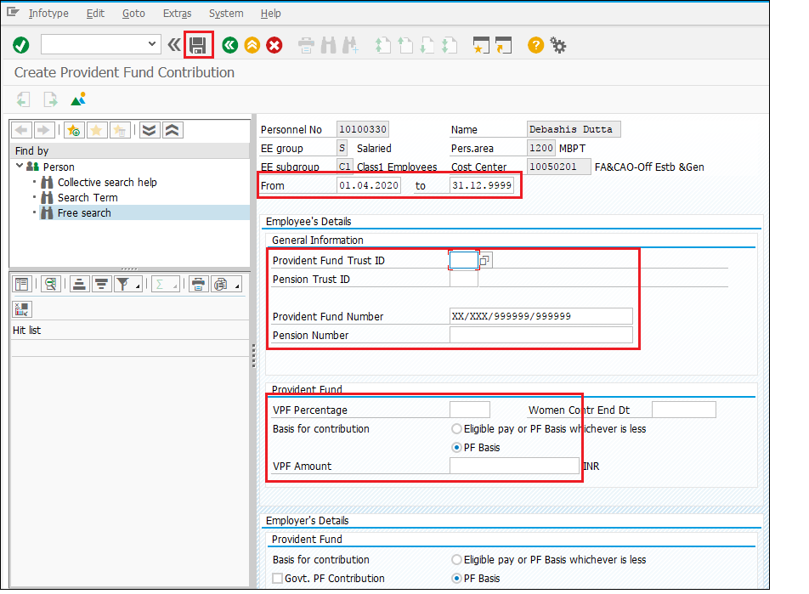
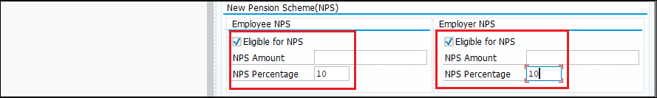
S.No. | Field/Activity | Value
1. | Start Date | Enter effective date.
2. | PF Trust ID and Number | Choose PF Trust ID and Maintain PF Number
3. | VPF Details | Enter VPF amount or Percentage
4. | NPS (Employee and Employer) | Check Eligible for Employee and Employer fields
5. | NPS Amount | Maintain NPS amount for Employee and Employer
6. | NPS | Maintain percentage of NPS calculation for Employee and Employer
7. | Save | Enter the icon to save the information.

Other Statutory Deductions Infotype (IT0588)

LWF (Labour Welfare Fund)
Check the box with Start and End date. LWF deduction will happen according to the frequency.
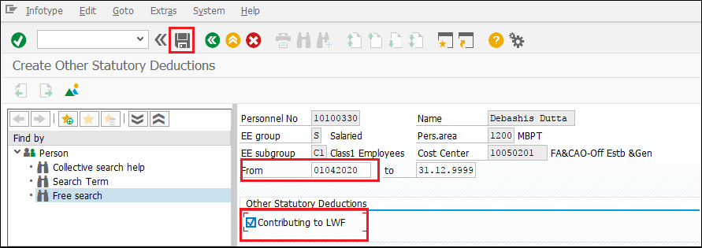

PTX (Professional Tax Eligibility)
Check the box with Start and End date. P.Tax deduction will happen according to the frequency and slab for the particular establishment (P.Tax body).
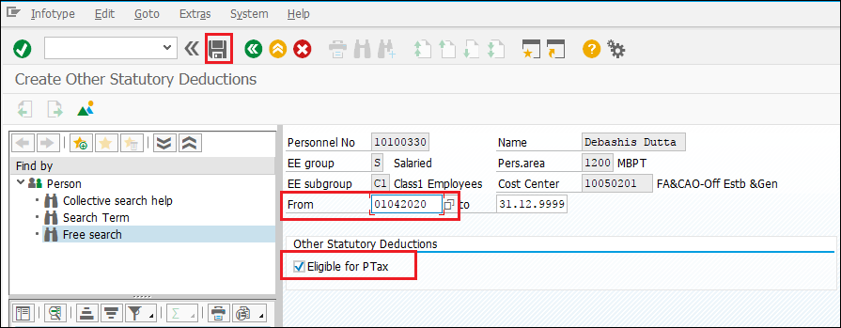

Taxation Option
This subtype is used for choosing the new taxation regime – Old tax regime or new tax regime.
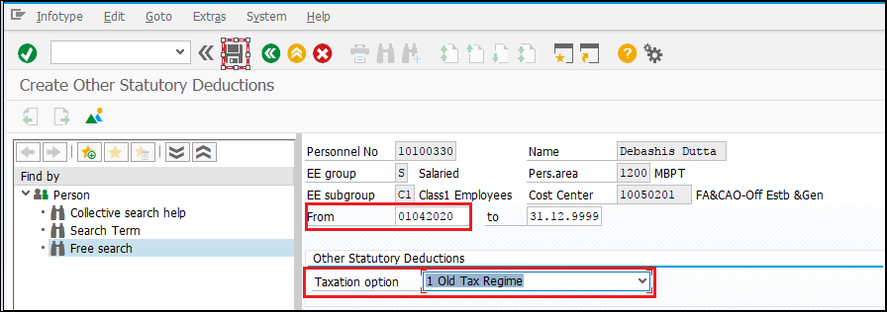

Nominations Infotype (IT0591)

S.No. | Field/Activity | Value
1. | Start and End date | Maintain Start and End date
2. | Type of Benefit | Choose from the list
3. | Nominee | Maintain the Nominee name
4. | Nominee Address | Maintain the Nominee Address
5. | Relationship | Maintain the Nominee relationship with Employee/Pensioner
6. | Date of Birth | Maintain the Nominee DOB
7 | Share | Maintain the percentage of share for the Nominee
8 | Guardian’s Adress | Maintain Guardian’s Address (If Nominee is a Minor)
9. | Save | Enter the icon to save the information.

Gratuity Benefit
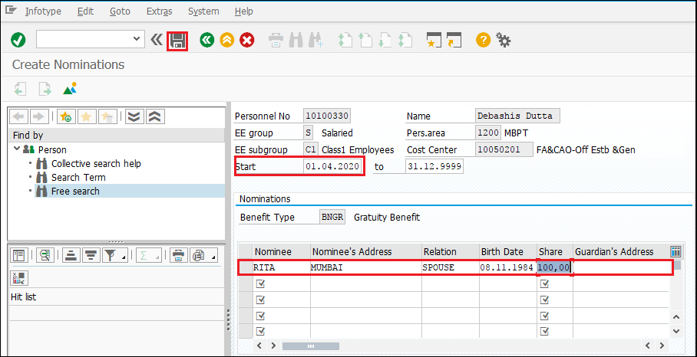

PF Benefit
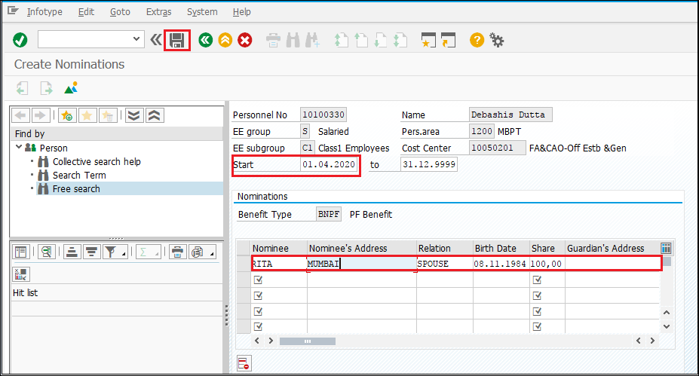

Pension Benefit
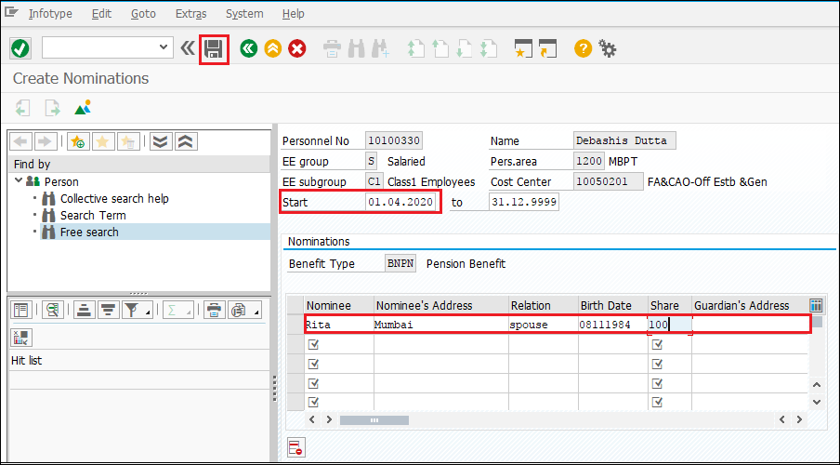

TIME AND PAYROLL INTEGRATION

Upon updating all Time and Payroll master data, Time Evaluation must be executed before running Payroll. This will update time balances of the Employee like Overtime, which will be remunerated in Payroll. This is Mandatory activity and has to be completed by the administrator every month just before the payroll.

Menu Path | Human Resources -> Time Management-> Administration-> Time Evaluation-> Time Evaluation
Transaction Code | PT60

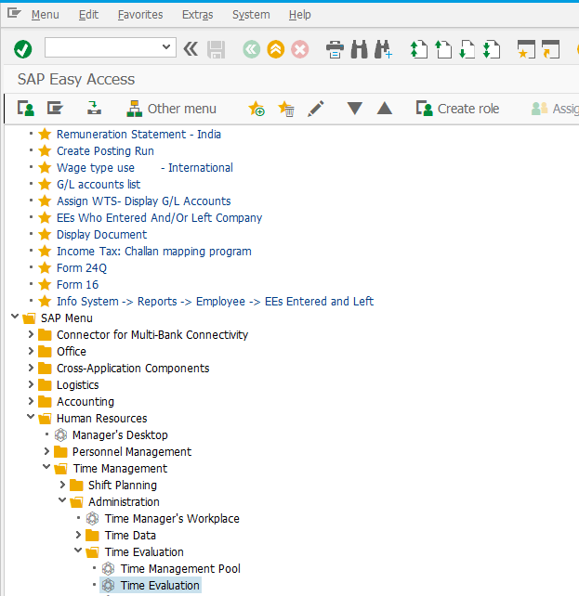

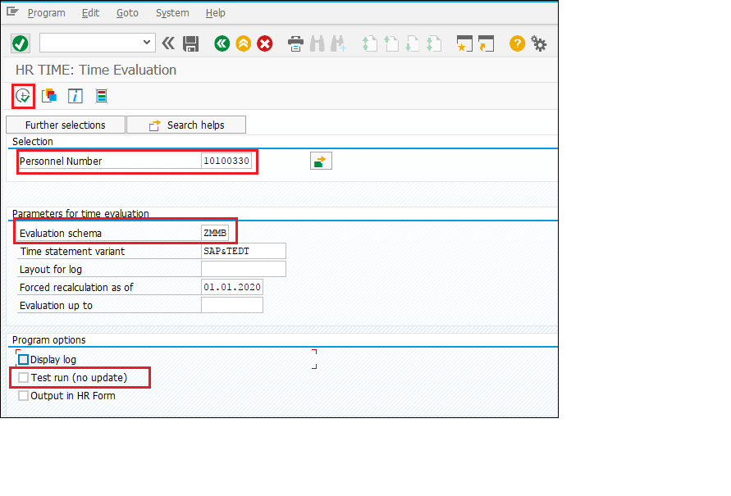
Field Name | Description | User Action and Values
Personnel No. | Personnel No. selection | Select single /multiple for which Time evaluation has to run.
Evaluation Schema | The personnel calculation schema (schema) defines the steps, which are involved in time evaluation. | Administrator has to select the Port-Specific Schema from the drop-down menu. Refer table given below.
Evaluation up to | Enter the date on which time evaluation must end in this field. If you do not make an entry, the system sets the current date. | Select the appropriate date.
Display Log | Tick the check box if want to see the detailed log. | Check or Un-check
Test run (no update) | In the test run, tables will not update. This is used for simulation purpose. Only in live run, database is updated | Check or Un-check
Execute | Select the ‘ ’ execute button to run the program. | Execute

Time Evaluation Schema:
CHPT | ZC04
MBPT | ZMMB
DPT | ZD04
DPT OOT - VADINAR | ZD04
KDS | ZK04
HDC | ZH04
PPT | ZP04

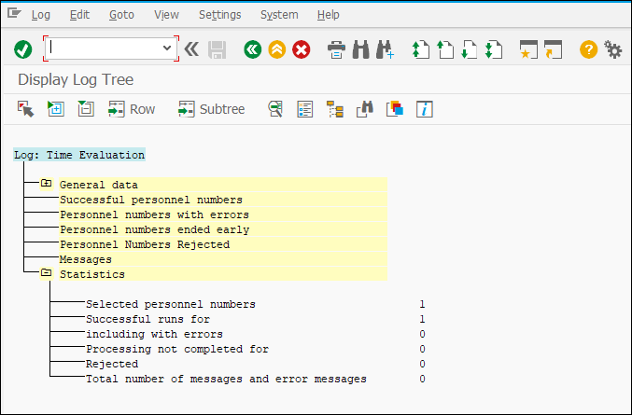
If the test run is successful without any error, “Uncheck the Test run” and run the program again to update the tables in backend.
Once Time Evaluation completed, Time balances (Overtime, SOT, DOT etc.,) and Absence entitlement will be generated and updated. Time balances will be the input for remuneration in Payroll.

PAYROLL RUN

3.1 Control Record

Following transaction and path to be followed to Maintain Payroll Control Record.

Menu Path | Human Resources -> Payroll-> Asia/Pacific-> India-> Tools-> PA03- Control Record
Transaction Code | PA03

Menu Path:
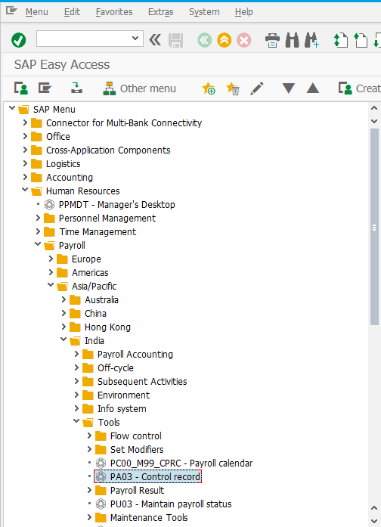

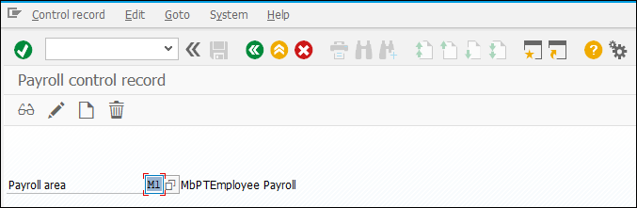

Choose the Payroll area from below table:

Port Name | Payroll Area | Payroll Area Text
Mumbai | M1 | MbPTEmployee Payroll
 | M2 | MbPTContract Payroll
 | M3 | MbPT Pension
 | M4 | MbPT Family Pension
Chennai | C1 | ChPTEmployee Payroll
 | C2 | ChPTContract Payroll
 | C3 | ChPT Pension BN2002
 | C4 | ChPTFamily Pension
 | C5 | ChPT Pension AN2002
DeenDayal | D1 | DPT Employee Payroll
 | D2 | DPT Contract Payroll
 | D3 | DPT Pension
 | D4 | DPT Family Pension
Haldia | H1 | HDC Employee Payroll
 | H2 | HDC Contract Payroll
 | H3 | HDC Pension
 | H4 | HDC Family Pension
Kolkata | K1 | KDS Employee Payroll
 | K2 | KDS Contract Payroll
 | K3 | KDS Pension
 | K4 | KDS Family Pension
Paradeep | P1 | PPT Employee Payroll
 | P2 | PPT Contract Payroll
 | P3 | PPT Pension
 | P4 | PPT Family Pension

Choose the Create “” button to create the payroll control record for the selected payroll area. On the Payroll Control Record Screen, enter the following data:
Field | Value | User Action and Values
Payroll period | Last payroll period paid | Enter the last payroll period. If payroll period 01 is be processed then enter payroll period 12 of previous payroll year
Earliest retro accounting period | Maximum permitted backdated processing for the control record | Enter the retroactive accounting period of Payroll month and year

After entering the above details, the following screen will appear. After creation save the control record.
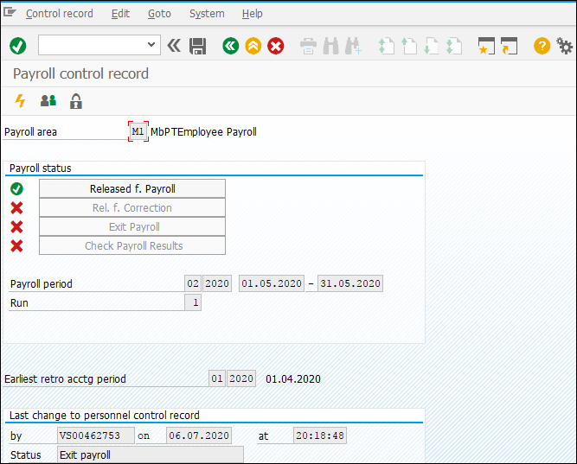

PA03 is the common method of maintaining all status in the same tractions. Below Transaction used for accessing and changing the status of control record.

Released for payroll - PC00_M99_PA03_RELEA
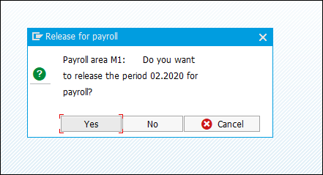

Released for Correction-PC00_M99_PA03_CORR
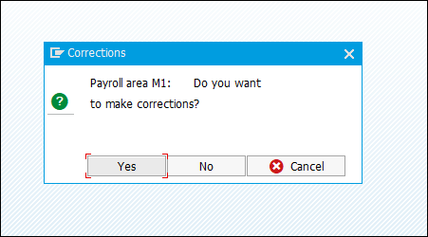
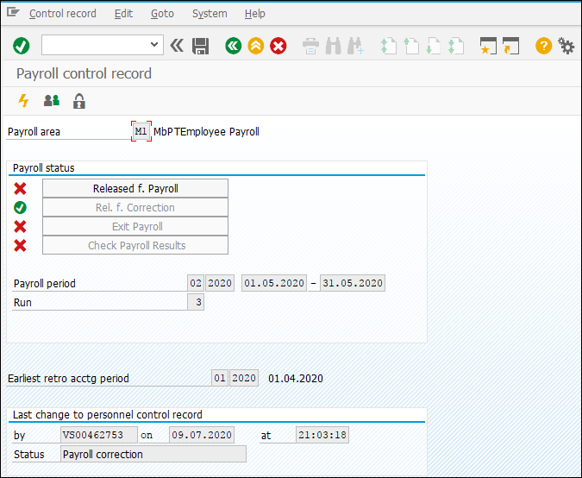

Exit payroll-PC00_M99_PA03_END
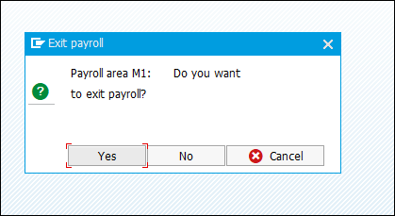
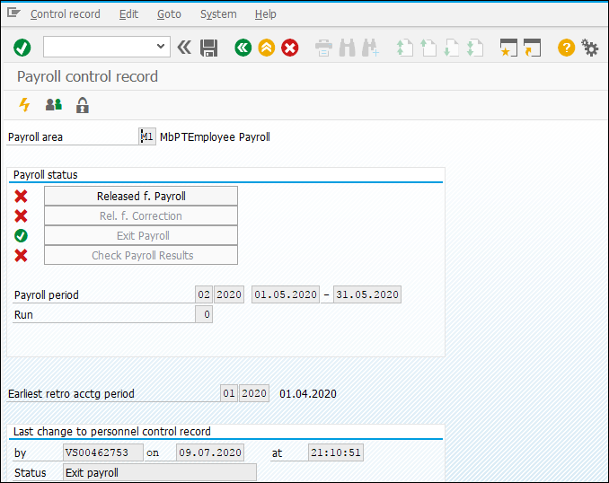

3.2 Simulation Payroll Processing

Payroll administrator can execute Payroll for single or multiple employees in simulation mode to evaluate Payroll outputs in the form of Error and Pay-slip. This simulates the actual payroll but doesn’t update any tables or database. Simulation can be run any no. of times. It is helpful in determining the errors and correcting them before the actual payroll run.

Menu Path | SAP Menu -> Human Resources – Payroll – Asia/Pacific – India – Payroll Accounting – Simulation
Transaction Code | PC00_M40_CALC_SIMU

Menu Path:
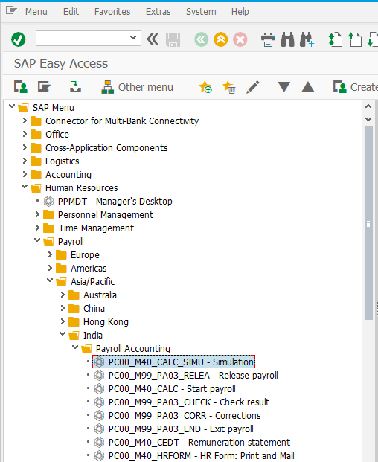

Input Fields:
On running PC00_M40_CALC_SIMU, the following screen will appear:
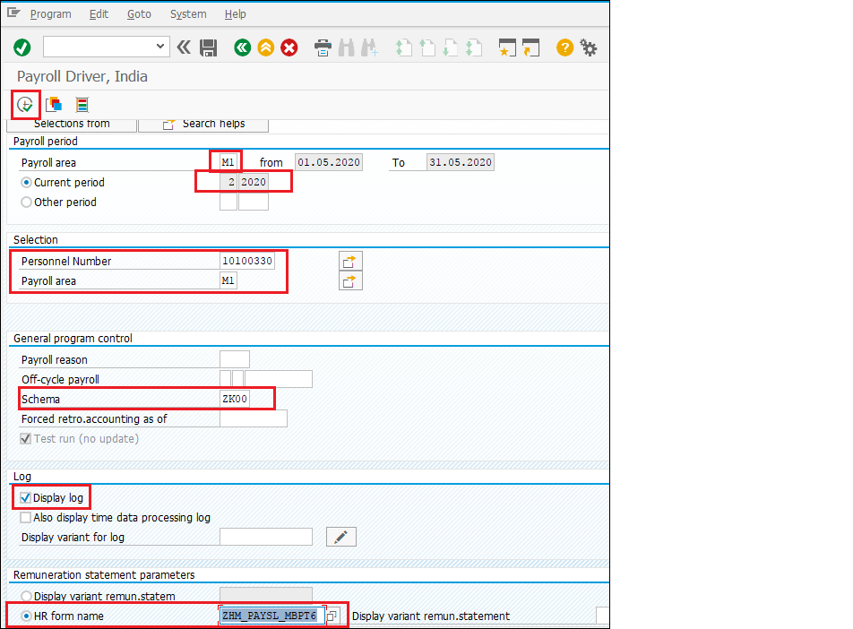

S.No. | Field | Value
1. | Payroll Area | Choose from the below table
2. | Current Period / Other Period | Current Period-Period from control record  Other Period-Choose the Period and Year manually
3. | Personnel Number | Choose from the list.  If not selected will be executed for whole Payroll Area
4. | Schema | Choose from the below table
5. | Display Log | Check or Uncheck
6. | HR Form Name | Choose from the drop-down table
7. | No Remuneration Statement | Check if no Pay slip required

Port Name | Payroll Area | Payroll Area Text
Mumbai | M1 | MbPTEmployee Payroll
 | M2 | MbPTContract Payroll
 | M3 | MbPT Pension
 | M4 | MbPT Family Pension
Chennai | C1 | ChPTEmployee Payroll
 | C2 | ChPTContract Payroll
 | C3 | ChPT Pension BN2002
 | C4 | ChPTFamily Pension
 | C5 | ChPT Pension AN2002
DeenDayal | D1 | DPT Employee Payroll
 | D2 | DPT Contract Payroll
 | D3 | DPT Pension
 | D4 | DPT Family Pension
Haldia | H1 | HDC Employee Payroll
 | H2 | HDC Contract Payroll
 | H3 | HDC Pension
 | H4 | HDC Family Pension
Kolkata | K1 | KDS Employee Payroll
 | K2 | KDS Contract Payroll
 | K3 | KDS Pension
 | K4 | KDS Family Pension
Paradeep | P1 | PPT Employee Payroll
 | P2 | PPT Contract Payroll
 | P3 | PPT Pension
 | P4 | PPT Family Pension

Port Name | Payroll Schema
CHPT | ZECH
CHPT PENSION | ZPCH
MBPT | ZEMB
MBPT PENSION | ZPMB
DPT | ZEDP
DPT PENSION | ZPDP
DPT OOT - VADINAR | ZEDP
KDS | ZEKD
KoPT PENSION | ZPKD
HDC | ZEHD
PPT | ZEPD
PPT PENSION | ZPPD

Click Execute ” icon or Press F8. On completion of the program, following screen will appear.

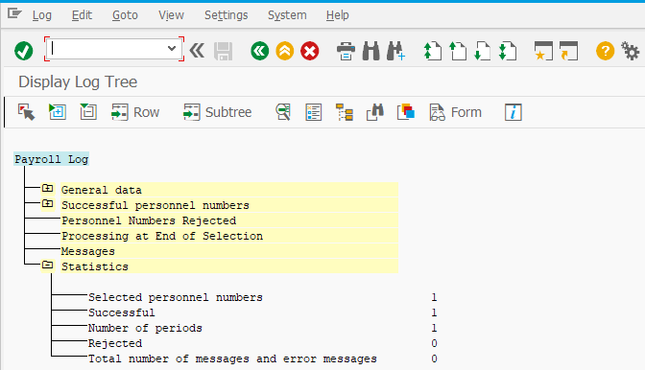

On clicking on ‘Form’ icon, system will show Pay slip of the employee.

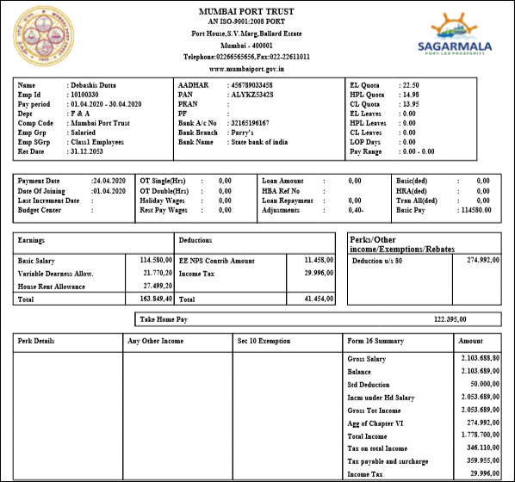

3.3 Live Payroll Run
Step 1: Go to control Record (PA03), enter the desired payroll area and click on edit
Step 2: Select “Released for Payroll” and save it.
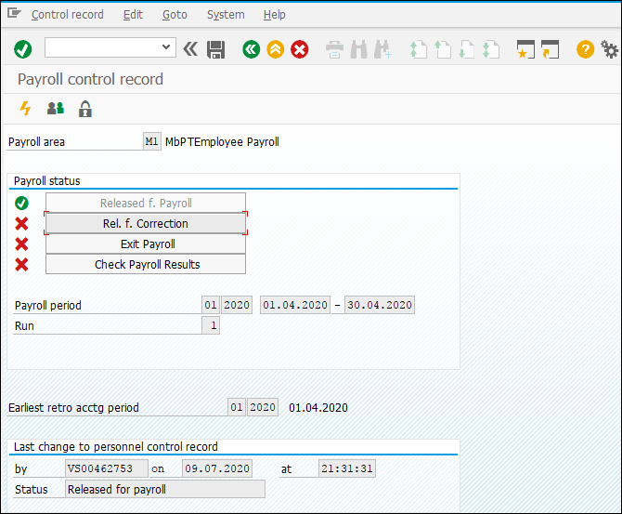

Step 3: Go to below Menu Path or T-code
Menu Path | SAP Menu -> Human Resources – Payroll – Asia/Pacific – India – Payroll Accounting – Start Payroll
Transaction Code | PC00_M40_CALC

Menu Path:
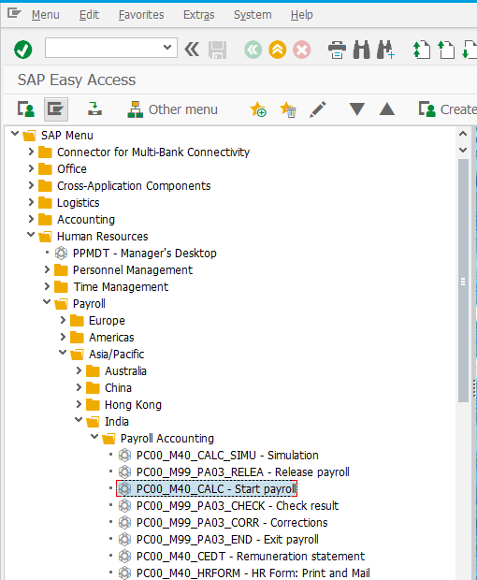

In Live Payroll run, uncheck Test run, fill rest of the details as shown in Simulation, and execute it. You can also save the below same details for the next payroll runs in the form of variant by clicking.

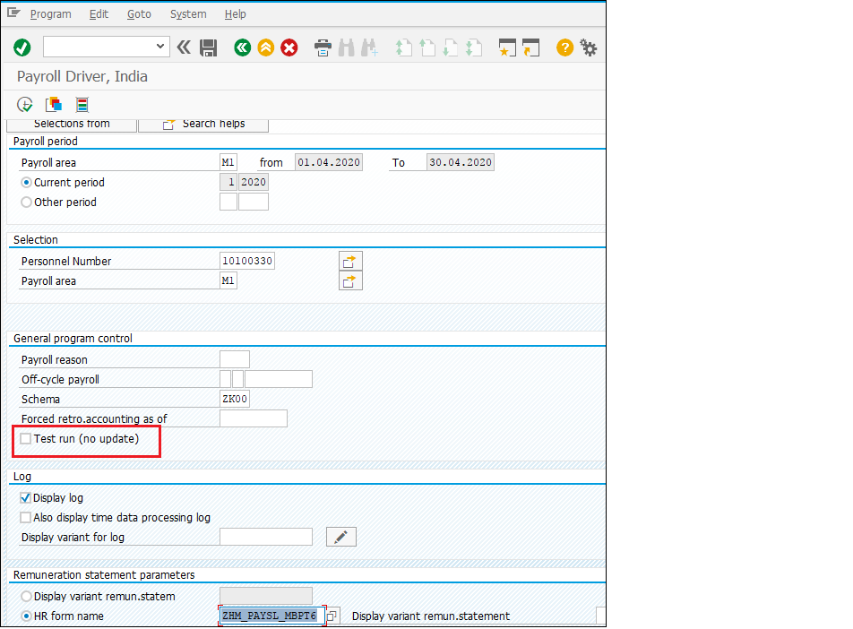

S.No. | Field | Value
1. | Payroll Area | Choose from the below table.
2. | Current Period / Other Period | Current Period-Period from control record  Other Period-Choose the Period and Year manually
3. | Personnel Number | Choose from the list.  If not selected will be executed for whole Payroll Area
4. | Schema | Choose from the below table
5. | Display Log | Check or Uncheck
6. | HR Form Name | Choose from the drop-down values
7. | No Remuneration Statement | Check if no Pay slip required

Port Name | Payroll Area | Payroll Area Text
Mumbai | M1 | MbPTEmployee Payroll
 | M2 | MbPTContract Payroll
 | M3 | MbPT Pension
 | M4 | MbPT Family Pension
Chennai | C1 | ChPTEmployee Payroll
 | C2 | ChPTContract Payroll
 | C3 | ChPT Pension BN2002
 | C4 | ChPTFamily Pension
 | C5 | ChPT Pension AN2002
DeenDayal | D1 | DPT Employee Payroll
 | D2 | DPT Contract Payroll
 | D3 | DPT Pension
 | D4 | DPT Family Pension
Haldia | H1 | HDC Employee Payroll
 | H2 | HDC Contract Payroll
 | H3 | HDC Pension
 | H4 | HDC Family Pension
Kolkata | K1 | KDS Employee Payroll
 | K2 | KDS Contract Payroll
 | K3 | KDS Pension
 | K4 | KDS Family Pension
Paradeep | P1 | PPT Employee Payroll
 | P2 | PPT Contract Payroll
 | P3 | PPT Pension
 | P4 | PPT Family Pension

Port Name | Payroll Schema
CHPT | ZECH
CHPT PENSION | ZPCH
MBPT | ZEMB
MBPT PENSION | ZPMB
DPT | ZEDP
DPT PENSION | ZPDP
DPT OOT - VADINAR | ZEDP
KDS | ZEKD
KoPT PENSION | ZPKD
HDC | ZEHD
PPT | ZEPD
PPT PENSION | ZPPD

Press “Enter” key and select “Execute - ” icon. On completion of the program, following screen will appear.
If the payroll is run for large no. of employees, uncheck the Display log and select ‘No remuneration statement’, as these details will consume a lot of time to run and complete payroll

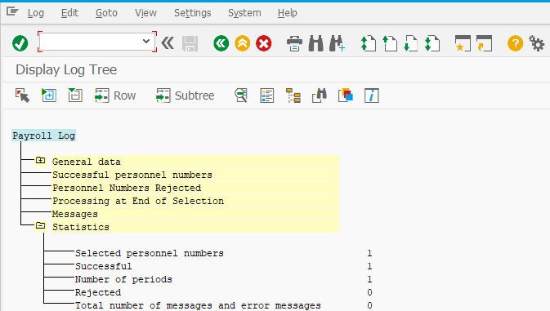

3.4 Payroll Results

Transaction Code: PC_PAYRESULT
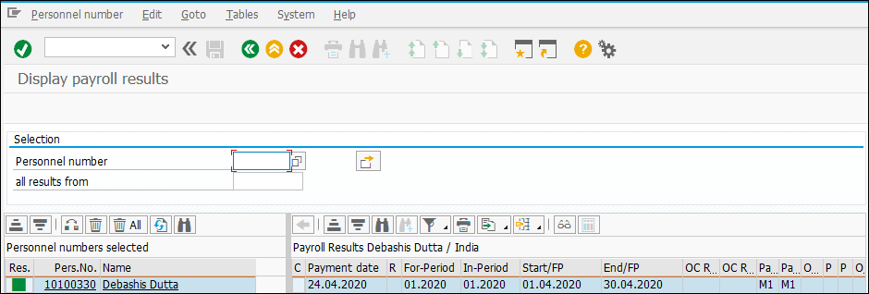

Below icon indicates if the payroll is in error or if the payroll is successfully run for the employee.
Green 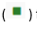for successful payroll run and Red for error Status.
.

WAGETYPE REPORTER

Following are the transaction code to be followed to process Wage type Reporter.
ChPT Wage Type Reporter | ZHR_CHPT_WT
DPT Wage Type Reporter | ZHR_DPT_WT
HDC Wage Type Reporter | ZHR_HDC_WT
KDS Wage Type Reporter | ZHR_KDS_WT
MbPT Wage Type Reporter | ZHR_MBPT_WT
PPT Wage Type Reporter | ZHR_PPT_WT
Pension Wage Type Reporter | ZHR_PENS_WT

Input Fields:
On running T-code: ZHR_MBPT_WT for MBPT, the following screen will show.

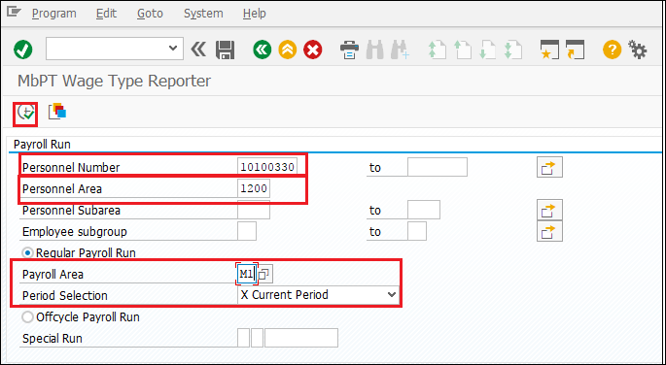

S.No. | Field | Value
1. | Personnel No. | Personnel number(s) that will be processed. Select any / multiple no. of employees from the selection.
2. | Personnel Area | Port Specific. Select the values from the below table
3. | Payroll Area | Port Specific. Select the values from the below table
4. | Regular Payroll Run | Select the Payroll Area and Period Selection- Current or Other.

Personnel Area:
1000 | CHPT
1200 | MBPT
1400 | DPT
1600 | DPT OOT - VADINAR
1700 | KDS
1900 | HDC
2000 | PPT

Port Name | Payroll Area | Payroll Area Text
Mumbai | M1 | MbPTEmployee Payroll
 | M2 | MbPTContract Payroll
 | M3 | MbPT Pension
 | M4 | MbPT Family Pension
Chennai | C1 | ChPTEmployee Payroll
 | C2 | ChPTContract Payroll
 | C3 | ChPT Pension BN2002
 | C4 | ChPTFamily Pension
 | C5 | ChPT Pension AN2002
DeenDayal | D1 | DPT Employee Payroll
 | D2 | DPT Contract Payroll
 | D3 | DPT Pension
 | D4 | DPT Family Pension
Haldia | H1 | HDC Employee Payroll
 | H2 | HDC Contract Payroll
 | H3 | HDC Pension
 | H4 | HDC Family Pension
Kolkata | K1 | KDS Employee Payroll
 | K2 | KDS Contract Payroll
 | K3 | KDS Pension
 | K4 | KDS Family Pension
Paradeep | P1 | PPT Employee Payroll
 | P2 | PPT Contract Payroll
 | P3 | PPT Pension
 | P4 | PPT Family Pension

Employee Group:
S | Salaried
A | Apprentice
C | Contract
T | Trainee

Employee Subgroup:
S | Salaried | C1 | Class1 Employees
S | Salaried | C2 | Class 2 Employees
S | Salaried | C3 | Class 3 Employees
S | Salaried | C4 | Class 4 Employees
A | Apprentice | AP | Apprentice
C | Contract | EX | Executive Contract
C | Contract | NE | Non-Executive Contract
T | Trainee | TR | Trainee

Select “Execute - ” icon. On completion of the program, following screen will appear.
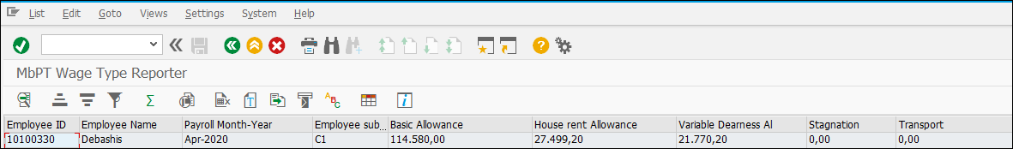

BANK REPORT

Following transaction code to be followed to process Bank Report.
Transaction Code | ZHR_BANK_RPT

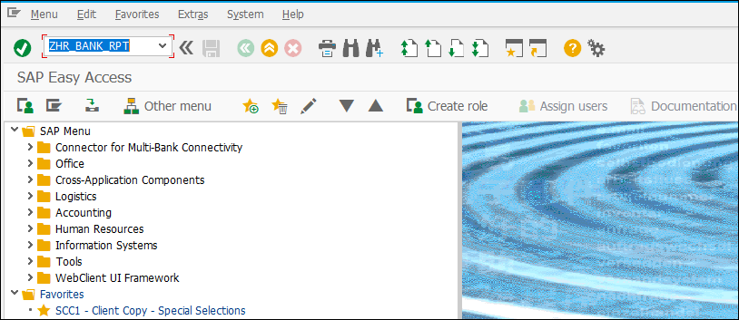

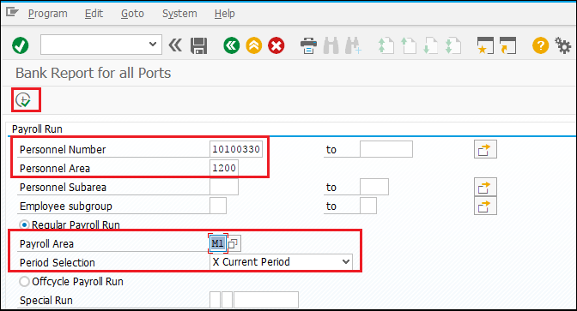
S.No. | Field | Value
1. | Personnel No. | Personnel number(s) that will be processed. Select any / multiple no. of employees from the selection.
2. | Personnel Area | Select the values from below table
3. | Payroll Area | Select the values from below table
4. | Regular Payroll Run | Select the Payroll Area and Period Selection- Current or Other.

Personnel Area:
1000 | CHPT
1200 | MBPT
1400 | DPT
1600 | DPT OOT - VADINAR
1700 | KDS
1900 | HDC
2000 | PPT

Port Name | Payroll Area | Payroll Area Text
Mumbai | M1 | MbPTEmployee Payroll
 | M2 | MbPTContract Payroll
 | M3 | MbPT Pension
 | M4 | MbPT Family Pension
Chennai | C1 | ChPTEmployee Payroll
 | C2 | ChPTContract Payroll
 | C3 | ChPT Pension BN2002
 | C4 | ChPTFamily Pension
 | C5 | ChPT Pension AN2002
DeenDayal | D1 | DPT Employee Payroll
 | D2 | DPT Contract Payroll
 | D3 | DPT Pension
 | D4 | DPT Family Pension
Haldia | H1 | HDC Employee Payroll
 | H2 | HDC Contract Payroll
 | H3 | HDC Pension
 | H4 | HDC Family Pension
Kolkata | K1 | KDS Employee Payroll
 | K2 | KDS Contract Payroll
 | K3 | KDS Pension
 | K4 | KDS Family Pension
Paradeep | P1 | PPT Employee Payroll
 | P2 | PPT Contract Payroll
 | P3 | PPT Pension
 | P4 | PPT Family Pension

Employee Group:
S | Salaried
A | Apprentice
C | Contract
T | Trainee

Employee Subgroup:
S | Salaried | C1 | Class1 Employees
S | Salaried | C2 | Class 2 Employees
S | Salaried | C3 | Class 3 Employees
S | Salaried | C4 | Class 4 Employees
A | Apprentice | AP | Apprentice
C | Contract | EX | Executive Contract
C | Contract | NE | Non-Executive Contract
T | Trainee | TR | Trainee

Select “Execute - ” icon. On completion of the program, following screen will appear.
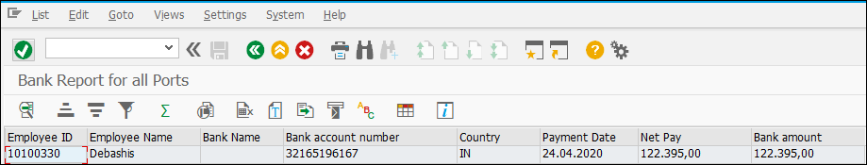

PAYROLL POSTING

Menu Path | SAP Menu -> Human Resources – Payroll – Asia/Pacific – India – Subsequent activities – Per Payroll Period – Posting to Accounting – Execute Run
Transaction Code | PC00_M99_CIPE

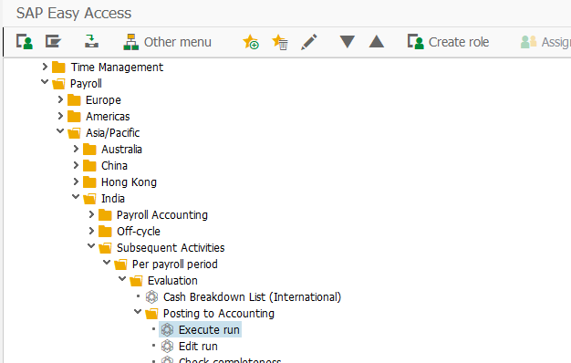

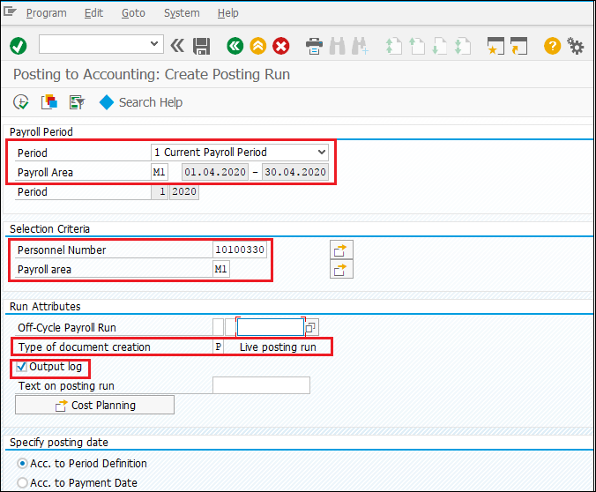
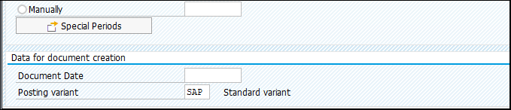

S.No. | Field | Value
1. | Payroll Area | Choose from the below table
2. | Current Period / Other Period | Current Period-Period from control record  Other Period-Choose the Period and Year manually
3. | Personnel Number | Choose from the list.  If not selected will be executed for whole Payroll Area
4. | Type of document creation | Choose Test, Simulation or Live
5. | Output Log | Check or Uncheck
6. | Posting Variant | Choose IPA from the list

Port Name | Payroll Area | Payroll Area Text
Mumbai | M1 | MbPTEmployee Payroll
 | M2 | MbPTContract Payroll
 | M3 | MbPT Pension
 | M4 | MbPT Family Pension
Chennai | C1 | ChPTEmployee Payroll
 | C2 | ChPTContract Payroll
 | C3 | ChPT Pension BN2002
 | C4 | ChPTFamily Pension
 | C5 | ChPT Pension AN2002
DeenDayal | D1 | DPT Employee Payroll
 | D2 | DPT Contract Payroll
 | D3 | DPT Pension
 | D4 | DPT Family Pension
Haldia | H1 | HDC Employee Payroll
 | H2 | HDC Contract Payroll
 | H3 | HDC Pension
 | H4 | HDC Family Pension
Kolkata | K1 | KDS Employee Payroll
 | K2 | KDS Contract Payroll
 | K3 | KDS Pension
 | K4 | KDS Family Pension
Paradeep | P1 | PPT Employee Payroll
 | P2 | PPT Contract Payroll
 | P3 | PPT Pension
 | P4 | PPT Family Pension

Note:-
Test run – For Posting execution with no document creation, Can’t see the document in PCP0
Simulation Run- For Posting execution with document creation, Can have posting document in PCP0 and can’t post to Finance
Live Run - For Posting execution with document creation, Can have posting document in PCP0 and can be posted to Finance module
Releasing the document
Menu Path | SAP Menu -> Human Resources – Payroll – Asia/Pacific – India – Subsequent activities – Per Payroll Period – Posting to Accounting – Edit
Transaction Code | PCP0

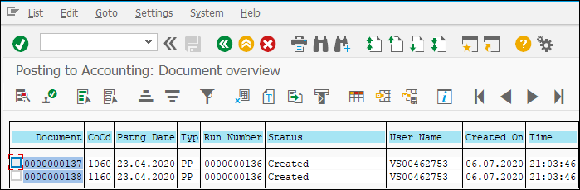

Choose the document and click on release button. We will get below status of posting run as “Released”
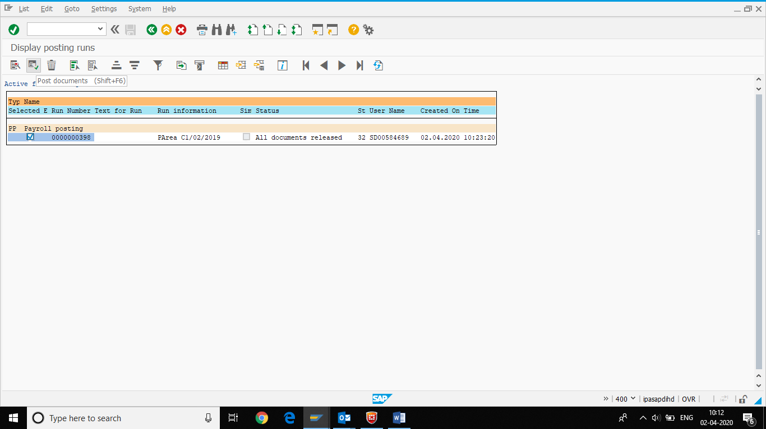

Click in Post the document, new window will pop-up, click on immediately
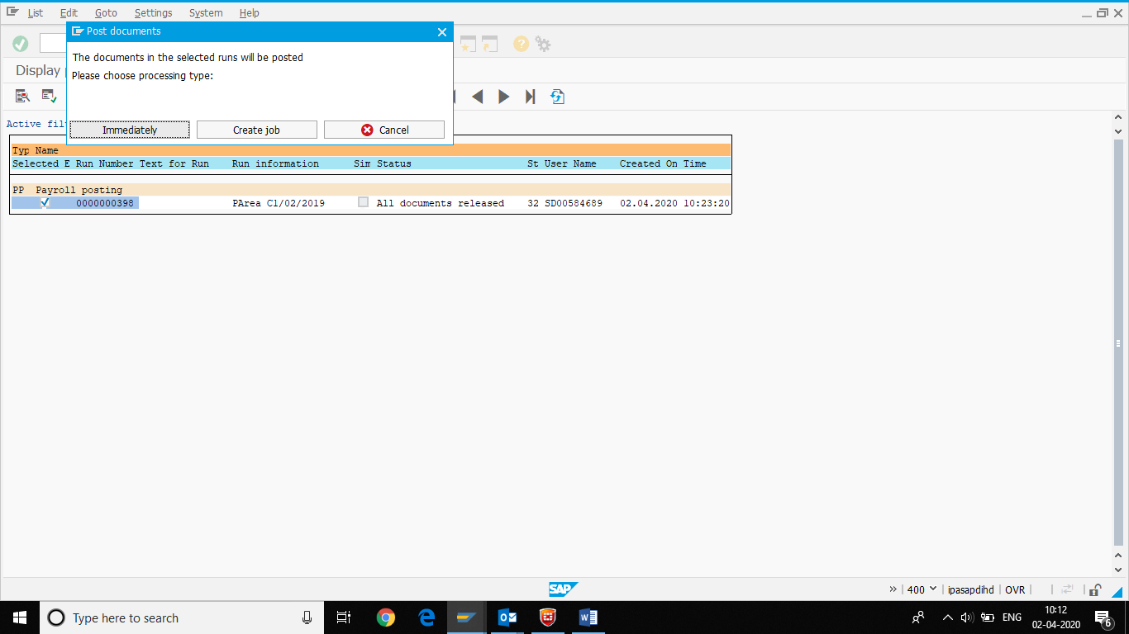

Payroll Document posted to FICO.
