Indian Ports Association (IPA)
Implementation of Port EBS Project
Enterprise Business System

Personnel Administration User Manual
(Human Capital Management)

Submitted by:

Plot No. 58 A & B,
Noida Special Economic Zone,
Uttar Pradesh-201305

www.techmahindra.com

SAP User Manual for Personnel Administration
Document History:
Authors & Participants
Role | Name

Revision History
Date | Document  Version | Document Revision  Description | Author
15.03.2020 | 1.0 | Initial Draft | Senthil

Reviewed and Approved By
Name | Title | Date | Approved

Table of contents

Icons Glossary 6
A. Purpose of the Document 7
B. Target Audience 7
C. Introduction of Personnel Administration 7
D. Infotype 8
E. HCM Structures 8
i. The personnel area 8
ii. Personnel Sub Area 8
iii. Employee Group 8
iv. Employee Sub groups 8
1. Appointment Action 9
1.1 Actions Infotype 11
1.2 Organizational Assignment Infotype 12
1.3 Personal Data Infotype 13
1.4 Address Infotype 14
1.5 Planned Working Time Infotype 15
1.6 Basic Pay Infotype 17
1.7 Bank Details Infotype 19
1.8 Family Details Infotype 20
1.9 Education Infotype 21
1.10 Communications Infotype 22
1.11 Personal IDs Infotype 22
2. Increment / MACP / FUG Action 24
2.1 Actions Infotype 26
2.2 Organizational assignment Infotype 28
2.3 Planned working time Infotype 29
2.4 Basic Pay Infotype 30
3. Promotion Action 32
3.1 Actions Infotype 34
3.2 Organizational Assignment Infotype 35
3.3 Planned Working Time Infotype 36
3.4 Basic Pay Infotype 37
4. Separation/Retirement Action 39
4.1 Actions Infotype 41
4.2 Organizational Assignment Infotype 42
4.3 Planned Working Time Infotype 43
4.4 Basic Pay Infotype 44
5. Transfer Action 47
6. Disciplinary Action 48
7. Deputation Action 49
7.1 Deputation Inward 49
7.2 Deputation Closure 49
7.3 Deputation Outward 49
7.4 Deputation Rejoin 49
8. Create Pensioner Master Data 50
8.1 Actions Infotype 52
8.2 Organizational Assignment Infotype 53
8.3 Personal Data Infotype 55
8.4 Address Infotype 56
8.5 Planned Working Time Infotype 57
8.6 Basic Pay Infotype 58
8.7 Bank Details Infotype 60
8.8 Family Details Infotype 61
8.9 Education Infotype 61
8.10 Communications Infotype 61
8.11 Personal IDs Infotype 62
9. Maintain HR Master Data (Infotypes Maintenance) 63
9.1 Personal Data (0002) Infotype 64
9.2 Addresses (0006) Infotype 65
9.3 Planned Working Time (0007) Infotype 67
9.4 Basic Pay (0008) Infotype 70
9.5 Bank Details (0009) Infotype 73
9.6 Recur. Payments/Deductions (0014) Infotype 74
9.7 Additional Payments (0015) Infotype 76
9.8 Contract Elements (0016) Infotype 78
9.9 Monitoring of Dates (0019) Infotype 80
9.10 Family/Related Person (0021) Infotype 82
9.11 Education (0022) Infotype 84
9.12 Qualifications (0024) Infotype 86
9.13 Pension Management (9003) Infotype 88

Icons Glossary
 | Create
 | Change
 | Display
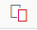 | Copy
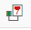 | Delimit
 | Delete
 | Overview
 | Save
 | Back / Previous Menu
 | Header
 | Details
 | Execute

Purpose of the Document
Personnel administration consists of many individual pieces of information, which are stored, updated and managed for each employee in HR system. To manage personnel data related to tasks in HR system, Personnel Administration is needed. All employee data is logged with the exact date. In addition, provide information with a structure, facilitate data entry, and enable you to store data for specific periods.

Target Audience
Establishment Team of respective Departments

Introduction of Personnel Administration
Trigger(s):

- An event takes place in the life cycle of an employee that requires a series of infotypes to be populated. The transaction performed within the system is a Personnel Action. The action may be the hiring/appointment process; a change within the organization such as promotion, department change, transfer or relocation, job change; or a termination of employment.

Overview
Employee master data is stored in SAP as separate infotypes. These infotypes are logical groupings of information. The transactions performed to create and store these infotypes initially are called Personnel actions. Personnel actions are customized to organize and present these infotypes according to a company’s personnel procedures. Actions allow the user easy data entry, because the system automatically presents the screens to be maintained for the particular personnel action.

Each action requires different infotypes and will be a separate action in the system. This document describes the typical procedure required to hire a new employee into your organization. This action describes the process an organization would complete in order to add a person to the headcount and pay the new employee. Based upon each organization’s unique requirements, the infotypes to be included and the order of the infotypes in each action should be customized.

Tips and Tricks:
- Use the pull-down arrow or press F4 to display all possible wage types.
- The transaction code PA40 is a generic path to the action menu. The appropriate action type needs to be selected on the “Personnel Action” screen. Your selections will determine what infotypes are displayed.
- An action is a set of infotypes that have been logically grouped together.
- The Action process described in this document explain how your organization could structure the Personnel action. Additional infotypes may be added or infotypes deleted according to your organization needs.
- Fields with a square and a check at the left-hand side are required. An error message will be displayed when information is not entered or field information is incorrect.

Infotype
Infotypes are units of information in the Human Resource Management System. Recording employee data for administrative, time recording and payroll purposes is of primary importance for master data administration. In the SAP System, the information units used to enter master data are called Infotypes. These are used to group related data fields together. They provide information with a structure, facilitate data entry, and enable you to store data for specific periods. Below list of Infotypes used in this implementation.

HCM Structures
Employee’s milestones are maintained in action Infotype (0000). In organizational assignment Infotype (IT0001) Enterprise structure, Personnel structure & Organizational Structure to which employee belongs to will be maintained.

The personnel area
The personnel area is an organizational unit; according to personnel administrative, time management and payroll organizational point of view. Personnel area represents a delimited enterprise area. Personnel areas are subdivided into personnel subareas.

Personnel Sub Area
Personnel sub areas are subdivisions of the personnel area. A personnel subarea is an organizational entity, which represents part of a personnel area, which is distinguished from others by unique features of personnel administration, time management and payroll accounting. Following table shows PA & PSA combination applicable in respective ports.

Employee Group
Employee group allows dividing employees into groups and allows defining their relationship to the enterprise. There are two EGs available as Salaried, Contract employees and Pensioner.

Employee Sub groups
The employee subgroup represents a subdivision of the employee group. Below is the list of employee group and sub group implemented in respective ports.

Appointment Action
Menu Path | Human Resources -> Personnel Management-> Administration-> HR Master Data-> PA40-Personnel actions
Transaction Code | PA40

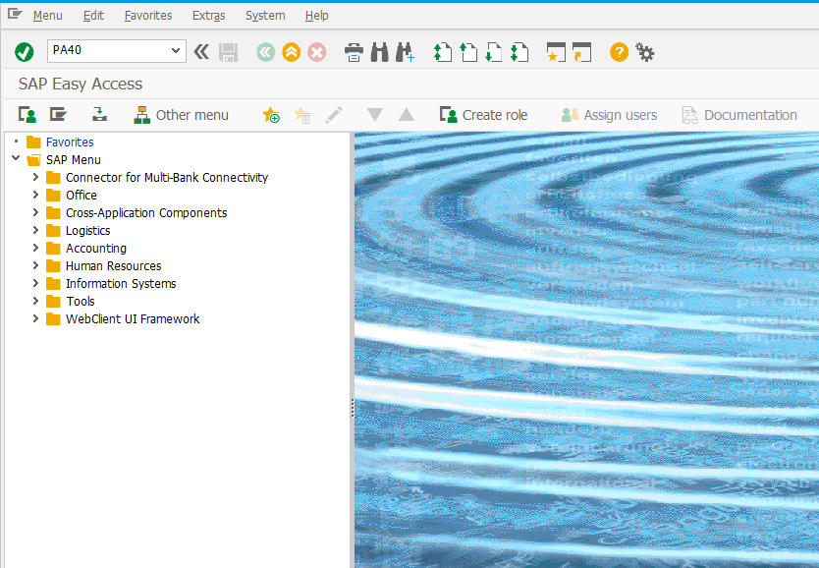

For an Appointment action of an employee, below Infotypes need to be created

0000 | Actions
0001 | Organizational assignment
0002 | Personal data
0006 | Addresses
0007 | Planned Working Time
0008 | Basic Pay
0009 | Bank Details
0016 | Contract Element
0019 | Monitoring of Tasks
0021 | Family Member/Dependents
0022 | Education
0105 | Communication
0185 | Personal IDs

Enter date and select “Appointment”.

Field | Value
Personnel no. | System will generate
From | Start date when employee is hired (dd.mm.yyyy)
Action Type | Choose the Action type

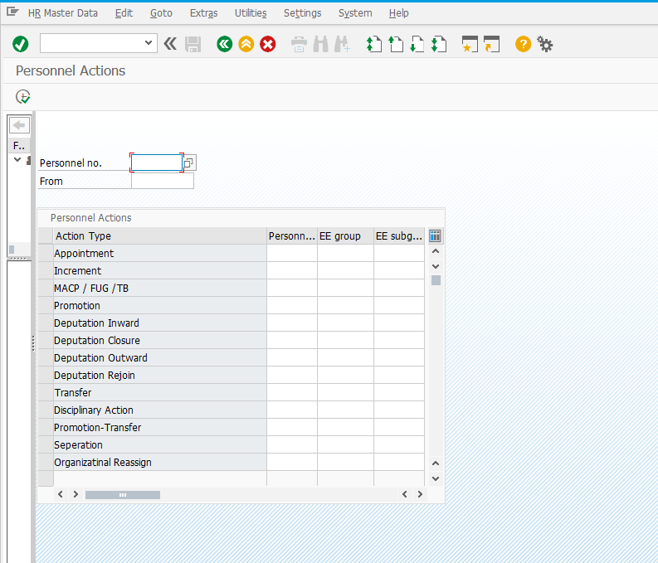
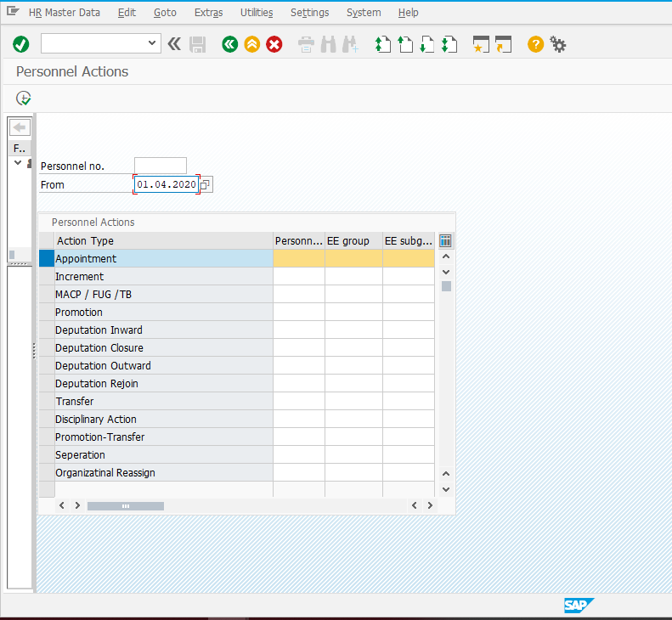

Actions Infotype
Field | Value
Reason for action | Choose the reason from the list
Position | Choose from the list
Personnel Area | Choose from the list
Employee Group | Choose from the list
Employee Sub Group | Choose from the list

Personnel Area:
1000 | CHPT
1200 | MBPT
1400 | DPT
1600 | DPT OOT - VADINAR
1700 | KDS
1900 | HDC
2000 | PPT

Employee Group:
S | Salaried
A | Apprentice
C | Contract
T | Trainee

Employee Subgroup:
S | Salaried | C1 | Class1 Employees
S | Salaried | C2 | Class 2 Employees
S | Salaried | C3 | Class 3 Employees
S | Salaried | C4 | Class 4 Employees
A | Apprentice | AP | Apprentice
C | Contract | EX | Executive Contract
C | Contract | NE | Non-Executive Contract
T | Trainee | TR | Trainee

Note: Click for the list of options available for the field, select one appropriate value, maintain other fields, click and save
To Hire Apprentice, Trainee, Contract: Employee Group and Employee Subgroup should be chosen based on the Key values mentioned above.
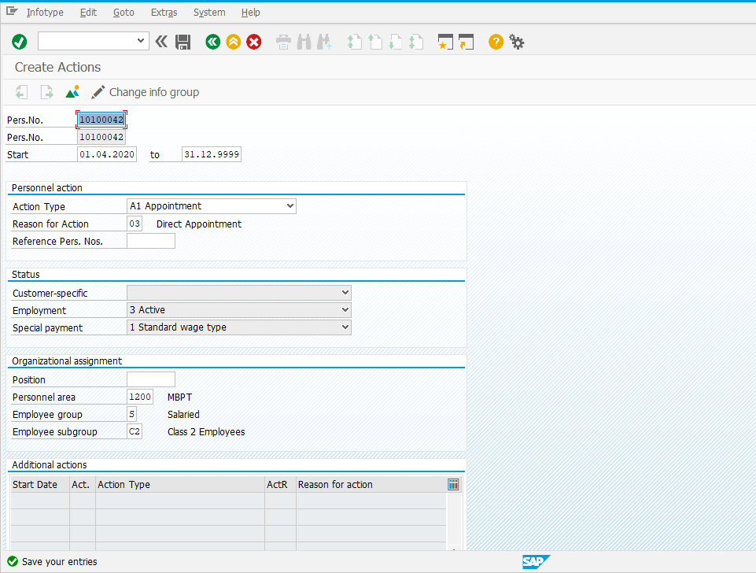

Organizational Assignment Infotype
Field | Value
Personnel Sub Area | Choose from the list based on the Employee Personnel Area

Note: Click for the list of options available for the field, select one appropriate value, maintain other fields, click and save
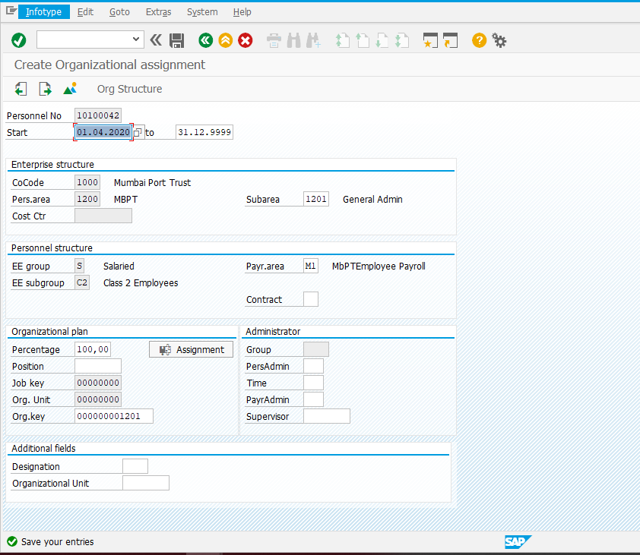

Personal Data Infotype
Field | Value
Title | Choose from the list
First Name | First Name of Employee
Last Name | Last Name of Employee
Gender | Choose from the list
Date of Birth | Enter DOB of Employee
Nationality | Choose from the list

Note: Click for the list of options available for the field, select one appropriate value, maintain other fields, click and save
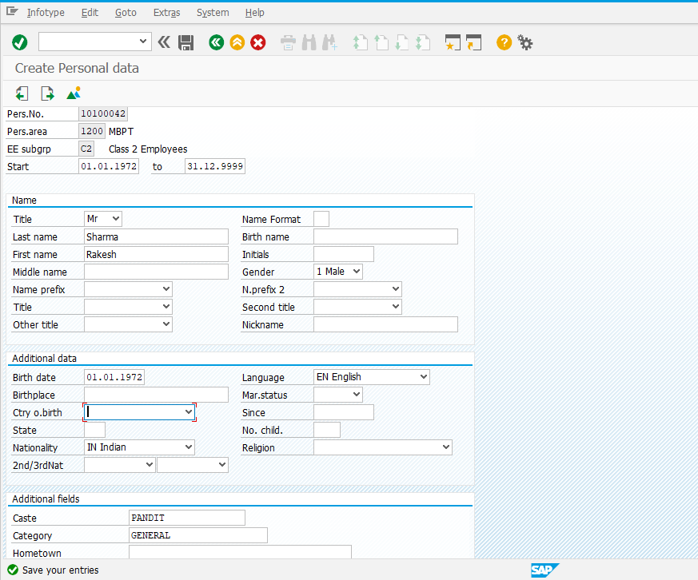

Address Infotype
Field | Value
Address Record Type | Choose Permanent Address
Address | Enter Address of the Employee
Pin code | Enter Pin code
City | Enter Name of City

Note: Click for the list of options available for the field, select one appropriate value, maintain other fields, click and save

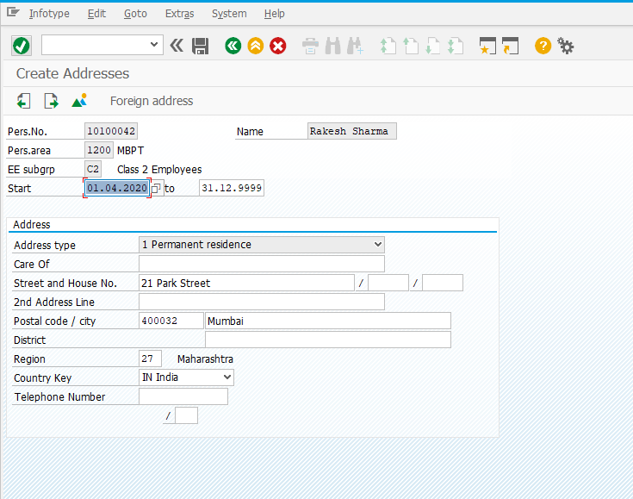

Planned Working Time Infotype
Field | Value
Work Schedule Rule | Choose the work schedule from the list
Time Mgmt. Status | Choose 9 - Time Evaluation of planned times from the list
Note: Click for the list of options available for the field, select one appropriate value, maintain other fields, click and save
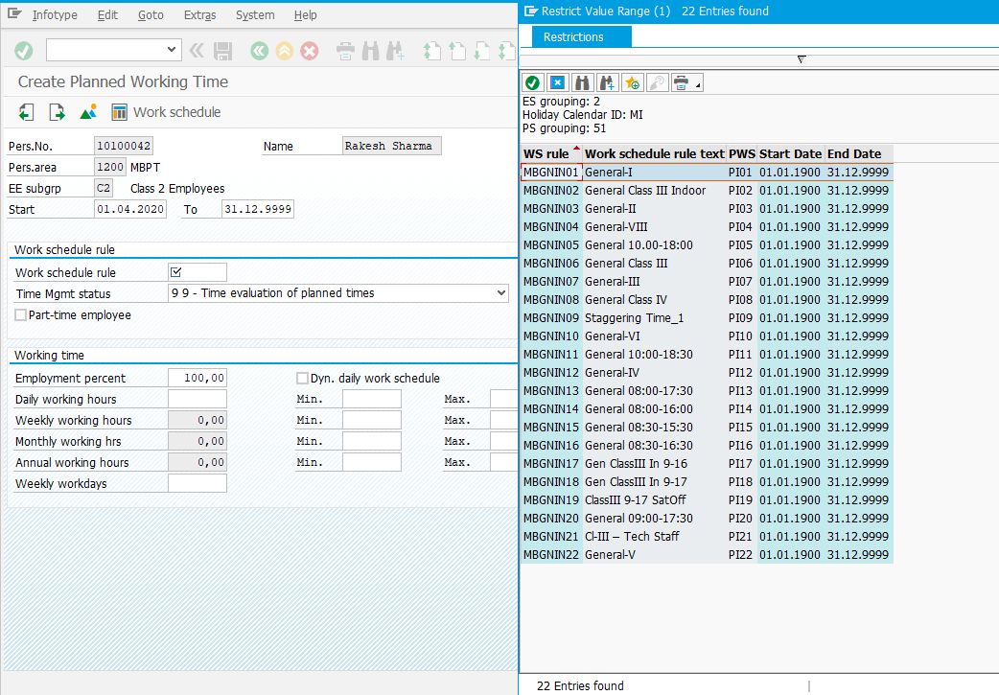
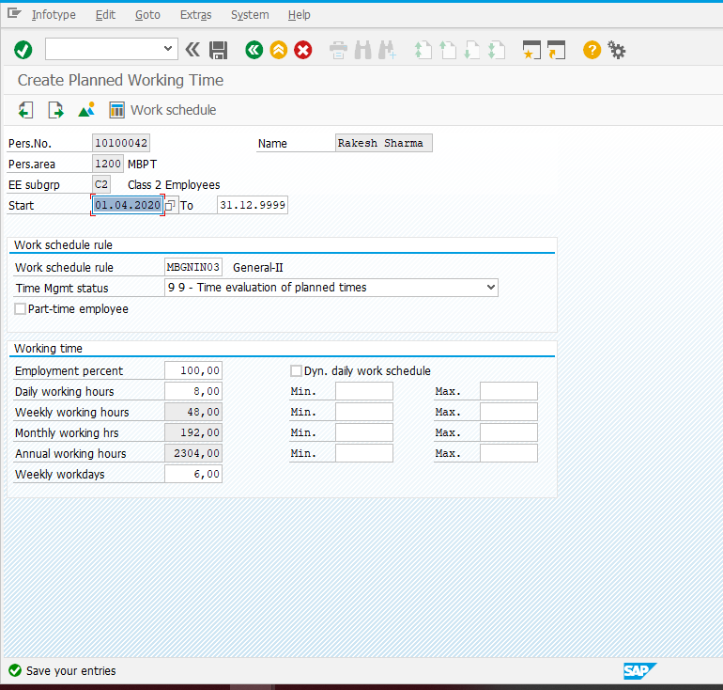

Basic Pay Infotype
Field | Value
Pay Scale Type | MB
Pay Scale Area | MB
PS Group & Level | Choose the Pay scale Group and Level from the list
Basic Salary | Basic Pay will be populated for Class3 and 4

Pay Scale Type and Pay Scale Area for all Ports except Mumbai Port is “SL”, “SL” respectively.
Note: Click for the list of options available for the field, select one appropriate value, maintain other fields, click and save
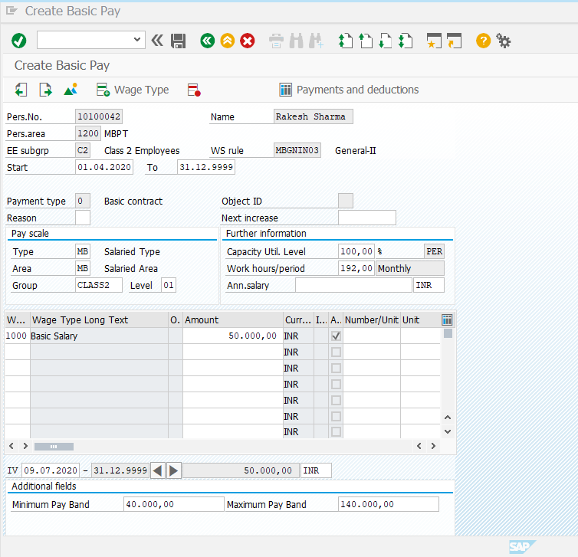

Bank Details Infotype
Field | Value
Postal Code/City | Postal code and city of the bank
Bank Key | Chose the bank key i.e. IFSC CODE from the list
Bank Account | Maintain the Bank Account number
Payment Method | Maintain Payment method as Bank Transfer only

Note: Click for the list of options available for the field, select one appropriate value, maintain other fields, click and save
.
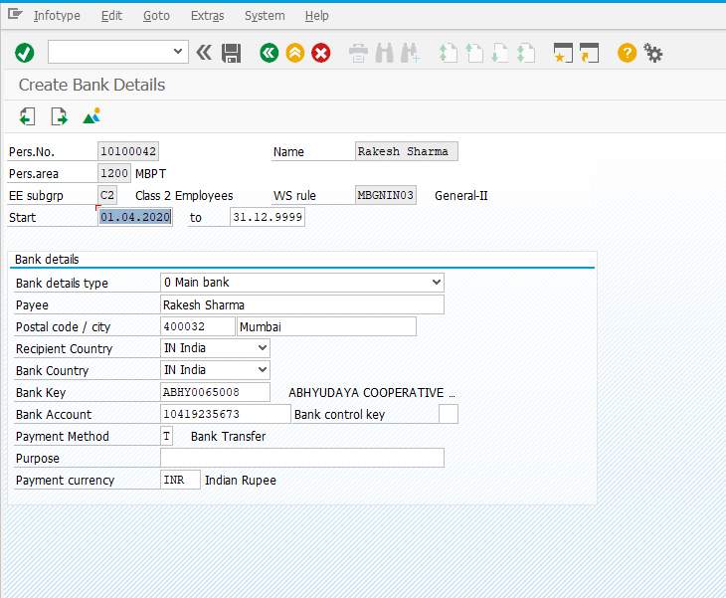

Family Details Infotype
Field | Value
Family Member Sub type | Choose from the list
First Name and Last Name | Maintain the First and Last Name
Gender | Gender of Dependent
Date of Birth | DOB of Dependent

Note: Click for the list of options available for the field, select one appropriate value, maintain other fields, click and save
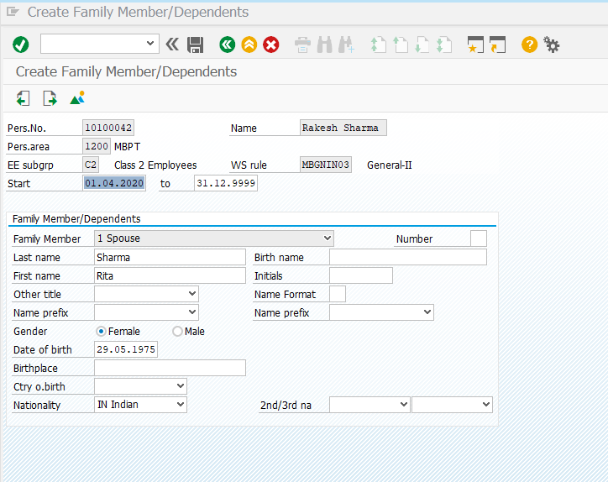

Education Infotype
Field | Value
Establishment | Choose from the list
Education/Training | Choose from the list
Institution | Enter the institute name
Country | Choose from the list
Certificate | Choose from the list
Curation | Choose from the list
Final Grade | Enter the value
Branch of Study1 | Choose from the list
Branch of Study2 | Choose from the list

Note: Click for the list of options available for the field, select one appropriate value, maintain other fields, click and save
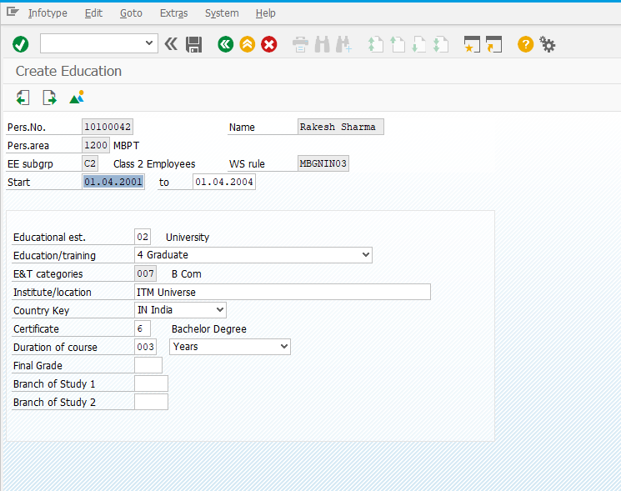

Communications Infotype
Field | Value
Subtype | Choose from the list
Communicate type | Enter communication information

Note: Click for the list of options available for the field, select one appropriate value, maintain other fields, click and save
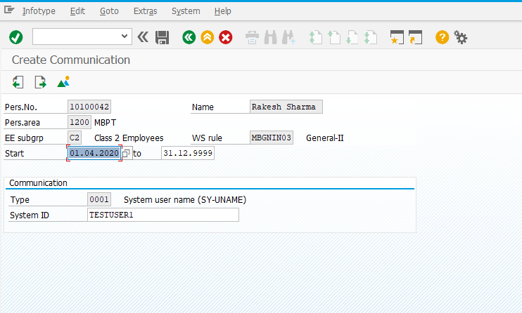

Personal IDs Infotype
Field | Value
Subtype | Choose from the list
ID Type | Enter ID Number

Note: Click for the list of options available for the field, select one appropriate value, maintain other fields, click and save
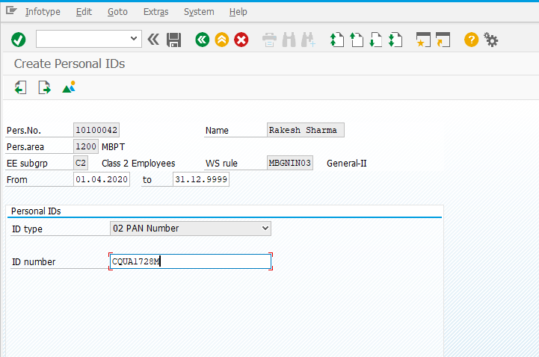

Increment / MACP / FUG Action
To perform Personnel actions, follow below path:

Menu Path | Human Resources -> Personnel Management-> Administration-> HR Master Data-> PA40-Personnel actions
Transaction Code | PA40

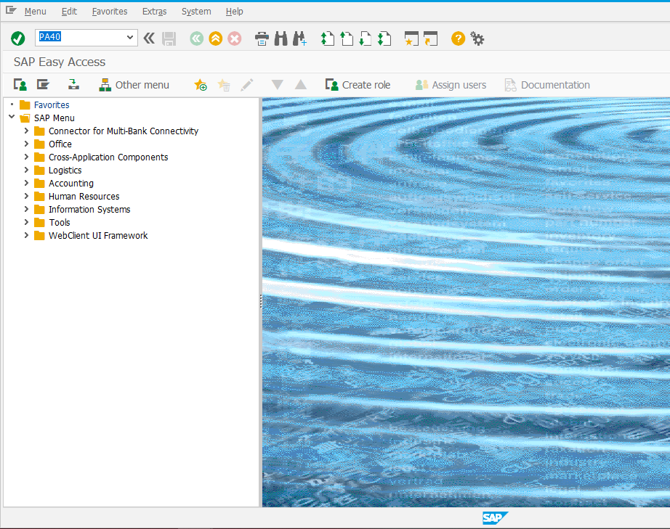

For an Increment action, below Infotypes need to be updated.
0000 | Actions
0001 | Organizational assignment
0007 | Planned Working Time
0008 | Basic Pay

Enter employee no and select an action “Increment”.
Field | Value
Personnel no. | Enter the Personnel Number
From | Start date of the action (dd.mm.yyyy)
Action Type | Choose the Action type

Note: Click for the list of options available for the field, select one appropriate value, maintain other fields, click and save
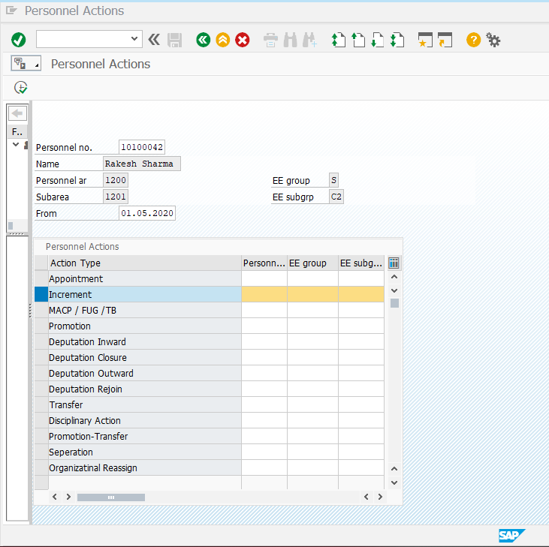

Actions Infotype
Field | Value
Reason for action | Choose from the list
Position | Choose from the list
Personnel Area | Choose from the list
Employee Group | Choose from the list
Employee Sub Group | Choose from the list

Personnel Area:
1000 | CHPT
1200 | MBPT
1400 | DPT
1600 | DPT OOT - VADINAR
1700 | KDS
1900 | HDC
2000 | PPT

Employee Group:
S | Salaried
A | Apprentice
C | Contract
T | Trainee

Employee Subgroup:
S | Salaried | C1 | Class1 Employees
S | Salaried | C2 | Class 2 Employees
S | Salaried | C3 | Class 3 Employees
S | Salaried | C4 | Class 4 Employees
A | Apprentice | AP | Apprentice
C | Contract | EX | Executive Contract
C | Contract | NE | Non-Executive Contract
T | Trainee | TR | Trainee

Note: Click for the list of options available for the field, select one appropriate value, maintain other fields, click and save
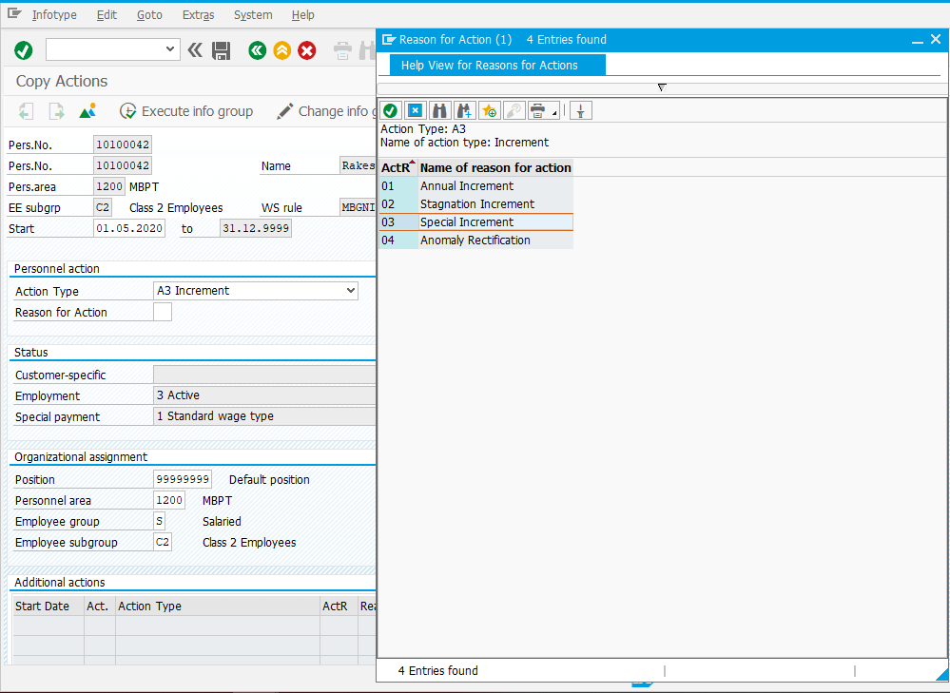
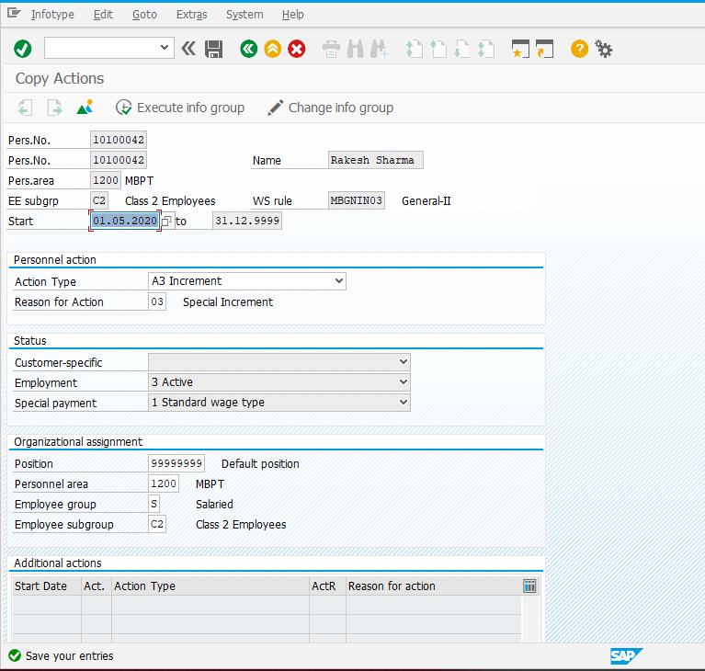

Organizational assignment Infotype
Field | Value
Personnel Sub Area | Choose the reason from the list based on the Personnel Area of Employee

Note: Click for the list of options available for the field, select one appropriate value, maintain other fields, click and save

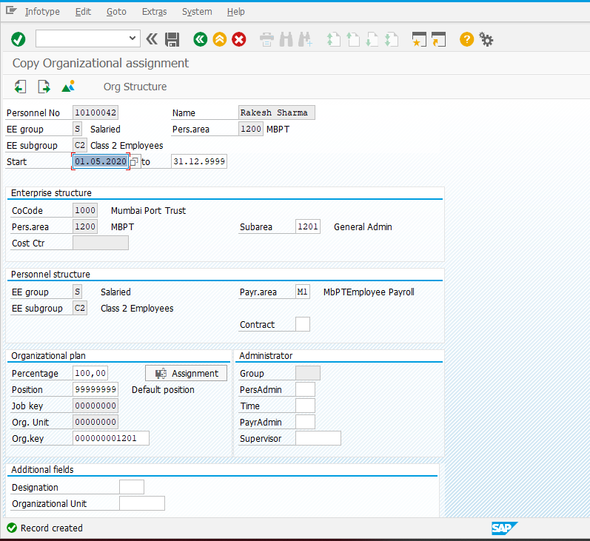

Planned working time Infotype
Field | Value
Work Schedule Rule | Choose the work schedule from the list
Time Mgmt. Status | Choose 9 - Time Evaluation of planned times from the list

Note: Click for the list of options available for the field, select one appropriate value, maintain other fields, click and save
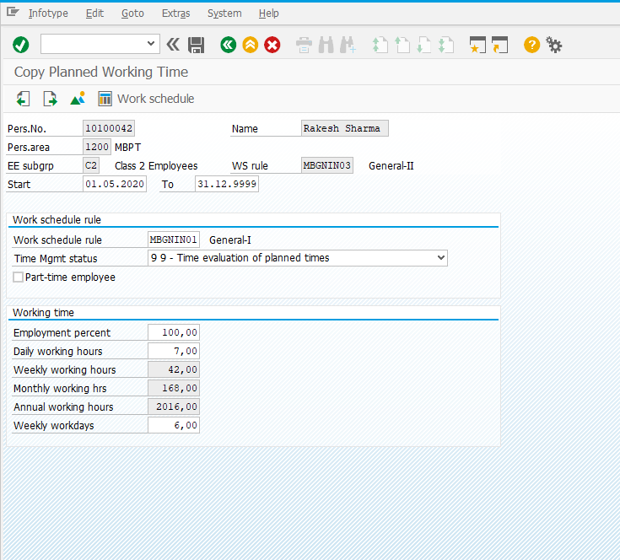

Basic Pay Infotype
Field | Value
Pay Scale Type | SL
Pay Scale Area | SL
PS Group & Level | Choose the Pay scale Group and Level from the list
Basic Salary | Basic Pay will be populated for Class3 and 4

Pay Scale Type and Pay Scale Area for all Ports except Mumbai Port is “SL”, “SL” respectively.
Note: Click for the list of options available for the field, select one appropriate value, maintain other fields, click and save
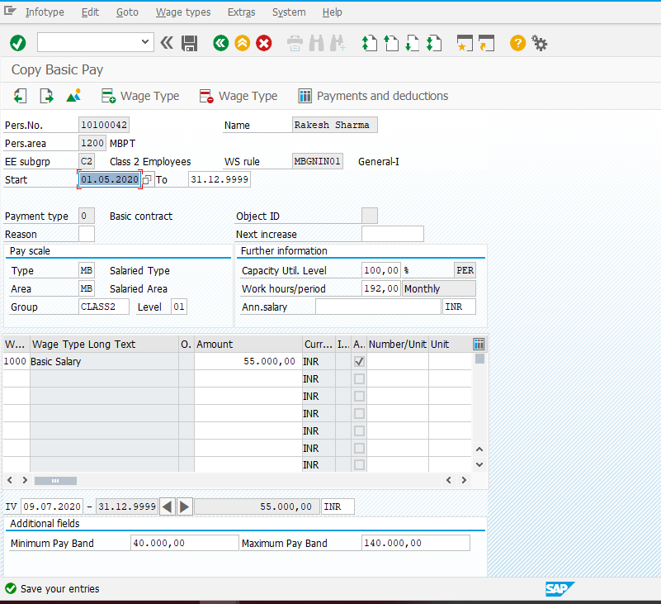

Promotion Action
Menu Path | Human Resources -> Personnel Management-> Administration-> HR Master Data-> PA40-Personnel actions
Transaction Code | PA40

For Promotion Action, below Infotypes need to be updated.
0000 | Actions
0001 | Organizational assignment
0007 | Planned Working Time
0008 | Basic Pay

Enter employee no and select an action “Promotion”.
Field | Value
Personnel no. | Enter the Personnel Number
From | Start date of the action (dd.mm.yyyy)
Action Type | Choose the Action type

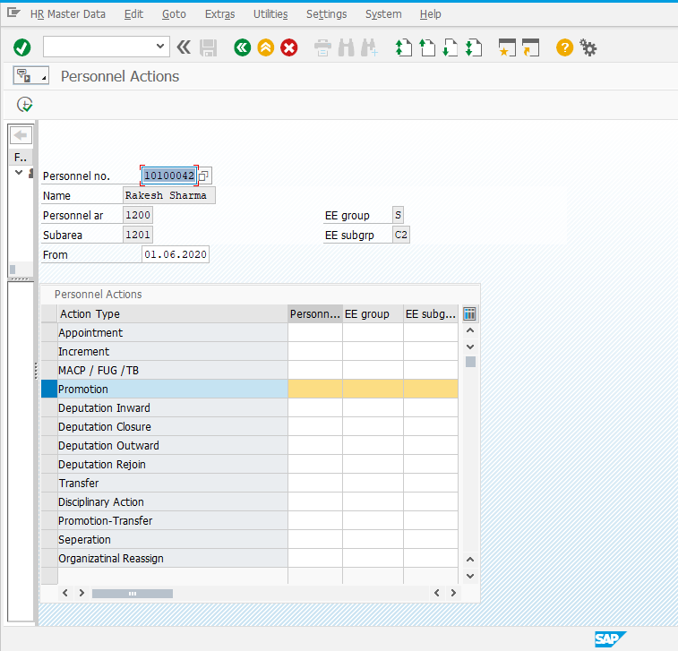

Actions Infotype
Field | Value
Reason for action | Choose the reason from the list
Position | Choose from the list
Personnel Area | Choose from the list
Employee Group | Choose from the list
Employee Sub Group | Choose from the list

Personnel Area:
1000 | CHPT
1200 | MBPT
1400 | DPT
1600 | DPT OOT - VADINAR
1700 | KDS
1900 | HDC
2000 | PPT

Employee Group:
S | Salaried
A | Apprentice
C | Contract
T | Trainee

Employee Subgroup:
S | Salaried | C1 | Class1 Employees
S | Salaried | C2 | Class 2 Employees
S | Salaried | C3 | Class 3 Employees
S | Salaried | C4 | Class 4 Employees
A | Apprentice | AP | Apprentice
C | Contract | EX | Executive Contract
C | Contract | NE | Non-Executive Contract
T | Trainee | TR | Trainee

Note: Click for the list of options available for the field, select one appropriate value, maintain other fields, click and save
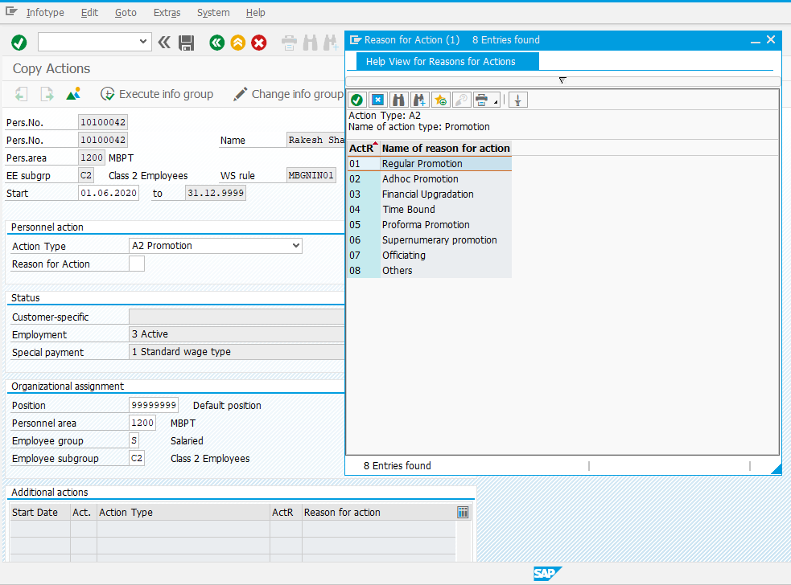
In case of Promotion, the employee subgroup needs to be updated.

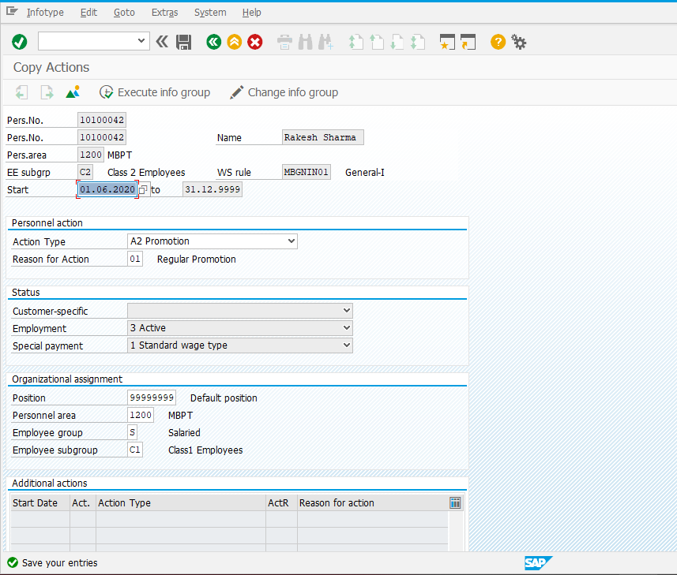

Organizational Assignment Infotype
Field | Value
Personnel Sub Area | Choose the reason from the list based on the personnel area of Employee

Note: Click for the list of options available for the field, select one appropriate value, maintain other fields, click and save
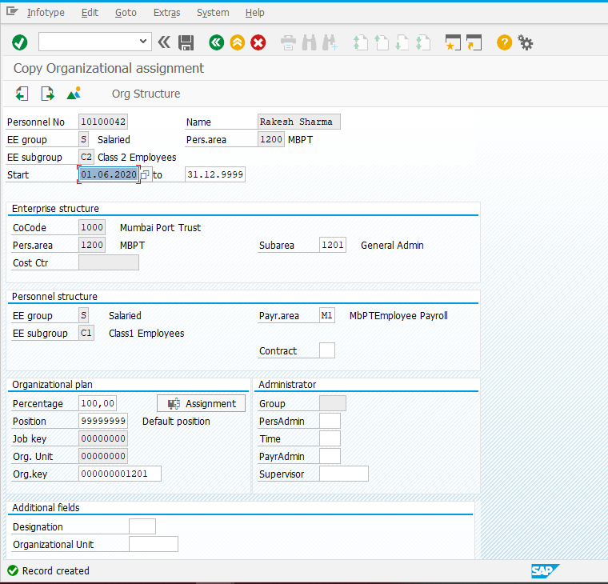

Planned Working Time Infotype
Field | Value
Work Schedule Rule | Choose the work schedule from the list
Time Mgmt. Status | Choose 9 - Time Evaluation of planned times from the list

Note: Click for the list of options available for the field, select one appropriate value, maintain other fields, click and save
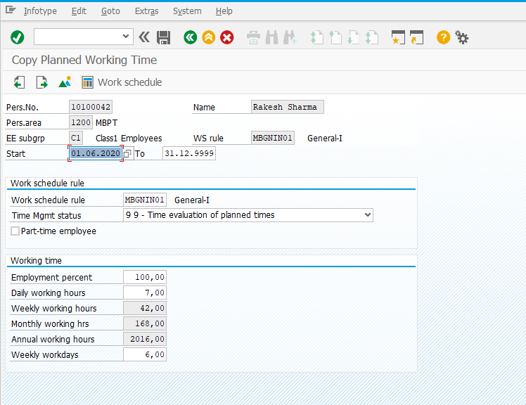

Basic Pay Infotype
Field | Value
Pay Scale Type | SL
Pay Scale Area | SL
PS Group & Level | Choose the Pay scale Group and Level from the list
Basic Salary | Basic Pay will be populated for Class3 and 4

Note: Click for the list of options available for the field, select one appropriate value, maintain other fields, click and save
Pay Scale Type and Pay Scale Area for all Ports except Mumbai Port is “SL”, “SL” respectively.

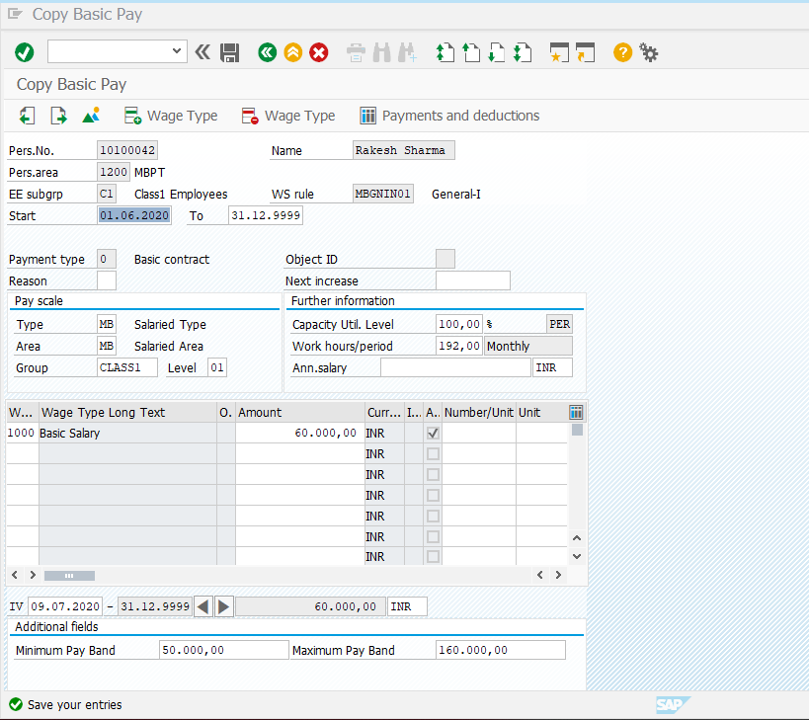

Separation/Retirement Action
To perform Personnel actions, follow below path:

Menu Path | Human Resources -> Personnel Management-> Administration-> HR Master Data-> PA40-Personnel actions
Transaction Code | PA40

For Separation action, below Infotypes need to be updated.
0000 | Actions
0001 | Organizational assignment
0007 | Planned Working Time
0008 | Basic Pay

Enter employee no and select an action “Separation”.
Field | Value
Personnel no. | Enter the Personnel Number
From | Start date of the action (dd.mm.yyyy)
Action Type | Choose the Action type

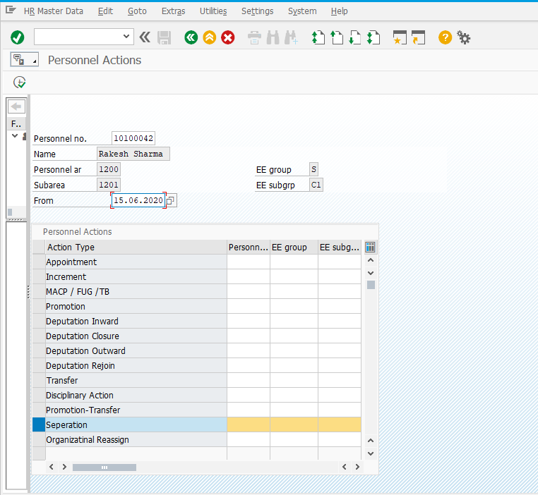

Actions Infotype
Field | Value
Reason for action | Choose the reason from the list

Personnel Area:
1000 | CHPT
1200 | MBPT
1400 | DPT
1600 | DPT OOT - VADINAR
1700 | KDS
1900 | HDC
2000 | PPT

Employee Group:
S | Salaried
A | Apprentice
C | Contract
T | Trainee

Employee Subgroup:
S | Salaried | C1 | Class1 Employees
S | Salaried | C2 | Class 2 Employees
S | Salaried | C3 | Class 3 Employees
S | Salaried | C4 | Class 4 Employees
A | Apprentice | AP | Apprentice
C | Contract | EX | Executive Contract
C | Contract | NE | Non-Executive Contract
T | Trainee | TR | Trainee

Note: Click for the list of options available for the field, select one appropriate value, maintain other fields, click and save

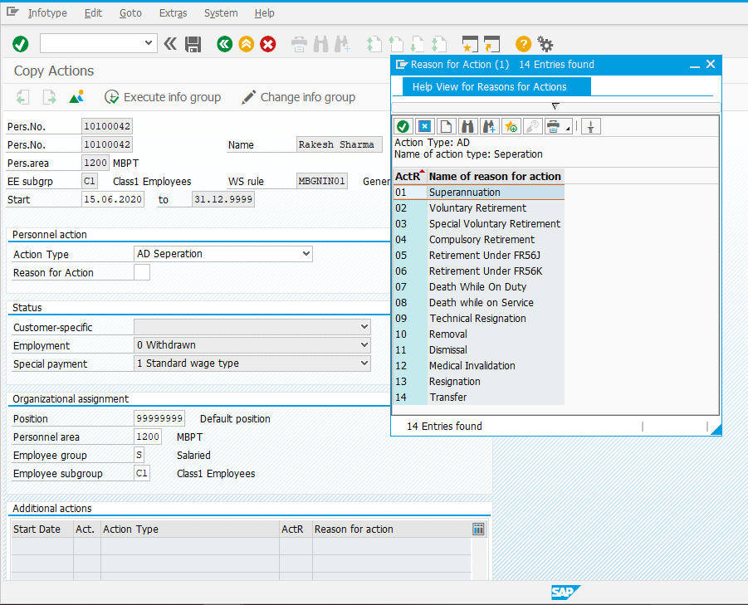
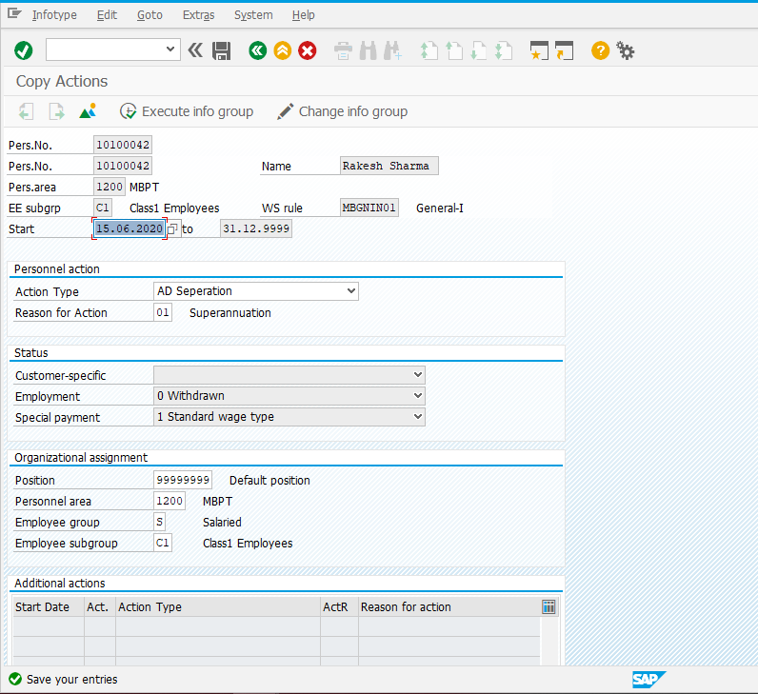

Organizational Assignment Infotype
Field | Value
Personnel Sub Area | Choose the reason from the list based on the Personnel Area of Employee

Note: Click for the list of options available for the field, select one appropriate value, maintain other fields, click and save

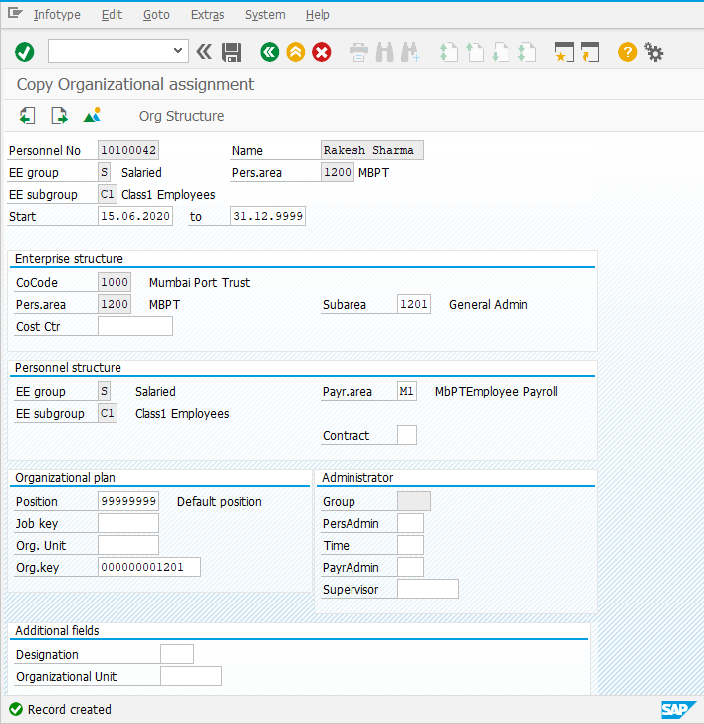

Planned Working Time Infotype
Field | Value
Work Schedule Rule | Choose the work schedule from the list
Time Mgmt. Status | Choose 9 - Time Evaluation of planned times from the list

Note: Click for the list of options available for the field, select one appropriate value, maintain other fields, click and save

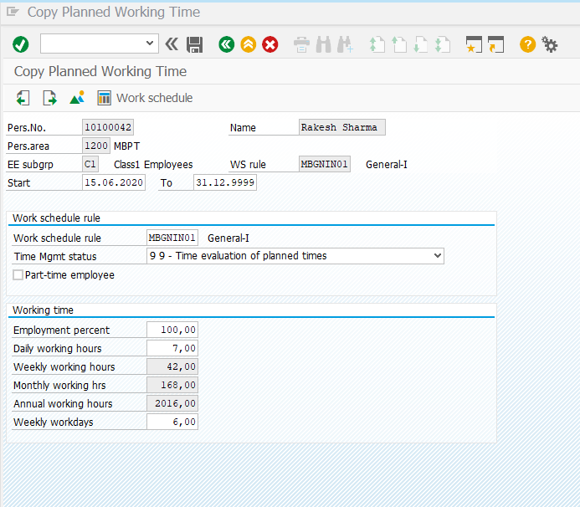

Basic Pay Infotype

Field | Value
Pay Scale Type | SL
Pay Scale Area | SL
PS Group & Level | Choose the Pay scale Group and Level from the list
Basic Salary | Basic Pay will be populated for Class3 and 4

Note: Click for the list of options available for the field, select one appropriate value, maintain other fields, click and save

Pay Scale Type and Pay Scale Area for all Ports except Mumbai Port is “SL”, “SL” respectively.

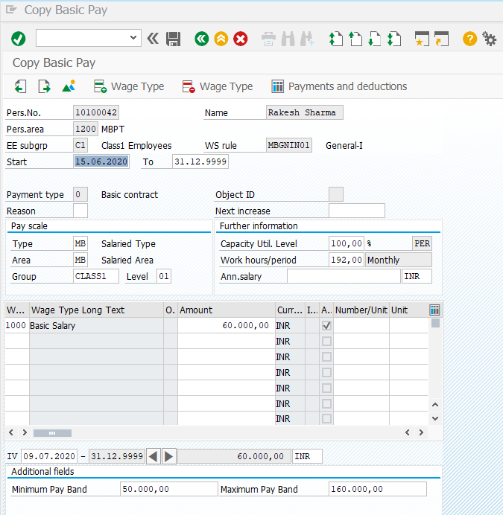

Transfer Action
For Transfer action. Below Infotypes need to be updated.
0000 | Actions
0001 | Organizational assignment
0007 | Planned Working Time

Note: The process of performing any personnel action is done through PA40. Each personnel action requires different infotypes to be updated. The master data is maintained according to the requirement.

data is maintained according to the requirement.

Disciplinary Action
For Suspension action. Below Infotypes need to be updated.
0000 | Actions
0001 | Organizational assignment
0007 | Planned Working Time
3743 | Disciplinary action
0008 | Basic Pay

Note: The process of performing any personnel action is done through PA40. Each personnel action requires different infotypes to be updated. The master data is maintained according to the requirement.

Deputation Action

Deputation Inward
For Deputation Inward action, below Infotypes need to be updated
0000 | Actions
0001 | Organizational assignment
0002 | Personal data
0006 | Addresses
0007 | Planned Working Time
0008 | Basic Pay
0009 | Bank Details

Deputation Closure
For Deputation Closure action, below Infotypes need to be updated.
0000 | Actions
0001 | Organizational assignment

Deputation Outward
For Deputation Outward action, below Infotypes need to be updated.
0000 | Actions
0001 | Organizational assignment

Deputation Rejoin
For Deputation Rejoin action, below Infotypes need to be updated.
0000 | Actions
0001 | Organizational assignment
0002 | Personal data
0006 | Addresses
0007 | Planned Working Time
0008 | Basic Pay
0009 | Bank Details

Note: The process of performing any personnel action is done through PA40. Each personnel action requires different infotypes to be updated. The master data is maintained according to the requirement.

Create Pensioner Master Data
Menu Path | Human Resources -> Personnel Management-> Administration-> HR Master Data-> PA40-Personnel actions
Transaction Code | PA40

For creating a pensioner, below Infotypes need to be updated.

0000 | Actions
0001 | Organizational assignment
0002 | Personal data
0006 | Addresses
0007 | Planned Working Time
0008 | Basic Pay
0009 | Bank Details
0105 | Communication
0185 | Personal IDs

Enter date and select “Pensioner”.

Field | Value
Personnel no. | System will generate
From | Start date when employee is hired (dd.mm.yyyy)
Action Type | Choose the Action type

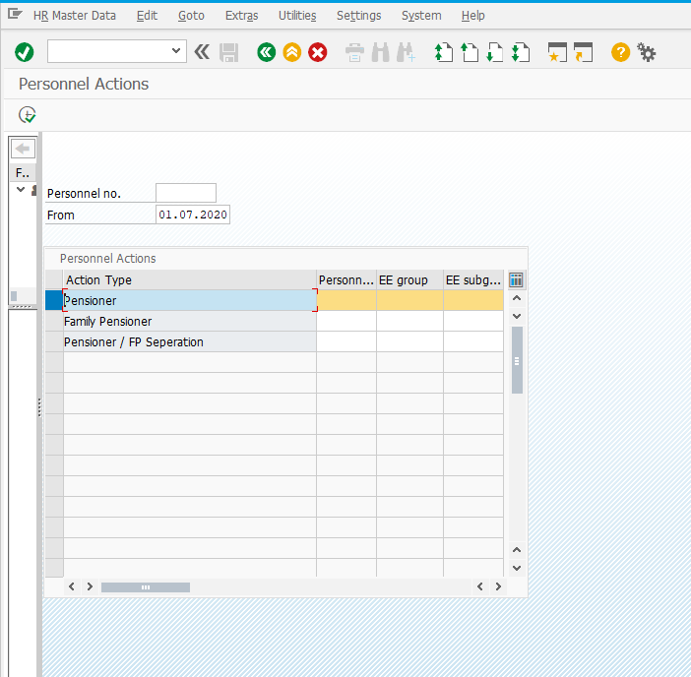

Actions Infotype
Field | Value
Reason for action | Choose the reason from the list
Position | Choose from the list
Personnel Area | Choose from the list
Employee Group | Choose from the list
Employee Sub Group | Choose from the list

Possible values for Personnel Area:
1100 | CHPT PENSION
1300 | MBPT PENSION
1500 | DPT PENSION
1800 | KoPT PENSION
2100 | PPT PENSION

Employee Group:
F | Family Pensioner
P | Pensioner

Employee Sub Group:
P | Pensioner | P1 | Class 1 Pensioner
P | Pensioner | P2 | Class 2 Pensioner
P | Pensioner | P3 | Class 3 Pensioner
P | Pensioner | P4 | Class 4 Pensioner
F | Family Pensioner | F1 | Class1 FPensioner
F | Family Pensioner | F2 | Class2 FPensioner
F | Family Pensioner | F3 | Class3 FPensioner
F | Family Pensioner | F4 | Class4 FPensioner

Note: Click for the list of options available for the field, select one appropriate value, maintain other fields, click and save
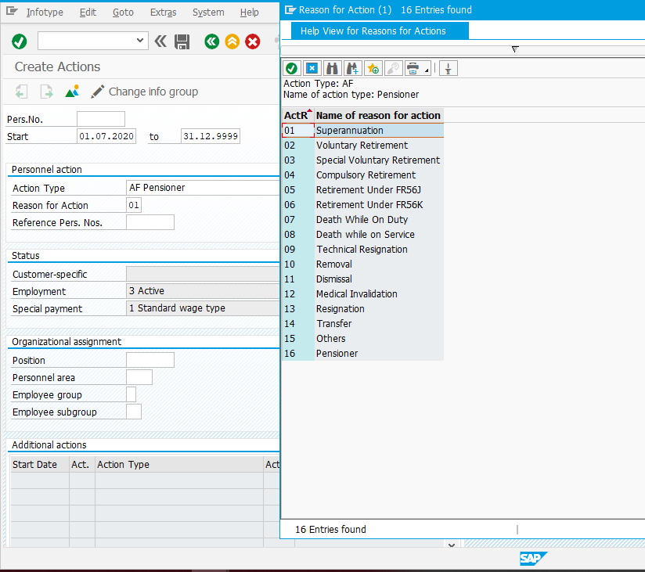
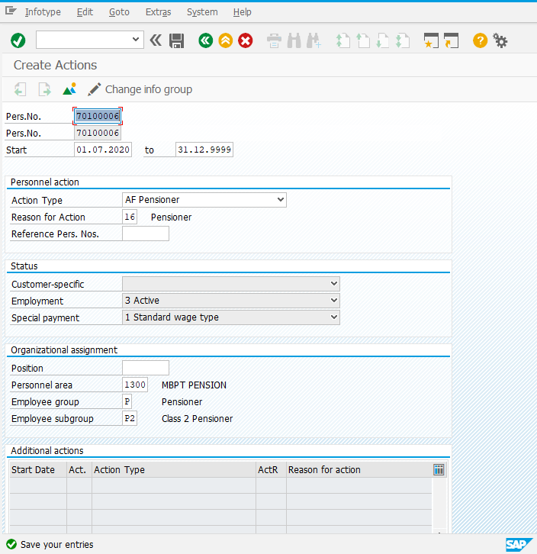

Organizational Assignment Infotype
Field | Value
Personnel Sub Area | Choose from the list based on the personnel area of employee

Possible values for Personnel Subarea:
1100 | CHPT PENSION | 1101 | Finance
1100 | CHPT PENSION | 1102 | General Admin
1100 | CHPT PENSION | 1103 | Medical
1100 | CHPT PENSION | 1104 | Traffic
1100 | CHPT PENSION | 1105 | Marine
1100 | CHPT PENSION | 1106 | Civil Engineeri
1100 | CHPT PENSION | 1107 | Vigilance
1100 | CHPT PENSION | 1108 | M&EE
1100 | CHPT PENSION | 1109 | Others
1300 | MBPT PENSION | 1301 | Gen Admin
1300 | MBPT PENSION | 1302 | Legal
1300 | MBPT PENSION | 1303 | Welfare Gen
1300 | MBPT PENSION | 1305 | Welfare Cant_OD
1300 | MBPT PENSION | 1306 | Security
1300 | MBPT PENSION | 1307 | Security OD
1300 | MBPT PENSION | 1308 | Vigilance
1300 | MBPT PENSION | 1310 | F & A
1300 | MBPT PENSION | 1311 | Medical
1300 | MBPT PENSION | 1312 | Medical OD
1300 | MBPT PENSION | 1313 | IT, E&T
1300 | MBPT PENSION | 1314 | IT, E&T OD
1300 | MBPT PENSION | 1315 | MM
1300 | MBPT PENSION | 1316 | MM OD
1300 | MBPT PENSION | 1317 | MEED - General
1300 | MBPT PENSION | 1318 | Workshop & CTH
1300 | MBPT PENSION | 1319 | Workshop&CTHOD
1300 | MBPT PENSION | 1320 | CDMID
1300 | MBPT PENSION | 1321 | CDMID OD
1300 | MBPT PENSION | 1322 | Mobile Cranes
1300 | MBPT PENSION | 1323 | Mobile CranesOD
1300 | MBPT PENSION | 1324 | EESD
1300 | MBPT PENSION | 1325 | EESD OD
1300 | MBPT PENSION | 1326 | EEND
1300 | MBPT PENSION | 1327 | EEND OD
1300 | MBPT PENSION | 1328 | EEWA
1300 | MBPT PENSION | 1329 | EEWA OD
1300 | MBPT PENSION | 1330 | MOT JD & OPL
1300 | MBPT PENSION | 1331 | MOT JD & OPL OD
1300 | MBPT PENSION | 1332 | Estate
1300 | MBPT PENSION | 1333 | Estate OD
1300 | MBPT PENSION | 1334 | Civil - General
1300 | MBPT PENSION | 1335 | Civil - General OD
1300 | MBPT PENSION | 1337 | Salvage&MSRC OD
1300 | MBPT PENSION | 1339 | GWSD OD
1300 | MBPT PENSION | 1341 | GWND OD
1300 | MBPT PENSION | 1343 | GWMOT OD
1300 | MBPT PENSION | 1345 | Rly Engg OD
1300 | MBPT PENSION | 1346 | Marine - Gen
1300 | MBPT PENSION | 1347 | Marine - Gen OD
1300 | MBPT PENSION | 1348 | SDM ID
1300 | MBPT PENSION | 1349 | SDM ID OD
1300 | MBPT PENSION | 1350 | DM JD
1300 | MBPT PENSION | 1351 | DM JD OD
1300 | MBPT PENSION | 1352 | Fire Service
1300 | MBPT PENSION | 1353 | Fire Service OD
1300 | MBPT PENSION | 1354 | Railways -Gene
1300 | MBPT PENSION | 1355 | Railways-Gen OD
1300 | MBPT PENSION | 1356 | Traffic -Gene
1300 | MBPT PENSION | 1357 | Traffic-Gen-OD
1300 | MBPT PENSION | 1358 | OBL
1300 | MBPT PENSION | 1359 | OBL OD
1300 | MBPT PENSION | 1361 | Hamallage OD
1300 | MBPT PENSION | 1362 | E&H(SHW)
1500 | DPT PENSION | 1501 | Finance
1500 | DPT PENSION | 1502 | General Admin
1500 | DPT PENSION | 1503 | Medical
1500 | DPT PENSION | 1504 | Traffic
1500 | DPT PENSION | 1505 | Marine
1500 | DPT PENSION | 1506 | Civil Engineeri
1500 | DPT PENSION | 1507 | Vigilance
1500 | DPT PENSION | 1508 | M&EE
1500 | DPT PENSION | 1509 | Others
1800 | KoPT PENSION | 1801 | Finance
1800 | KoPT PENSION | 1802 | General Admin
1800 | KoPT PENSION | 1803 | Medical
1800 | KoPT PENSION | 1804 | Traffic
1800 | KoPT PENSION | 1805 | Marine
1800 | KoPT PENSION | 1806 | Civil Engineeri
1800 | KoPT PENSION | 1807 | Vigilance
1800 | KoPT PENSION | 1808 | M&EE
1800 | KoPT PENSION | 1809 | Hydraulic Stud
1800 | KoPT PENSION | 1810 | Others
2100 | PPT PENSION | 2101 | Finance
2100 | PPT PENSION | 2102 | General Admin
2100 | PPT PENSION | 2103 | Medical
2100 | PPT PENSION | 2104 | Traffic
2100 | PPT PENSION | 2105 | Marine
2100 | PPT PENSION | 2106 | Civil Engineeri
2100 | PPT PENSION | 2107 | Vigilance
2100 | PPT PENSION | 2108 | M&EE
2100 | PPT PENSION | 2109 | Others

Note: Click for the list of options available for the field, select one appropriate value, maintain other fields, click and save

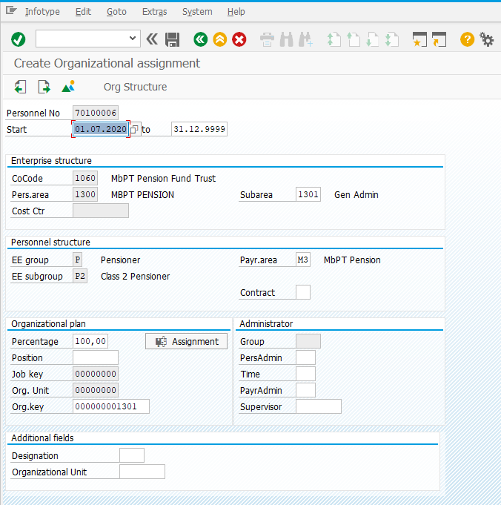

Personal Data Infotype
Field | Value
Title | Choose from the list
First Name | First Name of Employee
Last Name | Last Name of Employee
Gender | Choose from the list
Date of Birth | Enter DOB of Employee
Nationality | Choose from the list

Note: Click for the list of options available for the field, select one appropriate value, maintain other fields, click and save
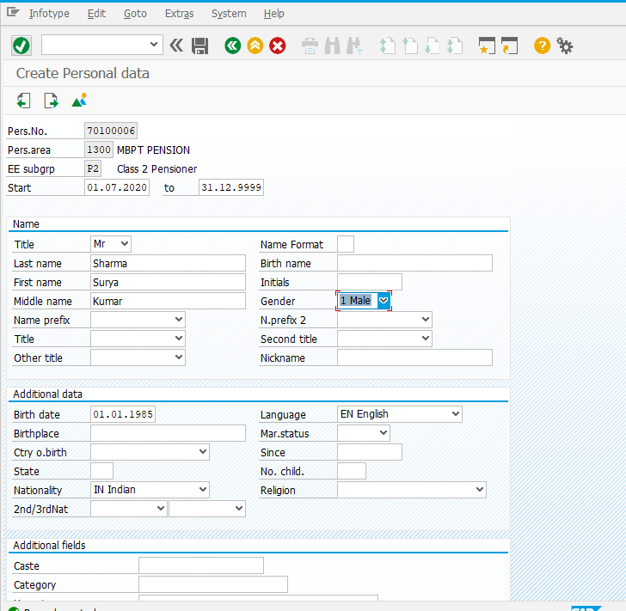

Address Infotype
Field | Value
Address Record Type | Choose Permanent Address
Address | Enter Address of the Employee
Pin code | Enter Pin code
City | Enter Name of City

Note: Click for the list of options available for the field, select one appropriate value, maintain other fields, click and save
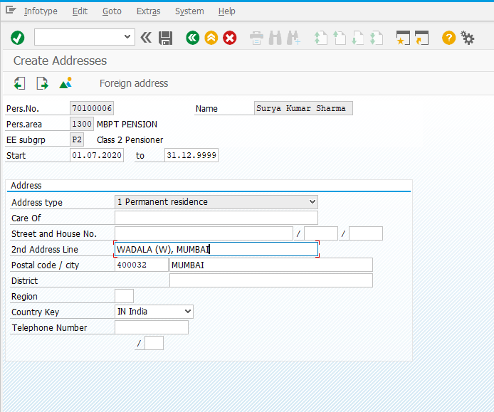

Planned Working Time Infotype
Field | Value
Work Schedule Rule | Choose the work schedule from the list
Time Mgmt. Status | Choose 9 - Time Evaluation of planned times from the list
Note: Click for the list of options available for the field, select one appropriate value, maintain other fields, click and save
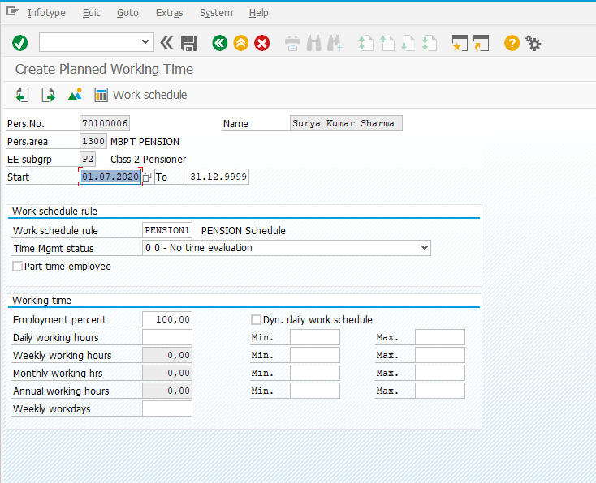

Basic Pay Infotype
Field | Value
Pay Scale Type | MB
Pay Scale Area | MB
PS Group & Level | Choose the Pay scale Group and Level from the list
Basic Salary | Basic Pay will be populated for Class3 and 4

Pay Scale Type and Pay Scale Area for all Ports except Mumbai Port is “SL”, “SL” respectively.

Note: Click for the list of options available for the field, select one appropriate value, maintain other fields, click and save
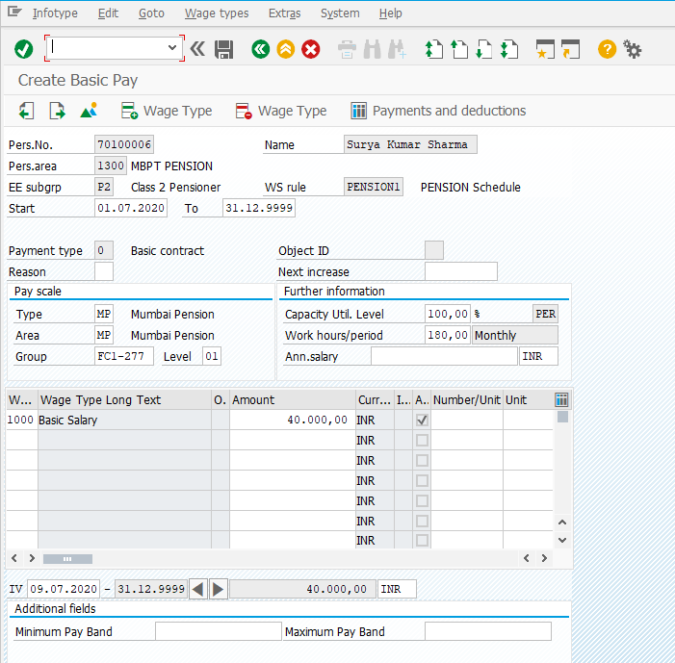

Bank Details Infotype
Field | Value
Postal Code/City | Postal code and city of the bank
Bank Key | Chose the bank key i.e. IFSC CODE from the list
Bank Account | Maintain the Bank Account number
Payment Method | Maintain Payment method as Bank Transfer only

Note: Click for the list of options available for the field, select one appropriate value, maintain other fields, click and save
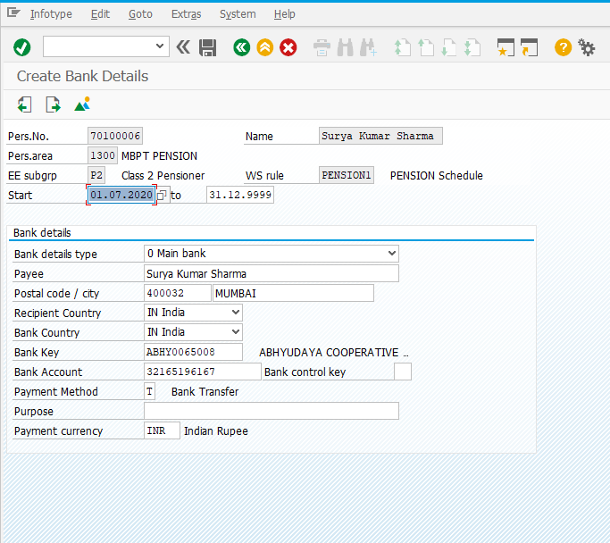

Family Details Infotype
Field | Value
Family Member Sub type | Choose from the list
First Name and Last Name | Maintain the First and Last Name
Gender | Gender of Dependent
Date of Birth | DOB of Dependent

Note: Click for the list of options available for the field, select one appropriate value, maintain other fields, click and save

Education Infotype
Field | Value
Establishment | Choose from the list
Education/Training | Choose from the list
Institution | Enter the institute name
Country | Choose from the list
Certificate | Choose from the list
Curation | Choose from the list
Final Grade | Enter the value
Branch of Study1 | Choose from the list
Branch of Study2 | Choose from the list

Note: Click for the list of options available for the field, select one appropriate value, maintain other fields, click and save

Communications Infotype
Field | Value
Subtype | Choose from the list
Communicate type | Enter communication information

Note: Click for the list of options available for the field, select one appropriate value, maintain other fields, click and save

Personal IDs Infotype
Field | Value
Subtype | Choose from the list
ID Type | Enter ID Number

Note: Click for the list of options available for the field, select one appropriate value, maintain other fields, click and save
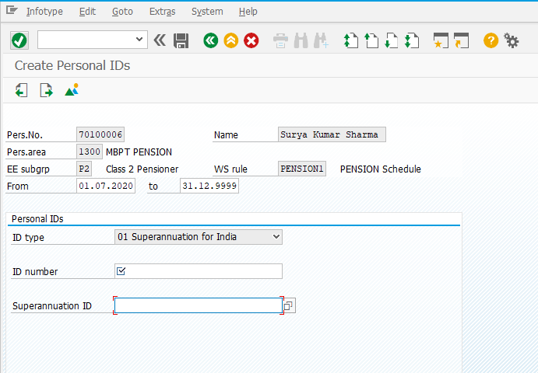

Maintain HR Master Data (Infotypes Maintenance)
To maintain employee details, follow below path:
Menu Path | Human Resources -> Personnel Management-> Administration-> HR Master Data-> PA30- Maintain
Transaction Code | PA30

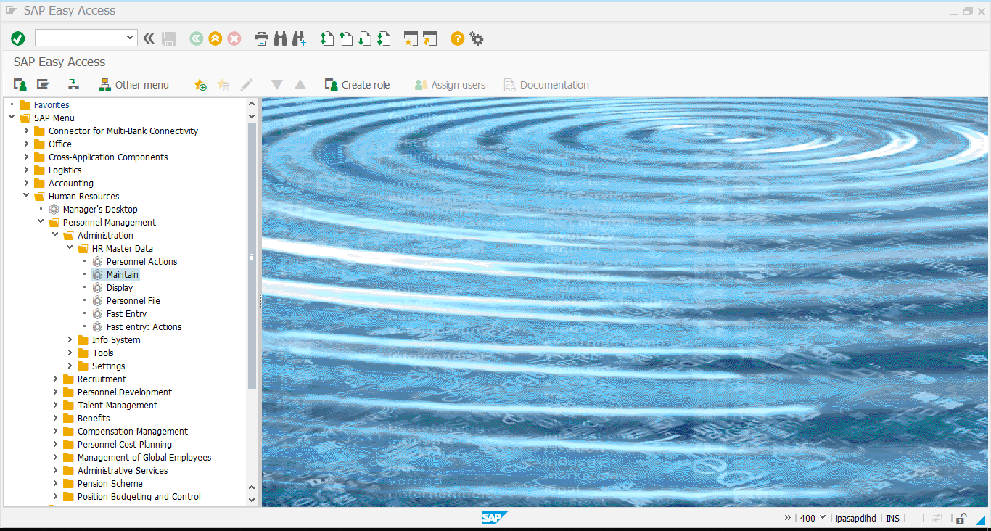

Give employee no, Infotype no “0002” on the screen and click Enter.
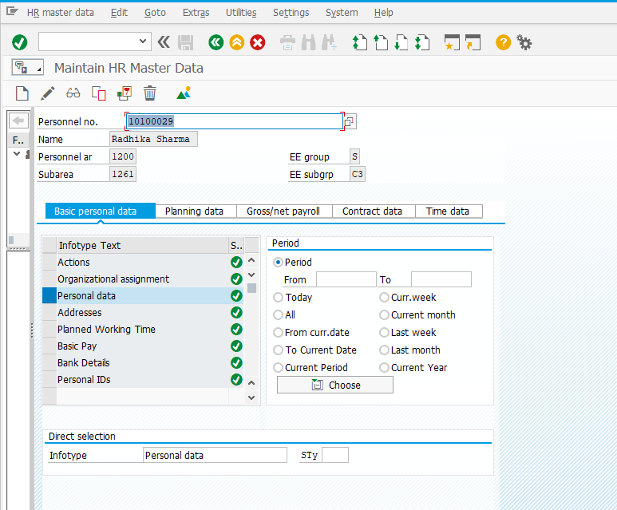

Personal Data (0002) Infotype
Field | Value
Title | Choose from the list
First Name | First Name of Employee
Last Name | Last Name of Employee
Gender | Choose from the list
Date of Birth | Enter DOB
Nationality | Choose from the list

Note: Click for the list of options available for the field, select one appropriate value, maintain other fields, click and save
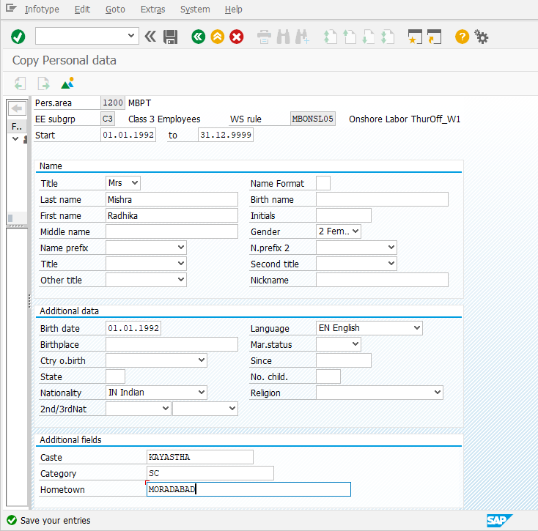

Addresses (0006) Infotype
Field | Value
Address Record Type | Permanent Address
Address | Address of the Employee
Pin code | Pin code
City | Name of City

Note: Click for the list of options available for the field, select one appropriate value, maintain other fields, click and save
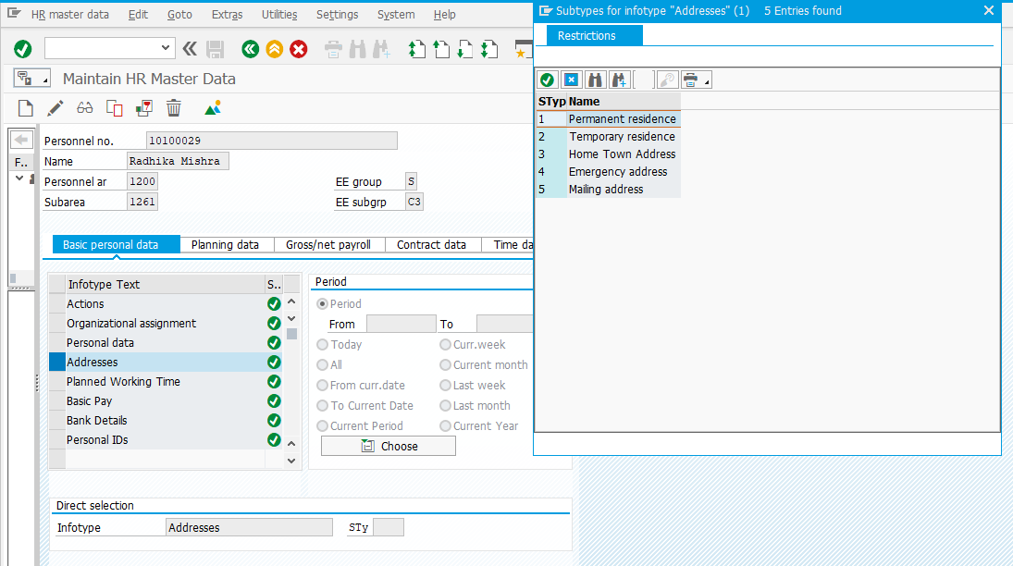
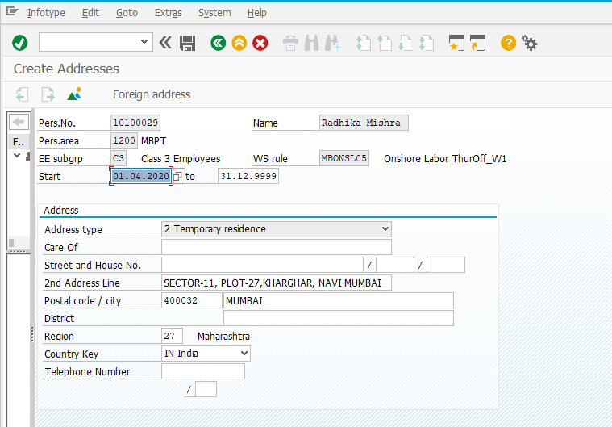

Planned Working Time (0007) Infotype
Field | Value
Work Schedule Rule | Choose the work schedule from the list
Time Mgmt. Status | Choose 9 - Time Evaluation of planned times from the list
Note: Click for the list of options available for the field, select one appropriate value, maintain other fields, click and save

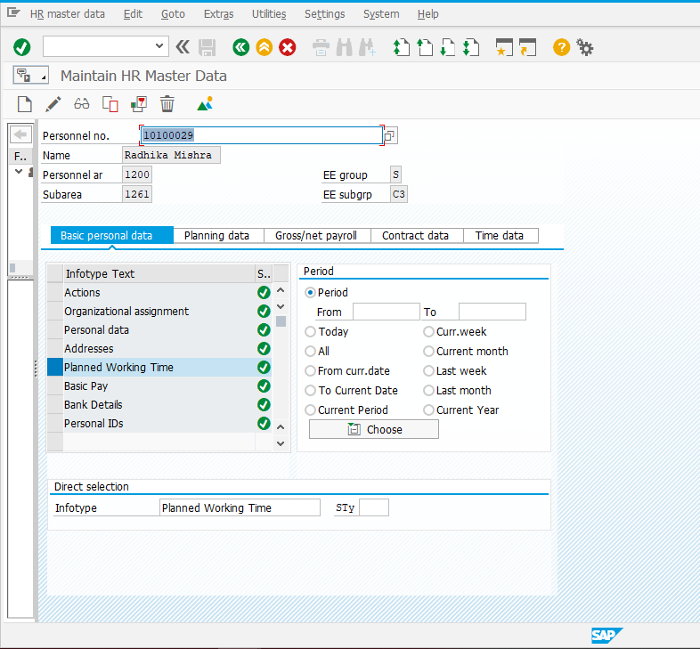
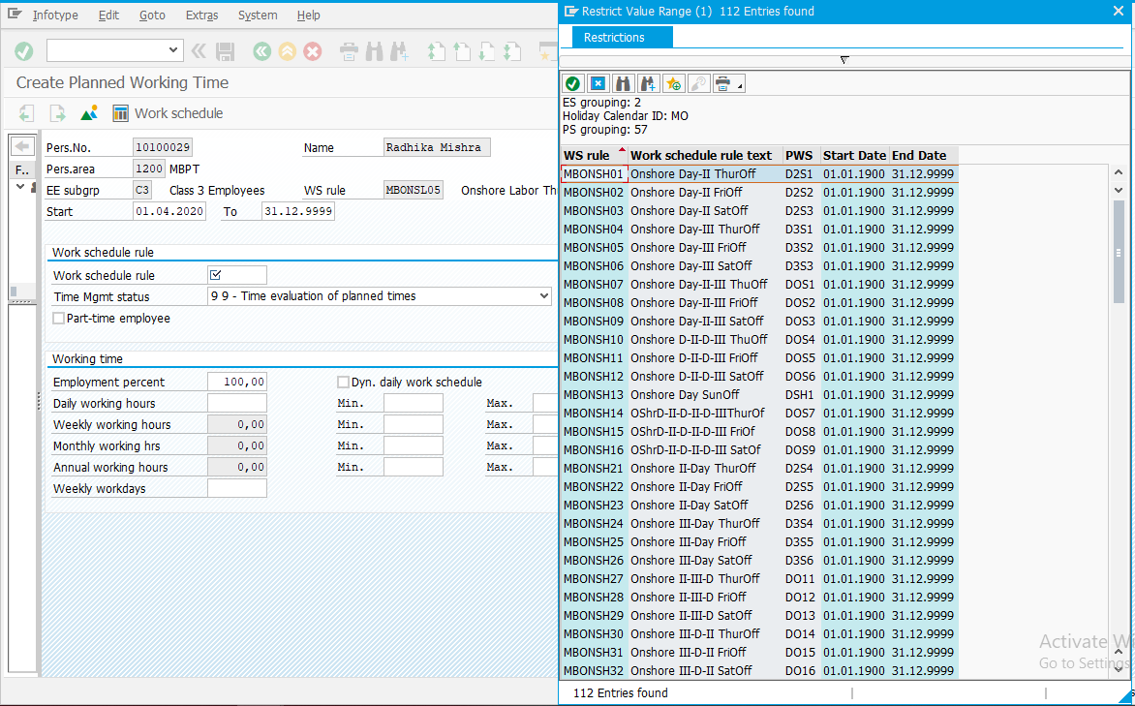
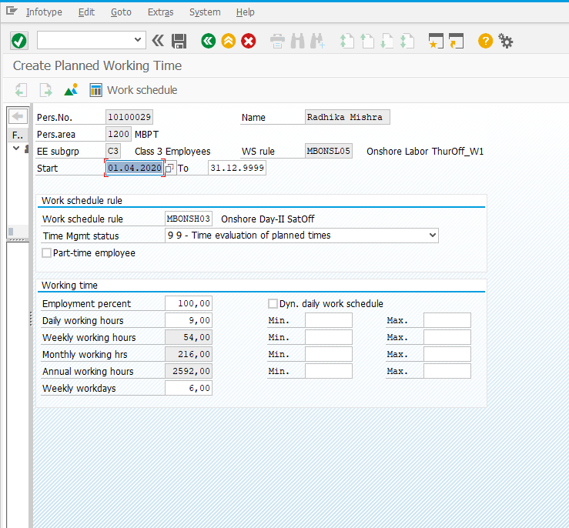

Basic Pay (0008) Infotype
Field | Value
Pay Scale Type | SL
Pay Scale Area | SL
PS Group & Level | Choose the Pay scale Group and Level from the list
Basic Salary | Basic Pay will be populated for Class3 and 4
Note: Click for the list of options available for the field, select one appropriate value, maintain other fields, click and save

Pay Scale Type and Pay Scale Area for all Ports except Mumbai Port is “SL”, “SL” respectively.
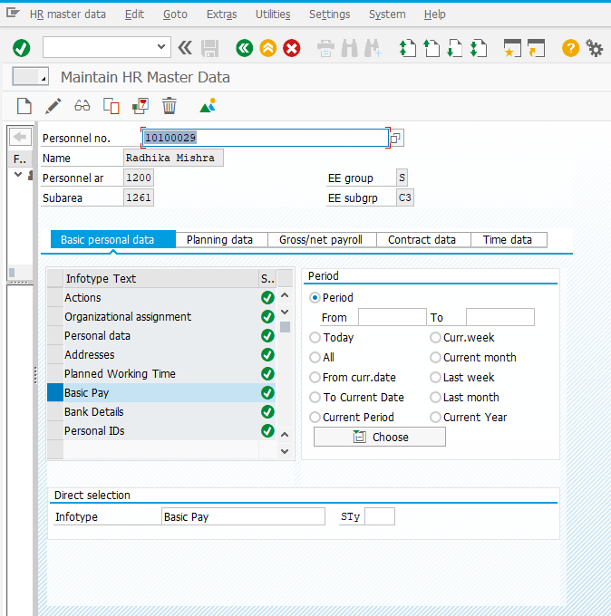
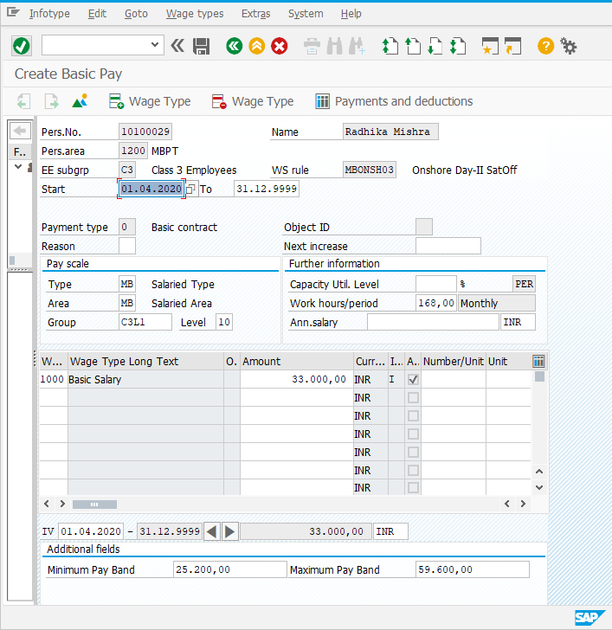

Bank Details (0009) Infotype
Field | Value
Postal Code/City | In this field you specify the postal code and city of the bank
Bank Key | Chose the bank key from the list
Bank Account | Maintain the Bank Account number
Payment Method | Maintain Payment method as Bank Transfer only

Note: Click for the list of options available for the field, select one appropriate value, maintain other fields, click and save
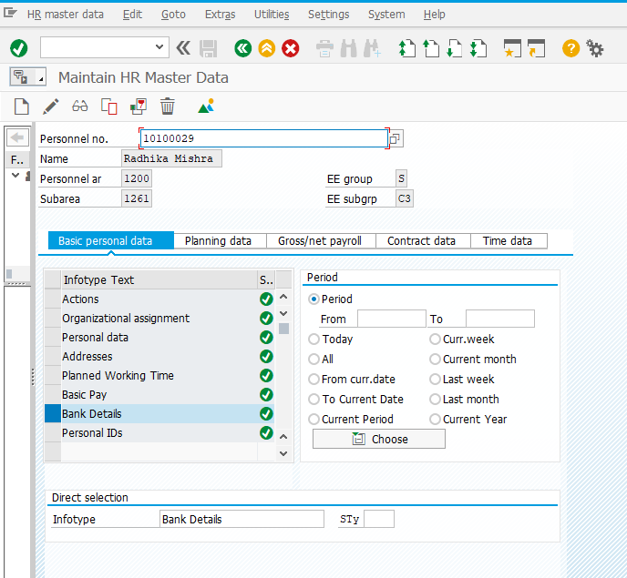
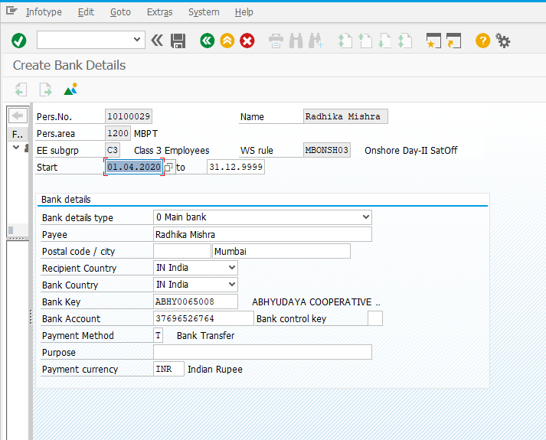

Recur. Payments/Deductions (0014) Infotype
Field | Value
Start and End Date | From and To date of wage type processing
Wage Type | Wage type Number
Amount | Amount of Processing

Note: Click for the list of options available for the field, select one appropriate value, maintain other fields, click and save

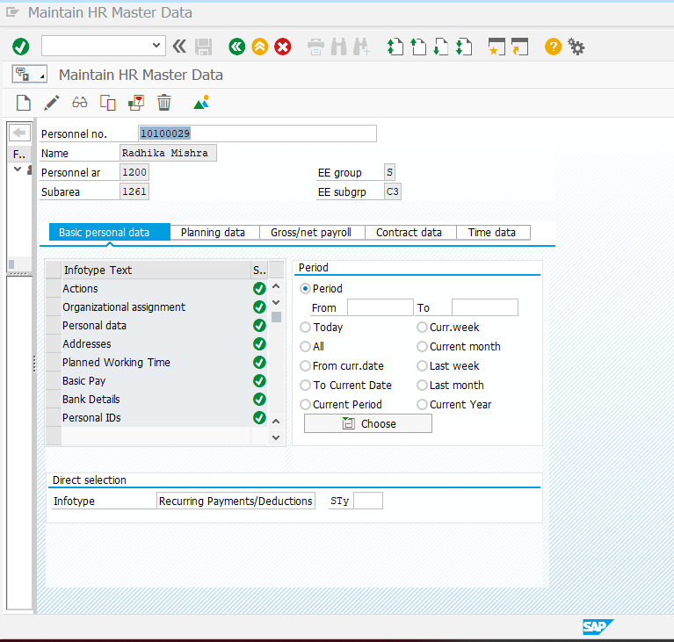
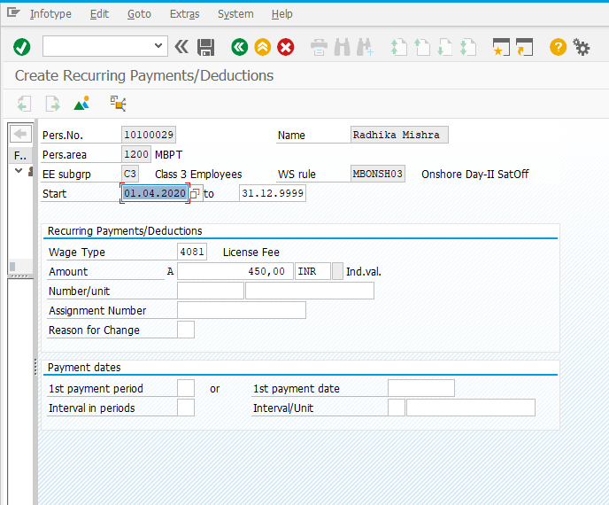

Additional Payments (0015) Infotype
Field | Value
Date of Origin | Date of Wage type processing
Wage Type | Wage type Number
Amount | Amount of Processing

Note: Click for the list of options available for the field, select one appropriate value, maintain other fields, click and save

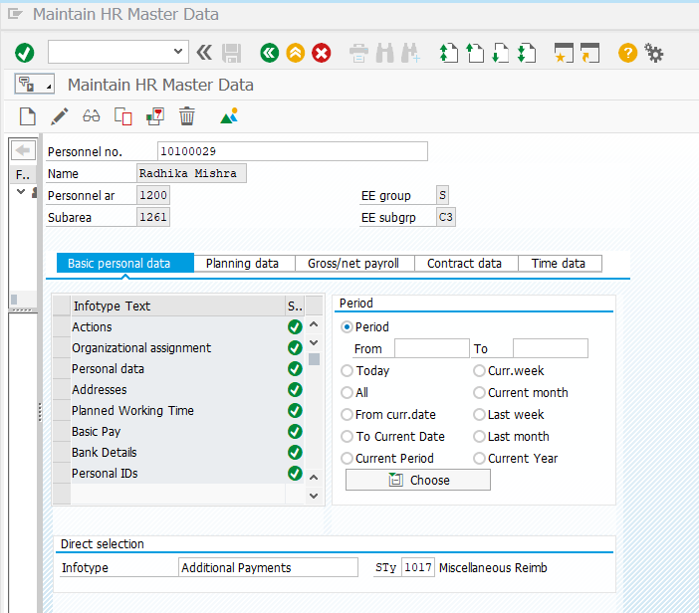
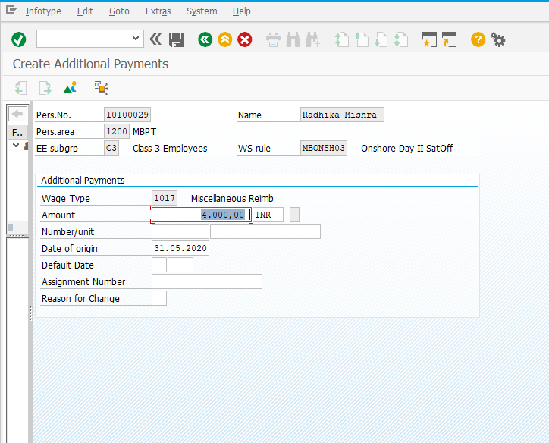

Contract Elements (0016) Infotype
Field | Value
Contract type | Choose from the list

Note: Click for the list of options available for the field, select one appropriate value, maintain other fields, click and save
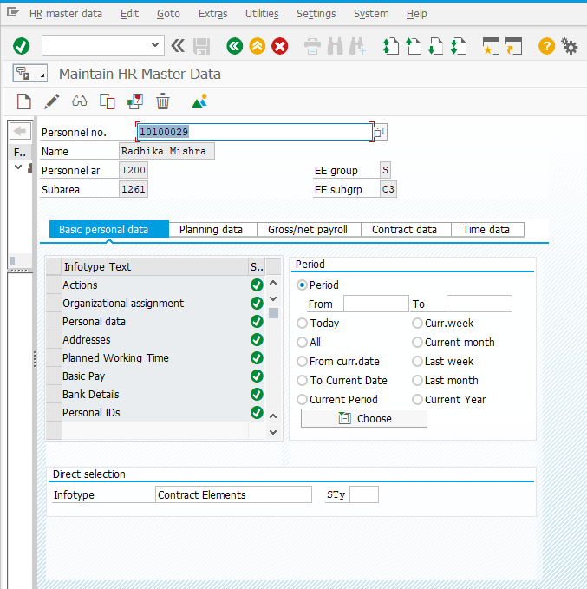
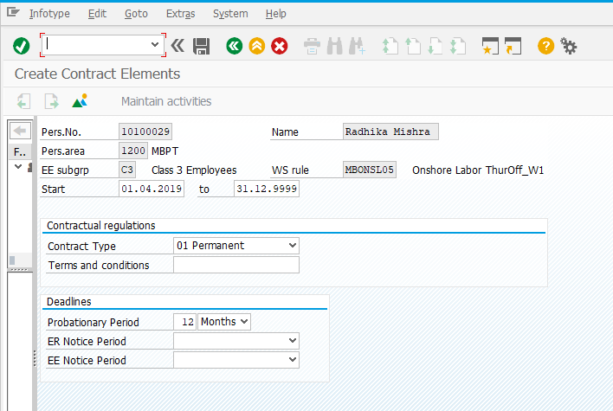

Monitoring of Dates (0019) Infotype
Field | Value
Task Type | Type relevant task type
Date of Task | Input Date of Task
Reminder Date | Input Reminder Date

Note: Click for the list of options available for the field, select one appropriate value, maintain other fields, click and save
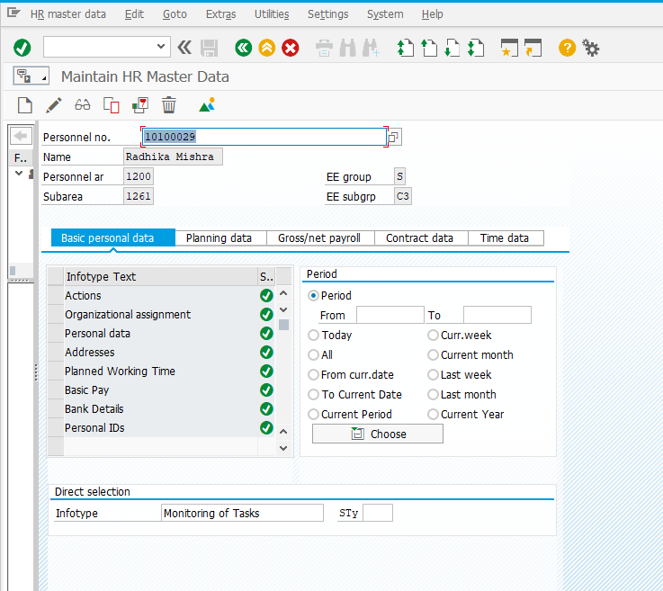
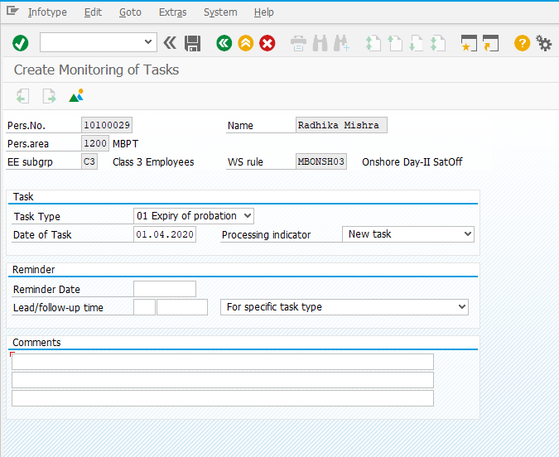

Family/Related Person (0021) Infotype
Field | Value
Family Member Sub type | Choose from the list
First Name and Last Name | Maintain the First and Last Name
Gender | Gender of Dependent
Date of Birth | DOB of Dependent

Note: Click for the list of options available for the field, select one appropriate value, maintain other fields, click and save

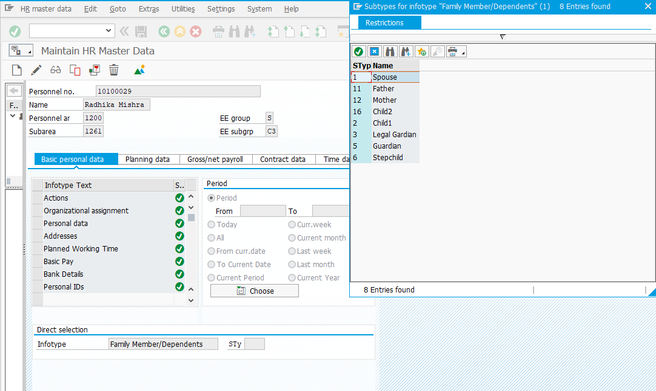
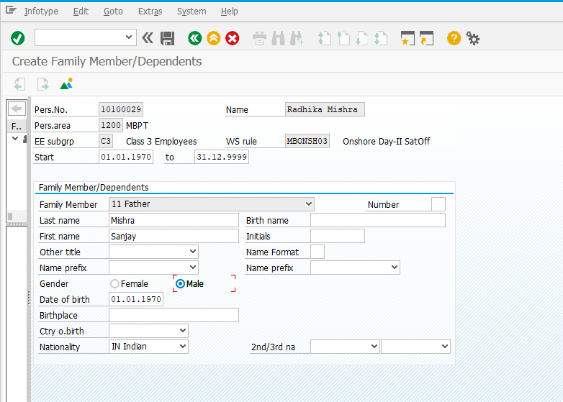

Education (0022) Infotype
Field | Value
Establishment | Choose from the list
Education/Training | Choose from the list
Institution | Enter the institute name
Country | Country of Study
Certificate | Choose from the list
Curation | Choose from the list
Final Grade | Enter the value
Branch of Study1 | Choose from the list
Branch of Study2 | Choose from the list

Note: Click for the list of options available for the field, select one appropriate value, maintain other fields, click and save
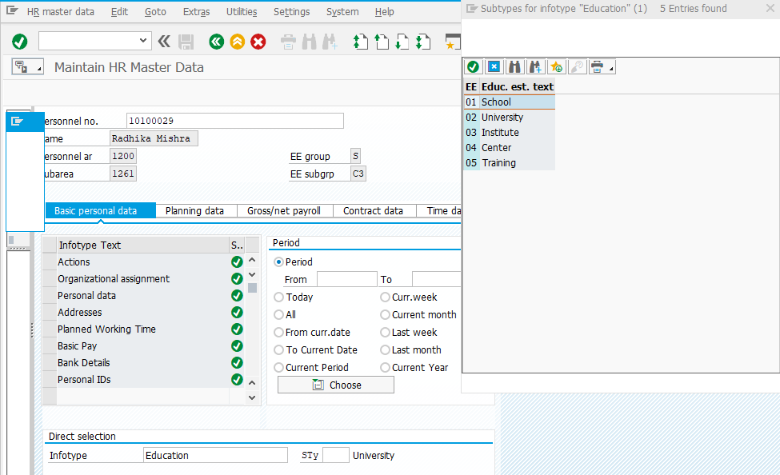
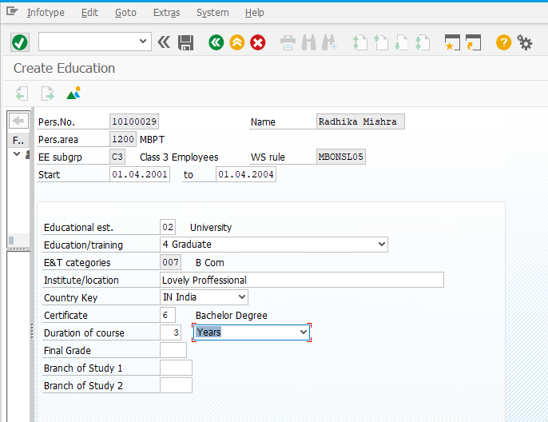

Qualifications (0024) Infotype
Field | Value
Qualification | Choose from the list
Proficiency | Choose from the list
Note: Click for the list of options available for the field, select one appropriate value, maintain other fields, click and save
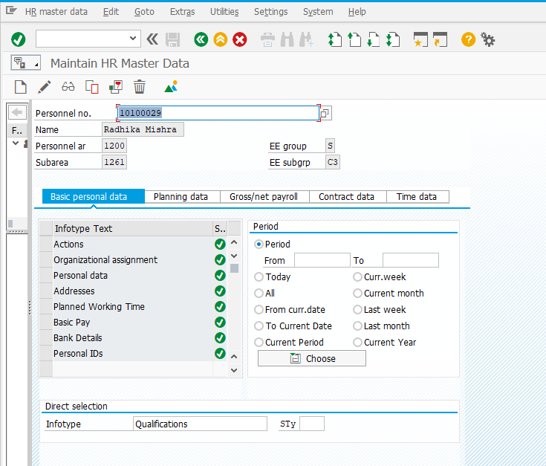
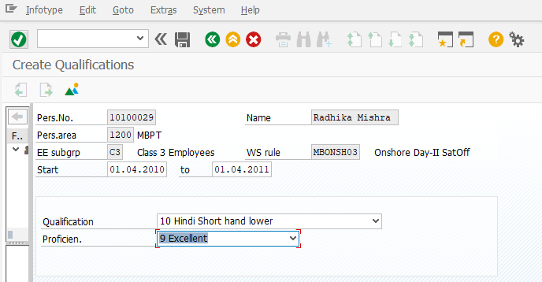

Pension Management (9003) Infotype
Pension related details would be filled by administrator during separation of Employee
Note: Click for the list of options available for the field, select one appropriate value, maintain other fields, click and save
