Indian Ports Association (IPA)
Implementation of Port EBS Project
Enterprise Business System

User Manual Organizational Management
(Human Capital Management)

Submitted by:

Plot No. 58 A & B,
Noida Special Economic Zone,
Uttar Pradesh-201305

www.techmahindra.com

Document History:
Authors & Participants
Role | Name

Revision History
Date | Document  Version | Document Revision  Description | Author
01.03.2020 | 1.0 | Initial Draft | Senthil

Reviewed and Approved By
Name | Title | Date | Approved

Table of contents
Icons Glossary 4
A. Purpose of Document 5
B. Target Audience 5
C. Organizational Management 5
i. Organizational Structure 5
ii. Organizational Unit 5
iii. Jobs 5
iv. Positions 6
v. Person 6
vi. Object Key 6
vii. Relationships 6
1. Creation of Root Organizational Unit 8
2. Change / Create of Organizational Structure 12
3. Maintain Object and Relationships 22
4. Creation of Position 25
5. Position to Organizational Unit 26
6. Position to Job 28
7. Position to Person 32
8. Position to Cost Center 34

Icons Glossary
 | Create
 | Change
 | Display
 | Copy
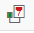 | Delimit
 | Delete
 | Overview
 | Save
 | Back / Previous Menu
 | Header
 | Details
 | Execute

Purpose of Document
Organizational management enables in analyzing the entire organizational structure and allows planning to develop personnel scenarios.

Target Audience
Establishment Team of respective Departments

Organizational Management

OM enables the depiction of the structure of the organization in the PAST, PRESENT and FUTURE.
OM allows depicting the organizational and reporting structures clearly by presenting an up-to-date picture of the enterprise’s organizational plan.

Org Units describe the various business (organizational) units that exist in the Organization. Multiple organizational units and their relationships form the organizational structure. Cost Centers can be assigned to organizational units.

Implementation of Organization Management lay down the foundation for successful running of other HR components like PA, PD, and Compensation Management.

Organizational management is based on the creation and use of organizational objects and their interrelationships.

Organizational Structure
In order to carry business and HR processes, organizational (staffing) plan required, i.e., a functional structure representing the enterprise based on business tasks. This is used for business, manpower status reporting and costing purposes. This functionality helps the organization to depict its structure including departments, position and job.

Organizational Unit
Represents a functional unit, example: HR department. According to how tasks are divided up within an enterprise, this could be a department, division or unit. This organizational unit (OU) differ from other units in an enterprise such as personnel areas, company codes, business areas etc. These are used to depict structures (administration or accounting, for example) in the corresponding components. The highest organizational unit in an organizational structure is the Root Organizational unit, which is Port trust.
An OU can contain any number of OUs under it. Nested structure is allowed.

- Positions (Roles) can be assigned to an OU
- Cost centers also can be mapped to an OU

Jobs
Jobs are classifications of functions (Administrator, for example), which are defined by the assignment of characteristics. Jobs serve as job descriptions that apply to several positions with similar tasks or characteristics. When creating a new position (purchasing administrator, for example), we need to relate it with job. The position then automatically inherits the tasks and characteristics of the job.

Positions
Represents a post that can be occupied by a person (employee) in the staff assignments of an organizational unit (purchasing administrator). Positions differ from jobs. A Job is not concrete but rather the basis for the creation of various positions with similar tasks and characteristics. Personnel capacity (headcount) of an organizational unit represented using positions. By representing the current status of an organizational unit and foreseeable requirements, the basis of the staff assignments created.
A position is:
- Occupied/filled, if a person (employee) or user is assigned to it
- Vacant, if a person (employee) is being found for it the position is marked as vacant in applicant administration in the Recruitment component.
- Unoccupied and vacant, if no person (employee) is being found for it
- Obsolete, if the position will no longer be required in the future.
- However, a position which is not required in one division, may be required in another division for operations which can be moved (To other division/Department) with a start date.
- A position can be flagged as Chief position. Chief positions are evaluated in SAP Business Workflow. User enters all this data according to exact dates. User can store characteristics for each position. Positions can have the following statuses.
- In case of vacant position, employee holding another position is directed by IT0001 additional field to track the additional responsibility of the vacant position

Person
An individual, who is listed as an employee in Personnel Administration. By assigning a person (employee) to a position, it is easy to find
- Where a person (employee) is functionally assigned in your enterprise
- Which tasks a person (employee) performs

Object Key
Object key is a notation, which helps in giving a distinct identity to various objects used in OM. The various object used in OM along with their respective keys are
- Organization Unit-O
- Job-C
- Position-S
- Cost Center -K
- Person-P

Relationships
There are many types of possible relationships between different objects. Each individual relationship is actually a subtype or category of the Relationships Infotype. Certain relationships can only be assigned to certain objects. That means that when you create relationship Infotype records, you must select a relationship that is suitable for the two objects involved. Maintaining relationship is an essential part of setting up information in the Organizational Management component. Without relationships, all objects are isolated pieces of information. The Following relationships are used in OM.
- Relationship between organizational units (A/B002) to form the organizational structure
- Relationship between organizational unit and position (A/B003)
- Relationship between organizational unit/Position and cost center (A 011)
- Relationship between job and position (A/B007)
- Relationship between positions (A/B002).
- Relationship to define chief position (A0012)

Creation of Root Organizational Unit
Menu Path | Human Resources -> Organizational Management-> Organizational Plan -> Organization and Staffing -> Create
Transaction Code | PPOCE

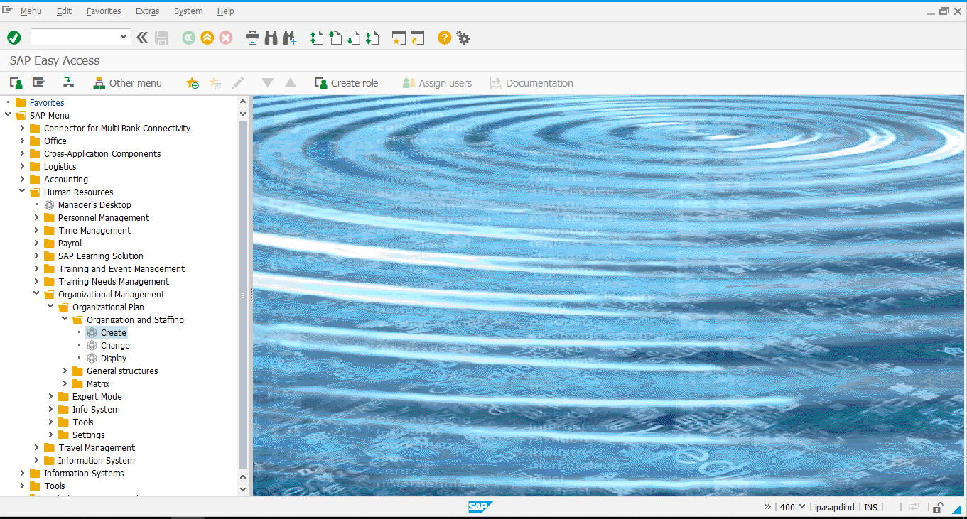
Enter Valid from and Valid to date for Organizational Unit and click on.
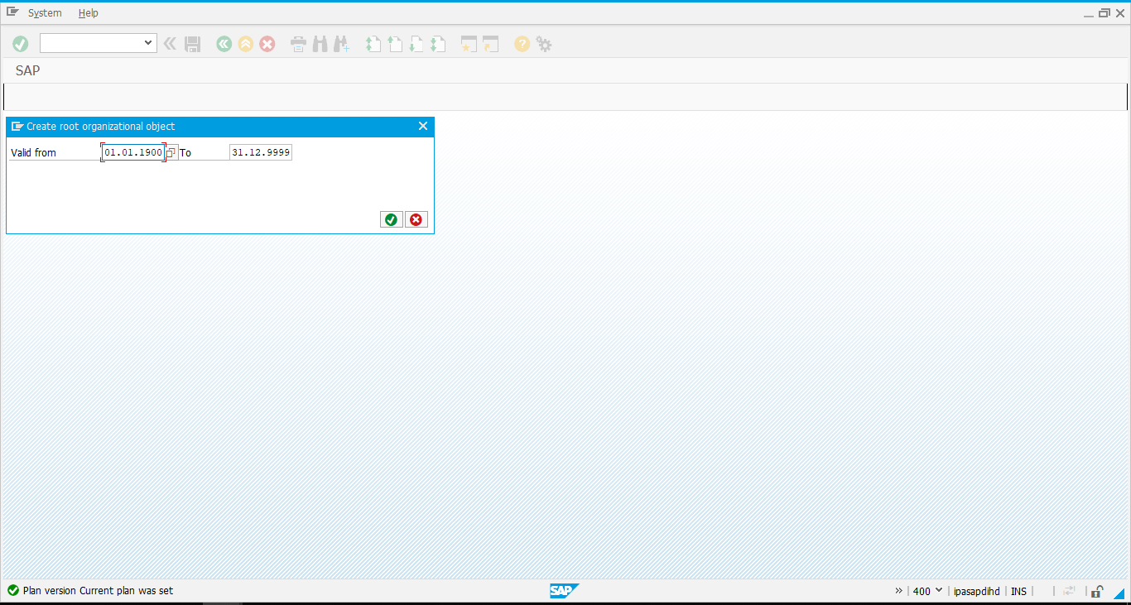
Enter Short description and Long description of Organizational Unit.
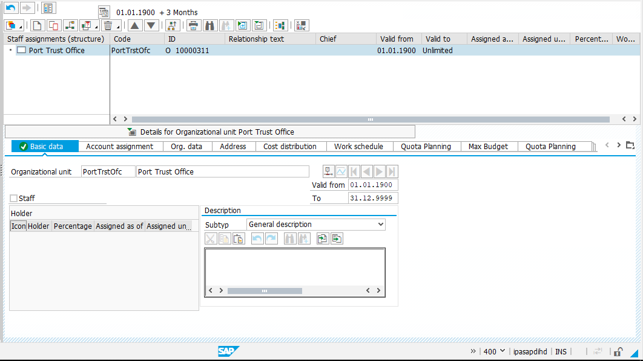
Long Description
Short Description
Valid from
Valid to

Valid
Click on below highlighted save icon to save the details.
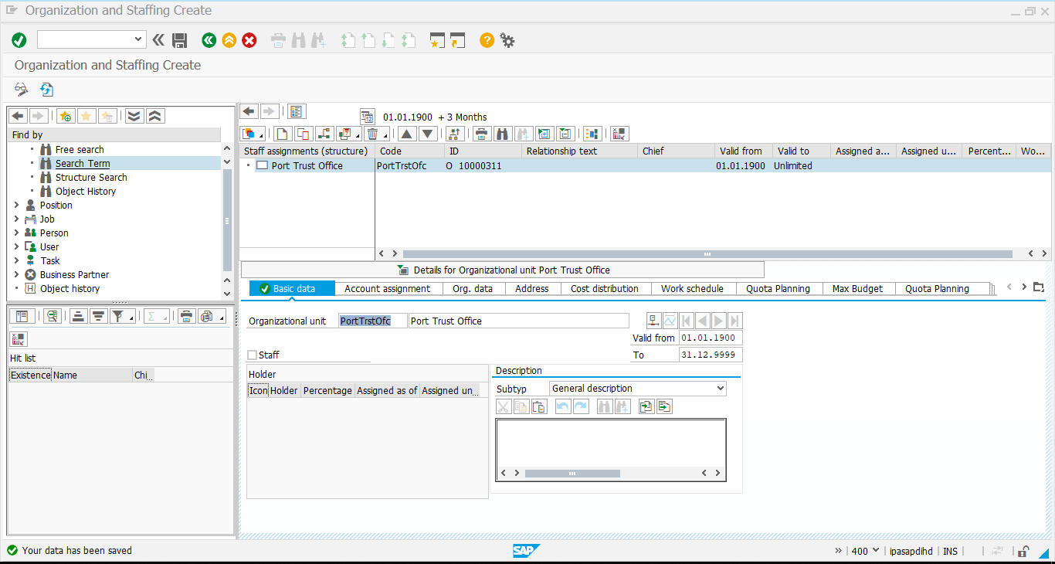
2nd Method:
Menu Path | Human Resources -> Organizational Management-> Expert Mode -> Simple Maintenance -> Create
Transaction Code | PPOCE_OLD

The following Screen appears. Give the necessary information in the fields.
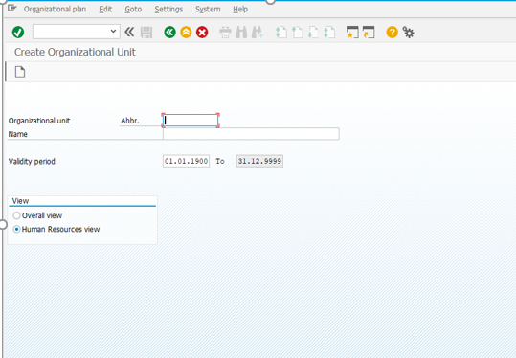

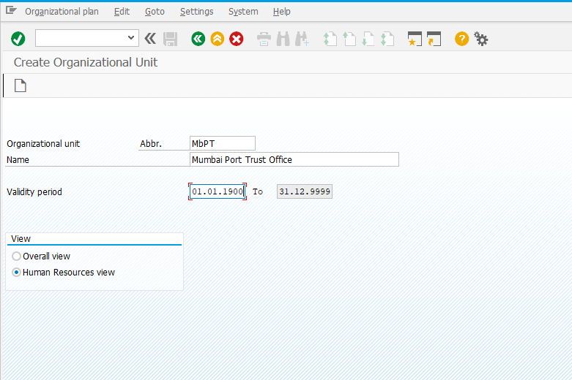Click on Create.

Change / Create of Organizational Structure
Menu Path | Human Resources -> Organizational Management-> Organizational Plan -> Organization and Staffing -> Change
Transaction Code | PPOME

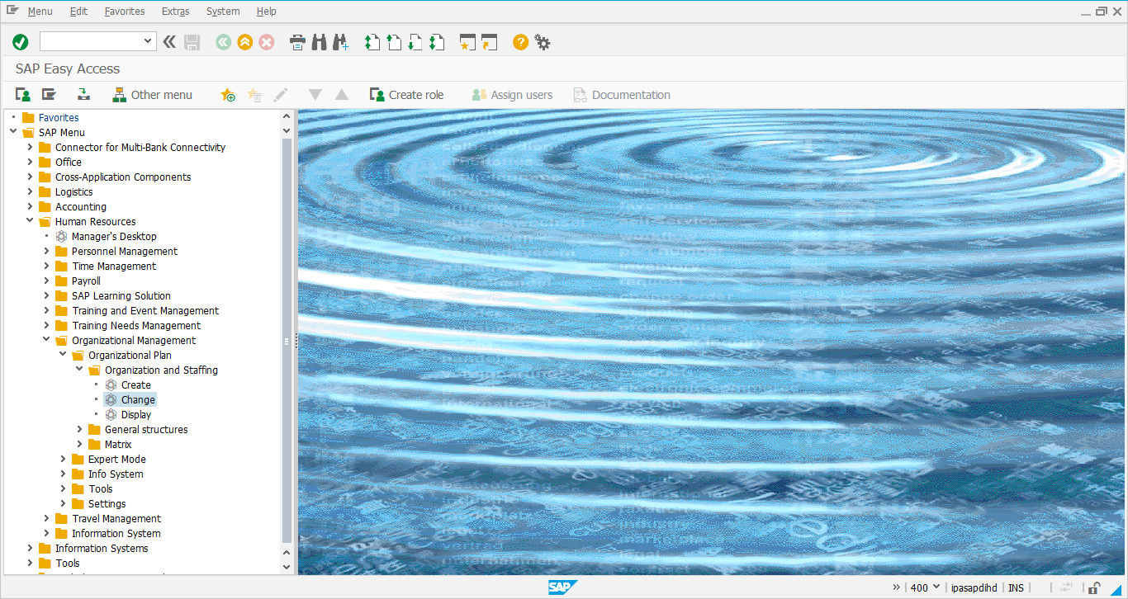
To Search existing object, click on search term highlighted below and search it.
Then, Double click on hit list term to see the structure on right hand side.
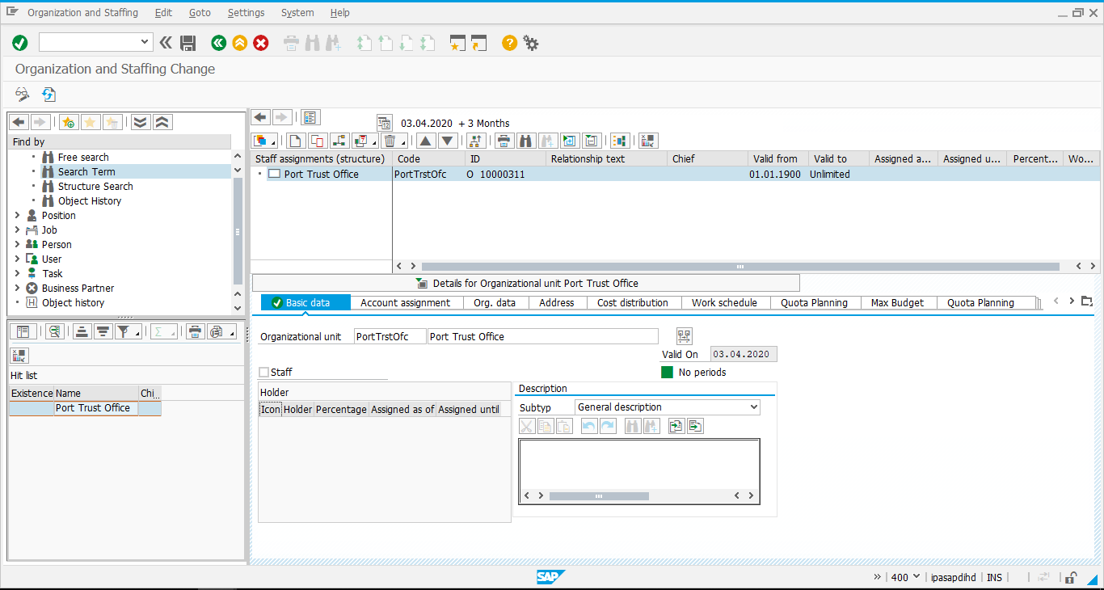
Create an Organizational Unit. To create an Organizational Unit under an Organizational Unit, use relationship “is line supervisor of”.
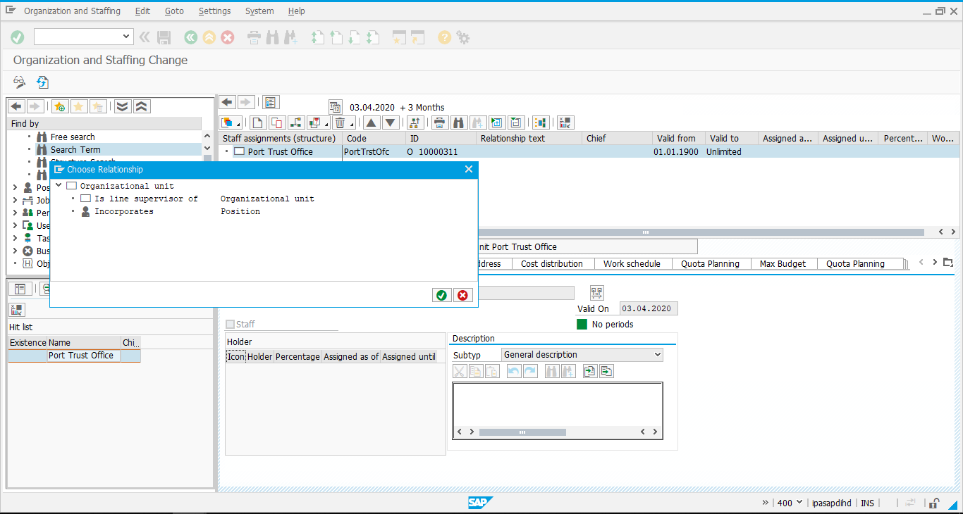
Enter Object short, long Description and valid from/ to date and save it.
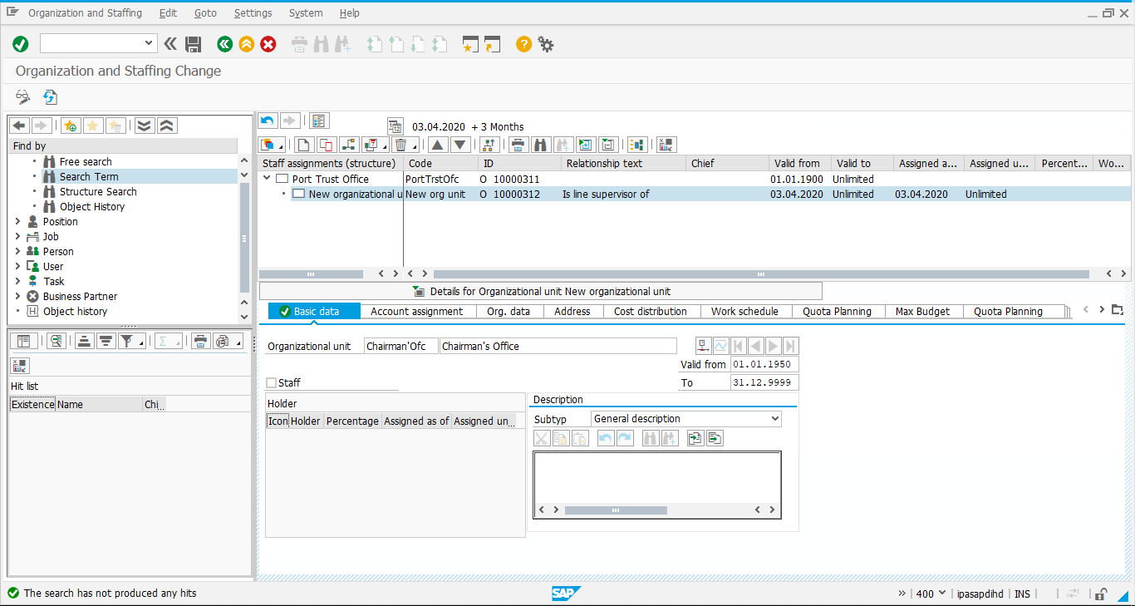

To create a Position, use relationship “Incorporates”.
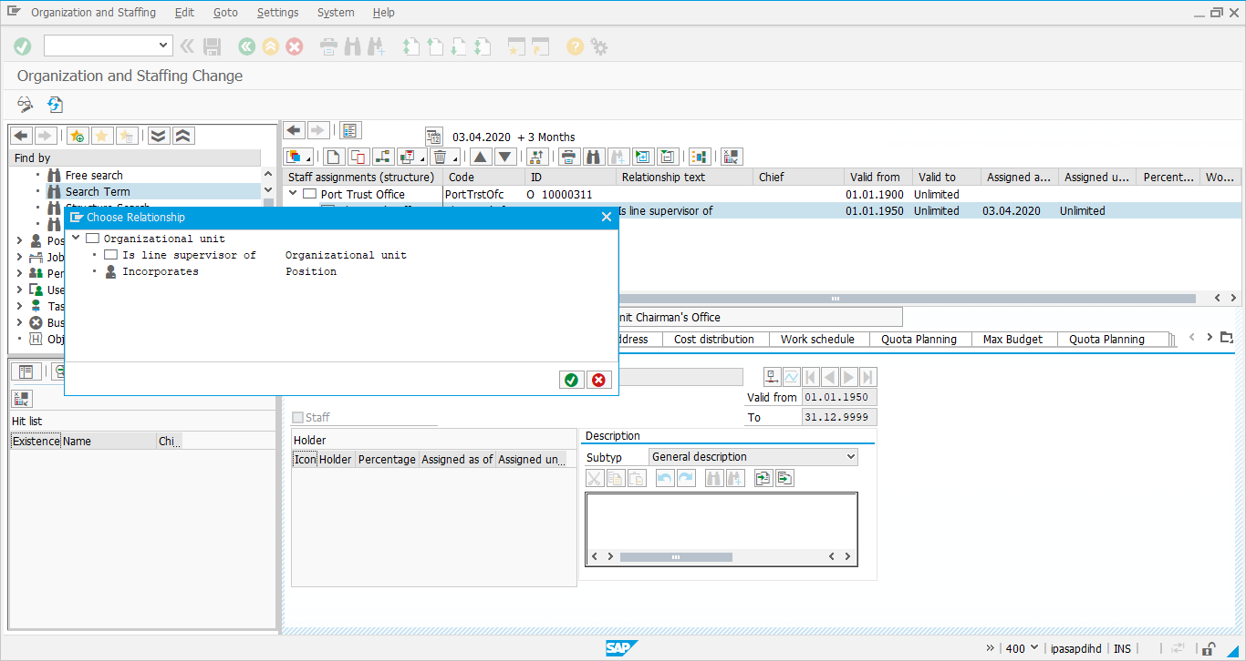
Enter Position Description, valid from/to date and save it.
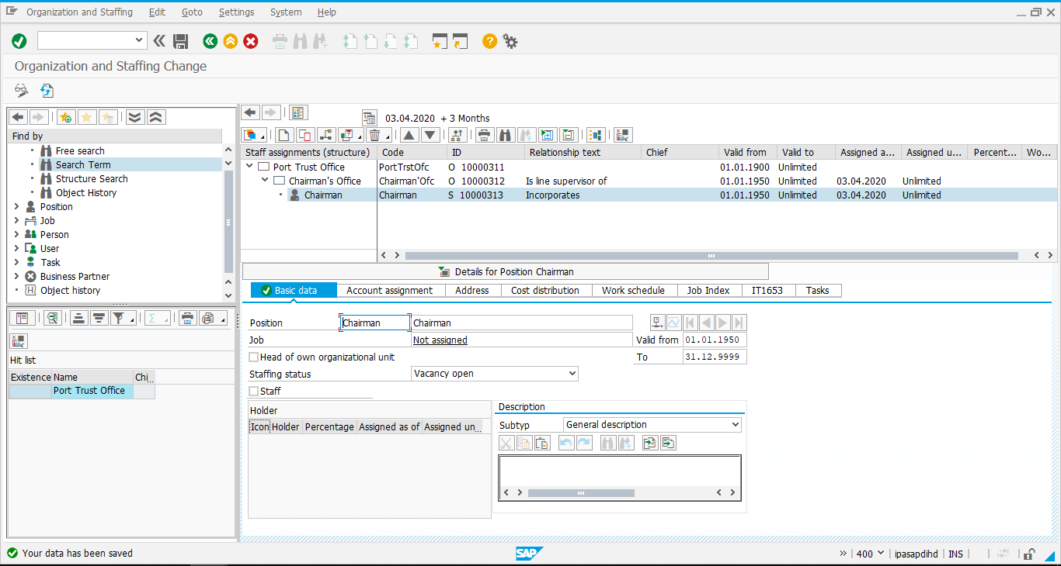

2nd Method:
If you want to add new organizational units to your organizational structure based on:
- Root organizational unit or an organizational structure, which already exists, you can
- Create an organizational unit.
In Simple Maintenance, you can create numerous organizational units at one time.

Menu Path | Human Resources -> Organizational Management-> Expert Mode -> Simple Maintenance -> Change
Transaction Code | PPOM_OLD

The following screen appears:
Give the required details as shown below.
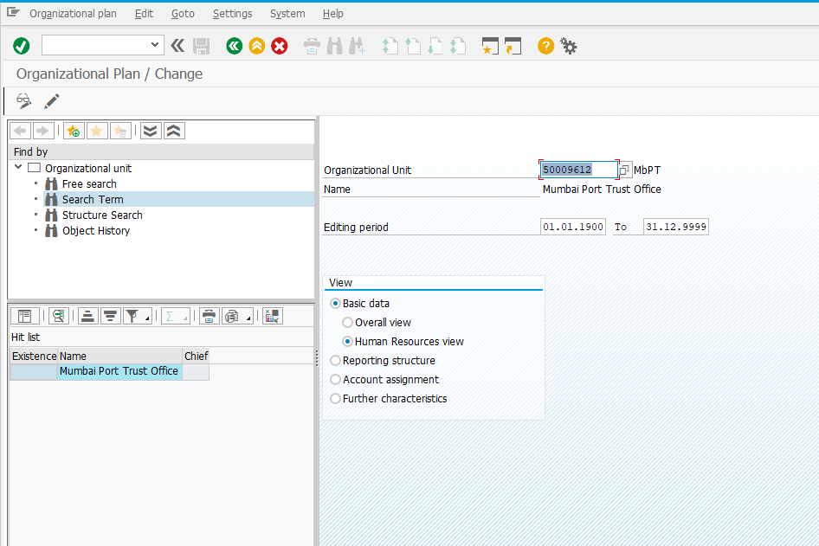
Click on change Icon.
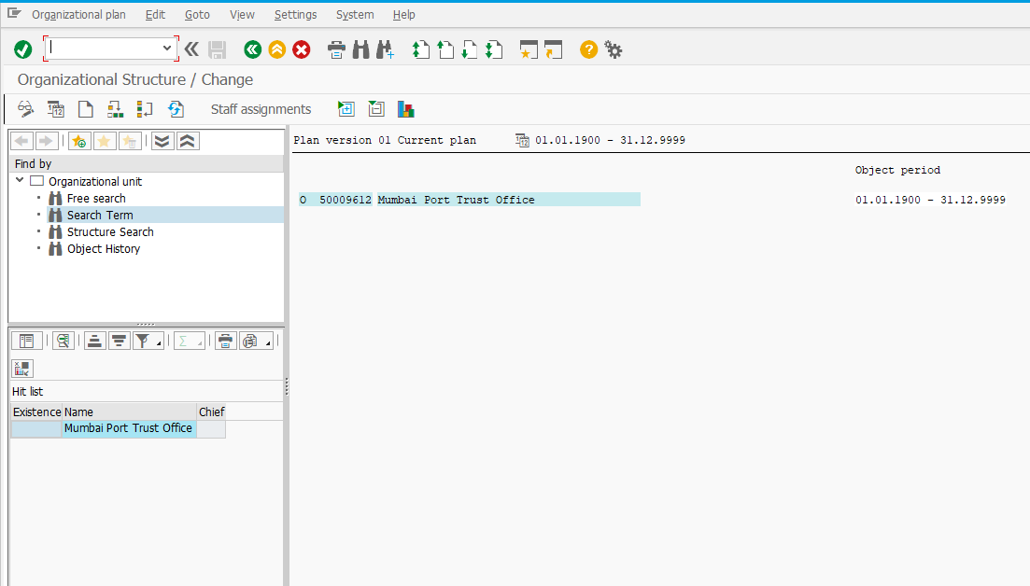
- Choose the organizational unit that is to become the parent object for the new Organizational unit or units you are creating.
- Choose Edit > Create > Organizational unit.
- The Create Organizational Units dialog box appears. The name of the organizational unit you selected as the parent is displayed at the top of the screen.
- In the Abbr. and Name fields, enter data as required for each organizational unit you want to create.
- If you need extra lines for further entries, select the further entries button.
- If necessary, choose Period, to adjust the validity period.
- The Validity Period dialog box appears.
- In the Organizational Unit and Relationship fields, enter validity dates as required.
- Choose Continue.
- The system applies the validity period to all of the organizational units you entered in the Create Organization Units dialog box.
- Save your entries.

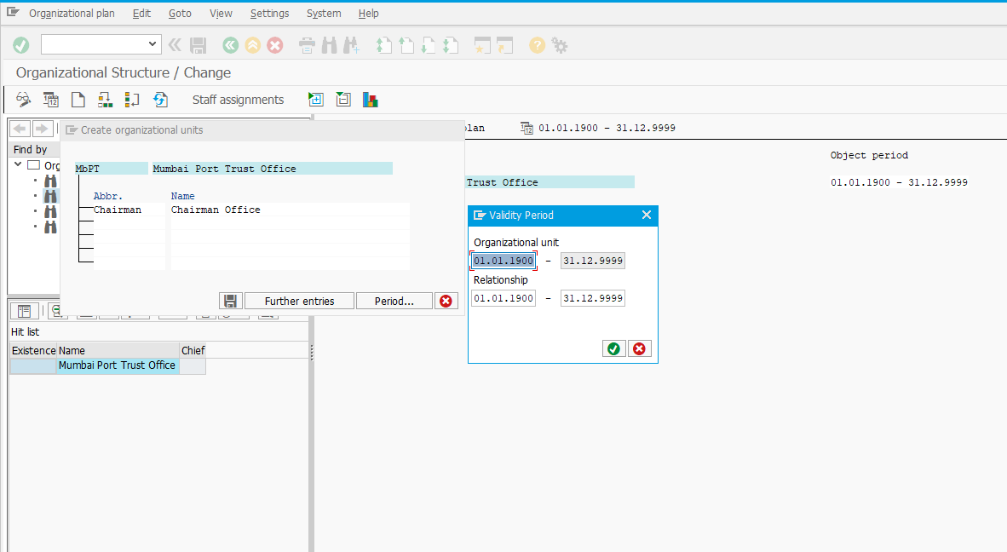
The entry is created as shown below.
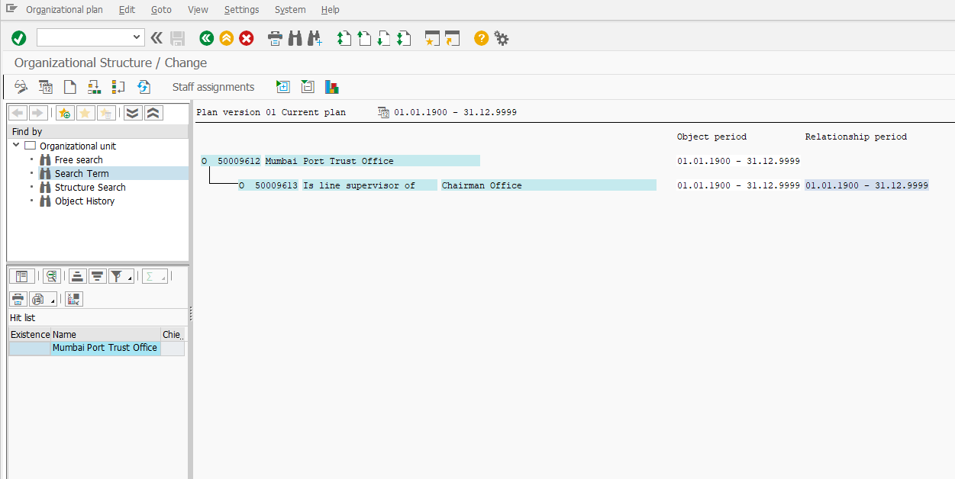
Creating Positions
- You create positions whenever you want to add new positions to an organizational Structure. You use this function to select the organizational unit to which you want to assign one or more positions
- In Simple Maintenance, you can create numerous positions at once.
- It is best to create positions by copying jobs. Choose the job, which forms the basis of the position, and create a position name using the name of the job. The position HR Manager will be derived from the job manager. This procedure offers two clear advantages to the system.
- Automatically creates a relationship between the job and the positions.
- Automatically assigns newly created positions to the organizational unit in use.
Procedure:
Select Edit > Create > Positions from the Change Staff Assignments screen.
The Create Positions dialog box appears.
- In the Describing job field, select the job to be copied.
- If a suitable job does not exist, you can create a new job by choosing Create job.
- In the Position field, enter data as required.
- Save your entries.
Put the cursor on the organizational unit where you want to create positions.
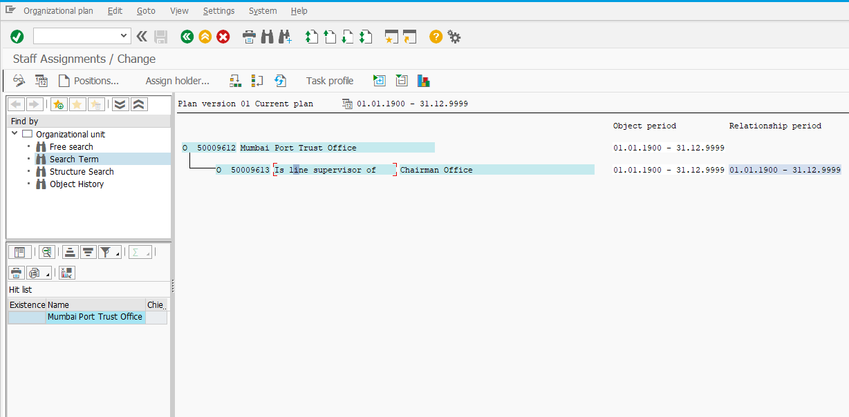

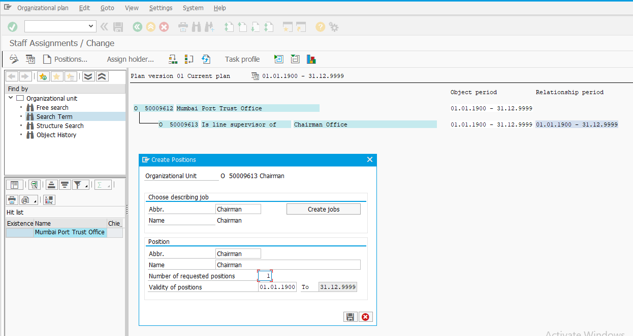
The position is created as shown below.
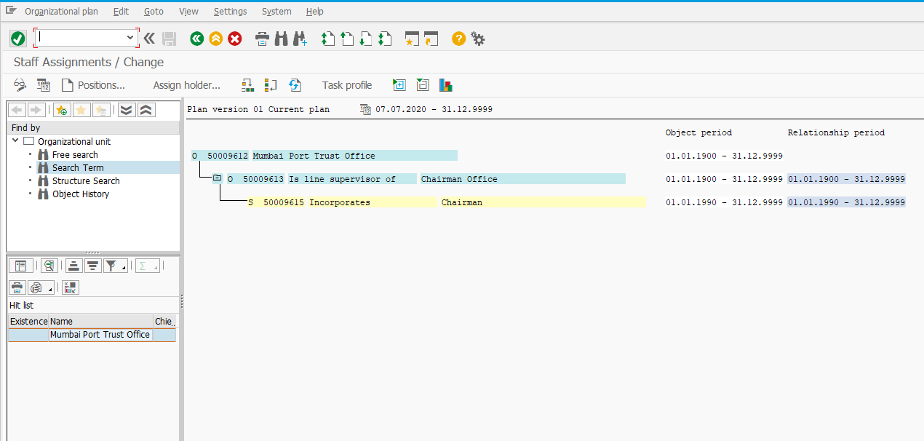
If more than one no of position needs to be created, give the no of requested positions count.
For e.g., If 5 Clerk Positions need to be created, give job details as “Clerk”, Position name “Clerk”, count as “5” in number of requested positions.
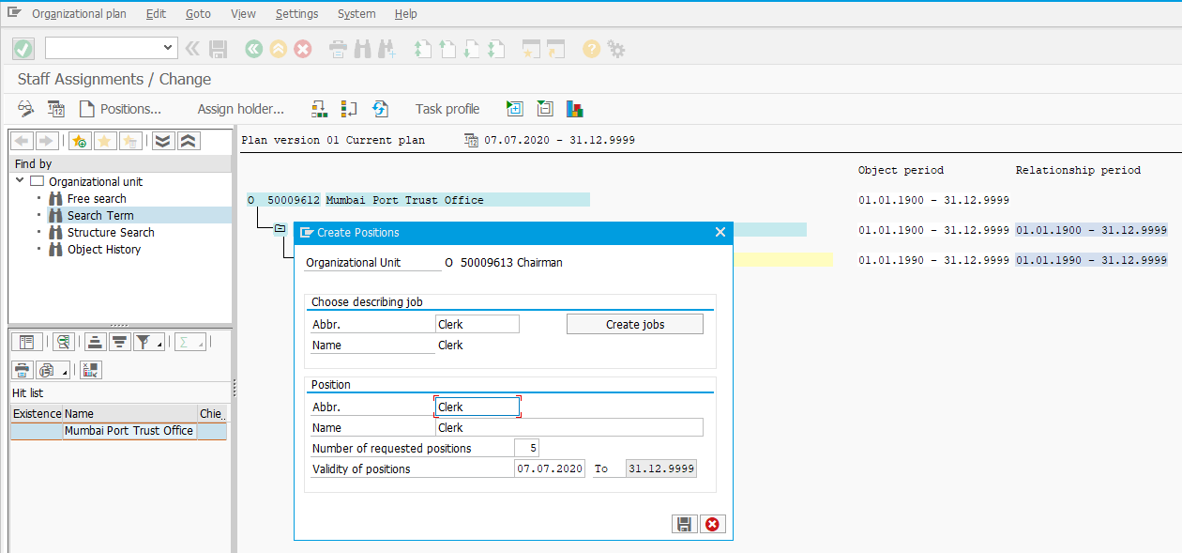
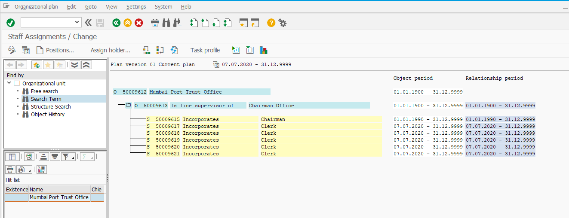

Maintain Object and Relationships
Menu Path | Human Resources -> Organizational Management-> Expert Mode -> General
Transaction Code | PP01

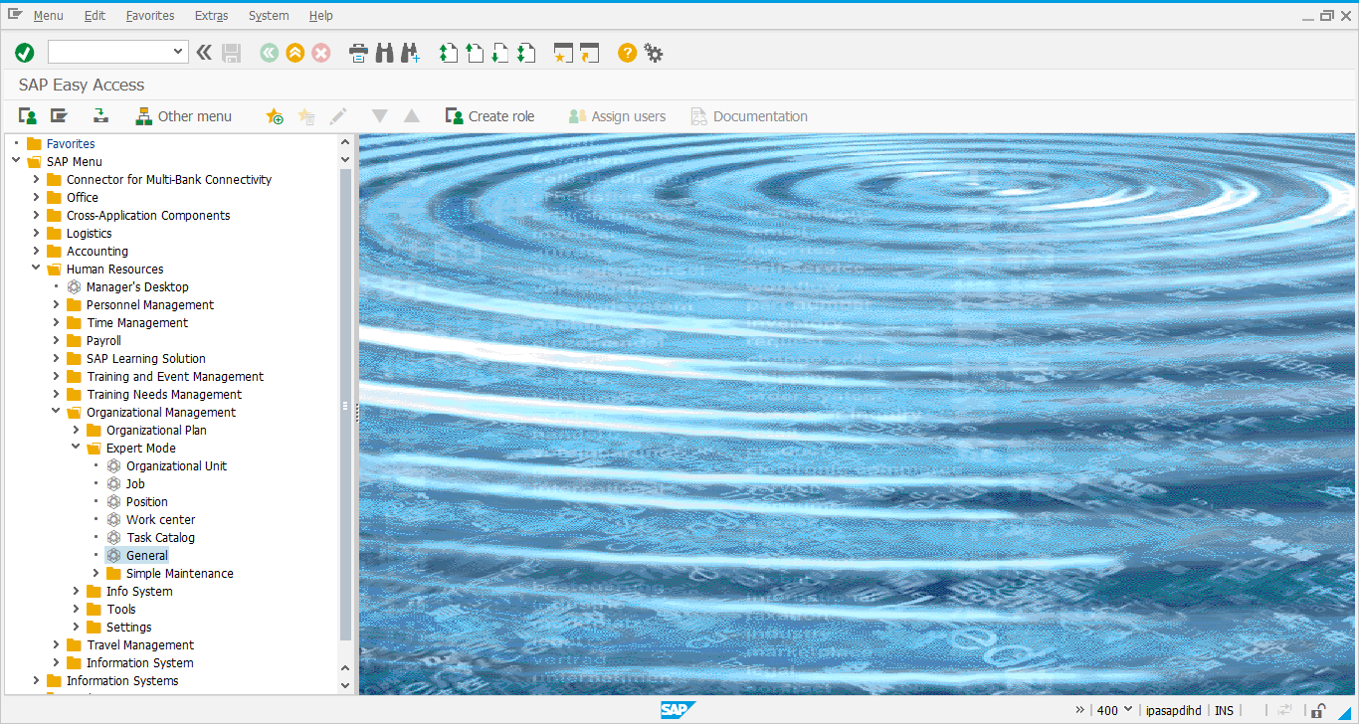

Below screenshot displays a position, its description and relationship with Organizational Unit.
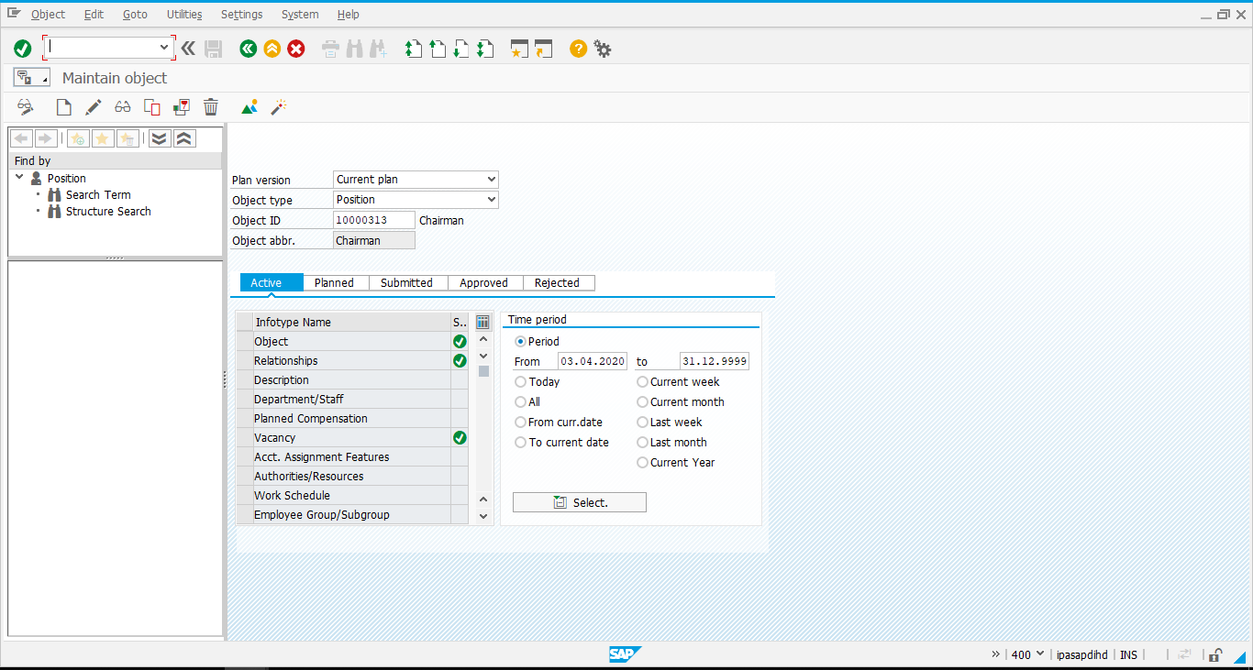
Select “Object” line item and click on to see the Object name.
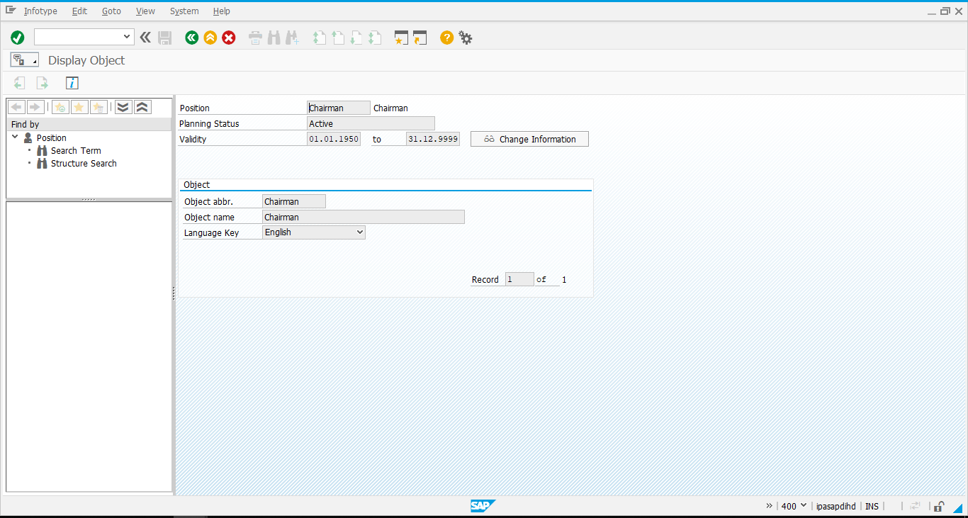

Display Relationship of Position and Organizational Unit
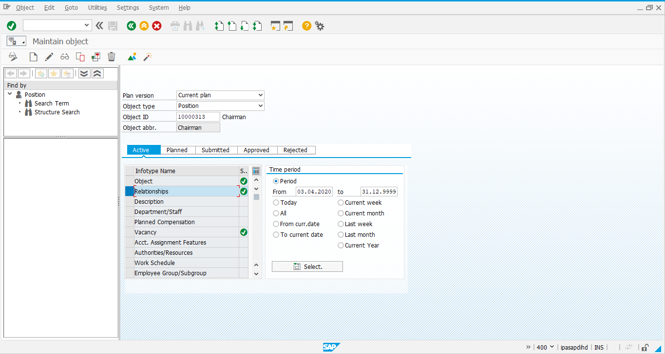
Select “Relationship” line item and click on to see relationship of Position and Organizational Unit.
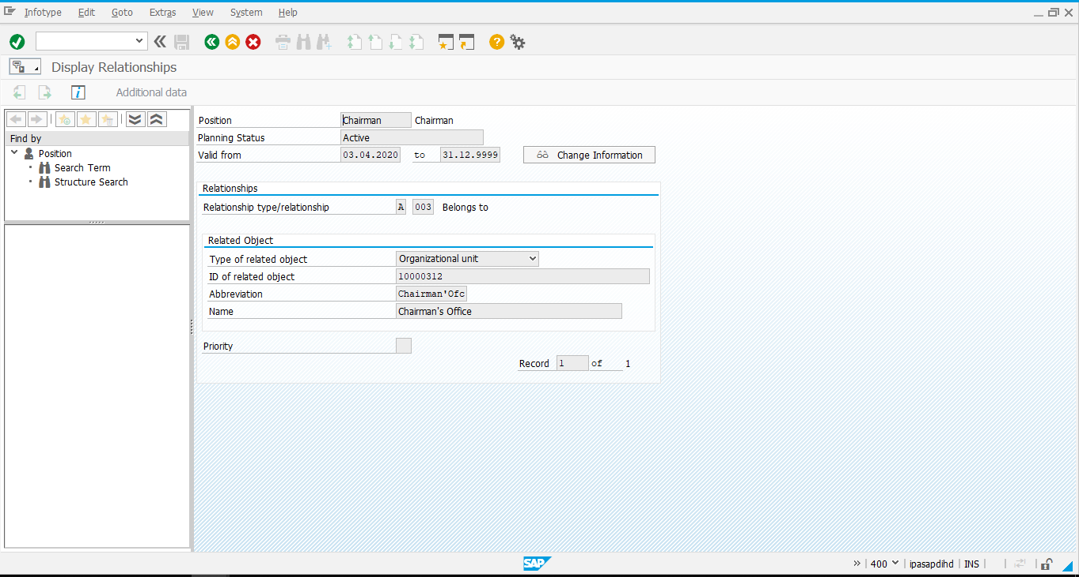

Creation of Position
Select Object Type as Position and click on Create icon highlighted in red.
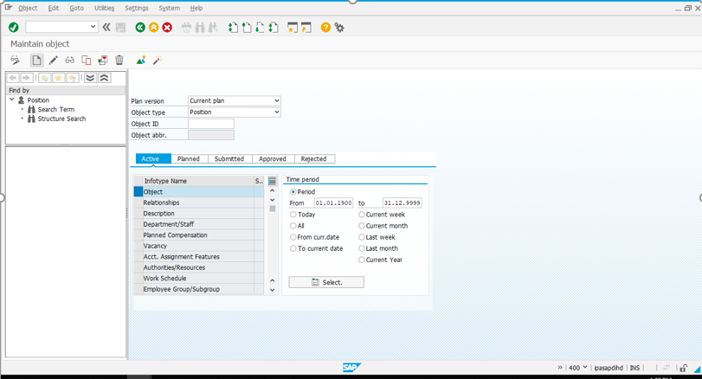
Object Definition – Give validity, Object name, language key, and click on save.
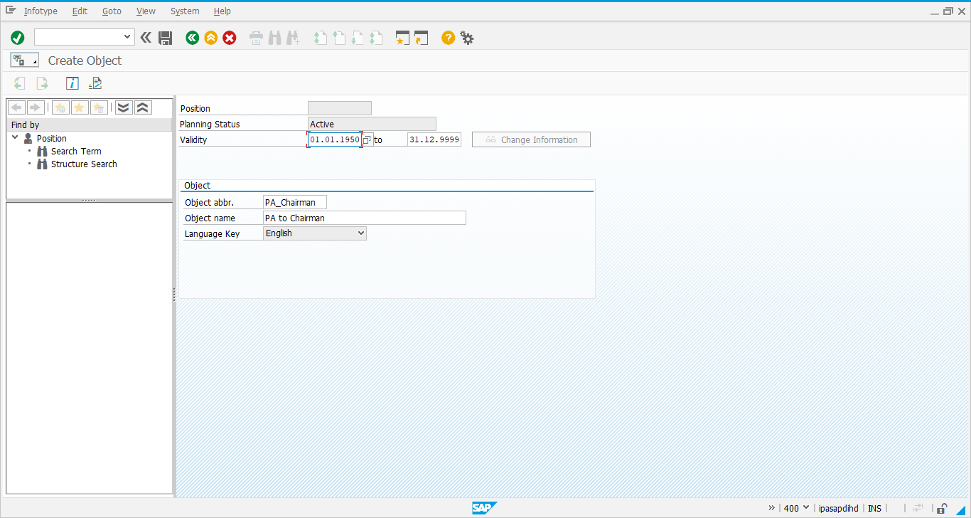

Position to Organizational Unit
Select “Relationship” line item and click on Create icon highlighted in red to maintain the relationship of Position and Organizational Unit.
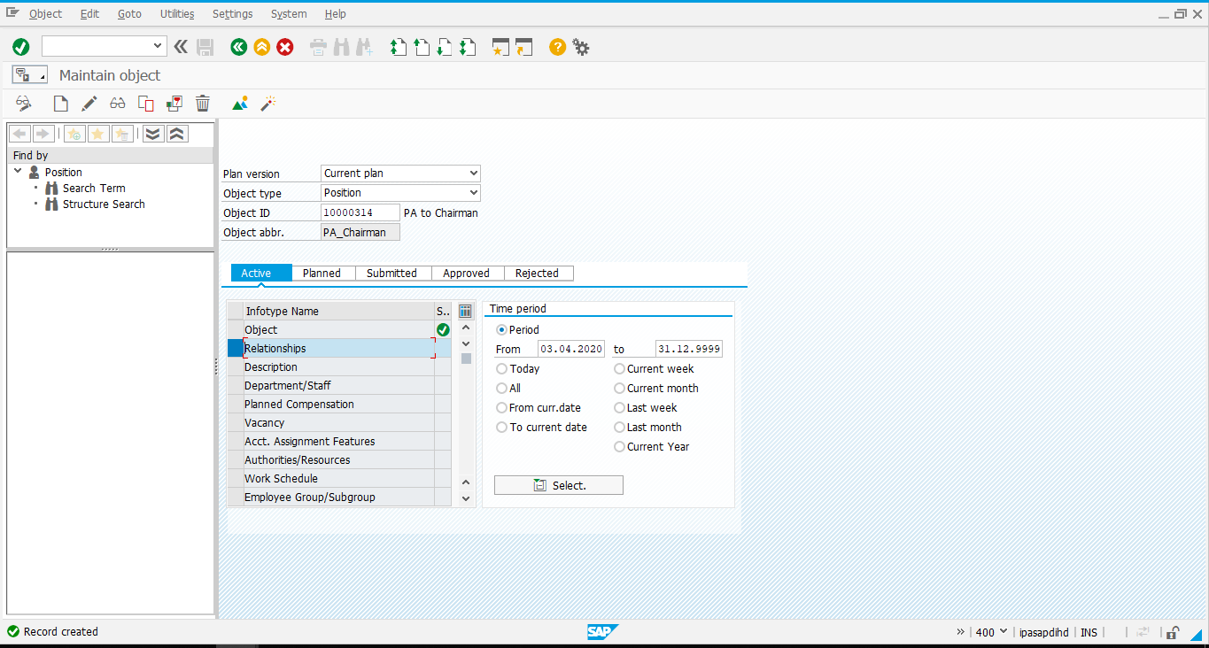
Enter Valid from/to date, relationship type as A 003, type of related object as “Organizational unit” and Object ID of Organizational Unit.
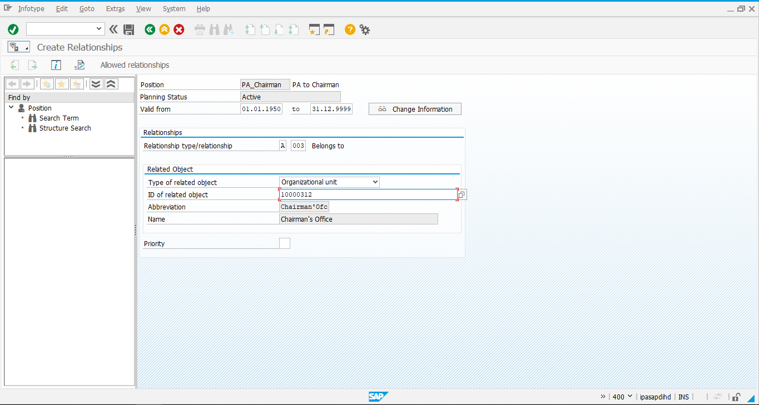
Click on to save the details.
Position is created and its info types Object and Relationships is maintained (denoted with green tick).
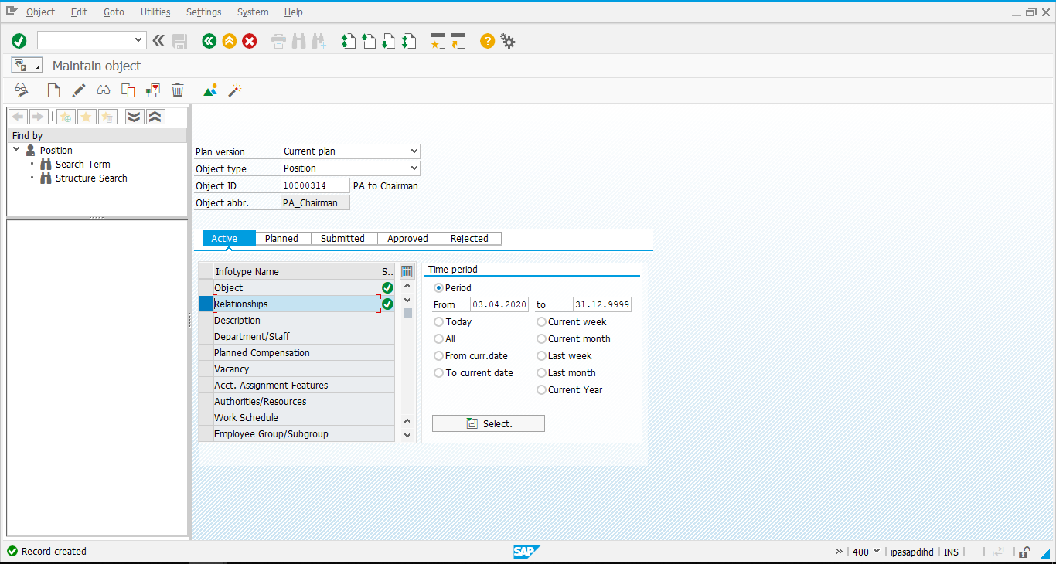

Position to Job
Create an Object Job and its relationship: Position to job
Select Object type as Job, line item as Object and click on Create icon highlighted in red.
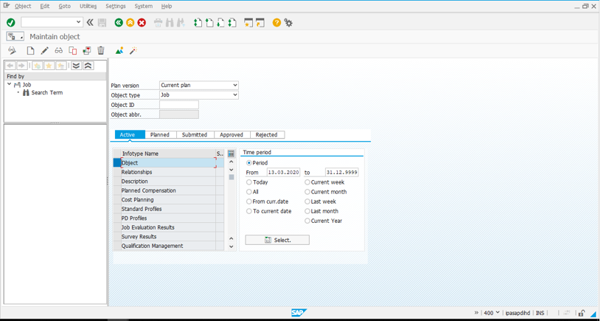
Give Job name and click on save.
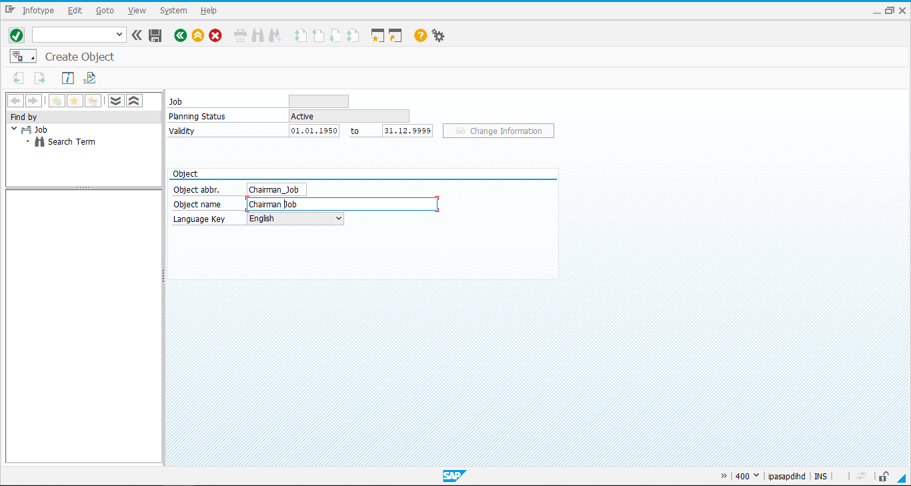
Job is created as shown below.
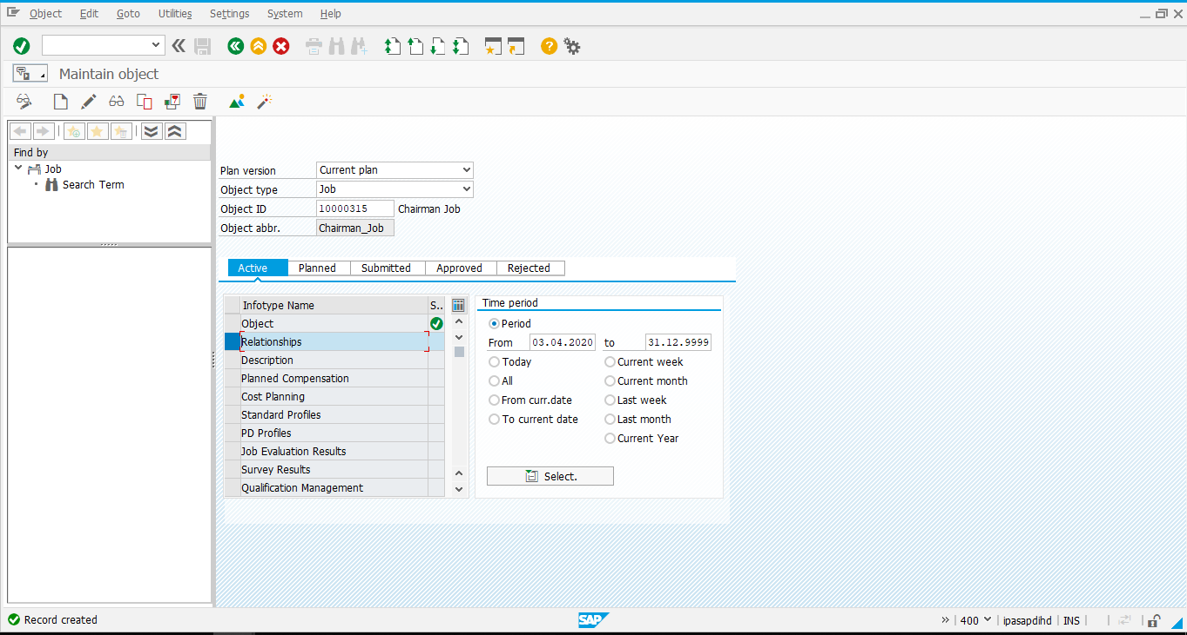

Position to Job.
Give Object Type as Position and Object ID
Select line item as Relationships and Click on Create icon as highlighted in red below.
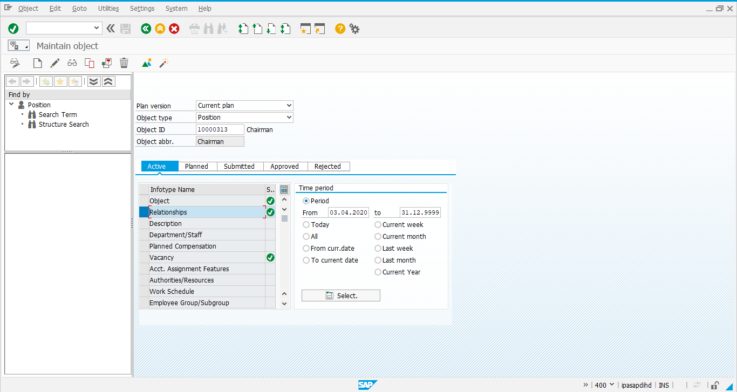
Job assignment: Give valid from/to date, relationship type as B 007, type of related object as “Job” and Object ID of Job. Click on save icon.
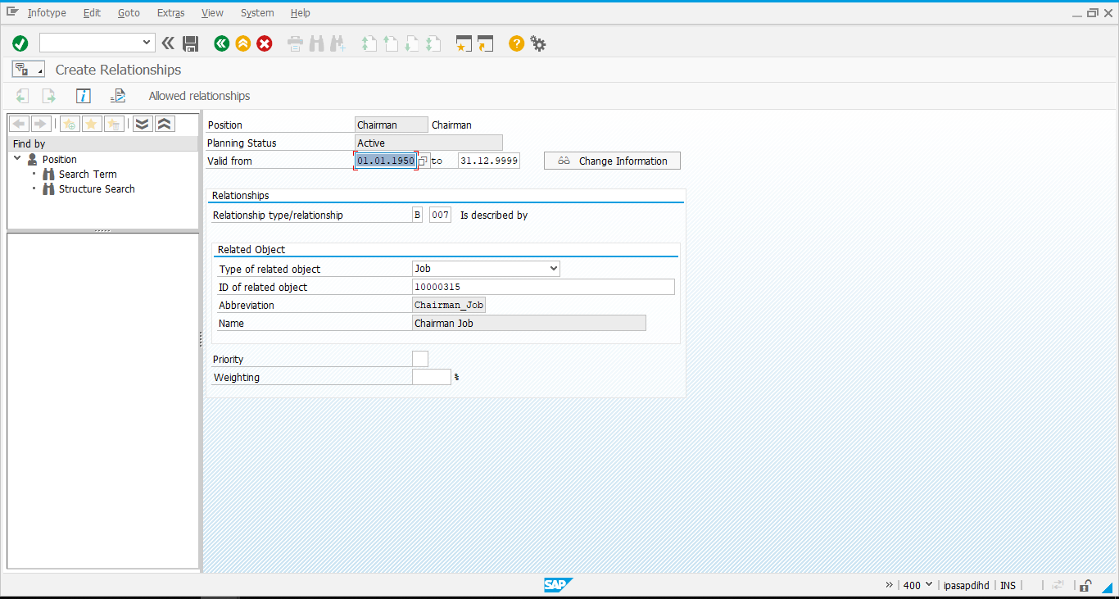
To see all relationships of Position, Click on Overview icon.
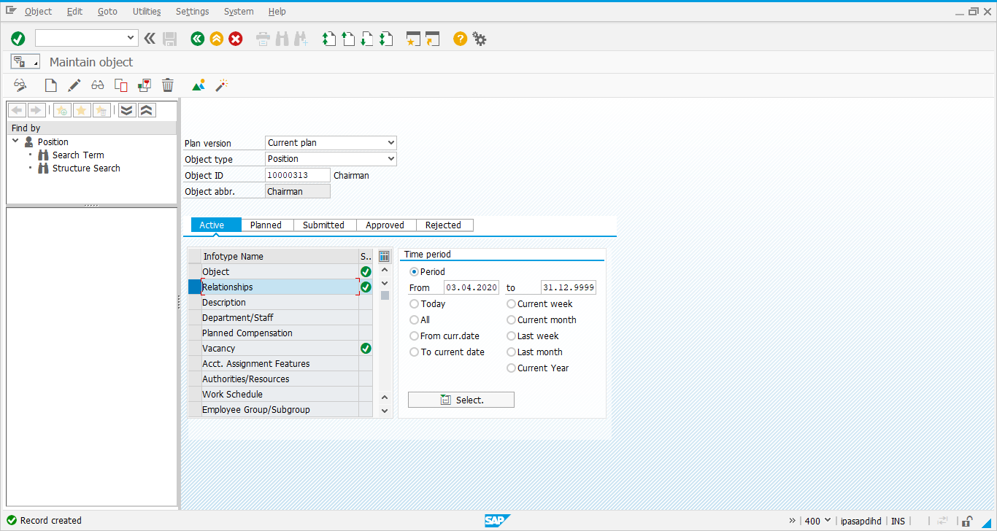
Below screenshot shows the relationship of Position with Organizational unit (O), Job (C), etc.
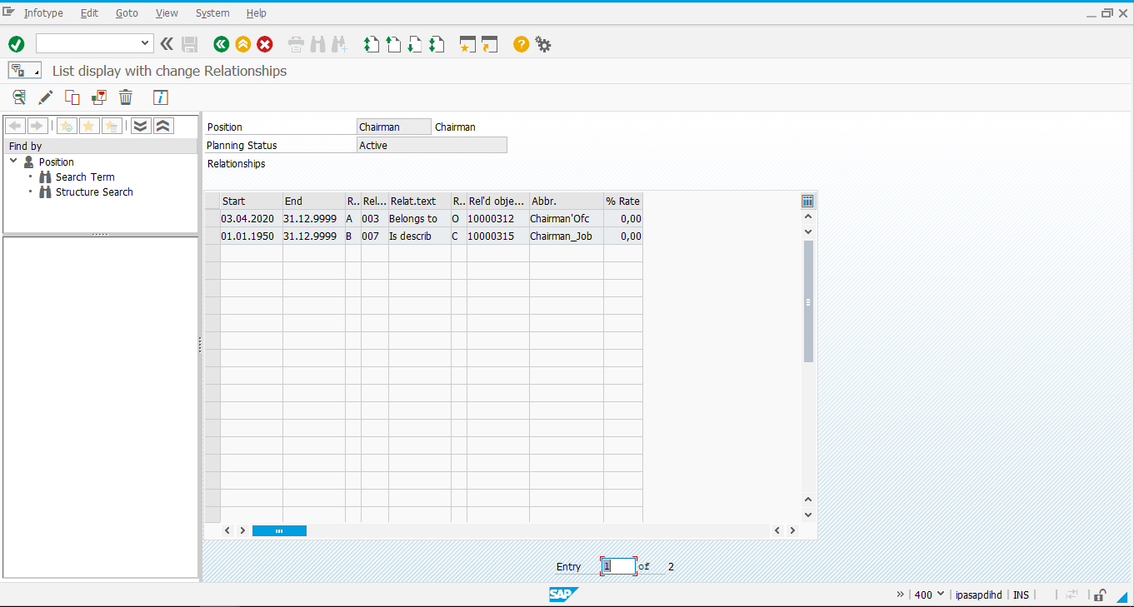

Position to Person
Select Relationships and click on Create.
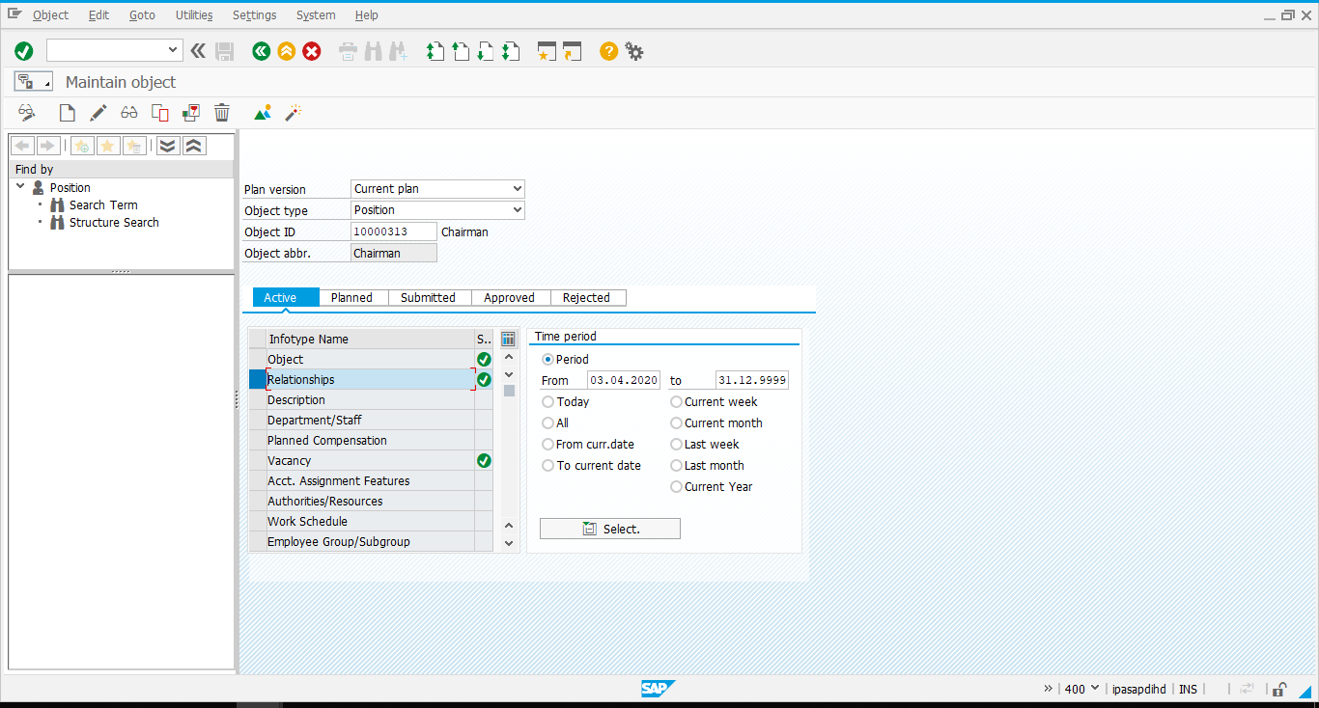
Position Relationship with Person: Enter Valid from/to date, relationship type as A 008, type of related object as “Person”, Object ID of Person and save

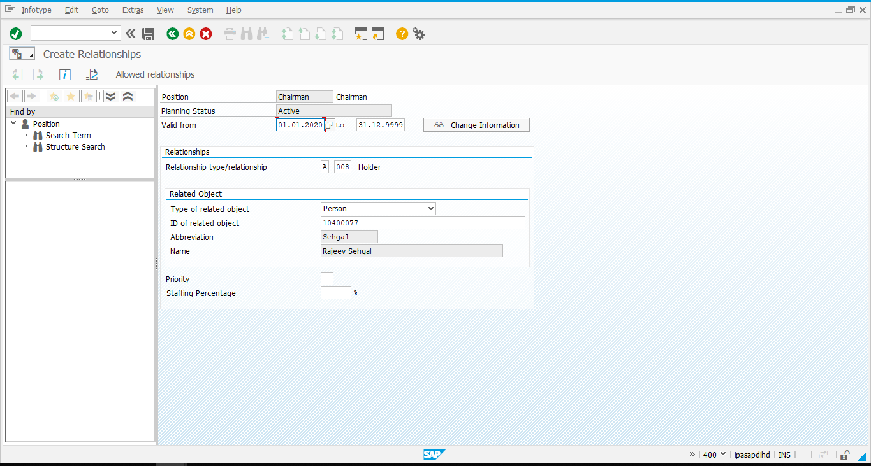
Overview of Position Relationship with Person (P).
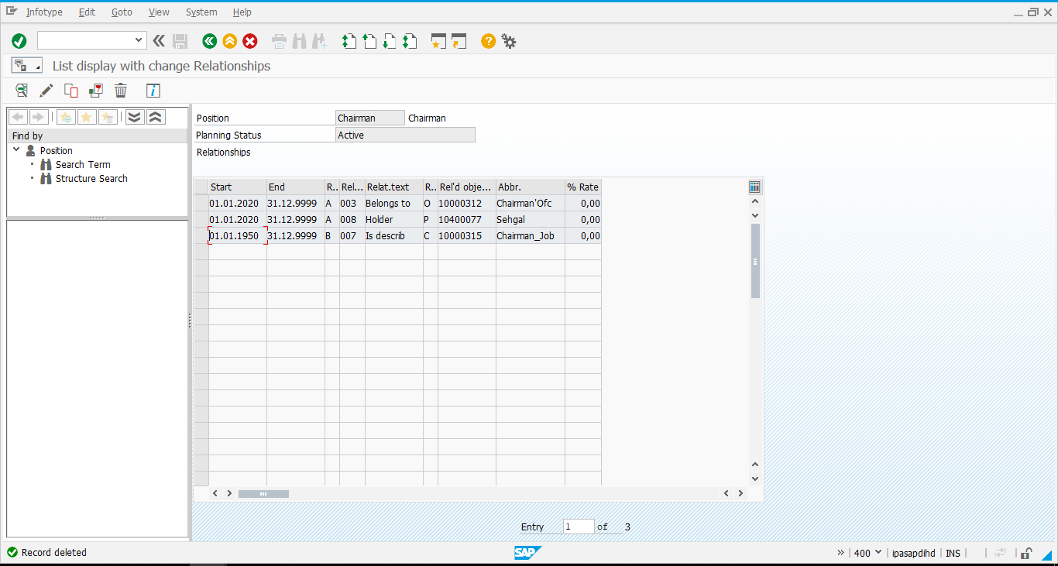

Position to Cost Center
Select line item as Relationships and click on Create.
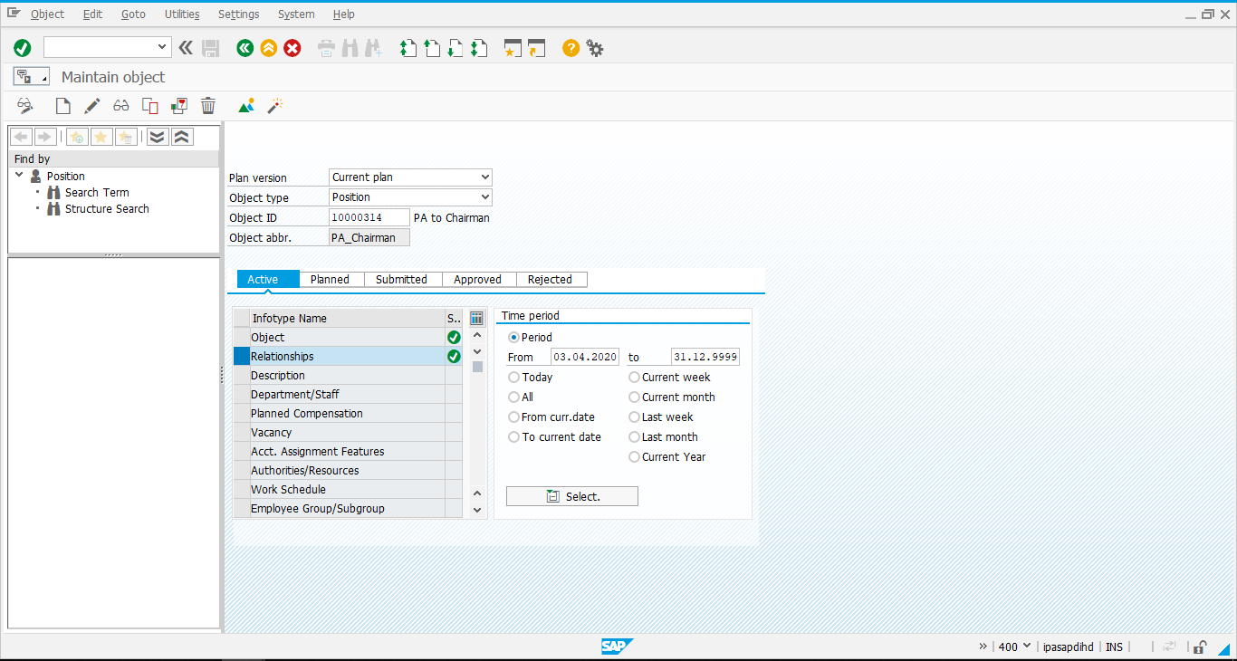
Maintain Relationship Cost Center assignment: Enter valid from/to date, relationship type as A 011, type of related object as “Cost center” and Object ID of Cost center.
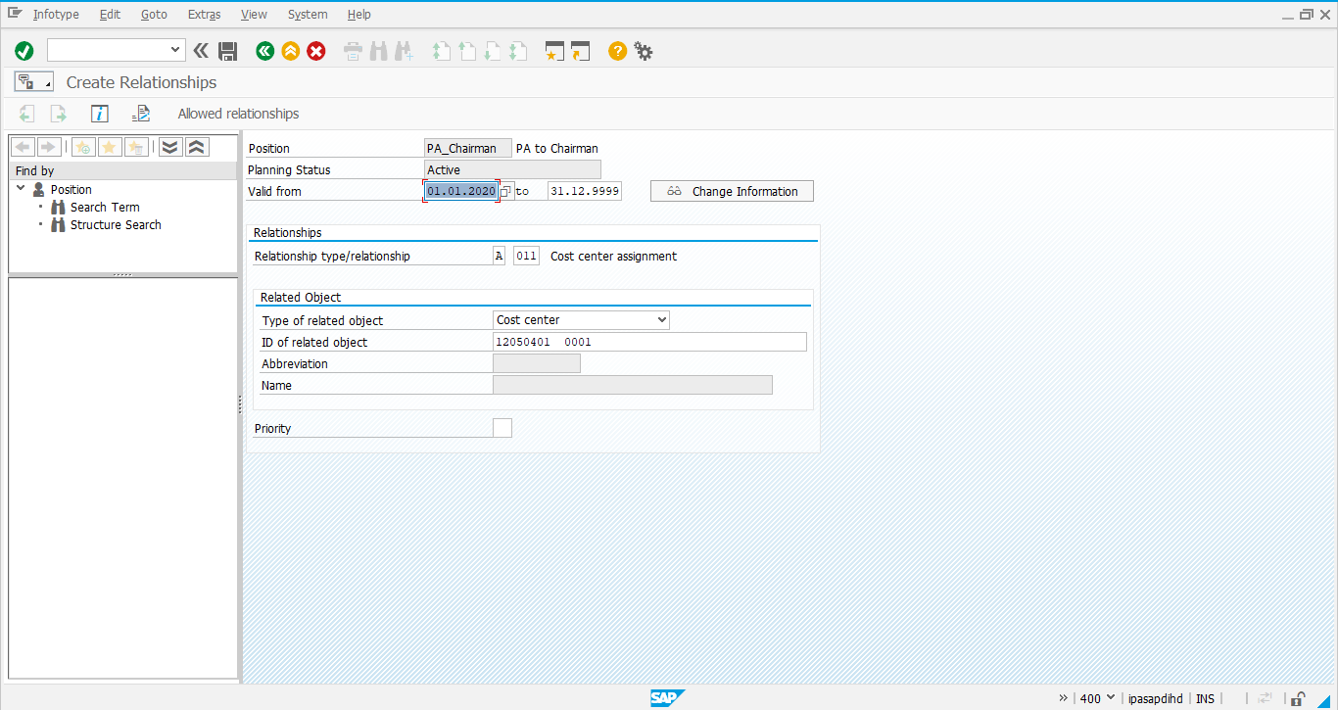
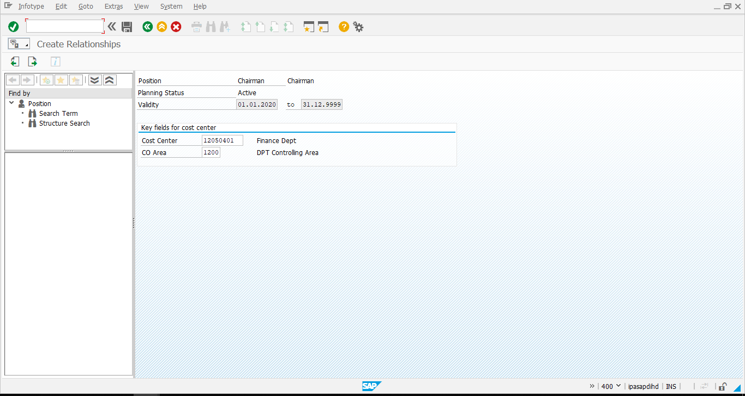
Click on save icon.
Overview of Position Relationship with Cost center is shown below.
